**Supplemental Appendix to *Safety of hydroxychloroquine, alone or in combination with azithromycin, in light of rapid wide-spread use for COVID-19: a multinational, network cohort and self-controlled case series study***

Jennifer C.E. Lane, James Weaver, Kristin Kostka, Talita Duarte-Salles, Maria Tereza F. Abrahao, Heba Alghoul, Osaid Alser, Thamir M Alshammari, Patricia Biedermann, Edward Burn, Paula Casajust, Mitch Conover, Aedin C. Culhane. Alexander Davydov, Scott L. DuVall, Dmitry Dymshyts, Sergio Fernandez-Bertolin, Kristina Fišter, Jill Hardin, Laura Hester, George Hripcsak, Seamus Kent, Sajan Khosla, Spyros Kolovos, Christophe G. Lambert, Johan van der Lei, Ajit A. Londhe, Kristine E. Lynch, Rupa Makadia, Andrea V. Margulis, Michael E. Matheny, Paras Mehta, Daniel R. Morales, Henry Morgan-Stewart, Mees Mosseveldl, Danielle Newby, Fredrik Nyberg, Anna Ostropolets, Rae Woong Park, Albert Prats-Uribe, Gowtham A. Rao, Christian Reich, Jenna Reps, Peter Rijnbeek, Selva Muthu Kumaran Sathappan, Martijn Schuemie, Sarah Seager, Anthony Sena, Azza Shoaibi, Matthew Spotnitz, Marc A. Suchard, Joel Swerdel, Carmen O. Torre, David Vizcaya, Haini Wen, Marcel de Wilde, Seng Chan You, Lin Zhang, Oleg Zhuk, Patrick Ryan, and Daniel Prieto-Alhambra

All artifacts generated as part of this study are publicly available in an interactive, web-based application at: <https://data.ohdsi.org/Covid19EstimationHydroxychloroquine/>

Contents

S1. Data sources 4

S2. Cohort definitions 5

S2.1. Exposures 5

S5.1.1. New users of Hydroxychloroquine with prior rheumatoid arthritis 5

S5.1.2. New users of sulfasazine with prior rheumatoid arthritis 6

S5.1.3. Users of Hydroxychloroquine + Azithromycin 6

S5.1.4. Users of Hydroxychloroquine + Amoxicillin 7

S2.2. Outcomes 7

S3. Negative control outcomes 7

S4. Covariate construction 9

S5. Exposure cohort counts 10

S6. Covariate balance before and after PS stratification 11

S6.1. HCQ vs SSZ 11

S6.1.1. AmbEMR 11

S6.1.2. CCAE 13

S6.1.3. CPRD 14

S6.1.4. DAGermany 15

S6.1.5. IMRD 17

S6.1.6. IPCI 19

S6.1.7. JMDC 20

S6.1.8. MDCD 21

S6.1.9. MDCR 23

S6.1.10. OpenClaims 24

S6.1.11. Optum 25

S6.1.12. PanTher 27

S6.1.13. SIDIAP 29

S6.1.14. VA 30

S6.2. AZM vs AMX 32

S6.2.1. AmbEMR 32

S6.2.2. CCAE 34

S6.2.3. CPRD 35

S6.2.4. DAGermany 36

S6.2.5. IMRD 37

S6.2.6 IPCI 38

S6.2.7. MDCD 39

S6.2.8. MDCR 41

S6.2.9. OpenClaims 43

S6.2.10. Optum 44

S6.2.11. PanTher 45

S6.2.12. SIDIAP 47

S6.2.13. VA 48

S7. Patient counts, events, incident rates 50

S8. Calibrated hazard ratio forest plots 56

S8.1. 30-day follow-up 56

S8.1.1. All-cause mortality 56

S8.1.2. CV-related mortality 57

S8.1.3. Myocardial infarction 58

S8.1.4. Chest pain or angina 59

S8.1.5. Heart failure 60

S8.1.6. Cardiovascular events 61

S8.1.7. Cardiac arrhythmia 62

S8.1.8. Bradycardia 63

S8.1.9. Transient ischemic attack 64

S8.1.10.Stroke 65

S8.1.11. Venous thromboembolism 66

S8.1.12. Gastrointestinal bleeding 67

S8.1.13. Acute renal failure 68

S8.1.14. End stage renal disease 69

S8.1.15. Hepatic failure 70

S8.1.16. Acute pancreatitis 71

S8.2. On-treatment follow-up 72

S8.2.1. All-cause mortality 72

S8.2.2. CV-related mortality 73

S8.2.3. Myocardial infarction 74

S8.2.4. Chest pain or angina 75

S8.2.5. Heart failure 76

S8.2.6. Cardiovascular events 77

S8.2.7. Cardiac arrhythmia 78

S8.2.8. Bradycardia 79

S8.2.9. Transient ischemic attack 80

S8.2.10. Stroke 81

S8.2.11. Venous thromboembolism 82

S8.2.12. Gastrointestinal bleeding 83

S8.2.13. Acute renal failure 84

S8.2.14. End stage renal disease 85

S8.2.15. Hepatic failure 86

S8.2.16. Acute pancreatitis 87

S9. Evidence evaluation diagnostics 88

S9.1. AmbEMR 89

S9.2. CCAE 90

S9.3. CPRD 91

S9.4. DAGermany 92

S9.5. IMRD 93

S9.6. IPCI 94

S9.7. JMDC 95

S9.8. MDCD 96

S9.9. MDCR 97

S9.10. OpenClaims 98

S9.11. Optum 99

S9.12. PanTher 100

S9.13. SIDIAP 101

S9.14. VA 102

S10. Self-controlled case series results for hydroxychloroquine 103

S10.1. CCAE 103

S10.2. CPRD 104

S10.3. JMDC 105

S10.4. MDCD 106

S10.5. MDCR 107

S10.6. Optum 108

S11. Literature review sources 109

S11.1. PubMed search strategy 109

S11.2. Embase search strategy (1974 to present) 109

S11.3. ClinicalTrials.gov search strategy 112

S11.4. ICTRP strategy 112

S12. References 113

# **S1. Data sources**

|  |  |  |  |  |  |
| --- | --- | --- | --- | --- | --- |
| **Database name** | **Abbreviation** | **Population** | **Patients (millions)** | **Data History** | **Data capture process and short database description** |
| Veteran’s Health Administration | VA | USA (Veteran population) | ~12M | 2000 – | VA OMOP data reflects the national Department of Veterans Affairs health care system, which is the largest integrated provider of medical and mental health services in the United States. Care is provided at 170 VA Medical Centers and 1,063 outpatient sites serving more than 9 million enrolled Veterans each year. |
| IQVIA Disease Analyzer Germany | DAGermany | Germany (General population) | 37M | 1992 – | Anonymized patient records collected from Patient Management software used by general practitioners and selected specialists to document patients’ medical records within their office-based practice during a visit. |
| IQVIA UK Integrated Medical Record Data | IMRD | UK (General population) | 15M | 1989 – | Pseudonymized Electronic Medical Records collected from patient management software used within UK Primary Care |
| IQVIA US Ambulatory EMR | AmbEMR | USA (General population) | 49M | 2006 – | General practice EHR, Outpatient specialist EHR - Dataset consists of longitudinal, de-identified ambulatory electronic health records data |
| IQVIA US LRxDx Open Claims | OpenClaims | USA (General population) | 654M | 2010 – | Pre-adjudicated claims at the anonymized patient level collected from office-based physicians and specialists via office management software and clearinghouse switch sources for the purpose of reimbursement. |
| Clinical Practice Research Datalink | CPRD | UK (General population) | 13M | 1995 – | De-identified patient data from a network of general practitioners’ practices across the UK. Primary care data are linked to a range of other health related data to provide a longitudinal, representative UK population health dataset. |
| IBM MarketScan Commercial Claims | CCAE | USA (Patients with commercial insurance aged <65 years) | 142M | 2000 – | Data from individuals enrolled in US employer-sponsored insurance health plans. The data includes adjudicated health insurance claims (e.g. inpatient, outpatient, and outpatient pharmacy) as well as enrollment data from large employers and health plans who provide private healthcare coverage to employees, their spouses,and dependents. Additionally, it captures laboratory tests for a subset of the covered lives. |
| IBM MarketScan Multi-State Medicaid Database | MDCD | USA | 26M | 2006 – | Adjudicated US health insurance claims for Medicaid enrollees from multiple states and includes hospital discharge diagnoses, outpatient diagnoses and procedures, and outpatient pharmacy claims as well as ethnicity and Medicare eligibility. |
| IBM MarketScan Medicare Supplemental Database | MDCR | USA (Patients with commercial insurance aged 65+ years) | 10M | 2000 – | Represents health services of retirees (aged 65 or older) in the United States with primary or Medicare supplemental coverage through privately insured fee-for-service, point-of-service, or capitated health plans. These data include adjudicated health insurance claims (e.g. inpatient, outpatient, and outpatient pharmacy). Additionally, it captures laboratory tests for a subset of the covered lives. |
| Integrated Primary Care Information | IPCI | Netherlands (General Population) | 2.5M | 1996- | Complete medical records collected from 450 general practitioners with geographical representation of the country. |
| Japan Medical Data Center | JMDC | Japan (insured general population) | 5.5M | 2005 – | Data from 60 Society-Managed Health Insurance plans covering workers aged 18 to 65 and their dependents (children younger than 18 years old and elderly people older than 65 years old). JMDC data includes membership status of the insured people and claims data provided byinsurers under contract (e.g. patient-level demographic information, inpatient and outpatient data inclusive of diagnosis and procedures, and prescriptions as dispensed claims information) |
| Optum De-Identified Clinformatics DataMart (DOD) | Optum | USA (Patients with commercial insurance or commercial Medicare insurance) | 85M | 2000 - | Inpatient and outpatient healthcare insurance claims |
| Optum De-identified Electronic Health Record Dataset | PanTher | USA (General population) | 93M | 2006 – | Optum’s de-identified electronic health record data medical records database. The medical record data includes clinical information, inclusive of prescriptions as prescribed and administered, lab results, vital signs, body measurements, diagnoses, procedures, and information derived from clinical notes using Natural Language Processing (NLP). |
| The Information System for Research in Primary Care | SIDIAP | Spain-Catalonia (80% of general population) | 7.7M | 2006 – | Electronic health records from primary care partially linked to inpatient data. SIDIAP is also linked to a pharmacy dispensations and primary care laboratories. Healthcare is universal and taxpayer funded in the region, and primary care physicians are gatekeepers for all care and responsible for repeat prescriptions. |

# **S2. Cohort definitions**

## **S2.1. Exposures**

The four exposure cohorts were constructed using the logic below. The full specification, including complete code sets and computer readable JSON and SQL representations are publicly available at the URLs for each definition:

### **S5.1.1. New users of Hydroxychloroquine with prior rheumatoid arthritis**

<https://atlas.ohdsi.org/#/cohortdefinition/173>

Initial Event Cohort

People having any of the following:

* a drug exposure of [OHDSI Cov19] Hydroxychloroquine1
  + for the first time in the person's history
  + with age >= 18

with continuous observation of at least 365 days prior and 0 days after event index date, and limit initial events to: **earliest event per person.**

Inclusion Rules

Inclusion Criteria #1: has rheumatoid arthritis recorded any time on or prior to treatment

Having any of the following criteria:

* at least 1 occurrences of a condition occurrence of [OHDSI Cov19] Rheumatoid arthritis2

where event starts between all days Before and 0 days After index start date

* or at least 1 occurrences of an observation of [OHDSI Cov19] Rheumatoid arthritis2

where event starts between all days Before and 0 days After index start date

Limit qualifying cohort to: **earliest event per person.**

End Date Strategy

Custom Drug Era Exit Criteria

This strategy creates a drug era from the codes found in the specified concept set. If the index event is found within an era, the cohort end date will use the era's end date. Otherwise, it will use the observation period end date that contains the index event.

Use the era end date of [OHDSI Cov19] Hydroxychloroquine1

* allowing 90 days between exposures
* adding 0 days after exposure end

Cohort Collapse Strategy:

Collapse cohort by era with a gap size of 0 days.

### **S5.1.2. New users of sulfasazine with prior rheumatoid arthritis**

<https://atlas.ohdsi.org/#/cohortdefinition/45>

Initial Event Cohort

People having any of the following:

* a drug exposure of [OHDSI Cov19] sulfasalazine2
  + for the first time in the person's history

with continuous observation of at least 365 days prior and 0 days after event index date, and limit initial events to: **earliest event per person.**

Inclusion Rules

Inclusion Criteria #1: has rheumatoid arthritis recorded any time on or prior to treatment

Having all of the following criteria:

* at least 1 occurrences of a condition occurrence of [OHDSI Cov19] Rheumatoid arthritis1

where event starts between all days Before and 0 days After index start date

Limit qualifying cohort to: **earliest event per person.**

End Date Strategy

Custom Drug Era Exit Criteria

This strategy creates a drug era from the codes found in the specified concept set. If the index event is found within an era, the cohort end date will use the era's end date. Otherwise, it will use the observation period end date that contains the index event.

Use the era end date of [OHDSI Cov19] sulfasalazine2

* allowing 90 days between exposures
* adding 0 days after exposure end

Cohort Collapse Strategy:

Collapse cohort by era with a gap size of 0 days.

### **S5.1.3. Users of Hydroxychloroquine + Azithromycin**

<https://atlas.ohdsi.org/#/cohortdefinition/170>

Initial Event Cohort

People having any of the following:

* a drug exposure of Hydroxychloroquine1
  + with age >= 18
* a drug exposure of [OHDSI Covid19] Azithromycin3
  + with age >= 18

with continuous observation of at least 365 days prior and 0 days after event index date, and limit initial events to: **all events per person.**

Inclusion Rules

Inclusion Criteria #1: has both drugs on index

Having all of the following criteria:

* at least 1 occurrences of a drug exposure of Hydroxychloroquine1

where event starts between 30 days Before and 0 days After index start date

* and at least 1 occurrences of a drug exposure of [OHDSI Covid19] Azithromycin3

where event starts between 30 days Before and 0 days After index start date

Inclusion Criteria #2: prior diagnosis of RA

Having any of the following criteria:

* at least 1 occurrences of a condition occurrence of [OHDSI Cov19] Rheumatoid arthritis2

where event starts between all days Before and 0 days After index start date

* or at least 1 occurrences of an observation of [OHDSI Cov19] Rheumatoid arthritis2

where event starts between all days Before and 0 days After index start date

Limit qualifying cohort to: **earliest event per person.**

End Date Strategy

Custom Drug Era Exit Criteria

This strategy creates a drug era from the codes found in the specified concept set. If the index event is found within an era, the cohort end date will use the era's end date. Otherwise, it will use the observation period end date that contains the index event.

Use the era end date of [OHDSI Covid19] Azithromycin3

* allowing 30 days between exposures
* adding 0 days after exposure end

Cohort Collapse Strategy:

Collapse cohort by era with a gap size of 0 days.

### **S5.1.4. Users of Hydroxychloroquine + Amoxicillin**

<https://atlas.ohdsi.org/#/cohortdefinition/171>

Initial Event Cohort

People having any of the following:

* a drug exposure of Hydroxychloroquine1
  + with age >= 18
* a drug exposure of [OHDSI Covid19] Amoxicillin3
  + with age >= 18

with continuous observation of at least 365 days prior and 0 days after event index date, and limit initial events to: **all events per person.**

Inclusion Rules

Inclusion Criteria #1: has both drugs on index

Having all of the following criteria:

* at least 1 occurrences of a drug exposure of Hydroxychloroquine1

where event starts between 30 days Before and 0 days After index start date

* and at least 1 occurrences of a drug exposure of [OHDSI Covid19] Amoxicillin3

where event starts between 30 days Before and 0 days After index start date

Inclusion Criteria #2: Prior diagnosis of RA

Having any of the following criteria:

* at least 1 occurrences of a condition occurrence of [OHDSI Cov19] Rheumatoid arthritis2

where event starts between all days Before and 0 days After index start date

* or at least 1 occurrences of an observation of [OHDSI Cov19] Rheumatoid arthritis2

where event starts between all days Before and 0 days After index start date

Limit qualifying cohort to: **earliest event per person.**

End Date Strategy

Custom Drug Era Exit Criteria

This strategy creates a drug era from the codes found in the specified concept set. If the index event is found within an era, the cohort end date will use the era's end date. Otherwise, it will use the observation period end date that contains the index event.

Use the era end date of [OHDSI Covid19] Amoxicillin3

* allowing 30 days between exposures
* adding 0 days after exposure end

Cohort Collapse Strategy:

Collapse cohort by era with a gap size of 0 days.

## **S2.2. Outcomes**

All safety outcomes for this study were defined as described in the supplementary appendix to Suchard et al (2019)[1].

# **S3. Negative control outcomes**

Negative control outcomes are conditions believed to have no causal relationship with hydroxychloroquine, sulfasalazine, azithromycin, or amoxicillin exposure and therefore assumed *a priori* to return a hazard ratio (HR) of 1.0 when their risk is compared between exposure cohorts in a pairwise comparison. A HR of a negative control outcome that differs from 1.0 represents an estimate of the residual error of the analysis that was unaccounted for by the analytic specification such as propensity score adjustment. The distribution of residual error estimates from the negative control outcomes reflects a range of biases inherent to the analysis. The estimates on the negative control outcomes represents the empirical null distribution and we used it to compute hazard ratios and confidence intervals calibrated to reflect the observed residual error of the analysis. The negative controls were selected through a semi-automated process{Voss, 2017 #6} and are listed below with the corresponding SNOMED concept ID.

|  |  |  |  |
| --- | --- | --- | --- |
| **Concept ID** | **Concept Name** | **Concept ID** | **Concept Name** |
| 378256 | Abnormal reflex | 435516 | Lipoprotein deficiency disorder |
| 4092879 | Absent kidney | 438808 | Mammary duct ectasia |
| 433753 | Alcohol abuse | 441553 | Myoclonus |
| 321689 | Apnea | 4119307 | Neurogenic claudication |
| 78200 | Benign mammary dysplasia | 4209423 | Nicotine dependence |
| 4195873 | Breath smells unpleasant | 438130 | Opioid abuse |
| 443792 | Calculus of bile duct | 313601 | Oxygen supply absent |
| 434327 | Cannabis abuse | 44782778 | Pain disorder with psychological factor |
| 197318 | Cholesterolosis of gallbladder | 4091513 | Passing flatus |
| 432303 | Cocaine abuse | 4022076 | Patient dependence on care provider |
| 439125 | Complete trisomy 21 syndrome | 439971 | Poisoning by anticoagulant |
| 433270 | Cord entanglement without compression | 46286594 | Problem related to lifestyle |
| 4311591 | Cramp in limb | 199876 | Prolapse of female genital organs |
| 441267 | Cystic fibrosis | 4049367 | Psychologic conversion disorder |
| 436233 | Delayed milestone | 440068 | Psychosexual dysfunction |
| 40486120 | Delay in physiological development | 436246 | Reduced libido |
| 439791 | Emotional upset | 73754 | Restless legs |
| 374801 | Foreign body in ear | 4168212 | Restlessness and agitation |
| 259995 | Foreign body in orifice | 138821 | Seborrhea |
| 196456 | Gallstone | 4198492 | Shoulder joint unstable |
| 4166231 | Genetic predisposition | 25518 | Sickle cell trait |
| 434164 | Glycosuria | 4176908 | Snapping thumb syndrome |
| 4163735 | Hemochromatosis | 4248728 | Snoring |
| 439871 | Hemospermia | 138278 | Sprains and strains of joints and adjacent muscles |
| 4058388 | Hypertrophic scar | 4008710 | Stenosis due to any device, implant AND/OR graft |
| 435522 | Hypervitaminosis D | 40479573 | Stimulant abuse |
| 443236 | Hypnotic or anxiolytic dependence | 40483172 | Stimulant dependence |
| 4098604 | Hypomagnesemia | 440233 | Strain of supraspinatus muscle AND/OR tendon |
| 435371 | Hypothermia | 4194160 | Thyroid function tests abnormal |
| 443447 | Iatrogenic hypotension | 4216708 | Urgent desire for stool |
| 374375 | Impacted cerumen | 4275889 | Visual hallucinations |
| 4344500 | Impingement syndrome of shoulder region | 4193634 | Worried |
| 440382 | Learning difficulties |  |  |

# **S4. Covariate construction**

The following consistently extracted set of baseline patient characteristics will be constructed for input in the PS model. From this large set of typically tens of thousands of covariates, key predictors of exposure classification will be selected for inclusion in the PS model. Note that not all data sources necessarily include data for all covariates. Covariates to be included:

* Demographics (age in 5-year bands, sex, race, ethnicity, index year, index month)
* All conditions occurrence records aggregated to SNOMED clinical finding level during the following lookback windows:
  + in 365 days prior to and including index date
  + in 30 days prior to and including index date
* All drug exposure records aggregated to RxNorm ingredient level and ATC classes during the following lookback windows:
  + in 365 days prior to and including index date
  + in 30 days prior to and including index date
  + persistent exposure that overlaps index date
* All procedure occurrence records during the following lookback windows:
  + in 365 days prior to and including index date
  + in 30 days prior to and including index date
* Measurements (including laboratories) within, above, and below normal range during the following lookback window:
  + in 365 days prior to and including index date
* Device exposure records during the following lookback windows:
  + in 365 days prior to and including index date
  + in 30 days prior to and including index date
* Comorbidity or risk scores including:
  + Charlson
  + DCSI
  + CHADS2
  + CHADS2VASc

# **S5. Exposure cohort counts**

The exposure cohort counts are calculated after the following study design criteria have been applied:

* Duplicate patients in the hydroxychloroquine and sulfasalazine with prior RA cohorts are removed from the cohort they qualified for second (i.e. retained in the cohort they qualified for first)
* Duplicate patients in the hydroxychloroquine + azithromycin and hydroxychloroquine + amoxicillin with prior RA cohorts are removed from the cohort they qualified for second (i.e. retained in the cohort they qualified for first)
* Restricted to the calendar time when both exposures in a pairwise comparison (i.e. HCQ vs SSA and HCQ+AZM vs HCQ+AMX) are observed in the database.

After applying these design criteria to the original cohorts, the resulting patients are eligible to contribute data to study diagnostics and potentially to final population-level effect estimates.

|  |  |  |  |  |  |
| --- | --- | --- | --- | --- | --- |
| **Exposure cohort** | **Database** | **Patients** | **Exposure cohort** | **Database** | **Patients** |
| Hydroxychloroquine with prior RA  N = 956,374 | AmbEMR | 57,662 | Hydroxychloroquine + Azithromycin with prior RA  N = 323,122 | AmbEMR | 13,197 |
| CCAE | 66,756 | CCAE | 32,693 |
| CPRD | 9,129 | CPRD | 115 |
| DAGermany | 3,887 | DAGermany | 89 |
| IMRD | 8,855 | IMRD | 112 |
| IPCI | 1,479 | IPCI | 121 |
| JMDC | 241 | JMDC | 22 |
| MDCD | 8,095 | MDCD | 3,811 |
| MDCR | 15,853 | MDCR | 8,156 |
| OpenClaims | 621,124 | OpenClaims | 216,195 |
| Optum | 51,352 | Optum | 23,645 |
| PanTher | 78,647 | PanTher | 18,592 |
| SIDIAP | 1,247 | SIDIAP | 130 |
| VA | 32,047 | VA | 6244 |
| Sulfasalazine with prior RA  N = 310,350 | AmbEMR | 15,358 | Hydroxychloroquine + Amoxicillin with prior RA  N = 351,956 | AmbEMR | 12,084 |
| CCAE | 22,407 | CCAE | 32,591 |
| CPRD | 11,401 | CPRD | 5,530 |
| DAGermany | 5,047 | DAGermany | 202 |
| IMRD | 8,463 | IMRD | 5,104 |
| IPCI | 528 | IPCI | 483 |
| JMDC | 2,099 | JDMC | 30 |
| MDCD | 2,200 | MDCD | 3,818 |
| MDCR | 5,193 | MDCR | 9,285 |
| OpenClaims | 183,566 | OpenClaims | 233,107 |
| Optum | 17,411 | Optum | 24,547 |
| PanTher | 21,944 | PanTher | 16,480 |
| SIDIAP | 381 | SIDIAP | 686 |
| VA | 14,352 | VA | 8,009 |

*Note that HCQ+AZM vs HCQ+AMX cohorts in JDMC were of insufficient sample to fit PS models so were not included in the study diagnostics or population-level effect estimation analyses.

# **S6. Covariate balance before and after PS stratification**

## **S6.1. HCQ vs SSZ**

### **S6.1.1. AmbEMR**

|  |  |  |  |  |  |  |
| --- | --- | --- | --- | --- | --- | --- |
|  | Before stratification |  |  | After stratification |  |  |
|  | HCQ | SSZ |  | HCQ | SSZ |  |
| Characteristic | % | % | Std. diff | % | % | Std. diff |
| Age group |  |  |  |  |  |  |
| 15-19 | 0.1 | 0.1 | 0.00 | 0.1 | 0.1 | 0.00 |
| 20-24 | 0.7 | 0.6 | 0.01 | 0.7 | 0.6 | 0.01 |
| 25-29 | 1.3 | 1.4 | -0.01 | 1.3 | 1.4 | 0.00 |
| 30-34 | 2.4 | 2.2 | 0.02 | 2.3 | 2.3 | 0.00 |
| 35-39 | 3.5 | 3.7 | -0.01 | 3.5 | 3.4 | 0.01 |
| 40-44 | 5.4 | 5.0 | 0.02 | 5.3 | 5.1 | 0.01 |
| 45-49 | 7.4 | 7.0 | 0.02 | 7.4 | 7.5 | 0.00 |
| 50-54 | 10.4 | 11.0 | -0.02 | 10.5 | 10.5 | 0.00 |
| 55-59 | 13.1 | 13.4 | -0.01 | 13.2 | 12.9 | 0.01 |
| 60-64 | 13.8 | 14.4 | -0.02 | 13.9 | 14.1 | 0.00 |
| 65-69 | 13.7 | 14.2 | -0.01 | 13.8 | 13.7 | 0.00 |
| 70-74 | 13.1 | 13.3 | -0.01 | 13.1 | 13.9 | -0.02 |
| 75-79 | 11.2 | 9.8 | 0.05 | 10.9 | 11.0 | 0.00 |
| 80-84 | 3.9 | 3.9 | 0.00 | 3.9 | 3.7 | 0.01 |
| Gender: female | 79.7 | 74.1 | 0.13 | 78.3 | 78.4 | 0.00 |
| Race |  |  |  |  |  |  |
| race = Asian | 1.4 | 1.5 | -0.02 | 1.4 | 1.3 | 0.00 |
| race = White | 70.9 | 71.7 | -0.02 | 71.1 | 71.3 | 0.00 |
| race = African American | 8.0 | 7.8 | 0.01 | 8.0 | 7.7 | 0.01 |
| Ethnicity |  |  |  |  |  |  |
| ethnicity = Hispanic or Latino | 1.3 | 1.8 | -0.04 | 1.4 | 1.5 | -0.01 |
| ethnicity = Not Hispanic or Latino | 80.3 | 81.0 | -0.02 | 80.5 | 80.3 | 0.00 |
| Medical history: General |  |  |  |  |  |  |
| Acute respiratory disease | 13.5 | 14.2 | -0.02 | 13.7 | 13.8 | 0.00 |
| Attention deficit hyperactivity disorder | 0.6 | 0.4 | 0.02 | 0.6 | 0.5 | 0.01 |
| Chronic liver disease | 1.5 | 1.5 | 0.00 | 1.5 | 1.4 | 0.01 |
| Chronic obstructive lung disease | 7.0 | 7.2 | -0.01 | 7.1 | 6.9 | 0.01 |
| Crohn's disease | 0.4 | 1.1 | -0.08 | 0.5 | 0.6 | -0.02 |
| Dementia | 0.6 | 0.5 | 0.02 | 0.6 | 0.6 | 0.00 |
| Diabetes mellitus | 13.2 | 13.2 | 0.00 | 13.2 | 13.7 | -0.02 |
| Gastroesophageal reflux disease | 15.9 | 14.6 | 0.04 | 15.6 | 15.7 | 0.00 |
| Gastrointestinal hemorrhage | 1.2 | 1.2 | 0.00 | 1.2 | 1.2 | 0.00 |
| Human immunodeficiency virus infection | 0.1 | 0.1 | 0.00 | 0.1 | 0.1 | 0.00 |
| Hyperlipidemia | 29.0 | 28.1 | 0.02 | 28.8 | 29.1 | -0.01 |
| Hypertensive disorder | 38.0 | 37.1 | 0.02 | 37.8 | 38.2 | -0.01 |
| Lesion of liver | 0.9 | 0.8 | 0.01 | 0.9 | 0.8 | 0.01 |
| Obesity | 8.9 | 8.9 | 0.00 | 8.9 | 9.0 | 0.00 |
| Osteoarthritis | 25.5 | 27.1 | -0.04 | 25.8 | 25.2 | 0.01 |
| Pneumonia | 3.1 | 3.4 | -0.01 | 3.2 | 3.1 | 0.01 |
| Psoriasis | 1.5 | 3.2 | -0.11 | 1.7 | 2.0 | -0.02 |
| Renal impairment | 5.3 | 4.8 | 0.02 | 5.2 | 5.3 | -0.01 |
| Rheumatoid arthritis | 84.0 | 82.2 | 0.05 | 83.6 | 84.4 | -0.02 |
| Ulcerative colitis | 0.3 | 1.2 | -0.10 | 0.4 | 0.6 | -0.03 |
| Urinary tract infectious disease | 6.0 | 5.2 | 0.04 | 5.8 | 5.5 | 0.01 |
| Viral hepatitis C | 1.0 | 1.0 | 0.00 | 1.0 | 0.9 | 0.01 |
| Visual system disorder | 8.6 | 8.8 | 0.00 | 8.6 | 8.5 | 0.00 |
| Medical history: Cardiovascular disease |  |  |  |  |  |  |
| Atrial fibrillation | 3.3 | 3.1 | 0.01 | 3.2 | 3.2 | 0.00 |
| Cerebrovascular disease | 3.1 | 2.8 | 0.02 | 3.1 | 3.1 | 0.00 |
| Coronary arteriosclerosis | 5.7 | 5.6 | 0.00 | 5.7 | 5.6 | 0.00 |
| Heart disease | 15.9 | 14.6 | 0.04 | 15.6 | 15.6 | 0.00 |
| Heart failure | 2.6 | 2.3 | 0.02 | 2.6 | 2.4 | 0.01 |
| Ischemic heart disease | 1.7 | 1.6 | 0.01 | 1.7 | 1.5 | 0.02 |
| Pulmonary embolism | 0.8 | 0.7 | 0.01 | 0.8 | 0.7 | 0.01 |
| Venous thrombosis | 1.3 | 1.2 | 0.01 | 1.3 | 1.4 | -0.01 |
| Medical history: Neoplasms |  |  |  |  |  |  |
| Hematologic neoplasm | 0.4 | 0.3 | 0.02 | 0.4 | 0.4 | 0.01 |
| Malignant lymphoma | 0.4 | 0.5 | -0.01 | 0.4 | 0.6 | -0.03 |
| Malignant neoplasm of anorectum | 0.1 | 0.1 | -0.01 | 0.1 | 0.1 | 0.00 |
| Malignant neoplastic disease | 6.9 | 6.6 | 0.01 | 6.8 | 7.0 | -0.01 |
| Malignant tumor of breast | 1.5 | 1.4 | 0.01 | 1.4 | 1.6 | -0.01 |
| Malignant tumor of colon | 0.3 | 0.3 | 0.00 | 0.3 | 0.3 | -0.01 |
| Malignant tumor of lung | 0.3 | 0.4 | -0.02 | 0.3 | 0.3 | -0.01 |
| Malignant tumor of urinary bladder | 0.2 | 0.3 | -0.01 | 0.2 | 0.2 | 0.00 |
| Primary malignant neoplasm of prostate | 0.4 | 0.3 | 0.00 | 0.4 | 0.3 | 0.01 |
| Medication use |  |  |  |  |  |  |
| Agents acting on the renin-angiotensin system | 33.2 | 33.6 | -0.01 | 33.3 | 33.6 | -0.01 |
| Antibacterials for systemic use | 24.7 | 25.3 | -0.01 | 24.9 | 24.5 | 0.01 |
| Antidepressants | 36.1 | 34.9 | 0.02 | 35.7 | 35.7 | 0.00 |
| Antiepileptics | 24.0 | 24.1 | 0.00 | 24.0 | 24.0 | 0.00 |
| Antiinflammatory and antirheumatic products | 42.8 | 44.4 | -0.03 | 43.1 | 43.4 | 0.00 |
| Antineoplastic agents | 35.9 | 41.4 | -0.11 | 37.3 | 37.8 | -0.01 |
| Antipsoriatics | 0.6 | 0.7 | 0.00 | 0.6 | 0.7 | 0.00 |
| Antithrombotic agents | 25.2 | 23.5 | 0.04 | 24.9 | 25.2 | -0.01 |
| Beta blocking agents | 25.2 | 25.1 | 0.00 | 25.2 | 25.8 | -0.02 |
| Calcium channel blockers | 17.5 | 17.7 | 0.00 | 17.5 | 17.7 | 0.00 |
| Diuretics | 30.6 | 30.0 | 0.01 | 30.5 | 31.2 | -0.01 |
| Drugs for obstructive airway diseases | 30.9 | 30.0 | 0.02 | 30.8 | 31.0 | 0.00 |
| Drugs used in diabetes | 14.2 | 14.3 | 0.00 | 14.3 | 14.8 | -0.01 |
| Immunosuppressants | 49.4 | 61.2 | -0.24 | 52.2 | 52.1 | 0.00 |
| Lipid modifying agents | 33.2 | 33.7 | -0.01 | 33.3 | 33.5 | 0.00 |
| Opioids | 28.4 | 30.7 | -0.05 | 28.9 | 28.8 | 0.00 |
| Psycholeptics | 26.3 | 25.6 | 0.02 | 26.1 | 26.1 | 0.00 |
| Psychostimulants, agents used for adhd and nootropics | 4.0 | 3.8 | 0.01 | 4.0 | 4.0 | 0.00 |

### **S6.1.2. CCAE**

|  |  |  |  |  |  |  |
| --- | --- | --- | --- | --- | --- | --- |
|  | Before stratification |  |  | After stratification |  |  |
|  | HCQ | SSZ |  | HCQ | SSZ |  |
| Characteristic | % | % | Std. diff | % | % | Std. diff |
| Age group |  |  |  |  |  |  |
| 20-24 | 1.9 | 1.9 | 0.00 | 1.8 | 2.0 | -0.01 |
| 25-29 | 2.6 | 2.6 | 0.00 | 2.5 | 2.7 | -0.01 |
| 30-34 | 4.5 | 4.6 | 0.00 | 4.5 | 4.4 | 0.00 |
| 40-44 | 9.8 | 9.5 | 0.01 | 9.7 | 9.5 | 0.01 |
| 45-49 | 13.7 | 12.9 | 0.02 | 13.6 | 13.4 | 0.00 |
| 50-54 | 18.2 | 18.1 | 0.00 | 18.2 | 18.0 | 0.01 |
| 55-59 | 20.6 | 21.0 | -0.01 | 20.8 | 20.8 | 0.00 |
| 60-64 | 19.0 | 19.8 | -0.02 | 19.4 | 19.8 | -0.01 |
| 65-69 | 1.8 | 1.7 | 0.00 | 1.8 | 1.6 | 0.01 |
| Gender: female | 82.0 | 74.3 | 0.19 | 80.1 | 79.7 | 0.01 |
| Medical history: General |  |  |  |  |  |  |
| Acute respiratory disease | 35.5 | 34.4 | 0.02 | 35.1 | 34.8 | 0.01 |
| Chronic liver disease | 3.2 | 3.2 | 0.00 | 3.2 | 3.3 | 0.00 |
| Chronic obstructive lung disease | 4.2 | 4.5 | -0.01 | 4.3 | 4.5 | -0.01 |
| Crohn's disease | 0.6 | 1.8 | -0.12 | 0.7 | 1.1 | -0.04 |
| Dementia | 0.2 | 0.2 | 0.01 | 0.2 | 0.2 | 0.00 |
| Depressive disorder | 13.4 | 13.5 | 0.00 | 13.3 | 13.5 | 0.00 |
| Diabetes mellitus | 13.5 | 13.4 | 0.00 | 13.6 | 13.8 | -0.01 |
| Gastroesophageal reflux disease | 13.7 | 13.5 | 0.01 | 13.6 | 13.5 | 0.00 |
| Gastrointestinal hemorrhage | 2.9 | 3.4 | -0.03 | 3.0 | 3.2 | -0.01 |
| Human immunodeficiency virus infection | 0.1 | 0.2 | -0.01 | 0.1 | 0.1 | 0.00 |
| Hyperlipidemia | 31.5 | 30.5 | 0.02 | 31.2 | 31.4 | 0.00 |
| Hypertensive disorder | 34.7 | 34.9 | 0.00 | 34.8 | 35.0 | 0.00 |
| Lesion of liver | 0.9 | 0.8 | 0.01 | 0.9 | 0.8 | 0.00 |
| Obesity | 9.3 | 9.1 | 0.00 | 9.2 | 9.5 | -0.01 |
| Osteoarthritis | 43.4 | 44.4 | -0.02 | 43.5 | 44.2 | -0.01 |
| Pneumonia | 4.0 | 3.9 | 0.00 | 4.0 | 4.0 | 0.00 |
| Psoriasis | 3.0 | 8.9 | -0.25 | 3.8 | 5.2 | -0.07 |
| Renal impairment | 3.1 | 2.8 | 0.02 | 3.0 | 2.8 | 0.01 |
| Rheumatoid arthritis | 84.2 | 85.7 | -0.04 | 84.9 | 85.3 | -0.01 |
| Schizophrenia | 0.1 | 0.1 | -0.01 | 0.1 | 0.1 | -0.01 |
| Ulcerative colitis | 0.6 | 1.9 | -0.12 | 0.7 | 1.0 | -0.04 |
| Urinary tract infectious disease | 11.9 | 10.8 | 0.03 | 11.6 | 11.5 | 0.00 |
| Viral hepatitis C | 1.1 | 1.0 | 0.01 | 1.1 | 1.0 | 0.01 |
| Visual system disorder | 25.7 | 26.2 | -0.01 | 25.7 | 25.9 | 0.00 |
| Medical history: Cardiovascular disease |  |  |  |  |  |  |
| Atrial fibrillation | 1.4 | 1.3 | 0.02 | 1.4 | 1.3 | 0.01 |
| Cerebrovascular disease | 2.8 | 2.6 | 0.01 | 2.8 | 2.9 | -0.01 |
| Heart disease | 15.7 | 15.0 | 0.02 | 15.5 | 15.4 | 0.00 |
| Heart failure | 1.9 | 2.0 | 0.00 | 1.9 | 2.0 | 0.00 |
| Ischemic heart disease | 2.9 | 3.1 | -0.01 | 3.0 | 3.1 | -0.01 |
| Peripheral vascular disease | 1.6 | 1.5 | 0.01 | 1.5 | 1.6 | -0.01 |
| Pulmonary embolism | 0.8 | 0.5 | 0.03 | 0.8 | 0.6 | 0.02 |
| Medical history: Neoplasms |  |  |  |  |  |  |
| Hematologic neoplasm | 1.0 | 1.0 | 0.00 | 1.0 | 1.0 | 0.00 |
| Malignant lymphoma | 0.5 | 0.5 | 0.00 | 0.5 | 0.4 | 0.02 |
| Malignant neoplasm of anorectum | 0.1 | 0.1 | 0.00 | 0.1 | 0.1 | 0.00 |
| Malignant tumor of breast | 1.8 | 1.6 | 0.02 | 1.7 | 1.7 | 0.00 |
| Malignant tumor of colon | 0.2 | 0.2 | 0.00 | 0.2 | 0.2 | 0.00 |
| Malignant tumor of lung | 0.1 | 0.2 | -0.01 | 0.2 | 0.1 | 0.00 |
| Primary malignant neoplasm of prostate | 0.4 | 0.4 | -0.01 | 0.4 | 0.4 | 0.00 |
| Medication use |  |  |  |  |  |  |
| Agents acting on the renin-angiotensin system | 24.3 | 24.9 | -0.01 | 24.5 | 24.6 | 0.00 |
| Antibacterials for systemic use | 43.8 | 44.3 | -0.01 | 43.8 | 44.0 | 0.00 |
| Antidepressants | 36.4 | 36.5 | 0.00 | 36.3 | 36.5 | 0.00 |
| Antiepileptics | 20.3 | 21.0 | -0.02 | 20.4 | 20.2 | 0.00 |
| Antiinflammatory and antirheumatic products | 55.3 | 57.4 | -0.04 | 55.8 | 56.7 | -0.02 |
| Antineoplastic agents | 30.7 | 37.8 | -0.15 | 33.0 | 33.1 | 0.00 |
| Antipsoriatics | 0.7 | 1.2 | -0.06 | 0.7 | 1.0 | -0.03 |
| Antithrombotic agents | 7.4 | 7.3 | 0.01 | 7.4 | 7.3 | 0.00 |
| Beta blocking agents | 15.8 | 16.2 | -0.01 | 15.9 | 16.2 | -0.01 |
| Calcium channel blockers | 11.7 | 11.5 | 0.01 | 11.7 | 11.8 | 0.00 |
| Drugs for acid related disorders | 32.3 | 33.6 | -0.03 | 32.6 | 32.6 | 0.00 |
| Drugs for obstructive airway diseases | 29.7 | 29.3 | 0.01 | 29.5 | 29.5 | 0.00 |
| Drugs used in diabetes | 10.4 | 10.5 | 0.00 | 10.5 | 10.8 | -0.01 |
| Immunosuppressants | 39.6 | 53.0 | -0.27 | 43.4 | 43.6 | 0.00 |
| Lipid modifying agents | 22.6 | 23.5 | -0.02 | 22.8 | 23.2 | -0.01 |
| Opioids | 38.5 | 40.7 | -0.05 | 39.0 | 39.3 | -0.01 |
| Psycholeptics | 33.6 | 33.7 | 0.00 | 33.4 | 33.3 | 0.00 |
| Psychostimulants, agents used for adhd and nootropics | 5.9 | 5.6 | 0.01 | 5.8 | 5.7 | 0.01 |

### **S6.1.3. CPRD**

|  |  |  |  |  |  |  |
| --- | --- | --- | --- | --- | --- | --- |
|  | Before stratification |  |  | After stratification |  |  |
|  | HCQ | SSZ |  | HCQ | SSZ |  |
| Characteristic | % | % | Std. diff | % | % | Std. diff |
| Age group |  |  |  |  |  |  |
| 15-19 | 0.3 | 0.2 | 0.01 | 0.3 | 0.2 | 0.00 |
| 20-24 | 0.8 | 1.0 | -0.02 | 0.9 | 0.9 | -0.01 |
| 25-29 | 1.2 | 1.7 | -0.04 | 1.4 | 1.6 | -0.02 |
| 30-34 | 2.7 | 3.1 | -0.02 | 3.0 | 3.0 | 0.00 |
| 35-39 | 4.6 | 4.6 | 0.00 | 4.7 | 4.6 | 0.01 |
| 40-44 | 5.6 | 6.6 | -0.04 | 6.2 | 6.4 | 0.00 |
| 45-49 | 8.9 | 8.1 | 0.03 | 8.6 | 8.5 | 0.00 |
| 50-54 | 11.4 | 10.8 | 0.02 | 11.2 | 10.9 | 0.01 |
| 55-59 | 13.2 | 12.6 | 0.02 | 13.4 | 12.8 | 0.02 |
| 60-64 | 13.1 | 13.2 | 0.00 | 12.8 | 13.0 | -0.01 |
| 65-69 | 12.6 | 12.7 | 0.00 | 12.6 | 12.7 | 0.00 |
| 70-74 | 10.8 | 11.6 | -0.02 | 11.2 | 11.2 | 0.00 |
| 80-84 | 4.5 | 4.3 | 0.01 | 4.2 | 4.4 | -0.01 |
| 85-89 | 1.6 | 1.3 | 0.03 | 1.3 | 1.4 | -0.01 |
| 90-94 | 0.3 | 0.2 | 0.03 | 0.3 | 0.2 | 0.03 |
| Medical history: General |  |  |  |  |  |  |
| Acute respiratory disease | 9.2 | 9.1 | 0.00 | 9.4 | 9.3 | 0.01 |
| Chronic obstructive lung disease | 2.3 | 2.0 | 0.02 | 2.2 | 2.0 | 0.01 |
| Crohn's disease | <0.1 | 0.1 | -0.03 | 0.1 | 0.1 | -0.01 |
| Depressive disorder | 2.7 | 3.2 | -0.03 | 3.0 | 3.1 | 0.00 |
| Diabetes mellitus | 2.2 | 2.1 | 0.01 | 2.1 | 2.2 | -0.01 |
| Gastroesophageal reflux disease | 0.5 | 0.4 | 0.02 | 0.4 | 0.4 | 0.00 |
| Gastrointestinal hemorrhage | 1.0 | 1.4 | -0.04 | 1.2 | 1.4 | -0.02 |
| Hyperlipidemia | 1.2 | 1.0 | 0.02 | 1.2 | 1.0 | 0.01 |
| Hypertensive disorder | 3.0 | 3.9 | -0.05 | 3.2 | 3.6 | -0.02 |
| Lesion of liver | 0.1 | 0.1 | 0.01 | 0.1 | 0.1 | 0.01 |
| Obesity | 0.4 | 0.5 | -0.01 | 0.4 | 0.5 | -0.01 |
| Osteoarthritis | 7.6 | 10.4 | -0.10 | 8.6 | 8.9 | -0.01 |
| Pneumonia | 0.8 | 0.6 | 0.03 | 0.9 | 0.6 | 0.03 |
| Psoriasis | 0.7 | 1.9 | -0.10 | 1.2 | 1.5 | -0.03 |
| Renal impairment | 2.3 | 1.8 | 0.03 | 1.9 | 2.2 | -0.02 |
| Rheumatoid arthritis | 61.3 | 72.3 | -0.24 | 67.4 | 66.3 | 0.02 |
| Visual system disorder | 7.0 | 6.9 | 0.00 | 6.7 | 6.9 | -0.01 |
| Medical history: Cardiovascular disease |  |  |  |  |  |  |
| Atrial fibrillation | 0.7 | 0.7 | 0.00 | 0.8 | 0.7 | 0.02 |
| Cerebrovascular disease | 0.4 | 0.8 | -0.05 | 0.5 | 0.7 | -0.03 |
| Coronary arteriosclerosis | 0.1 | 0.1 | 0.00 | 0.1 | 0.1 | 0.00 |
| Heart disease | 3.0 | 3.4 | -0.02 | 3.4 | 3.1 | 0.01 |
| Heart failure | 0.5 | 0.7 | -0.02 | 0.7 | 0.6 | 0.01 |
| Ischemic heart disease | 1.0 | 1.5 | -0.04 | 1.2 | 1.3 | -0.01 |
| Peripheral vascular disease | 0.2 | 0.2 | 0.01 | 0.3 | 0.2 | 0.02 |
| Pulmonary embolism | 0.2 | 0.2 | -0.01 | 0.2 | 0.2 | -0.02 |
| Venous thrombosis | 0.8 | 1.0 | -0.01 | 0.9 | 1.0 | 0.00 |
| Medical history: Neoplasms |  |  |  |  |  |  |
| Malignant neoplastic disease | 1.3 | 1.0 | 0.02 | 1.1 | 1.0 | 0.01 |
| Malignant tumor of breast | 0.1 | 0.1 | 0.00 | 0.1 | 0.1 | -0.01 |
| Medication use |  |  |  |  |  |  |
| Agents acting on the renin-angiotensin system | 22.0 | 16.8 | 0.13 | 19.4 | 19.4 | 0.00 |
| Antibacterials for systemic use | 37.3 | 35.0 | 0.05 | 35.7 | 36.2 | -0.01 |
| Antidepressants | 26.6 | 22.6 | 0.09 | 25.0 | 24.9 | 0.00 |
| Antiepileptics | 6.5 | 4.3 | 0.10 | 5.4 | 5.2 | 0.01 |
| Antiinflammatory and antirheumatic products | 60.5 | 67.7 | -0.15 | 64.3 | 63.8 | 0.01 |
| Antineoplastic agents | 51.4 | 28.6 | 0.48 | 39.3 | 40.8 | -0.03 |
| Antipsoriatics | 0.7 | 1.3 | -0.06 | 0.9 | 1.2 | -0.02 |
| Antithrombotic agents | 17.9 | 16.7 | 0.03 | 17.3 | 17.2 | 0.00 |
| Beta blocking agents | 14.4 | 13.5 | 0.03 | 14.4 | 13.9 | 0.02 |
| Calcium channel blockers | 15.5 | 12.1 | 0.10 | 13.4 | 13.6 | 0.00 |
| Diuretics | 19.0 | 20.9 | -0.05 | 20.0 | 20.1 | 0.00 |
| Drugs for acid related disorders | 58.3 | 51.0 | 0.15 | 54.1 | 54.6 | -0.01 |
| Drugs used in diabetes | 7.1 | 5.8 | 0.05 | 6.2 | 6.6 | -0.02 |
| Immunosuppressants | 55.2 | 30.0 | 0.53 | 42.2 | 43.0 | -0.02 |
| Lipid modifying agents | 23.0 | 17.1 | 0.15 | 19.5 | 19.8 | -0.01 |
| Opioids | 36.3 | 41.1 | -0.10 | 39.0 | 38.9 | 0.00 |
| Psycholeptics | 16.5 | 16.4 | 0.00 | 16.7 | 16.5 | 0.00 |
| Psychostimulants, agents used for adhd and nootropics | 0.1 | 0.1 | 0.01 | 0.1 | 0.1 | 0.01 |

### **S6.1.4. DAGermany**

|  |  |  |  |  |  |  |
| --- | --- | --- | --- | --- | --- | --- |
|  | Before stratification |  |  | After stratification |  |  |
|  | HCQ | SSZ |  | HCQ | SSZ |  |
| Characteristic | % | % | Std. diff | % | % | Std. diff |
| Age group |  |  |  |  |  |  |
| 15-19 | 0.3 | 0.5 | -0.03 | 0.3 | 0.5 | -0.03 |
| 20-24 | 1.1 | 1.3 | -0.02 | 1.1 | 1.2 | -0.01 |
| 25-29 | 1.9 | 2.4 | -0.04 | 2.0 | 2.4 | -0.03 |
| 30-34 | 2.4 | 3.5 | -0.07 | 2.9 | 3.0 | -0.01 |
| 35-39 | 4.0 | 4.1 | -0.01 | 3.9 | 4.1 | -0.01 |
| 40-44 | 5.8 | 6.6 | -0.03 | 6.1 | 6.3 | -0.01 |
| 50-54 | 12.0 | 12.7 | -0.02 | 12.7 | 12.5 | 0.01 |
| 55-59 | 14.2 | 14.8 | -0.02 | 14.8 | 14.9 | 0.00 |
| 60-64 | 13.2 | 12.1 | 0.03 | 12.3 | 12.4 | 0.00 |
| 65-69 | 11.4 | 10.6 | 0.03 | 11.2 | 10.6 | 0.02 |
| 70-74 | 10.2 | 9.5 | 0.02 | 9.8 | 9.7 | 0.00 |
| 75-79 | 9.1 | 7.5 | 0.06 | 8.2 | 8.1 | 0.01 |
| 80-84 | 4.4 | 3.9 | 0.02 | 4.2 | 4.0 | 0.01 |
| 85-89 | 1.4 | 1.0 | 0.04 | 1.2 | 1.0 | 0.02 |
| 90-94 | 0.2 | 0.2 | 0.00 | 0.2 | 0.2 | 0.00 |
| Gender: female | 81.4 | 72.5 | 0.21 | 76.0 | 77.2 | -0.03 |
| Medical history: General |  |  |  |  |  |  |
| Acute respiratory disease | 11.9 | 12.6 | -0.02 | 12.2 | 12.0 | 0.01 |
| Attention deficit hyperactivity disorder | <0.1 | 0.1 | -0.01 | <0.1 | <0.1 | 0.02 |
| Chronic liver disease | 0.6 | 0.3 | 0.05 | 0.6 | 0.3 | 0.05 |
| Chronic obstructive lung disease | 3.4 | 4.0 | -0.03 | 3.4 | 3.7 | -0.02 |
| Crohn's disease | 0.2 | 1.5 | -0.14 | 0.5 | 1.0 | -0.06 |
| Dementia | 0.6 | 0.5 | 0.01 | 0.6 | 0.5 | 0.01 |
| Depressive disorder | 8.3 | 8.3 | 0.00 | 8.2 | 8.0 | 0.01 |
| Diabetes mellitus | 6.9 | 7.6 | -0.03 | 7.3 | 7.1 | 0.01 |
| Gastroesophageal reflux disease | 1.9 | 2.0 | -0.01 | 1.9 | 2.0 | 0.00 |
| Gastrointestinal hemorrhage | 0.4 | 0.6 | -0.03 | 0.5 | 0.6 | -0.02 |
| Hyperlipidemia | 7.1 | 8.4 | -0.05 | 8.0 | 7.7 | 0.01 |
| Hypertensive disorder | 18.5 | 19.2 | -0.02 | 19.0 | 18.3 | 0.02 |
| Lesion of liver | 0.5 | 0.3 | 0.03 | 0.4 | 0.3 | 0.02 |
| Obesity | 2.2 | 2.4 | -0.01 | 2.2 | 2.2 | 0.00 |
| Osteoarthritis | 11.4 | 13.2 | -0.06 | 12.4 | 12.1 | 0.01 |
| Pneumonia | 1.9 | 1.5 | 0.03 | 2.0 | 1.6 | 0.04 |
| Psoriasis | 2.3 | 4.4 | -0.12 | 3.7 | 3.5 | 0.01 |
| Renal impairment | 2.6 | 2.3 | 0.02 | 2.4 | 2.4 | 0.00 |
| Rheumatoid arthritis | 46.4 | 54.7 | -0.17 | 52.4 | 50.1 | 0.04 |
| Schizophrenia | <0.1 | 0.1 | -0.03 | <0.1 | 0.1 | -0.01 |
| Ulcerative colitis | 0.2 | 1.6 | -0.16 | 0.4 | 1.1 | -0.08 |
| Urinary tract infectious disease | 4.0 | 4.1 | -0.01 | 4.0 | 3.9 | 0.00 |
| Viral hepatitis C | 0.3 | 0.1 | 0.04 | 0.3 | 0.1 | 0.04 |
| Visual system disorder | 5.8 | 5.6 | 0.01 | 5.6 | 5.5 | 0.01 |
| Medical history: Cardiovascular disease |  |  |  |  |  |  |
| Atrial fibrillation | 0.8 | 0.8 | 0.00 | 0.8 | 0.7 | 0.00 |
| Cerebrovascular disease | 1.4 | 1.8 | -0.03 | 1.4 | 1.6 | -0.02 |
| Coronary arteriosclerosis | 1.0 | 1.1 | -0.01 | 1.1 | 1.1 | 0.00 |
| Heart disease | 10.5 | 11.4 | -0.03 | 10.6 | 10.6 | 0.00 |
| Heart failure | 2.1 | 2.6 | -0.04 | 2.0 | 2.4 | -0.03 |
| Ischemic heart disease | 4.3 | 5.2 | -0.04 | 4.7 | 4.6 | 0.00 |
| Peripheral vascular disease | 1.0 | 1.0 | 0.00 | 0.9 | 0.9 | 0.00 |
| Pulmonary embolism | 0.6 | 0.3 | 0.04 | 0.6 | 0.4 | 0.03 |
| Venous thrombosis | 1.3 | 1.4 | -0.02 | 1.5 | 1.5 | 0.00 |
| Medical history: Neoplasms |  |  |  |  |  |  |
| Hematologic neoplasm | 0.3 | 0.2 | 0.03 | 0.3 | 0.2 | 0.02 |
| Malignant lymphoma | 0.2 | 0.2 | 0.01 | 0.2 | 0.1 | 0.01 |
| Malignant neoplasm of anorectum | 0.2 | 0.2 | 0.01 | 0.1 | 0.1 | 0.00 |
| Malignant neoplastic disease | 3.4 | 3.2 | 0.01 | 3.2 | 3.2 | 0.00 |
| Malignant tumor of breast | 0.7 | 0.6 | 0.01 | 0.6 | 0.6 | 0.00 |
| Malignant tumor of colon | 0.3 | 0.1 | 0.03 | 0.3 | 0.1 | 0.04 |
| Malignant tumor of lung | <0.1 | <0.1 | 0.02 | <0.1 | <0.1 | 0.00 |
| Malignant tumor of urinary bladder | <0.1 | 0.2 | -0.05 | <0.1 | 0.2 | -0.05 |
| Primary malignant neoplasm of prostate | 0.2 | 0.3 | -0.03 | 0.2 | 0.2 | -0.02 |
| Medication use |  |  |  |  |  |  |
| Agents acting on the renin-angiotensin system | 16.7 | 17.1 | -0.01 | 16.8 | 16.5 | 0.01 |
| Antibacterials for systemic use | 12.7 | 14.7 | -0.06 | 13.5 | 13.7 | 0.00 |
| Antiepileptics | 3.0 | 2.3 | 0.04 | 2.6 | 2.2 | 0.02 |
| Antiinflammatory and antirheumatic products | 33.3 | 36.1 | -0.06 | 35.4 | 34.7 | 0.01 |
| Antineoplastic agents | 31.8 | 26.8 | 0.11 | 29.4 | 30.4 | -0.02 |
| Antipsoriatics | 0.2 | 0.3 | -0.01 | 0.2 | 0.2 | 0.00 |
| Antithrombotic agents | 10.1 | 9.9 | 0.01 | 9.6 | 9.4 | 0.01 |
| Beta blocking agents | 13.7 | 13.3 | 0.01 | 13.0 | 13.1 | 0.00 |
| Calcium channel blockers | 7.6 | 7.7 | 0.00 | 7.6 | 7.3 | 0.01 |
| Diuretics | 13.9 | 14.6 | -0.02 | 14.5 | 13.7 | 0.02 |
| Drugs for acid related disorders | 32.1 | 32.7 | -0.01 | 32.3 | 32.5 | 0.00 |
| Drugs for obstructive airway diseases | 7.0 | 7.7 | -0.03 | 7.4 | 7.2 | 0.01 |
| Drugs used in diabetes | 4.4 | 4.8 | -0.02 | 4.7 | 4.5 | 0.01 |
| Immunosuppressants | 40.7 | 35.0 | 0.12 | 38.9 | 38.5 | 0.01 |
| Lipid modifying agents | 7.3 | 9.2 | -0.07 | 8.2 | 8.2 | 0.00 |
| Opioids | 12.5 | 12.9 | -0.01 | 12.2 | 12.3 | 0.00 |
| Psycholeptics | 4.8 | 6.0 | -0.05 | 4.8 | 5.3 | -0.02 |
| Psychostimulants, agents used for adhd and nootropics | 0.2 | 0.4 | -0.03 | 0.2 | 0.3 | -0.03 |

### **S6.1.5. IMRD**

|  |  |  |  |  |  |  |
| --- | --- | --- | --- | --- | --- | --- |
|  | Before stratification |  |  | After stratification |  |  |
|  | HCQ | SSZ |  | HCQ | SSZ |  |
| Characteristic | % | % | Std. diff | % | % | Std. diff |
| Age group |  |  |  |  |  |  |
| 15-19 | 0.2 | 0.2 | 0.02 | 0.2 | 0.2 | 0.01 |
| 20-24 | 0.8 | 1.0 | -0.03 | 0.8 | 1.0 | -0.02 |
| 25-29 | 1.2 | 1.6 | -0.03 | 1.4 | 1.6 | -0.01 |
| 30-34 | 2.8 | 3.2 | -0.02 | 2.9 | 3.1 | -0.01 |
| 35-39 | 4.8 | 5.0 | -0.01 | 5.0 | 4.8 | 0.01 |
| 40-44 | 6.0 | 6.1 | 0.00 | 6.3 | 6.0 | 0.01 |
| 45-49 | 8.7 | 7.8 | 0.03 | 8.4 | 8.5 | 0.00 |
| 50-54 | 11.3 | 10.8 | 0.02 | 11.2 | 11.0 | 0.01 |
| 55-59 | 13.0 | 12.4 | 0.02 | 12.7 | 12.4 | 0.01 |
| 60-64 | 13.2 | 13.8 | -0.02 | 13.5 | 13.5 | 0.00 |
| 65-69 | 13.0 | 12.8 | 0.01 | 12.9 | 13.0 | 0.00 |
| 70-74 | 11.0 | 11.4 | -0.01 | 11.2 | 11.2 | 0.00 |
| 75-79 | 7.7 | 8.3 | -0.02 | 7.8 | 8.0 | 0.00 |
| 80-84 | 4.4 | 4.1 | 0.02 | 4.1 | 4.2 | 0.00 |
| 85-89 | 1.5 | 1.3 | 0.02 | 1.3 | 1.4 | -0.01 |
| 90-94 | 0.3 | 0.2 | 0.02 | 0.2 | 0.2 | 0.00 |
| Gender: female | 73.2 | 68.0 | 0.11 | 70.7 | 71.0 | 0.00 |
| Race |  |  |  |  |  |  |
| race = Asian | 0.1 | 0.1 | 0.02 | 0.1 | 0.1 | 0.00 |
| race = White | 29.8 | 25.8 | 0.09 | 27.4 | 27.6 | 0.00 |
| race = Asian Indian | 0.7 | 0.4 | 0.04 | 0.6 | 0.5 | 0.02 |
| race = Bangladeshi | 0.1 | <0.1 | 0.02 | <0.1 | <0.1 | 0.02 |
| race = Chinese | 0.1 | <0.1 | 0.03 | 0.1 | <0.1 | 0.03 |
| race = Pakistani | 0.3 | 0.2 | 0.03 | 0.3 | 0.2 | 0.03 |
| race = Black | 0.4 | 0.2 | 0.03 | 0.3 | 0.2 | 0.02 |
| race = African | 0.2 | <0.1 | 0.05 | 0.2 | <0.1 | 0.04 |
| race = European | 0.1 | <0.1 | 0.02 | 0.1 | <0.1 | 0.02 |
| Medical history: General |  |  |  |  |  |  |
| Acute respiratory disease | 9.2 | 9.3 | 0.00 | 9.2 | 9.1 | 0.00 |
| Chronic liver disease | 0.1 | 0.1 | 0.00 | <0.1 | <0.1 | 0.00 |
| Chronic obstructive lung disease | 2.1 | 2.5 | -0.02 | 2.2 | 2.3 | -0.01 |
| Crohn's disease | <0.1 | 0.2 | -0.05 | <0.1 | 0.1 | -0.04 |
| Dementia | 0.2 | 0.1 | 0.03 | 0.1 | 0.1 | 0.02 |
| Depressive disorder | 2.6 | 2.9 | -0.02 | 2.9 | 2.7 | 0.01 |
| Diabetes mellitus | 2.3 | 2.2 | 0.01 | 2.2 | 2.1 | 0.01 |
| Gastroesophageal reflux disease | 0.3 | 0.6 | -0.03 | 0.4 | 0.6 | -0.03 |
| Gastrointestinal hemorrhage | 0.9 | 1.3 | -0.04 | 1.0 | 1.1 | -0.01 |
| Hyperlipidemia | 1.1 | 1.3 | -0.02 | 1.1 | 1.2 | 0.00 |
| Hypertensive disorder | 3.1 | 3.7 | -0.03 | 3.2 | 3.3 | 0.00 |
| Lesion of liver | 0.1 | 0.1 | 0.01 | 0.1 | <0.1 | 0.01 |
| Obesity | 0.3 | 0.5 | -0.03 | 0.4 | 0.6 | -0.03 |
| Osteoarthritis | 7.5 | 9.4 | -0.07 | 8.1 | 8.2 | 0.00 |
| Pneumonia | 0.7 | 0.6 | 0.00 | 0.7 | 0.7 | 0.00 |
| Psoriasis | 0.8 | 2.2 | -0.12 | 1.3 | 1.6 | -0.02 |
| Rheumatoid arthritis | 61.4 | 69.3 | -0.17 | 65.6 | 63.7 | 0.04 |
| Schizophrenia | <0.1 | <0.1 | 0.01 | <0.1 | <0.1 | 0.02 |
| Ulcerative colitis | <0.1 | <0.1 | -0.01 | <0.1 | <0.1 | -0.01 |
| Urinary tract infectious disease | 3.1 | 2.9 | 0.01 | 3.1 | 3.0 | 0.01 |
| Visual system disorder | 6.6 | 7.0 | -0.02 | 6.6 | 6.8 | 0.00 |
| Medical history: Cardiovascular disease |  |  |  |  |  |  |
| Atrial fibrillation | 0.7 | 0.7 | 0.00 | 0.7 | 0.6 | 0.01 |
| Cerebrovascular disease | 0.5 | 0.7 | -0.03 | 0.5 | 0.7 | -0.02 |
| Coronary arteriosclerosis | 0.1 | 0.1 | 0.01 | 0.1 | 0.1 | 0.02 |
| Heart disease | 2.7 | 2.9 | -0.01 | 2.8 | 2.6 | 0.01 |
| Heart failure | 0.4 | 0.4 | -0.01 | 0.4 | 0.4 | 0.01 |
| Ischemic heart disease | 0.8 | 1.2 | -0.04 | 1.0 | 1.0 | 0.00 |
| Peripheral vascular disease | 0.2 | 0.2 | 0.01 | 0.3 | 0.2 | 0.02 |
| Pulmonary embolism | 0.2 | 0.2 | -0.01 | 0.2 | 0.3 | -0.02 |
| Venous thrombosis | 0.8 | 1.1 | -0.03 | 0.8 | 1.1 | -0.02 |
| Medical history: Neoplasms |  |  |  |  |  |  |
| Hematologic neoplasm | 0.1 | 0.1 | 0.01 | 0.1 | <0.1 | 0.02 |
| Malignant neoplasm of anorectum | <0.1 | <0.1 | 0.02 | <0.1 | <0.1 | 0.02 |
| Malignant neoplastic disease | 1.3 | 1.1 | 0.02 | 1.2 | 1.0 | 0.02 |
| Malignant tumor of breast | 0.2 | 0.2 | 0.02 | 0.2 | 0.2 | 0.01 |
| Malignant tumor of colon | <0.1 | <0.1 | -0.01 | <0.1 | <0.1 | 0.00 |
| Malignant tumor of lung | 0.1 | 0.1 | 0.01 | 0.1 | 0.1 | 0.02 |
| Medication use |  |  |  |  |  |  |
| Agents acting on the renin-angiotensin system | 0.6 | 0.6 | 0.00 | 0.6 | 0.8 | -0.02 |
| Antibacterials for systemic use | 3.8 | 3.4 | 0.02 | 3.6 | 3.5 | 0.01 |
| Antidepressants | 1.1 | 1.1 | -0.01 | 1.0 | 1.2 | -0.02 |
| Antiepileptics | 0.1 | 0.2 | -0.03 | 0.1 | 0.2 | -0.03 |
| Antiinflammatory and antirheumatic products | 1.6 | 1.9 | -0.03 | 1.6 | 1.8 | -0.01 |
| Antineoplastic agents | 1.5 | 0.6 | 0.08 | 1.2 | 0.9 | 0.02 |
| Antithrombotic agents | 1.1 | 1.1 | 0.00 | 1.2 | 1.2 | 0.00 |
| Beta blocking agents | 0.4 | 0.6 | -0.02 | 0.5 | 0.6 | -0.01 |
| Calcium channel blockers | 0.6 | 0.5 | 0.00 | 0.6 | 0.5 | 0.02 |
| Diuretics | 0.8 | 1.0 | -0.02 | 1.0 | 0.9 | 0.01 |
| Drugs for acid related disorders | 1.6 | 1.7 | 0.00 | 1.7 | 1.7 | 0.01 |
| Drugs for obstructive airway diseases | 0.4 | 0.4 | 0.00 | 0.5 | 0.4 | 0.00 |
| Drugs used in diabetes | 0.2 | 0.2 | 0.01 | 0.2 | 0.2 | 0.00 |
| Immunosuppressants | 1.6 | 0.7 | 0.08 | 1.3 | 1.0 | 0.02 |
| Lipid modifying agents | 0.9 | 0.9 | 0.00 | 0.9 | 1.0 | -0.01 |
| Opioids | 0.6 | 0.6 | -0.01 | 0.6 | 0.6 | -0.01 |
| Psycholeptics | 0.4 | 0.5 | -0.01 | 0.4 | 0.4 | -0.01 |

### **S6.1.6. IPCI**

|  |  |  |  |  |  |  |
| --- | --- | --- | --- | --- | --- | --- |
|  | Before stratification |  |  | After stratification |  |  |
|  | HCQ | SSZ |  | HCQ | SSZ |  |
| Characteristic | % | % | Std. diff | % | % | Std. diff |
| Age group |  |  |  |  |  |  |
| 15-19 | 0.4 | <0.9 | 0.00 | 0.4 | <0.9 | 0.02 |
| 20-24 | 0.6 | 1.3 | -0.07 | 0.6 | 1.0 | -0.04 |
| 25-29 | 1.4 | 3.0 | -0.11 | 1.5 | 2.7 | -0.08 |
| 30-34 | 1.6 | 4.4 | -0.16 | 1.8 | 3.7 | -0.12 |
| 35-39 | 3.2 | 4.0 | -0.04 | 3.4 | 4.0 | -0.03 |
| 40-44 | 6.0 | 4.4 | 0.08 | 6.4 | 3.4 | 0.14 |
| 45-49 | 8.5 | 10.4 | -0.06 | 9.0 | 10.1 | -0.04 |
| 50-54 | 10.5 | 9.7 | 0.03 | 11.0 | 9.1 | 0.06 |
| 55-59 | 11.2 | 14.6 | -0.10 | 11.5 | 14.4 | -0.09 |
| 60-64 | 12.2 | 12.3 | 0.00 | 11.7 | 12.7 | -0.03 |
| 65-69 | 11.8 | 12.9 | -0.03 | 11.9 | 12.4 | -0.02 |
| 70-74 | 12.3 | 9.8 | 0.08 | 12.0 | 10.6 | 0.04 |
| 75-79 | 9.0 | 8.5 | 0.02 | 8.8 | 9.8 | -0.04 |
| 80-84 | 7.4 | 3.2 | 0.19 | 6.7 | 4.3 | 0.11 |
| 85-89 | 2.8 | 0.9 | 0.14 | 2.7 | 1.4 | 0.09 |
| 90-94 | 0.8 | <0.9 | 0.09 | 0.8 | <0.9 | 0.08 |
| Gender: female | 68.4 | 68.0 | 0.01 | 68.6 | 67.2 | 0.03 |
| Medical history: General |  |  |  |  |  |  |
| Acute respiratory disease | 14.1 | 16.1 | -0.06 | 14.3 | 16.2 | -0.05 |
| Attention deficit hyperactivity disorder | <0.3 | <0.9 | -0.03 | <0.3 | <0.9 | -0.01 |
| Depressive disorder | 4.7 | 4.2 | 0.02 | 4.8 | 4.5 | 0.02 |
| Diabetes mellitus | 8.6 | 8.9 | -0.01 | 8.2 | 9.9 | -0.06 |
| Gastroesophageal reflux disease | 0.7 | <0.9 | 0.02 | 0.7 | <0.9 | 0.04 |
| Gastrointestinal hemorrhage | 1.1 | 1.9 | -0.07 | 1.0 | 1.8 | -0.07 |
| Hyperlipidemia | 3.4 | 4.0 | -0.03 | 3.4 | 4.3 | -0.05 |
| Hypertensive disorder | 16.3 | 17.6 | -0.04 | 15.6 | 17.6 | -0.06 |
| Obesity | 1.1 | 1.1 | 0.00 | 1.2 | 1.1 | 0.01 |
| Osteoarthritis | 9.7 | 6.4 | 0.12 | 9.4 | 6.7 | 0.10 |
| Pneumonia | 4.1 | 4.5 | -0.02 | 3.9 | 4.4 | -0.02 |
| Psoriasis | 1.1 | 2.8 | -0.12 | 1.2 | 2.5 | -0.09 |
| Renal impairment | 2.1 | 1.5 | 0.04 | 2.0 | 1.4 | 0.05 |
| Ulcerative colitis | <0.3 | 0.9 | -0.10 | <0.3 | 1.1 | -0.12 |
| Urinary tract infectious disease | 9.1 | 7.4 | 0.06 | 9.0 | 7.0 | 0.08 |
| Visual system disorder | 13.3 | 13.4 | 0.00 | 13.4 | 12.1 | 0.04 |
| Medical history: Cardiovascular disease |  |  |  |  |  |  |
| Atrial fibrillation | 2.9 | 2.3 | 0.04 | 2.7 | 2.3 | 0.02 |
| Cerebrovascular disease | 2.6 | 3.0 | -0.03 | 2.4 | 3.4 | -0.06 |
| Coronary arteriosclerosis | 0.5 | <0.9 | 0.05 | 0.5 | <0.9 | 0.07 |
| Heart disease | 10.2 | 9.1 | 0.04 | 9.7 | 10.0 | -0.01 |
| Heart failure | 1.6 | 1.1 | 0.04 | 1.5 | 1.4 | 0.01 |
| Ischemic heart disease | 4.5 | 4.4 | 0.00 | 4.3 | 5.0 | -0.03 |
| Peripheral vascular disease | 3.6 | 4.4 | -0.04 | 3.7 | 4.6 | -0.05 |
| Pulmonary embolism | 0.4 | <0.9 | -0.02 | 0.4 | <0.9 | -0.01 |
| Venous thrombosis | 1.4 | 0.9 | 0.04 | 1.4 | <0.9 | 0.07 |
| Medical history: Neoplasms |  |  |  |  |  |  |
| Malignant lymphoma | <0.3 | <0.9 | -0.02 | <0.3 | <0.9 | 0.01 |
| Malignant neoplasm of anorectum | 0.5 | <0.9 | -0.04 | 0.4 | <0.9 | -0.04 |
| Malignant neoplastic disease | 4.5 | 4.4 | 0.01 | 4.5 | 4.3 | 0.01 |
| Malignant tumor of breast | 1.1 | <0.9 | 0.06 | 1.2 | <0.9 | 0.10 |
| Malignant tumor of lung | 0.5 | 0.9 | -0.06 | 0.5 | 1.3 | -0.09 |
| Medication use |  |  |  |  |  |  |
| Agents acting on the renin-angiotensin system | 29.6 | 23.5 | 0.14 | 28.0 | 26.6 | 0.03 |
| Antibacterials for systemic use | 30.4 | 29.5 | 0.02 | 30.4 | 29.1 | 0.03 |
| Antidepressants | 12.8 | 13.6 | -0.02 | 12.8 | 13.8 | -0.03 |
| Antiepileptics | 5.0 | 4.9 | 0.00 | 5.0 | 5.6 | -0.03 |
| Antiinflammatory and antirheumatic products | 42.7 | 45.1 | -0.05 | 42.5 | 42.9 | -0.01 |
| Antineoplastic agents | 42.5 | 41.1 | 0.03 | 41.2 | 45.5 | -0.09 |
| Antipsoriatics | 0.7 | <0.9 | 0.00 | 0.8 | 0.9 | 0.00 |
| Antithrombotic agents | 22.2 | 18.4 | 0.10 | 20.5 | 22.6 | -0.05 |
| Beta blocking agents | 24.0 | 21.4 | 0.06 | 22.7 | 24.2 | -0.04 |
| Calcium channel blockers | 16.0 | 12.5 | 0.10 | 15.2 | 14.5 | 0.02 |
| Diuretics | 25.3 | 23.1 | 0.05 | 24.0 | 24.5 | -0.01 |
| Drugs for acid related disorders | 66.9 | 67.8 | -0.02 | 66.0 | 67.6 | -0.03 |
| Drugs for obstructive airway diseases | 25.4 | 26.7 | -0.03 | 25.6 | 26.8 | -0.03 |
| Drugs used in diabetes | 11.5 | 11.4 | 0.00 | 11.0 | 13.9 | -0.09 |
| Immunosuppressants | 44.8 | 46.8 | -0.04 | 44.0 | 49.1 | -0.10 |
| Lipid modifying agents | 29.3 | 25.0 | 0.10 | 27.6 | 29.5 | -0.04 |
| Opioids | 20.8 | 21.2 | -0.01 | 20.6 | 22.7 | -0.05 |
| Psycholeptics | 19.5 | 19.3 | 0.01 | 19.4 | 19.9 | -0.01 |
| Psychostimulants, agents used for adhd and nootropics | 0.9 | 1.1 | -0.03 | 0.9 | 1.7 | -0.07 |

### **S6.1.7. JMDC**

|  |  |  |  |  |  |  |
| --- | --- | --- | --- | --- | --- | --- |
|  | Before stratification |  |  | After stratification |  |  |
|  | HCQ | SSZ |  | HCQ | SSZ |  |
| Characteristic | % | % | Std. diff | % | % | Std. diff |
| Age group |  |  |  |  |  |  |
| 15-19 | <2.1 | <0.2 | 0.12 | <0.8 | <0.3 | 0.04 |
| 20-24 | 4.1 | 1.1 | 0.19 | 1.4 | 1.2 | 0.02 |
| 25-29 | 5.4 | 2.2 | 0.17 | 1.8 | 2.2 | -0.03 |
| 30-34 | 9.1 | 3.8 | 0.22 | 3.1 | 3.8 | -0.04 |
| 35-39 | 9.5 | 7.4 | 0.08 | 3.2 | 7.1 | -0.17 |
| 40-44 | 15.4 | 10.3 | 0.15 | 38.4 | 10.4 | 0.65 |
| 50-54 | 16.6 | 16.5 | 0.00 | 16.6 | 16.6 | 0.00 |
| 55-59 | 13.7 | 16.0 | -0.06 | 15.6 | 16.3 | -0.02 |
| 60-64 | 4.1 | 13.4 | -0.33 | 1.4 | 13.0 | -0.46 |
| 65-69 | 3.3 | 8.4 | -0.22 | 1.1 | 8.7 | -0.35 |
| 70-74 | <2.1 | 3.4 | -0.22 | <0.8 | 3.6 | -0.26 |
| Gender: female | 89.6 | 68.2 | 0.54 | 85.5 | 69.6 | 0.38 |
| Medical history: General |  |  |  |  |  |  |
| Acute respiratory disease | 57.3 | 52.4 | 0.10 | 63.6 | 53.6 | 0.20 |
| Chronic liver disease | 10.8 | 5.5 | 0.20 | 3.7 | 5.9 | -0.10 |
| Chronic obstructive lung disease | <2.1 | 1.5 | 0.02 | <0.8 | 1.5 | -0.09 |
| Crohn's disease | <2.1 | 0.5 | -0.02 | <0.8 | 0.7 | -0.08 |
| Depressive disorder | 12.0 | 8.6 | 0.11 | 37.3 | 9.2 | 0.66 |
| Diabetes mellitus | 39.8 | 18.5 | 0.48 | 13.5 | 19.8 | -0.16 |
| Gastroesophageal reflux disease | <2.1 | 0.3 | 0.01 | <0.8 | 0.3 | -0.04 |
| Gastrointestinal hemorrhage | 5.4 | 1.3 | 0.23 | 12.8 | 1.4 | 0.42 |
| Hyperlipidemia | 46.5 | 26.4 | 0.43 | 48.9 | 27.5 | 0.43 |
| Hypertensive disorder | 49.0 | 23.6 | 0.55 | 27.6 | 24.8 | 0.06 |
| Lesion of liver | 5.8 | 1.5 | 0.23 | 2.0 | 1.5 | 0.03 |
| Obesity | <2.1 | 0.8 | -0.05 | <0.8 | 0.9 | -0.10 |
| Osteoarthritis | 20.3 | 38.7 | -0.41 | 17.9 | 38.1 | -0.45 |
| Pneumonia | 9.5 | 4.8 | 0.19 | 47.4 | 5.2 | 1.02 |
| Psoriasis | 3.3 | 5.5 | -0.10 | 1.1 | 5.6 | -0.25 |
| Renal impairment | 9.5 | 1.9 | 0.34 | 3.2 | 2.2 | 0.06 |
| Rheumatoid arthritis | 86.3 | 99.0 | -0.50 | 95.4 | 98.9 | -0.20 |
| Schizophrenia | 3.3 | 2.3 | 0.06 | 1.1 | 2.5 | -0.10 |
| Ulcerative colitis | <2.1 | 1.5 | -0.02 | <0.8 | 1.8 | -0.13 |
| Urinary tract infectious disease | 4.6 | 2.5 | 0.11 | 34.7 | 2.8 | 0.83 |
| Viral hepatitis C | 2.5 | 1.8 | 0.05 | 0.8 | 1.8 | -0.08 |
| Visual system disorder | 93.4 | 43.1 | 1.28 | 53.6 | 47.5 | 0.12 |
| Medical history: Cardiovascular disease |  |  |  |  |  |  |
| Cerebrovascular disease | 4.1 | 2.8 | 0.08 | 1.4 | 2.9 | -0.10 |
| Coronary arteriosclerosis | <2.1 | <0.2 | 0.05 | <0.8 | <0.3 | -0.02 |
| Heart disease | 40.7 | 12.7 | 0.67 | 13.8 | 13.8 | 0.00 |
| Heart failure | 20.3 | 5.8 | 0.44 | 6.9 | 6.6 | 0.01 |
| Ischemic heart disease | 22.8 | 5.1 | 0.53 | 7.7 | 5.7 | 0.08 |
| Peripheral vascular disease | 6.2 | 2.7 | 0.17 | 2.1 | 2.8 | -0.04 |
| Pulmonary embolism | <2.1 | 0.2 | 0.12 | <0.8 | 0.4 | 0.00 |
| Venous thrombosis | 9.1 | 1.6 | 0.34 | 3.1 | 2.0 | 0.07 |
| Medical history: Neoplasms |  |  |  |  |  |  |
| Hematologic neoplasm | <2.1 | 0.9 | 0.00 | <0.8 | 0.9 | -0.08 |
| Malignant lymphoma | 2.5 | 1.2 | 0.09 | 0.8 | 1.5 | -0.06 |
| Malignant neoplastic disease | 6.2 | 6.7 | -0.02 | 2.1 | 7.1 | -0.24 |
| Malignant tumor of breast | <2.1 | 1.4 | -0.06 | <0.8 | 1.5 | -0.13 |
| Malignant tumor of colon | <2.1 | 0.6 | -0.03 | <0.8 | 0.6 | -0.08 |
| Medication use |  |  |  |  |  |  |
| Agents acting on the renin-angiotensin system | 26.1 | 12.7 | 0.35 | 8.9 | 13.5 | -0.14 |
| Antibacterials for systemic use | 71.4 | 50.9 | 0.43 | 79.3 | 52.5 | 0.57 |
| Antidepressants | 10.8 | 7.2 | 0.13 | 3.7 | 7.7 | -0.17 |
| Antiepileptics | 11.6 | 10.9 | 0.02 | 3.9 | 11.6 | -0.28 |
| Antiinflammatory and antirheumatic products | 39.4 | 72.9 | -0.72 | 79.5 | 71.9 | 0.17 |
| Antineoplastic agents | 15.4 | 28.7 | -0.33 | 16.2 | 28.5 | -0.29 |
| Antipsoriatics | 2.1 | 3.2 | -0.07 | <0.8 | 3.4 | -0.19 |
| Antithrombotic agents | 44.8 | 12.1 | 0.78 | 15.2 | 13.3 | 0.05 |
| Beta blocking agents | 7.9 | 3.9 | 0.17 | 13.6 | 4.3 | 0.31 |
| Calcium channel blockers | 19.5 | 12.4 | 0.20 | 17.6 | 12.8 | 0.13 |
| Diuretics | 9.5 | 4.0 | 0.22 | 3.2 | 4.3 | -0.05 |
| Drugs for acid related disorders | 90.0 | 81.8 | 0.24 | 96.6 | 81.8 | 0.48 |
| Drugs for obstructive airway diseases | 25.7 | 23.3 | 0.06 | 52.9 | 24.3 | 0.59 |
| Drugs used in diabetes | 8.7 | 6.6 | 0.08 | 3.0 | 7.1 | -0.19 |
| Immunosuppressants | 66.8 | 32.6 | 0.73 | 33.6 | 33.8 | 0.00 |
| Lipid modifying agents | 27.4 | 14.7 | 0.32 | 9.3 | 15.6 | -0.18 |
| Opioids | 27.4 | 23.3 | 0.09 | 42.5 | 24.4 | 0.37 |
| Psycholeptics | 43.2 | 27.5 | 0.33 | 58.8 | 28.7 | 0.61 |
| Psychostimulants, agents used for adhd and nootropics | <2.1 | 0.9 | -0.06 | <0.8 | 0.9 | -0.11 |

### **S6.1.8. MDCD**

|  |  |  |  |  |  |  |
| --- | --- | --- | --- | --- | --- | --- |
|  | Before stratification |  |  | After stratification |  |  |
|  | HCQ | SSZ |  | HCQ | SSZ |  |
| Characteristic | % | % | Std. diff | % | % | Std. diff |
| Age group |  |  |  |  |  |  |
| 15-19 | 1.2 | 1.2 | 0.00 | 1.2 | 1.3 | -0.01 |
| 20-24 | 2.1 | 2.8 | -0.04 | 2.1 | 3.1 | -0.06 |
| 25-29 | 4.4 | 3.8 | 0.03 | 4.3 | 4.2 | 0.00 |
| 30-34 | 6.6 | 6.8 | -0.01 | 6.4 | 6.9 | -0.02 |
| 35-39 | 9.0 | 8.8 | 0.01 | 8.8 | 8.8 | 0.00 |
| 40-44 | 10.2 | 9.3 | 0.03 | 10.0 | 9.1 | 0.03 |
| 45-49 | 13.3 | 13.0 | 0.01 | 13.2 | 13.7 | -0.01 |
| 50-54 | 15.9 | 16.1 | 0.00 | 16.2 | 15.9 | 0.01 |
| 55-59 | 15.8 | 16.2 | -0.01 | 15.9 | 15.5 | 0.01 |
| 60-64 | 12.0 | 13.9 | -0.06 | 12.3 | 12.9 | -0.02 |
| 65-69 | 4.5 | 4.0 | 0.02 | 4.6 | 4.2 | 0.02 |
| 70-74 | 2.0 | 1.9 | 0.01 | 2.0 | 1.9 | 0.00 |
| 75-79 | 1.6 | 1.0 | 0.06 | 1.6 | 1.0 | 0.05 |
| 80-84 | 1.0 | 1.0 | 0.00 | 1.0 | 1.0 | 0.00 |
| 85-89 | 0.4 | <0.2 | 0.04 | 0.4 | 0.3 | 0.01 |
| Gender: female | 85.9 | 79.0 | 0.18 | 84.4 | 84.5 | 0.00 |
| Race |  |  |  |  |  |  |
| race = Black or African American | 28.8 | 24.7 | 0.09 | 27.9 | 26.2 | 0.04 |
| race = White | 54.4 | 57.4 | -0.06 | 55.1 | 54.9 | 0.00 |
| Ethnicity |  |  |  |  |  |  |
| ethnicity = Hispanic or Latino | 2.3 | 1.9 | 0.03 | 2.4 | 2.1 | 0.02 |
| Medical history: General |  |  |  |  |  |  |
| Acute respiratory disease | 41.8 | 40.5 | 0.03 | 41.5 | 41.6 | 0.00 |
| Attention deficit hyperactivity disorder | 2.6 | 2.0 | 0.04 | 2.6 | 2.1 | 0.03 |
| Chronic liver disease | 6.9 | 7.4 | -0.02 | 6.9 | 7.4 | -0.02 |
| Chronic obstructive lung disease | 21.0 | 21.6 | -0.02 | 21.2 | 21.5 | -0.01 |
| Crohn's disease | 0.8 | 3.5 | -0.19 | 1.0 | 1.9 | -0.08 |
| Dementia | 1.2 | 0.9 | 0.03 | 1.1 | 1.1 | 0.01 |
| Depressive disorder | 36.0 | 35.4 | 0.01 | 35.5 | 35.8 | -0.01 |
| Gastroesophageal reflux disease | 29.5 | 30.8 | -0.03 | 29.5 | 30.7 | -0.03 |
| Gastrointestinal hemorrhage | 4.9 | 6.4 | -0.06 | 5.0 | 5.9 | -0.04 |
| Human immunodeficiency virus infection | 0.5 | 0.7 | -0.02 | 0.5 | 0.8 | -0.03 |
| Hyperlipidemia | 36.4 | 36.7 | -0.01 | 36.4 | 38.3 | -0.04 |
| Hypertensive disorder | 55.7 | 53.0 | 0.05 | 55.2 | 54.6 | 0.01 |
| Lesion of liver | 2.0 | 1.9 | 0.01 | 2.0 | 2.2 | -0.01 |
| Obesity | 21.5 | 20.0 | 0.04 | 21.2 | 20.2 | 0.02 |
| Osteoarthritis | 57.1 | 57.0 | 0.00 | 57.4 | 57.6 | 0.00 |
| Pneumonia | 8.7 | 8.0 | 0.02 | 8.5 | 8.0 | 0.02 |
| Psoriasis | 2.0 | 6.6 | -0.23 | 2.5 | 3.4 | -0.06 |
| Renal impairment | 9.4 | 8.0 | 0.05 | 9.2 | 8.3 | 0.03 |
| Rheumatoid arthritis | 80.9 | 84.4 | -0.09 | 81.9 | 83.4 | -0.04 |
| Schizophrenia | 1.7 | 2.1 | -0.03 | 1.6 | 2.3 | -0.05 |
| Ulcerative colitis | 0.5 | 1.7 | -0.11 | 0.6 | 1.2 | -0.06 |
| Urinary tract infectious disease | 17.8 | 16.5 | 0.04 | 17.4 | 16.6 | 0.02 |
| Viral hepatitis C | 5.9 | 6.0 | 0.00 | 5.9 | 6.3 | -0.02 |
| Visual system disorder | 39.9 | 40.7 | -0.02 | 40.0 | 39.9 | 0.00 |
| Medical history: Cardiovascular disease |  |  |  |  |  |  |
| Atrial fibrillation | 3.3 | 2.3 | 0.06 | 3.2 | 3.2 | 0.00 |
| Cerebrovascular disease | 5.3 | 5.2 | 0.00 | 5.1 | 5.3 | -0.01 |
| Coronary arteriosclerosis | 9.7 | 8.7 | 0.04 | 9.6 | 10.1 | -0.02 |
| Heart disease | 29.7 | 26.8 | 0.07 | 29.0 | 28.8 | 0.00 |
| Ischemic heart disease | 7.3 | 7.0 | 0.01 | 7.1 | 8.0 | -0.03 |
| Peripheral vascular disease | 4.8 | 4.1 | 0.03 | 4.6 | 4.3 | 0.02 |
| Pulmonary embolism | 2.0 | 1.0 | 0.08 | 1.9 | 1.6 | 0.02 |
| Venous thrombosis | 3.1 | 2.5 | 0.04 | 2.9 | 3.2 | -0.02 |
| Medical history: Neoplasms |  |  |  |  |  |  |
| Hematologic neoplasm | 1.5 | 1.2 | 0.03 | 1.5 | 1.2 | 0.02 |
| Malignant lymphoma | 0.4 | 0.5 | 0.00 | 0.4 | 0.3 | 0.01 |
| Malignant neoplasm of anorectum | 0.2 | 0.2 | -0.02 | 0.2 | <0.2 | 0.00 |
| Malignant neoplastic disease | 7.2 | 7.5 | -0.01 | 7.1 | 7.4 | -0.02 |
| Malignant tumor of breast | 2.0 | 1.7 | 0.02 | 1.9 | 1.6 | 0.02 |
| Malignant tumor of colon | 0.3 | 0.3 | 0.00 | 0.4 | 0.3 | 0.01 |
| Malignant tumor of lung | 0.4 | 0.3 | 0.02 | 0.4 | 0.3 | 0.02 |
| Malignant tumor of urinary bladder | 0.2 | <0.2 | 0.02 | 0.2 | <0.2 | 0.04 |
| Primary malignant neoplasm of prostate | 0.2 | 0.2 | -0.01 | 0.2 | <0.2 | 0.01 |
| Medication use |  |  |  |  |  |  |
| Agents acting on the renin-angiotensin system | 32.6 | 32.2 | 0.01 | 32.5 | 32.9 | -0.01 |
| Antibacterials for systemic use | 50.4 | 48.5 | 0.04 | 50.1 | 47.8 | 0.04 |
| Antidepressants | 53.7 | 53.0 | 0.01 | 53.5 | 53.0 | 0.01 |
| Antiepileptics | 43.0 | 41.7 | 0.02 | 42.7 | 42.3 | 0.01 |
| Antiinflammatory and antirheumatic products | 58.2 | 60.0 | -0.04 | 58.4 | 59.8 | -0.03 |
| Antineoplastic agents | 30.7 | 41.0 | -0.22 | 33.9 | 32.0 | 0.04 |
| Antipsoriatics | 0.8 | 0.7 | 0.01 | 0.8 | 0.6 | 0.03 |
| Antithrombotic agents | 18.8 | 17.0 | 0.05 | 18.5 | 17.9 | 0.02 |
| Beta blocking agents | 24.9 | 22.9 | 0.05 | 24.4 | 23.3 | 0.03 |
| Calcium channel blockers | 20.0 | 19.2 | 0.02 | 19.7 | 20.4 | -0.02 |
| Diuretics | 33.7 | 32.1 | 0.04 | 33.3 | 32.7 | 0.02 |
| Drugs for acid related disorders | 50.0 | 51.2 | -0.02 | 50.3 | 48.0 | 0.05 |
| Drugs for obstructive airway diseases | 46.2 | 46.9 | -0.01 | 46.2 | 46.5 | -0.01 |
| Drugs used in diabetes | 18.5 | 19.6 | -0.03 | 18.4 | 19.1 | -0.02 |
| Immunosuppressants | 39.8 | 56.0 | -0.33 | 44.4 | 41.8 | 0.05 |
| Lipid modifying agents | 29.2 | 30.0 | -0.02 | 29.3 | 30.9 | -0.04 |
| Opioids | 62.1 | 62.6 | -0.01 | 62.0 | 62.7 | -0.01 |
| Psycholeptics | 49.8 | 49.5 | 0.00 | 49.3 | 50.0 | -0.01 |
| Psychostimulants, agents used for adhd and nootropics | 7.4 | 6.7 | 0.02 | 7.2 | 6.9 | 0.01 |

### **S6.1.9. MDCR**

|  |  |  |  |  |  |  |
| --- | --- | --- | --- | --- | --- | --- |
|  | Before stratification |  |  | After stratification |  |  |
|  | HCQ | SSZ |  | HCQ | SSZ |  |
| Characteristic | % | % | Std. diff | % | % | Std. diff |
| Age group |  |  |  |  |  |  |
| 45-49 | 0.1 | <0.1 | 0.01 | 0.1 | <0.1 | 0.01 |
| 55-59 | 0.7 | 1.0 | -0.03 | 0.8 | 0.8 | -0.01 |
| 60-64 | 1.7 | 2.1 | -0.03 | 1.8 | 2.0 | -0.02 |
| 65-69 | 23.7 | 26.3 | -0.06 | 24.4 | 24.4 | 0.00 |
| 70-74 | 28.1 | 30.9 | -0.06 | 28.6 | 28.8 | 0.00 |
| 75-79 | 22.6 | 20.6 | 0.05 | 22.2 | 21.9 | 0.01 |
| 80-84 | 14.6 | 13.2 | 0.04 | 14.3 | 14.2 | 0.00 |
| 90-94 | 1.3 | 1.2 | 0.02 | 1.3 | 1.3 | 0.00 |
| 95-99 | 0.1 | 0.1 | 0.01 | 0.1 | 0.1 | 0.01 |
| Gender: female | 72.9 | 68.6 | 0.10 | 71.8 | 71.5 | 0.00 |
| Medical history: General |  |  |  |  |  |  |
| Acute respiratory disease | 27.5 | 26.4 | 0.02 | 27.4 | 27.2 | 0.00 |
| Attention deficit hyperactivity disorder | 0.2 | 0.2 | 0.00 | 0.2 | 0.2 | 0.00 |
| Chronic liver disease | 2.1 | 1.9 | 0.02 | 2.1 | 1.8 | 0.02 |
| Chronic obstructive lung disease | 15.8 | 16.0 | -0.01 | 15.7 | 16.0 | -0.01 |
| Crohn's disease | 0.5 | 1.3 | -0.08 | 0.6 | 1.1 | -0.05 |
| Dementia | 2.0 | 1.7 | 0.03 | 2.0 | 1.8 | 0.01 |
| Depressive disorder | 9.2 | 9.2 | 0.00 | 9.2 | 9.2 | 0.00 |
| Diabetes mellitus | 23.1 | 22.6 | 0.01 | 22.9 | 22.7 | 0.00 |
| Gastroesophageal reflux disease | 16.5 | 16.6 | 0.00 | 16.2 | 16.5 | -0.01 |
| Gastrointestinal hemorrhage | 4.8 | 5.1 | -0.01 | 4.8 | 4.9 | -0.01 |
| Human immunodeficiency virus infection | 0.1 | <0.1 | 0.01 | 0.1 | <0.1 | 0.01 |
| Hyperlipidemia | 41.3 | 39.2 | 0.04 | 40.7 | 41.3 | -0.01 |
| Hypertensive disorder | 61.8 | 59.3 | 0.05 | 61.1 | 61.3 | 0.00 |
| Lesion of liver | 1.0 | 1.0 | -0.01 | 1.0 | 1.0 | -0.01 |
| Obesity | 5.6 | 5.4 | 0.01 | 5.5 | 5.4 | 0.01 |
| Osteoarthritis | 62.0 | 59.5 | 0.05 | 61.2 | 61.9 | -0.01 |
| Pneumonia | 9.2 | 9.2 | 0.00 | 9.2 | 9.1 | 0.00 |
| Psoriasis | 2.3 | 4.9 | -0.14 | 2.7 | 3.3 | -0.04 |
| Renal impairment | 11.3 | 10.5 | 0.03 | 11.1 | 11.2 | 0.00 |
| Rheumatoid arthritis | 88.4 | 89.7 | -0.04 | 88.9 | 89.3 | -0.02 |
| Schizophrenia | 0.1 | <0.1 | 0.00 | 0.1 | 0.1 | -0.01 |
| Ulcerative colitis | 0.6 | 2.0 | -0.12 | 0.7 | 1.2 | -0.05 |
| Urinary tract infectious disease | 13.6 | 12.7 | 0.03 | 13.5 | 12.7 | 0.02 |
| Viral hepatitis C | 0.5 | 0.6 | -0.01 | 0.5 | 0.5 | 0.00 |
| Visual system disorder | 55.3 | 55.4 | 0.00 | 55.3 | 55.1 | 0.00 |
| Medical history: Cardiovascular disease |  |  |  |  |  |  |
| Atrial fibrillation | 10.6 | 9.5 | 0.04 | 10.4 | 10.2 | 0.01 |
| Heart failure | 10.1 | 9.9 | 0.01 | 10.0 | 10.4 | -0.01 |
| Ischemic heart disease | 10.1 | 10.1 | 0.00 | 10.1 | 10.4 | -0.01 |
| Peripheral vascular disease | 6.4 | 5.5 | 0.04 | 6.3 | 6.0 | 0.01 |
| Pulmonary embolism | 1.5 | 1.3 | 0.02 | 1.5 | 1.3 | 0.02 |
| Venous thrombosis | 3.4 | 3.4 | 0.00 | 3.3 | 3.6 | -0.01 |
| Medical history: Neoplasms |  |  |  |  |  |  |
| Hematologic neoplasm | 2.2 | 2.3 | 0.00 | 2.2 | 2.4 | -0.01 |
| Malignant lymphoma | 1.3 | 1.5 | -0.02 | 1.3 | 1.4 | -0.01 |
| Malignant neoplasm of anorectum | 0.4 | 0.4 | 0.00 | 0.4 | 0.4 | 0.00 |
| Malignant neoplastic disease | 18.5 | 19.8 | -0.03 | 18.7 | 19.0 | -0.01 |
| Malignant tumor of breast | 3.8 | 4.0 | -0.01 | 3.8 | 3.8 | 0.00 |
| Malignant tumor of colon | 0.8 | 0.7 | 0.02 | 0.9 | 0.7 | 0.02 |
| Malignant tumor of lung | 0.7 | 0.6 | 0.00 | 0.7 | 0.5 | 0.02 |
| Malignant tumor of urinary bladder | 1.0 | 1.1 | -0.02 | 1.0 | 0.9 | 0.00 |
| Primary malignant neoplasm of prostate | 2.4 | 2.8 | -0.02 | 2.5 | 2.4 | 0.01 |
| Medication use |  |  |  |  |  |  |
| Antibacterials for systemic use | 46.3 | 49.0 | -0.05 | 47.0 | 46.3 | 0.01 |
| Antidepressants | 31.5 | 31.4 | 0.00 | 31.7 | 31.3 | 0.01 |
| Antiepileptics | 20.1 | 21.8 | -0.04 | 20.3 | 20.6 | -0.01 |
| Antiinflammatory and antirheumatic products | 44.0 | 44.4 | -0.01 | 44.1 | 44.8 | -0.02 |
| Antineoplastic agents | 32.1 | 40.3 | -0.17 | 34.8 | 33.3 | 0.03 |
| Antipsoriatics | 1.0 | 1.4 | -0.03 | 1.0 | 1.3 | -0.02 |
| Antithrombotic agents | 22.8 | 22.1 | 0.02 | 22.6 | 22.5 | 0.00 |
| Beta blocking agents | 39.4 | 39.3 | 0.00 | 39.3 | 39.2 | 0.00 |
| Calcium channel blockers | 30.0 | 28.6 | 0.03 | 29.6 | 30.3 | -0.02 |
| Diuretics | 47.1 | 45.2 | 0.04 | 46.7 | 46.2 | 0.01 |
| Drugs for acid related disorders | 44.6 | 45.6 | -0.02 | 44.7 | 45.1 | -0.01 |
| Drugs for obstructive airway diseases | 33.2 | 32.4 | 0.02 | 33.2 | 32.8 | 0.01 |
| Drugs used in diabetes | 17.4 | 16.9 | 0.01 | 17.3 | 16.9 | 0.01 |
| Immunosuppressants | 41.2 | 54.9 | -0.28 | 45.5 | 42.8 | 0.05 |
| Lipid modifying agents | 49.8 | 48.5 | 0.03 | 49.5 | 49.4 | 0.00 |
| Opioids | 43.6 | 44.0 | -0.01 | 43.8 | 43.2 | 0.01 |
| Psycholeptics | 34.6 | 34.1 | 0.01 | 34.5 | 33.6 | 0.02 |
| Psychostimulants, agents used for adhd and nootropics | 2.0 | 2.0 | 0.00 | 2.0 | 1.9 | 0.01 |

### **S6.1.10. OpenClaims**

|  |  |  |  |  |  |  |
| --- | --- | --- | --- | --- | --- | --- |
|  | Before stratification |  |  | After stratification |  |  |
|  | HCQ | SSZ |  | HCQ | SSZ |  |
| Characteristic | % | % | Std. diff | % | % | Std. diff |
| Age group |  |  |  |  |  |  |
| 15-19 | 0.3 | 0.3 | -0.01 | 0.3 | 0.3 | 0.00 |
| 20-24 | 1.2 | 1.2 | -0.01 | 1.2 | 1.2 | 0.00 |
| 25-29 | 1.9 | 1.9 | 0.00 | 1.9 | 1.8 | 0.00 |
| 30-34 | 3.0 | 2.9 | 0.00 | 2.9 | 2.9 | 0.00 |
| 35-39 | 4.3 | 4.4 | -0.01 | 4.3 | 4.3 | 0.00 |
| 40-44 | 5.8 | 5.9 | 0.00 | 5.8 | 5.7 | 0.00 |
| 45-49 | 8.3 | 8.3 | 0.00 | 8.2 | 8.1 | 0.00 |
| 50-54 | 11.5 | 11.9 | -0.01 | 11.5 | 11.5 | 0.00 |
| 55-59 | 13.6 | 14.2 | -0.02 | 13.7 | 13.8 | 0.00 |
| 60-64 | 13.4 | 13.8 | -0.01 | 13.6 | 13.5 | 0.00 |
| 70-74 | 9.9 | 9.6 | 0.01 | 9.9 | 10.0 | 0.00 |
| 75-79 | 10.7 | 9.0 | 0.06 | 10.3 | 10.6 | -0.01 |
| 80-84 | 3.7 | 3.5 | 0.01 | 3.6 | 3.6 | 0.00 |
| 85-89 | 0.2 | 0.2 | 0.00 | 0.2 | 0.2 | 0.00 |
| Gender: female | 81.0 | 73.5 | 0.18 | 79.3 | 79.1 | 0.00 |
| Medical history: General |  |  |  |  |  |  |
| Acute respiratory disease | 20.1 | 19.2 | 0.02 | 19.9 | 19.9 | 0.00 |
| Chronic liver disease | 2.1 | 2.0 | 0.00 | 2.0 | 2.1 | 0.00 |
| Chronic obstructive lung disease | 7.6 | 7.7 | 0.00 | 7.6 | 7.8 | 0.00 |
| Crohn's disease | 0.4 | 1.6 | -0.11 | 0.5 | 0.9 | -0.04 |
| Dementia | 0.8 | 0.7 | 0.01 | 0.8 | 0.8 | 0.00 |
| Depressive disorder | 9.7 | 9.6 | 0.00 | 9.6 | 9.8 | -0.01 |
| Diabetes mellitus | 15.6 | 16.1 | -0.01 | 15.7 | 16.0 | -0.01 |
| Gastrointestinal hemorrhage | 2.4 | 2.5 | -0.01 | 2.4 | 2.4 | 0.00 |
| Hyperlipidemia | 26.0 | 25.8 | 0.01 | 26.0 | 26.4 | -0.01 |
| Hypertensive disorder | 35.0 | 34.5 | 0.01 | 34.9 | 35.2 | -0.01 |
| Lesion of liver | 0.8 | 0.7 | 0.01 | 0.8 | 0.8 | 0.00 |
| Obesity | 6.3 | 6.6 | -0.01 | 6.4 | 6.5 | 0.00 |
| Osteoarthritis | 36.0 | 37.0 | -0.02 | 36.1 | 36.8 | -0.02 |
| Psoriasis | 1.9 | 5.4 | -0.19 | 2.2 | 3.3 | -0.06 |
| Renal impairment | 6.2 | 5.5 | 0.03 | 6.1 | 6.0 | 0.00 |
| Rheumatoid arthritis | 69.0 | 69.6 | -0.01 | 69.3 | 69.8 | -0.01 |
| Schizophrenia | 0.2 | 0.2 | 0.00 | 0.2 | 0.2 | 0.00 |
| Ulcerative colitis | 0.4 | 1.7 | -0.12 | 0.5 | 1.0 | -0.06 |
| Viral hepatitis C | 1.1 | 1.1 | 0.00 | 1.1 | 1.1 | 0.00 |
| Visual system disorder | 21.9 | 20.7 | 0.03 | 21.6 | 21.6 | 0.00 |
| Medical history: Cardiovascular disease |  |  |  |  |  |  |
| Atrial fibrillation | 3.6 | 3.4 | 0.01 | 3.6 | 3.6 | 0.00 |
| Cerebrovascular disease | 3.4 | 2.8 | 0.03 | 3.2 | 3.3 | 0.00 |
| Coronary arteriosclerosis | 6.8 | 6.8 | 0.00 | 6.8 | 6.9 | 0.00 |
| Heart disease | 18.3 | 17.3 | 0.03 | 18.1 | 18.3 | 0.00 |
| Heart failure | 4.0 | 3.7 | 0.02 | 3.9 | 4.0 | 0.00 |
| Ischemic heart disease | 3.5 | 3.4 | 0.01 | 3.5 | 3.6 | 0.00 |
| Peripheral vascular disease | 9.7 | 9.1 | 0.02 | 9.6 | 9.6 | 0.00 |
| Venous thrombosis | 1.5 | 1.4 | 0.01 | 1.5 | 1.5 | 0.00 |
| Medical history: Neoplasms |  |  |  |  |  |  |
| Hematologic neoplasm | 0.9 | 0.9 | 0.00 | 0.9 | 1.0 | 0.00 |
| Malignant neoplasm of anorectum | 0.1 | 0.1 | 0.00 | 0.1 | 0.1 | 0.00 |
| Malignant neoplastic disease | 7.2 | 7.2 | 0.00 | 7.2 | 7.3 | 0.00 |
| Malignant tumor of breast | 1.8 | 1.6 | 0.01 | 1.7 | 1.7 | 0.00 |
| Malignant tumor of lung | 0.3 | 0.3 | 0.00 | 0.3 | 0.3 | 0.00 |
| Malignant tumor of urinary bladder | 0.2 | 0.3 | -0.01 | 0.3 | 0.3 | 0.00 |
| Medication use |  |  |  |  |  |  |
| Agents acting on the renin-angiotensin system | 30.8 | 33.0 | -0.05 | 31.4 | 31.4 | 0.00 |
| Antibacterials for systemic use | 36.1 | 38.8 | -0.06 | 36.8 | 36.6 | 0.00 |
| Antidepressants | 34.5 | 35.7 | -0.03 | 34.7 | 34.8 | 0.00 |
| Antiepileptics | 24.0 | 26.4 | -0.05 | 24.5 | 24.6 | 0.00 |
| Antiinflammatory and antirheumatic products | 41.0 | 45.2 | -0.08 | 42.0 | 41.9 | 0.00 |
| Antineoplastic agents | 31.6 | 38.0 | -0.14 | 33.3 | 33.4 | 0.00 |
| Antipsoriatics | 0.7 | 1.0 | -0.03 | 0.8 | 0.9 | -0.01 |
| Beta blocking agents | 23.1 | 24.1 | -0.02 | 23.3 | 23.5 | 0.00 |
| Drugs used in diabetes | 14.0 | 15.4 | -0.04 | 14.3 | 14.6 | -0.01 |
| Immunosuppressants | 41.9 | 53.4 | -0.23 | 44.7 | 44.7 | 0.00 |
| Lipid modifying agents | 29.0 | 31.5 | -0.05 | 29.6 | 29.8 | 0.00 |
| Opioids | 34.8 | 37.8 | -0.06 | 35.4 | 35.5 | 0.00 |
| Psycholeptics | 29.5 | 30.8 | -0.03 | 29.7 | 29.9 | 0.00 |
| Psychostimulants, agents used for adhd and nootropics | 4.5 | 4.8 | -0.01 | 4.5 | 4.6 | 0.00 |

### **S6.1.11. Optum**

|  |  |  |  |  |  |  |
| --- | --- | --- | --- | --- | --- | --- |
|  | Before stratification |  |  | After stratification |  |  |
|  | HCQ | SSZ |  | HCQ | SSZ |  |
| Characteristic | % | % | Std. diff | % | % | Std. diff |
| Age group |  |  |  |  |  |  |
| 15-19 | 0.3 | 0.4 | -0.01 | 0.3 | 0.4 | -0.02 |
| 20-24 | 1.1 | 1.1 | -0.01 | 1.1 | 1.1 | -0.01 |
| 25-29 | 1.8 | 2.0 | -0.01 | 1.8 | 1.8 | 0.00 |
| 30-34 | 3.4 | 3.2 | 0.01 | 3.3 | 3.3 | 0.00 |
| 35-39 | 4.9 | 5.2 | -0.02 | 4.9 | 4.8 | 0.00 |
| 40-44 | 6.8 | 6.7 | 0.01 | 6.8 | 6.5 | 0.01 |
| 45-49 | 8.9 | 9.1 | 0.00 | 8.9 | 8.9 | 0.00 |
| 50-54 | 11.6 | 11.6 | 0.00 | 11.6 | 11.7 | 0.00 |
| 55-59 | 12.5 | 13.3 | -0.02 | 12.7 | 12.8 | 0.00 |
| 60-64 | 11.6 | 12.6 | -0.03 | 11.9 | 11.9 | 0.00 |
| 65-69 | 11.3 | 12.2 | -0.03 | 11.6 | 11.7 | 0.00 |
| 70-74 | 10.8 | 10.6 | 0.01 | 10.9 | 10.6 | 0.01 |
| 75-79 | 7.9 | 6.9 | 0.04 | 7.7 | 7.7 | 0.00 |
| 80-84 | 5.0 | 3.8 | 0.06 | 4.7 | 4.9 | -0.01 |
| 85-89 | 1.9 | 1.3 | 0.05 | 1.8 | 1.7 | 0.01 |
| Gender: female | 79.6 | 71.9 | 0.18 | 77.6 | 77.6 | 0.00 |
| Medical history: General |  |  |  |  |  |  |
| Acute respiratory disease | 34.7 | 33.2 | 0.03 | 34.2 | 34.2 | 0.00 |
| Attention deficit hyperactivity disorder | 1.2 | 1.1 | 0.00 | 1.2 | 1.1 | 0.00 |
| Chronic liver disease | 3.7 | 3.8 | -0.01 | 3.7 | 3.9 | -0.01 |
| Chronic obstructive lung disease | 11.2 | 10.9 | 0.01 | 11.1 | 11.2 | 0.00 |
| Crohn's disease | 0.7 | 2.4 | -0.14 | 0.9 | 1.4 | -0.05 |
| Dementia | 1.3 | 1.2 | 0.01 | 1.2 | 1.5 | -0.02 |
| Depressive disorder | 18.5 | 18.1 | 0.01 | 18.4 | 18.2 | 0.00 |
| Diabetes mellitus | 20.9 | 20.2 | 0.02 | 20.7 | 21.1 | -0.01 |
| Gastroesophageal reflux disease | 21.6 | 21.1 | 0.01 | 21.5 | 21.8 | -0.01 |
| Gastrointestinal hemorrhage | 4.0 | 4.5 | -0.02 | 4.0 | 4.1 | 0.00 |
| Human immunodeficiency virus infection | 0.2 | 0.2 | -0.01 | 0.2 | 0.2 | -0.01 |
| Hyperlipidemia | 46.8 | 45.3 | 0.03 | 46.4 | 47.1 | -0.01 |
| Hypertensive disorder | 51.4 | 51.0 | 0.01 | 51.2 | 51.9 | -0.01 |
| Lesion of liver | 1.3 | 1.2 | 0.00 | 1.3 | 1.3 | 0.00 |
| Obesity | 12.2 | 12.5 | -0.01 | 12.2 | 12.2 | 0.00 |
| Osteoarthritis | 56.4 | 55.4 | 0.02 | 56.1 | 56.7 | -0.01 |
| Pneumonia | 6.5 | 5.8 | 0.03 | 6.3 | 6.4 | 0.00 |
| Psoriasis | 3.2 | 8.0 | -0.21 | 3.9 | 4.9 | -0.05 |
| Renal impairment | 9.9 | 9.2 | 0.03 | 9.7 | 9.9 | 0.00 |
| Rheumatoid arthritis | 84.3 | 85.5 | -0.04 | 84.8 | 85.2 | -0.01 |
| Schizophrenia | 0.2 | 0.1 | 0.01 | 0.2 | 0.1 | 0.01 |
| Ulcerative colitis | 0.7 | 2.2 | -0.13 | 0.9 | 1.3 | -0.04 |
| Viral hepatitis C | 1.5 | 1.7 | -0.02 | 1.5 | 1.7 | -0.02 |
| Visual system disorder | 40.3 | 39.7 | 0.01 | 40.0 | 39.8 | 0.00 |
| Medical history: Cardiovascular disease |  |  |  |  |  |  |
| Atrial fibrillation | 5.1 | 4.1 | 0.04 | 4.8 | 4.8 | 0.00 |
| Cerebrovascular disease | 6.3 | 5.5 | 0.03 | 6.1 | 6.0 | 0.00 |
| Coronary arteriosclerosis | 10.8 | 10.5 | 0.01 | 10.7 | 11.0 | -0.01 |
| Heart disease | 27.8 | 26.1 | 0.04 | 27.3 | 27.9 | -0.01 |
| Heart failure | 6.3 | 5.8 | 0.02 | 6.1 | 6.4 | -0.01 |
| Ischemic heart disease | 6.5 | 6.4 | 0.01 | 6.5 | 6.6 | -0.01 |
| Peripheral vascular disease | 4.7 | 4.3 | 0.02 | 4.7 | 4.6 | 0.00 |
| Pulmonary embolism | 1.2 | 0.9 | 0.03 | 1.2 | 1.1 | 0.01 |
| Venous thrombosis | 2.3 | 2.1 | 0.02 | 2.2 | 2.4 | -0.01 |
| Medical history: Neoplasms |  |  |  |  |  |  |
| Hematologic neoplasm | 1.4 | 1.2 | 0.02 | 1.4 | 1.3 | 0.01 |
| Malignant lymphoma | 0.7 | 0.8 | -0.01 | 0.7 | 0.8 | -0.01 |
| Malignant neoplasm of anorectum | 0.2 | 0.3 | -0.02 | 0.2 | 0.2 | -0.02 |
| Malignant neoplastic disease | 10.4 | 10.4 | 0.00 | 10.4 | 10.6 | -0.01 |
| Malignant tumor of breast | 2.5 | 2.0 | 0.04 | 2.4 | 2.4 | 0.00 |
| Malignant tumor of colon | 0.4 | 0.5 | -0.01 | 0.4 | 0.5 | -0.01 |
| Malignant tumor of lung | 0.4 | 0.4 | 0.01 | 0.4 | 0.4 | 0.01 |
| Malignant tumor of urinary bladder | 0.3 | 0.4 | -0.01 | 0.3 | 0.3 | 0.00 |
| Primary malignant neoplasm of prostate | 1.0 | 1.2 | -0.02 | 1.0 | 1.0 | 0.00 |
| Medication use |  |  |  |  |  |  |
| Agents acting on the renin-angiotensin system | 32.3 | 32.6 | -0.01 | 32.4 | 32.7 | -0.01 |
| Antibacterials for systemic use | 41.2 | 41.9 | -0.01 | 41.3 | 41.1 | 0.00 |
| Antidepressants | 35.1 | 35.2 | 0.00 | 35.0 | 34.9 | 0.00 |
| Antiinflammatory and antirheumatic products | 47.9 | 50.1 | -0.04 | 48.5 | 49.0 | -0.01 |
| Antineoplastic agents | 29.8 | 38.5 | -0.18 | 32.6 | 32.2 | 0.01 |
| Antipsoriatics | 0.9 | 1.1 | -0.03 | 0.9 | 0.9 | 0.00 |
| Antithrombotic agents | 11.8 | 10.6 | 0.04 | 11.5 | 11.4 | 0.00 |
| Beta blocking agents | 23.2 | 22.4 | 0.02 | 23.1 | 23.2 | 0.00 |
| Calcium channel blockers | 17.8 | 16.6 | 0.03 | 17.6 | 17.8 | 0.00 |
| Diuretics | 30.3 | 29.0 | 0.03 | 30.0 | 30.7 | -0.02 |
| Drugs for acid related disorders | 33.7 | 34.4 | -0.02 | 33.8 | 34.4 | -0.01 |
| Drugs for obstructive airway diseases | 29.4 | 28.9 | 0.01 | 29.2 | 29.5 | 0.00 |
| Drugs used in diabetes | 14.1 | 14.1 | 0.00 | 14.1 | 14.5 | -0.01 |
| Immunosuppressants | 38.7 | 53.1 | -0.29 | 43.0 | 42.2 | 0.02 |
| Lipid modifying agents | 31.9 | 32.1 | 0.00 | 32.0 | 32.6 | -0.01 |
| Opioids | 38.4 | 40.2 | -0.04 | 38.8 | 38.9 | 0.00 |
| Psycholeptics | 30.4 | 29.3 | 0.02 | 30.1 | 29.9 | 0.00 |
| Psychostimulants, agents used for adhd and nootropics | 4.0 | 3.7 | 0.02 | 4.0 | 3.7 | 0.01 |

### **S6.1.12. PanTher**

|  |  |  |  |  |  |  |
| --- | --- | --- | --- | --- | --- | --- |
|  | Before stratification |  |  | After stratification |  |  |
|  | HCQ | SSZ |  | HCQ | SSZ |  |
| Characteristic | % | % | Std. diff | % | % | Std. diff |
| Age group |  |  |  |  |  |  |
| 15-19 | 0.2 | 0.3 | -0.02 | 0.2 | 0.3 | -0.01 |
| 20-24 | 1.0 | 1.0 | 0.00 | 1.0 | 1.0 | 0.00 |
| 25-29 | 1.8 | 1.9 | -0.01 | 1.8 | 1.9 | -0.01 |
| 30-34 | 3.1 | 3.0 | 0.00 | 3.1 | 3.0 | 0.00 |
| 35-39 | 4.2 | 4.6 | -0.02 | 4.2 | 4.2 | 0.00 |
| 40-44 | 5.9 | 5.8 | 0.01 | 5.9 | 5.6 | 0.01 |
| 45-49 | 7.9 | 8.2 | -0.01 | 7.9 | 7.9 | 0.00 |
| 50-54 | 11.5 | 11.9 | -0.01 | 11.6 | 11.5 | 0.00 |
| 55-59 | 13.8 | 14.7 | -0.03 | 14.0 | 14.3 | -0.01 |
| 60-64 | 13.3 | 13.9 | -0.02 | 13.5 | 13.4 | 0.00 |
| 65-69 | 12.1 | 12.7 | -0.02 | 12.3 | 12.6 | -0.01 |
| 70-74 | 10.1 | 9.6 | 0.02 | 10.0 | 9.9 | 0.00 |
| 75-79 | 8.1 | 6.9 | 0.04 | 7.8 | 7.9 | 0.00 |
| 80-84 | 5.5 | 4.2 | 0.06 | 5.2 | 5.3 | -0.01 |
| 85-89 | 1.6 | 1.2 | 0.03 | 1.5 | 1.4 | 0.00 |
| Gender: female | 80.1 | 72.4 | 0.18 | 78.2 | 78.6 | -0.01 |
| Race |  |  |  |  |  |  |
| race = Asian | 1.5 | 1.1 | 0.04 | 1.5 | 1.4 | 0.01 |
| race = Black or African American | 10.1 | 8.4 | 0.06 | 9.7 | 9.6 | 0.00 |
| race = White | 81.4 | 83.3 | -0.05 | 81.8 | 81.9 | 0.00 |
| Ethnicity |  |  |  |  |  |  |
| ethnicity = Hispanic or Latino | 5.3 | 6.1 | -0.04 | 5.4 | 5.4 | 0.00 |
| Medical history: General |  |  |  |  |  |  |
| Acute respiratory disease | 17.9 | 18.3 | -0.01 | 17.9 | 18.1 | 0.00 |
| Attention deficit hyperactivity disorder | 1.0 | 0.8 | 0.01 | 0.9 | 0.8 | 0.01 |
| Chronic liver disease | 2.7 | 3.0 | -0.02 | 2.8 | 2.9 | -0.01 |
| Chronic obstructive lung disease | 8.5 | 9.2 | -0.03 | 8.6 | 8.9 | -0.01 |
| Crohn's disease | 0.5 | 1.6 | -0.12 | 0.6 | 0.9 | -0.04 |
| Dementia | 1.1 | 0.9 | 0.02 | 1.0 | 1.1 | -0.01 |
| Depressive disorder | 15.7 | 15.4 | 0.01 | 15.6 | 15.7 | 0.00 |
| Diabetes mellitus | 14.9 | 15.0 | 0.00 | 15.0 | 15.3 | -0.01 |
| Gastroesophageal reflux disease | 18.4 | 18.1 | 0.01 | 18.3 | 18.1 | 0.00 |
| Gastrointestinal hemorrhage | 2.1 | 2.4 | -0.02 | 2.1 | 2.2 | 0.00 |
| Human immunodeficiency virus infection | 0.1 | 0.2 | -0.01 | 0.1 | 0.2 | -0.01 |
| Hyperlipidemia | 30.4 | 31.1 | -0.02 | 30.5 | 30.6 | 0.00 |
| Hypertensive disorder | 38.9 | 38.6 | 0.01 | 38.8 | 39.2 | -0.01 |
| Lesion of liver | 1.1 | 0.9 | 0.02 | 1.0 | 1.0 | 0.01 |
| Obesity | 11.3 | 12.1 | -0.03 | 11.4 | 11.6 | -0.01 |
| Osteoarthritis | 35.1 | 36.2 | -0.02 | 35.3 | 35.7 | -0.01 |
| Pneumonia | 5.0 | 5.1 | 0.00 | 5.0 | 5.0 | 0.00 |
| Psoriasis | 1.7 | 4.4 | -0.16 | 2.1 | 2.7 | -0.04 |
| Renal impairment | 7.7 | 6.7 | 0.04 | 7.4 | 7.7 | -0.01 |
| Rheumatoid arthritis | 84.8 | 84.7 | 0.00 | 84.9 | 85.5 | -0.02 |
| Ulcerative colitis | 0.4 | 1.5 | -0.11 | 0.5 | 0.8 | -0.04 |
| Urinary tract infectious disease | 7.6 | 6.3 | 0.05 | 7.2 | 7.1 | 0.00 |
| Viral hepatitis C | 1.2 | 1.5 | -0.02 | 1.3 | 1.4 | -0.01 |
| Visual system disorder | 13.8 | 13.6 | 0.00 | 13.7 | 13.4 | 0.01 |
| Medical history: Cardiovascular disease |  |  |  |  |  |  |
| Coronary arteriosclerosis | 8.3 | 8.5 | 0.00 | 8.3 | 8.5 | -0.01 |
| Heart disease | 20.9 | 20.2 | 0.02 | 20.7 | 21.1 | -0.01 |
| Heart failure | 4.7 | 4.4 | 0.02 | 4.7 | 4.9 | -0.01 |
| Ischemic heart disease | 4.4 | 4.5 | 0.00 | 4.4 | 4.5 | 0.00 |
| Peripheral vascular disease | 2.6 | 2.4 | 0.01 | 2.6 | 2.5 | 0.00 |
| Pulmonary embolism | 1.0 | 1.0 | 0.00 | 1.0 | 1.0 | -0.01 |
| Venous thrombosis | 1.9 | 2.0 | -0.01 | 1.9 | 2.0 | -0.01 |
| Medical history: Neoplasms |  |  |  |  |  |  |
| Hematologic neoplasm | 1.1 | 1.2 | -0.01 | 1.1 | 1.2 | -0.01 |
| Malignant lymphoma | 0.6 | 0.7 | -0.01 | 0.6 | 0.7 | 0.00 |
| Malignant neoplasm of anorectum | 0.2 | 0.2 | 0.01 | 0.2 | 0.2 | 0.01 |
| Malignant neoplastic disease | 8.5 | 8.8 | -0.01 | 8.5 | 8.8 | -0.01 |
| Malignant tumor of breast | 1.9 | 1.7 | 0.02 | 1.9 | 1.9 | 0.00 |
| Malignant tumor of colon | 0.4 | 0.3 | 0.00 | 0.4 | 0.4 | 0.00 |
| Malignant tumor of lung | 0.4 | 0.4 | -0.01 | 0.4 | 0.4 | -0.01 |
| Malignant tumor of urinary bladder | 0.2 | 0.4 | -0.03 | 0.2 | 0.3 | -0.02 |
| Primary malignant neoplasm of prostate | 0.6 | 0.8 | -0.03 | 0.7 | 0.7 | 0.00 |
| Medication use |  |  |  |  |  |  |
| Agents acting on the renin-angiotensin system | 30.6 | 31.6 | -0.02 | 30.8 | 31.3 | -0.01 |
| Antibacterials for systemic use | 28.1 | 29.8 | -0.04 | 28.3 | 28.2 | 0.00 |
| Antidepressants | 36.0 | 35.6 | 0.01 | 35.8 | 36.3 | -0.01 |
| Antiepileptics | 24.0 | 24.8 | -0.02 | 24.2 | 24.4 | -0.01 |
| Antiinflammatory and antirheumatic products | 43.7 | 47.2 | -0.07 | 44.5 | 44.6 | 0.00 |
| Antineoplastic agents | 34.4 | 38.1 | -0.08 | 35.4 | 36.4 | -0.02 |
| Antipsoriatics | 0.6 | 0.7 | -0.01 | 0.6 | 0.6 | 0.00 |
| Antithrombotic agents | 33.0 | 31.7 | 0.03 | 32.6 | 33.2 | -0.01 |
| Beta blocking agents | 26.7 | 27.0 | -0.01 | 26.8 | 27.2 | -0.01 |
| Calcium channel blockers | 17.2 | 16.7 | 0.01 | 17.1 | 17.5 | -0.01 |
| Diuretics | 29.2 | 28.3 | 0.02 | 29.1 | 29.4 | -0.01 |
| Drugs for acid related disorders | 45.1 | 45.5 | -0.01 | 45.1 | 45.4 | 0.00 |
| Drugs for obstructive airway diseases | 34.5 | 35.2 | -0.02 | 34.6 | 35.0 | -0.01 |
| Drugs used in diabetes | 15.1 | 15.7 | -0.02 | 15.3 | 15.8 | -0.01 |
| Immunosuppressants | 47.1 | 56.1 | -0.18 | 49.2 | 50.2 | -0.02 |
| Lipid modifying agents | 30.2 | 31.7 | -0.03 | 30.6 | 31.0 | -0.01 |
| Opioids | 39.3 | 41.1 | -0.04 | 39.6 | 40.3 | -0.01 |
| Psycholeptics | 35.2 | 35.0 | 0.00 | 35.1 | 35.5 | -0.01 |
| Psychostimulants, agents used for adhd and nootropics | 4.3 | 4.0 | 0.01 | 4.2 | 4.1 | 0.01 |

### **S6.1.13. SIDIAP**

|  |  |  |  |  |  |  |
| --- | --- | --- | --- | --- | --- | --- |
|  | Before stratification |  |  | After stratification |  |  |
|  | HCQ | SSZ |  | HCQ | SSZ |  |
| Characteristic | % | % | Std. diff | % | % | Std. diff |
| Age group |  |  |  |  |  |  |
| 20-24 | 0.6 | <1.3 | -0.02 | 0.6 | <1.0 | -0.02 |
| 25-29 | 2.2 | 2.9 | -0.05 | 2.0 | 4.6 | -0.15 |
| 30-34 | 4.4 | 4.7 | -0.02 | 4.6 | 4.3 | 0.01 |
| 35-39 | 7.1 | 9.7 | -0.09 | 7.2 | 13.3 | -0.20 |
| 40-44 | 8.0 | 6.8 | 0.05 | 8.3 | 5.6 | 0.11 |
| 45-49 | 7.5 | 9.4 | -0.07 | 7.4 | 7.3 | 0.00 |
| 50-54 | 10.1 | 12.3 | -0.07 | 10.5 | 7.7 | 0.10 |
| 55-59 | 11.5 | 9.4 | 0.07 | 11.5 | 9.5 | 0.06 |
| 60-64 | 11.2 | 10.8 | 0.02 | 10.9 | 11.1 | -0.01 |
| 65-69 | 10.8 | 10.2 | 0.02 | 11.1 | 8.7 | 0.08 |
| 70-74 | 9.9 | 6.8 | 0.11 | 9.6 | 9.6 | 0.00 |
| 75-79 | 7.5 | 9.4 | -0.07 | 7.6 | 9.1 | -0.05 |
| 80-84 | 6.2 | 5.8 | 0.02 | 6.0 | 8.0 | -0.08 |
| 85-89 | 2.0 | <1.3 | 0.13 | 2.0 | <1.0 | 0.16 |
| 90-94 | 0.6 | <1.3 | 0.06 | 0.6 | <1.0 | 0.06 |
| Gender: female | 79.2 | 66.7 | 0.29 | 75.9 | 79.8 | -0.09 |
| Medical history: General |  |  |  |  |  |  |
| Acute respiratory disease | 17.9 | 17.3 | 0.02 | 17.4 | 26.6 | -0.22 |
| Chronic liver disease | 1.0 | <1.3 | -0.01 | 1.0 | <1.0 | 0.04 |
| Chronic obstructive lung disease | 2.6 | 2.6 | 0.00 | 2.4 | 1.7 | 0.05 |
| Depressive disorder | 3.0 | 4.7 | -0.09 | 3.1 | 9.0 | -0.25 |
| Diabetes mellitus | 2.9 | 3.1 | -0.02 | 2.8 | 2.3 | 0.03 |
| Gastroesophageal reflux disease | 1.0 | 1.3 | -0.02 | 1.1 | 1.5 | -0.04 |
| Gastrointestinal hemorrhage | 2.7 | 3.7 | -0.05 | 2.9 | 3.6 | -0.04 |
| Hyperlipidemia | 4.3 | 3.4 | 0.04 | 4.0 | 7.8 | -0.16 |
| Hypertensive disorder | 5.3 | 6.6 | -0.05 | 5.7 | 7.9 | -0.09 |
| Obesity | 4.8 | 4.2 | 0.03 | 4.6 | 3.3 | 0.07 |
| Osteoarthritis | 3.0 | 3.1 | -0.01 | 3.2 | 4.9 | -0.09 |
| Pneumonia | 2.0 | 2.4 | -0.02 | 2.2 | 7.3 | -0.24 |
| Psoriasis | 0.7 | 2.1 | -0.12 | 0.6 | 2.0 | -0.12 |
| Renal impairment | 1.8 | 2.4 | -0.04 | 2.0 | 2.1 | -0.01 |
| Rheumatoid arthritis | 35.6 | 26.5 | 0.20 | 33.2 | 42.3 | -0.19 |
| Urinary tract infectious disease | 7.5 | 5.8 | 0.07 | 7.4 | 6.0 | 0.06 |
| Viral hepatitis C | 0.9 | <1.3 | 0.04 | 0.9 | <1.0 | 0.07 |
| Visual system disorder | 16.0 | 17.3 | -0.03 | 15.6 | 19.5 | -0.10 |
| Medical history: Cardiovascular disease |  |  |  |  |  |  |
| Atrial fibrillation | 0.6 | 1.3 | -0.08 | 0.5 | 4.1 | -0.24 |
| Cerebrovascular disease | 2.2 | <1.3 | 0.09 | 2.2 | <1.0 | 0.13 |
| Heart disease | 7.2 | 6.8 | 0.02 | 7.0 | 9.2 | -0.08 |
| Heart failure | 1.1 | <1.3 | 0.01 | 1.1 | 3.3 | -0.15 |
| Ischemic heart disease | 1.6 | <1.3 | 0.10 | 1.5 | <1.0 | 0.13 |
| Peripheral vascular disease | 3.6 | 2.4 | 0.07 | 3.8 | 1.7 | 0.13 |
| Pulmonary embolism | 0.4 | <1.3 | 0.02 | 0.4 | <1.0 | 0.04 |
| Medical history: Neoplasms |  |  |  |  |  |  |
| Hematologic neoplasm | <0.4 | <1.3 | -0.08 | <0.4 | <1.0 | -0.06 |
| Malignant neoplastic disease | 3.0 | 3.4 | -0.02 | 3.0 | 2.4 | 0.04 |
| Malignant tumor of breast | 0.4 | <1.3 | -0.02 | <0.4 | <1.0 | -0.02 |
| Malignant tumor of colon | <0.4 | <1.3 | 0.01 | <0.4 | <1.0 | 0.04 |
| Malignant tumor of lung | <0.4 | <1.3 | -0.04 | <0.4 | <1.0 | -0.03 |
| Malignant tumor of urinary bladder | <0.4 | <1.3 | -0.05 | <0.4 | <1.0 | -0.02 |
| Medication use |  |  |  |  |  |  |
| Agents acting on the renin-angiotensin system | 26.2 | 30.7 | -0.10 | 27.2 | 27.0 | 0.00 |
| Antibacterials for systemic use | 17.4 | 17.8 | -0.01 | 17.1 | 19.2 | -0.05 |
| Antidepressants | 21.9 | 22.8 | -0.02 | 21.9 | 27.7 | -0.13 |
| Antiepileptics | 9.9 | 11.8 | -0.06 | 9.9 | 11.9 | -0.06 |
| Antiinflammatory and antirheumatic products | 70.0 | 71.7 | -0.04 | 69.8 | 68.2 | 0.03 |
| Antineoplastic agents | 21.3 | 21.0 | 0.01 | 21.3 | 20.6 | 0.02 |
| Antipsoriatics | 1.3 | 1.6 | -0.02 | 1.4 | <1.0 | 0.04 |
| Antithrombotic agents | 17.4 | 16.3 | 0.03 | 17.3 | 15.6 | 0.05 |
| Beta blocking agents | 11.2 | 10.5 | 0.02 | 11.5 | 10.1 | 0.04 |
| Calcium channel blockers | 10.3 | 6.0 | 0.16 | 9.8 | 9.7 | 0.00 |
| Diuretics | 22.9 | 21.8 | 0.03 | 22.6 | 19.2 | 0.08 |
| Drugs for acid related disorders | 77.9 | 83.5 | -0.14 | 78.8 | 78.0 | 0.02 |
| Drugs for obstructive airway diseases | 24.7 | 25.5 | -0.02 | 24.2 | 21.1 | 0.07 |
| Drugs used in diabetes | 10.5 | 10.8 | -0.01 | 10.6 | 9.2 | 0.05 |
| Immunosuppressants | 32.6 | 36.2 | -0.08 | 33.1 | 30.3 | 0.06 |
| Lipid modifying agents | 25.3 | 21.5 | 0.09 | 24.5 | 23.3 | 0.03 |
| Opioids | 22.6 | 23.4 | -0.02 | 22.9 | 23.5 | -0.01 |
| Psycholeptics | 36.3 | 40.7 | -0.09 | 37.1 | 44.2 | -0.14 |
| Psychostimulants, agents used for adhd and nootropics | 1.3 | 3.1 | -0.13 | 1.3 | 2.0 | -0.05 |

### **S6.1.14. VA**

|  |  |  |  |  |  |  |
| --- | --- | --- | --- | --- | --- | --- |
|  | Before stratification |  |  | After stratification |  |  |
|  | HCQ | SSZ |  | HCQ | SSZ |  |
| Characteristic | % | % | Std. diff | % | % | Std. diff |
| Age group |  |  |  |  |  |  |
| 20-24 | 0.1 | 0.1 | 0.00 | 0.1 | 0.2 | -0.02 |
| 25-29 | 0.6 | 0.6 | 0.00 | 0.6 | 0.6 | -0.01 |
| 30-34 | 1.2 | 1.0 | 0.02 | 1.1 | 1.1 | 0.00 |
| 35-39 | 1.6 | 1.7 | 0.00 | 1.5 | 1.7 | -0.02 |
| 40-44 | 2.7 | 3.0 | -0.02 | 2.7 | 2.8 | -0.01 |
| 45-49 | 5.1 | 5.1 | 0.00 | 5.1 | 5.0 | 0.00 |
| 50-54 | 8.4 | 9.7 | -0.05 | 8.8 | 8.7 | 0.00 |
| 55-59 | 12.8 | 14.5 | -0.05 | 13.4 | 13.1 | 0.01 |
| 60-64 | 17.1 | 17.8 | -0.02 | 17.3 | 17.6 | -0.01 |
| 65-69 | 16.9 | 17.0 | 0.00 | 17.1 | 17.0 | 0.00 |
| 70-74 | 13.8 | 13.7 | 0.00 | 13.9 | 13.7 | 0.00 |
| 75-79 | 10.0 | 9.1 | 0.03 | 9.8 | 9.7 | 0.00 |
| 80-84 | 6.5 | 4.7 | 0.08 | 5.9 | 6.2 | -0.01 |
| 85-89 | 2.5 | 1.6 | 0.06 | 2.2 | 2.2 | 0.00 |
| 90-94 | 0.5 | 0.3 | 0.03 | 0.5 | 0.3 | 0.03 |
| Gender: female | 14.5 | 10.4 | 0.13 | 13.2 | 13.1 | 0.00 |
| Race |  |  |  |  |  |  |
| race = Asian | 0.5 | 0.4 | 0.00 | 0.5 | 0.4 | 0.01 |
| race = Black or African American | 14.4 | 12.9 | 0.04 | 13.9 | 13.6 | 0.01 |
| race = White | 73.6 | 74.6 | -0.02 | 73.9 | 74.1 | 0.00 |
| race = Unknown | 9.9 | 10.4 | -0.02 | 10.1 | 10.2 | 0.00 |
| race = Native Hawaiian or Other Pacific Islander | 0.7 | 0.8 | -0.01 | 0.7 | 0.8 | -0.02 |
| race = American Indian or Alaska Native | 0.9 | 0.9 | 0.00 | 0.9 | 0.8 | 0.01 |
| Ethnicity |  |  |  |  |  |  |
| ethnicity = Hispanic or Latino | 4.8 | 4.9 | 0.00 | 4.9 | 4.7 | 0.00 |
| ethnicity = Not Hispanic or Latino | 89.3 | 88.6 | 0.02 | 89.0 | 89.1 | 0.00 |
| Medical history: General |  |  |  |  |  |  |
| Acute respiratory disease | 11.4 | 12.3 | -0.03 | 11.8 | 11.3 | 0.02 |
| Attention deficit hyperactivity disorder | 0.4 | 0.4 | 0.00 | 0.4 | 0.5 | -0.01 |
| Chronic liver disease | 3.4 | 3.4 | 0.00 | 3.5 | 3.6 | 0.00 |
| Crohn's disease | 0.3 | 0.9 | -0.07 | 0.4 | 0.6 | -0.02 |
| Dementia | 1.2 | 1.0 | 0.02 | 1.1 | 1.1 | 0.00 |
| Depressive disorder | 21.9 | 21.6 | 0.01 | 21.8 | 21.6 | 0.00 |
| Diabetes mellitus | 24.5 | 23.8 | 0.02 | 24.1 | 24.1 | 0.00 |
| Gastroesophageal reflux disease | 5.8 | 5.4 | 0.01 | 5.6 | 5.5 | 0.01 |
| Gastrointestinal hemorrhage | 2.1 | 2.8 | -0.04 | 2.3 | 2.3 | 0.00 |
| Human immunodeficiency virus infection | 0.2 | 0.2 | 0.00 | 0.2 | 0.2 | 0.00 |
| Hypertensive disorder | 58.1 | 57.6 | 0.01 | 58.0 | 58.0 | 0.00 |
| Lesion of liver | 1.4 | 1.4 | 0.00 | 1.4 | 1.4 | 0.01 |
| Obesity | 14.3 | 14.3 | 0.00 | 14.2 | 14.3 | 0.00 |
| Psoriasis | 2.2 | 7.0 | -0.23 | 3.2 | 4.1 | -0.05 |
| Renal impairment | 7.2 | 6.6 | 0.02 | 7.0 | 7.1 | 0.00 |
| Rheumatoid arthritis | 90.4 | 89.6 | 0.02 | 90.5 | 90.2 | 0.01 |
| Schizophrenia | 0.6 | 0.7 | -0.01 | 0.6 | 0.6 | 0.01 |
| Ulcerative colitis | 0.4 | 1.0 | -0.06 | 0.5 | 0.7 | -0.02 |
| Urinary tract infectious disease | 3.5 | 3.1 | 0.02 | 3.4 | 3.1 | 0.02 |
| Viral hepatitis C | 3.7 | 3.7 | 0.00 | 3.7 | 3.8 | 0.00 |
| Visual system disorder | 38.5 | 41.9 | -0.07 | 39.5 | 38.7 | 0.02 |
| Medical history: Cardiovascular disease |  |  |  |  |  |  |
| Atrial fibrillation | 6.1 | 5.4 | 0.03 | 5.9 | 5.8 | 0.00 |
| Cerebrovascular disease | 4.3 | 4.0 | 0.02 | 4.3 | 4.3 | 0.00 |
| Coronary arteriosclerosis | 14.7 | 15.1 | -0.01 | 14.8 | 15.2 | -0.01 |
| Heart disease | 30.5 | 30.4 | 0.00 | 30.6 | 31.1 | -0.01 |
| Heart failure | 5.9 | 6.1 | -0.01 | 5.9 | 6.1 | -0.01 |
| Ischemic heart disease | 11.0 | 11.2 | 0.00 | 11.1 | 11.1 | 0.00 |
| Pulmonary embolism | 0.7 | 0.8 | 0.00 | 0.7 | 0.8 | -0.01 |
| Venous thrombosis | 1.4 | 1.3 | 0.01 | 1.4 | 1.3 | 0.01 |
| Medical history: Neoplasms |  |  |  |  |  |  |
| Hematologic neoplasm | 1.1 | 1.0 | 0.02 | 1.1 | 1.0 | 0.01 |
| Malignant lymphoma | 0.8 | 0.6 | 0.01 | 0.8 | 0.6 | 0.02 |
| Malignant neoplasm of anorectum | 0.1 | 0.1 | 0.00 | 0.2 | 0.1 | 0.01 |
| Malignant tumor of breast | 0.4 | 0.2 | 0.02 | 0.3 | 0.3 | 0.01 |
| Malignant tumor of colon | 0.6 | 0.6 | 0.00 | 0.6 | 0.6 | 0.00 |
| Malignant tumor of lung | 0.3 | 0.4 | -0.01 | 0.4 | 0.4 | 0.00 |
| Malignant tumor of urinary bladder | 0.8 | 0.8 | -0.01 | 0.7 | 0.9 | -0.01 |
| Medication use |  |  |  |  |  |  |
| Agents acting on the renin-angiotensin system | 38.5 | 39.2 | -0.01 | 38.8 | 39.0 | 0.00 |
| Antibacterials for systemic use | 22.8 | 25.3 | -0.06 | 23.8 | 23.2 | 0.01 |
| Antidepressants | 35.0 | 36.1 | -0.02 | 35.3 | 34.8 | 0.01 |
| Antiepileptics | 21.3 | 20.9 | 0.01 | 21.1 | 21.0 | 0.00 |
| Antiinflammatory and antirheumatic products | 47.8 | 52.1 | -0.09 | 49.2 | 47.8 | 0.03 |
| Antineoplastic agents | 36.8 | 41.7 | -0.10 | 38.8 | 38.2 | 0.01 |
| Antipsoriatics | 1.0 | 2.0 | -0.09 | 1.1 | 1.5 | -0.03 |
| Antithrombotic agents | 28.6 | 28.9 | -0.01 | 28.8 | 28.6 | 0.01 |
| Beta blocking agents | 32.0 | 32.2 | 0.00 | 32.0 | 32.1 | 0.00 |
| Calcium channel blockers | 21.8 | 21.8 | 0.00 | 21.9 | 22.3 | -0.01 |
| Diuretics | 32.8 | 33.5 | -0.02 | 33.1 | 33.2 | 0.00 |
| Drugs for acid related disorders | 52.3 | 55.9 | -0.07 | 53.5 | 52.8 | 0.01 |
| Drugs for obstructive airway diseases | 27.8 | 28.9 | -0.02 | 28.2 | 28.0 | 0.00 |
| Drugs used in diabetes | 19.7 | 19.4 | 0.01 | 19.4 | 19.6 | 0.00 |
| Immunosuppressants | 44.0 | 51.9 | -0.16 | 47.0 | 46.3 | 0.01 |
| Lipid modifying agents | 45.7 | 45.1 | 0.01 | 45.5 | 45.6 | 0.00 |
| Opioids | 31.0 | 34.1 | -0.06 | 32.0 | 31.5 | 0.01 |
| Psycholeptics | 23.7 | 24.8 | -0.03 | 24.0 | 24.0 | 0.00 |
| Psychostimulants, agents used for adhd and nootropics | 1.8 | 1.6 | 0.02 | 1.8 | 1.6 | 0.01 |

## **S6.2. AZM vs AMX**

### **S6.2.1. AmbEMR**

|  |  |  |  |  |  |  |
| --- | --- | --- | --- | --- | --- | --- |
|  | Before stratification |  |  | After stratification |  |  |
|  | AZM | AMX |  | AZM | AMX |  |
| Characteristic | % | % | Std. diff | % | % | Std. diff |
| Age group |  |  |  |  |  |  |
| 20-24 | 0.8 | 0.7 | 0.01 | 0.8 | 0.7 | 0.01 |
| 25-29 | 1.2 | 1.3 | -0.01 | 1.3 | 1.2 | 0.00 |
| 30-34 | 2.5 | 2.3 | 0.02 | 2.6 | 2.3 | 0.02 |
| 35-39 | 3.5 | 3.9 | -0.02 | 3.7 | 3.7 | 0.00 |
| 40-44 | 5.8 | 5.1 | 0.03 | 5.8 | 5.4 | 0.02 |
| 45-49 | 7.5 | 7.3 | 0.01 | 7.7 | 7.3 | 0.01 |
| 50-54 | 10.1 | 10.4 | -0.01 | 10.1 | 10.5 | -0.01 |
| 55-59 | 13.4 | 13.7 | -0.01 | 13.5 | 14.0 | -0.01 |
| 60-64 | 14.1 | 14.4 | -0.01 | 13.9 | 14.2 | -0.01 |
| 65-69 | 13.8 | 14.1 | -0.01 | 13.7 | 14.1 | -0.01 |
| 70-74 | 12.7 | 12.1 | 0.02 | 12.2 | 11.9 | 0.01 |
| 75-79 | 10.6 | 10.1 | 0.02 | 10.6 | 10.3 | 0.01 |
| 80-84 | 3.9 | 4.5 | -0.03 | 4.1 | 4.2 | -0.01 |
| Gender: female | 83.2 | 82.5 | 0.02 | 83.2 | 82.9 | 0.01 |
| Race |  |  |  |  |  |  |
| race = Asian | 1.5 | 1.1 | 0.03 | 1.4 | 1.1 | 0.02 |
| race = White | 75.6 | 75.3 | 0.01 | 75.7 | 75.6 | 0.00 |
| race = African American | 8.2 | 8.1 | 0.00 | 8.2 | 8.1 | 0.00 |
| Ethnicity |  |  |  |  |  |  |
| ethnicity = Hispanic or Latino | 1.5 | 1.2 | 0.03 | 1.4 | 1.2 | 0.02 |
| ethnicity = Not Hispanic or Latino | 85.2 | 84.5 | 0.02 | 85.3 | 84.8 | 0.02 |
| Medical history: General |  |  |  |  |  |  |
| Acute respiratory disease | 43.3 | 34.9 | 0.17 | 39.9 | 40.4 | -0.01 |
| Attention deficit hyperactivity disorder | 0.7 | 0.9 | -0.03 | 0.7 | 0.9 | -0.03 |
| Chronic liver disease | 1.5 | 1.7 | -0.02 | 1.5 | 1.7 | -0.02 |
| Chronic obstructive lung disease | 10.6 | 8.4 | 0.07 | 9.2 | 10.4 | -0.04 |
| Crohn's disease | 0.4 | 0.6 | -0.02 | 0.4 | 0.5 | -0.01 |
| Dementia | 0.7 | 0.9 | -0.03 | 0.7 | 0.9 | -0.02 |
| Depressive disorder | 19.4 | 19.5 | 0.00 | 19.8 | 19.7 | 0.00 |
| Diabetes mellitus | 14.0 | 15.1 | -0.03 | 14.6 | 14.9 | -0.01 |
| Gastroesophageal reflux disease | 20.6 | 21.1 | -0.01 | 20.9 | 21.3 | -0.01 |
| Gastrointestinal hemorrhage | 1.6 | 1.8 | -0.01 | 1.7 | 1.7 | 0.00 |
| Human immunodeficiency virus infection | 0.1 | 0.1 | 0.00 | 0.1 | 0.1 | 0.00 |
| Hyperlipidemia | 33.2 | 32.8 | 0.01 | 33.2 | 32.8 | 0.01 |
| Hypertensive disorder | 41.4 | 42.2 | -0.02 | 41.8 | 41.6 | 0.00 |
| Lesion of liver | 0.8 | 1.1 | -0.03 | 0.9 | 1.1 | -0.02 |
| Obesity | 11.7 | 11.6 | 0.00 | 12.0 | 11.8 | 0.00 |
| Osteoarthritis | 28.3 | 29.7 | -0.03 | 28.8 | 28.8 | 0.00 |
| Pneumonia | 6.5 | 5.0 | 0.06 | 5.7 | 6.5 | -0.03 |
| Psoriasis | 1.6 | 1.8 | -0.02 | 1.6 | 1.7 | -0.01 |
| Renal impairment | 6.5 | 7.3 | -0.03 | 6.7 | 7.2 | -0.02 |
| Rheumatoid arthritis | 80.0 | 78.7 | 0.03 | 79.5 | 79.2 | 0.01 |
| Schizophrenia | 0.1 | 0.1 | 0.01 | 0.1 | 0.1 | 0.01 |
| Ulcerative colitis | 0.5 | 0.4 | 0.02 | 0.6 | 0.4 | 0.04 |
| Urinary tract infectious disease | 9.5 | 11.9 | -0.08 | 10.4 | 10.5 | -0.01 |
| Viral hepatitis C | 0.8 | 1.1 | -0.03 | 0.8 | 1.0 | -0.02 |
| Visual system disorder | 12.0 | 12.4 | -0.01 | 12.2 | 12.2 | 0.00 |
| Medical history: Cardiovascular disease |  |  |  |  |  |  |
| Atrial fibrillation | 3.3 | 4.0 | -0.04 | 3.4 | 3.9 | -0.03 |
| Cerebrovascular disease | 3.5 | 3.7 | -0.01 | 3.6 | 3.4 | 0.01 |
| Heart disease | 17.5 | 18.4 | -0.02 | 17.7 | 18.2 | -0.01 |
| Heart failure | 3.5 | 3.6 | -0.01 | 3.4 | 3.7 | -0.02 |
| Ischemic heart disease | 1.9 | 2.0 | 0.00 | 2.0 | 1.9 | 0.01 |
| Peripheral vascular disease | 2.0 | 2.2 | -0.01 | 2.0 | 2.0 | 0.00 |
| Pulmonary embolism | 1.0 | 1.0 | 0.00 | 1.0 | 1.0 | 0.00 |
| Venous thrombosis | 1.6 | 1.9 | -0.03 | 1.7 | 1.8 | -0.01 |
| Medical history: Neoplasms |  |  |  |  |  |  |
| Hematologic neoplasm | 0.6 | 0.4 | 0.02 | 0.5 | 0.5 | 0.00 |
| Malignant neoplastic disease | 7.4 | 7.7 | -0.01 | 7.4 | 7.7 | -0.01 |
| Malignant tumor of breast | 1.6 | 1.6 | 0.00 | 1.6 | 1.6 | 0.00 |
| Malignant tumor of lung | 0.5 | 0.4 | 0.02 | 0.4 | 0.5 | -0.01 |
| Malignant tumor of urinary bladder | 0.2 | 0.3 | -0.01 | 0.2 | 0.3 | -0.01 |
| Primary malignant neoplasm of prostate | 0.3 | 0.2 | 0.03 | 0.3 | 0.2 | 0.02 |
| Medication use |  |  |  |  |  |  |
| Agents acting on the renin-angiotensin system | 35.5 | 36.7 | -0.02 | 35.8 | 36.0 | 0.00 |
| Antibacterials for systemic use | 41.3 | 44.0 | -0.05 | 42.9 | 43.4 | -0.01 |
| Antidepressants | 43.1 | 44.5 | -0.03 | 44.2 | 44.2 | 0.00 |
| Antiepileptics | 28.9 | 30.3 | -0.03 | 30.1 | 29.8 | 0.01 |
| Antiinflammatory and antirheumatic products | 46.2 | 47.0 | -0.02 | 46.7 | 46.7 | 0.00 |
| Antineoplastic agents | 39.6 | 38.0 | 0.03 | 38.4 | 39.1 | -0.02 |
| Antipsoriatics | 0.9 | 0.9 | 0.00 | 1.0 | 0.8 | 0.02 |
| Antithrombotic agents | 25.1 | 27.4 | -0.05 | 25.9 | 26.1 | 0.00 |
| Beta blocking agents | 26.4 | 28.5 | -0.05 | 27.4 | 27.6 | 0.00 |
| Calcium channel blockers | 19.5 | 20.2 | -0.02 | 19.9 | 19.9 | 0.00 |
| Diuretics | 35.3 | 35.5 | 0.00 | 35.6 | 35.4 | 0.00 |
| Drugs for acid related disorders | 49.4 | 51.4 | -0.04 | 50.5 | 50.9 | -0.01 |
| Drugs for obstructive airway diseases | 53.3 | 45.1 | 0.16 | 49.3 | 50.8 | -0.03 |
| Drugs used in diabetes | 14.6 | 15.9 | -0.04 | 15.2 | 15.4 | 0.00 |
| Immunosuppressants | 55.9 | 54.7 | 0.02 | 55.1 | 55.5 | -0.01 |
| Lipid modifying agents | 34.4 | 34.8 | -0.01 | 34.9 | 34.5 | 0.01 |
| Opioids | 34.8 | 36.9 | -0.04 | 36.1 | 35.4 | 0.02 |
| Psychostimulants, agents used for adhd and nootropics | 5.4 | 5.4 | 0.00 | 5.5 | 5.4 | 0.01 |

### **S6.2.2. CCAE**

|  |  |  |  |  |  |  |
| --- | --- | --- | --- | --- | --- | --- |
|  | Before stratification |  |  | After stratification |  |  |
|  | AZM | AMX |  | AZM | AMX |  |
| Characteristic | % | % | Std. diff | % | % | Std. diff |
| Age group |  |  |  |  |  |  |
| 15-19 | 0.5 | 0.4 | 0.00 | 0.5 | 0.5 | 0.00 |
| 20-24 | 1.4 | 1.3 | 0.01 | 1.4 | 1.4 | 0.00 |
| 25-29 | 2.2 | 2.1 | 0.01 | 2.2 | 2.2 | 0.00 |
| 30-34 | 4.0 | 3.7 | 0.02 | 4.0 | 3.9 | 0.01 |
| 35-39 | 6.8 | 6.5 | 0.02 | 6.8 | 6.7 | 0.00 |
| 40-44 | 9.5 | 8.9 | 0.02 | 9.3 | 9.3 | 0.00 |
| 45-49 | 13.1 | 13.2 | 0.00 | 13.2 | 13.3 | 0.00 |
| 50-54 | 18.3 | 17.9 | 0.01 | 18.1 | 18.0 | 0.00 |
| 55-59 | 21.5 | 22.0 | -0.01 | 21.5 | 21.8 | -0.01 |
| 60-64 | 20.6 | 21.8 | -0.03 | 21.1 | 21.1 | 0.00 |
| 65-69 | 2.0 | 2.1 | 0.00 | 2.0 | 2.0 | 0.00 |
| Medical history: General |  |  |  |  |  |  |
| Acute respiratory disease | 62.5 | 50.7 | 0.24 | 58.0 | 57.5 | 0.01 |
| Attention deficit hyperactivity disorder | 1.4 | 1.5 | -0.01 | 1.4 | 1.5 | 0.00 |
| Chronic liver disease | 2.7 | 2.9 | -0.01 | 2.7 | 2.8 | -0.01 |
| Chronic obstructive lung disease | 5.6 | 4.4 | 0.06 | 5.0 | 5.2 | -0.01 |
| Dementia | 0.3 | 0.2 | 0.01 | 0.3 | 0.2 | 0.01 |
| Depressive disorder | 14.7 | 14.7 | 0.00 | 14.7 | 14.8 | 0.00 |
| Diabetes mellitus | 12.7 | 13.3 | -0.02 | 13.2 | 13.1 | 0.00 |
| Gastroesophageal reflux disease | 16.5 | 16.8 | -0.01 | 16.7 | 16.8 | 0.00 |
| Human immunodeficiency virus infection | 0.1 | 0.1 | 0.01 | 0.1 | 0.1 | 0.01 |
| Hyperlipidemia | 30.4 | 30.4 | 0.00 | 30.4 | 30.3 | 0.00 |
| Lesion of liver | 0.8 | 0.8 | -0.01 | 0.8 | 0.8 | 0.00 |
| Obesity | 9.4 | 10.8 | -0.05 | 10.2 | 10.1 | 0.00 |
| Osteoarthritis | 40.1 | 42.2 | -0.04 | 41.5 | 41.0 | 0.01 |
| Pneumonia | 6.8 | 4.3 | 0.11 | 5.7 | 5.5 | 0.01 |
| Psoriasis | 3.1 | 3.0 | 0.00 | 3.0 | 3.0 | 0.00 |
| Renal impairment | 3.9 | 4.3 | -0.02 | 4.2 | 4.1 | 0.00 |
| Rheumatoid arthritis | 83.6 | 82.2 | 0.04 | 82.9 | 83.0 | 0.00 |
| Ulcerative colitis | 0.7 | 0.7 | 0.00 | 0.7 | 0.7 | 0.00 |
| Urinary tract infectious disease | 13.6 | 14.3 | -0.02 | 14.0 | 13.9 | 0.00 |
| Viral hepatitis C | 0.7 | 0.9 | -0.02 | 0.8 | 0.9 | -0.01 |
| Visual system disorder | 36.8 | 37.0 | 0.00 | 36.9 | 37.1 | 0.00 |
| Medical history: Cardiovascular disease |  |  |  |  |  |  |
| Atrial fibrillation | 1.5 | 1.9 | -0.03 | 1.7 | 1.8 | 0.00 |
| Cerebrovascular disease | 3.2 | 3.1 | 0.00 | 3.1 | 3.2 | -0.01 |
| Coronary arteriosclerosis | 4.8 | 5.0 | -0.01 | 5.0 | 4.9 | 0.00 |
| Heart disease | 17.3 | 18.2 | -0.02 | 17.8 | 17.9 | 0.00 |
| Heart failure | 2.5 | 2.3 | 0.01 | 2.5 | 2.4 | 0.01 |
| Ischemic heart disease | 3.2 | 3.2 | 0.00 | 3.3 | 3.1 | 0.01 |
| Peripheral vascular disease | 1.6 | 1.7 | -0.01 | 1.6 | 1.7 | -0.01 |
| Pulmonary embolism | 0.9 | 1.0 | -0.01 | 0.9 | 1.0 | -0.01 |
| Venous thrombosis | 1.6 | 1.8 | -0.01 | 1.7 | 1.8 | 0.00 |
| Medical history: Neoplasms |  |  |  |  |  |  |
| Hematologic neoplasm | 1.2 | 1.1 | 0.01 | 1.2 | 1.1 | 0.00 |
| Malignant lymphoma | 0.7 | 0.6 | 0.00 | 0.6 | 0.6 | 0.00 |
| Malignant neoplastic disease | 7.6 | 7.5 | 0.00 | 7.6 | 7.5 | 0.00 |
| Malignant tumor of colon | 0.2 | 0.2 | -0.01 | 0.2 | 0.2 | 0.00 |
| Malignant tumor of lung | 0.2 | 0.2 | 0.01 | 0.2 | 0.2 | 0.01 |
| Malignant tumor of urinary bladder | 0.2 | 0.1 | 0.00 | 0.1 | 0.1 | 0.00 |
| Primary malignant neoplasm of prostate | 0.2 | 0.3 | -0.02 | 0.2 | 0.3 | -0.01 |
| Medication use |  |  |  |  |  |  |
| Agents acting on the renin-angiotensin system | 26.6 | 27.2 | -0.01 | 27.1 | 26.9 | 0.00 |
| Antibacterials for systemic use | 50.6 | 50.3 | 0.00 | 51.1 | 51.0 | 0.00 |
| Antidepressants | 43.3 | 42.0 | 0.02 | 43.0 | 42.8 | 0.00 |
| Antiinflammatory and antirheumatic products | 51.0 | 53.1 | -0.04 | 51.9 | 52.0 | 0.00 |
| Antipsoriatics | 0.9 | 0.9 | -0.01 | 0.9 | 0.9 | 0.00 |
| Antithrombotic agents | 8.9 | 10.8 | -0.06 | 9.8 | 9.9 | 0.00 |
| Beta blocking agents | 18.1 | 18.6 | -0.01 | 18.7 | 18.4 | 0.01 |
| Calcium channel blockers | 13.8 | 14.0 | -0.01 | 14.1 | 13.9 | 0.00 |
| Diuretics | 28.0 | 28.0 | 0.00 | 28.3 | 28.3 | 0.00 |
| Drugs for acid related disorders | 40.7 | 40.1 | 0.01 | 40.5 | 40.8 | -0.01 |
| Drugs for obstructive airway diseases | 43.6 | 37.0 | 0.13 | 41.1 | 40.7 | 0.01 |
| Drugs used in diabetes | 9.8 | 10.4 | -0.02 | 10.3 | 10.2 | 0.00 |
| Immunosuppressants | 52.5 | 49.8 | 0.05 | 51.1 | 51.2 | 0.00 |
| Lipid modifying agents | 22.5 | 22.9 | -0.01 | 22.7 | 22.6 | 0.00 |
| Opioids | 40.1 | 42.0 | -0.04 | 41.4 | 41.2 | 0.00 |
| Psycholeptics | 38.6 | 37.4 | 0.02 | 38.2 | 38.1 | 0.00 |
| Psychostimulants, agents used for adhd and nootropics | 7.3 | 7.1 | 0.01 | 7.3 | 7.4 | 0.00 |

### **S6.2.3. CPRD**

|  |  |  |  |  |  |  |
| --- | --- | --- | --- | --- | --- | --- |
|  | Before stratification |  |  | After stratification |  |  |
|  | AZM | AMX |  | AZM | AMX |  |
| Characteristic | % | % | Std. diff | % | % | Std. diff |
| Age group |  |  |  |  |  |  |
| 20-24 | <4.3 | 0.3 | 0.07 | 2.8 | 0.3 | 0.20 |
| 25-29 | <4.3 | 1.0 | -0.01 | 2.8 | 1.0 | 0.13 |
| 35-39 | <4.3 | 3.4 | 0.00 | 9.4 | 3.4 | 0.24 |
| 40-44 | <4.3 | 4.8 | -0.07 | 8.9 | 4.8 | 0.16 |
| 45-49 | 7.0 | 7.2 | -0.01 | 4.4 | 7.2 | -0.12 |
| 50-54 | 5.2 | 10.1 | -0.18 | 8.1 | 10.0 | -0.07 |
| 55-59 | 13.9 | 12.9 | 0.03 | 9.4 | 12.9 | -0.11 |
| 60-64 | 20.9 | 14.2 | 0.18 | 13.3 | 14.2 | -0.03 |
| 65-69 | 13.0 | 14.3 | -0.04 | 9.2 | 14.3 | -0.16 |
| 70-74 | 14.8 | 12.2 | 0.08 | 13.3 | 12.2 | 0.03 |
| 75-79 | 8.7 | 9.6 | -0.03 | 5.3 | 9.6 | -0.17 |
| 80-84 | 6.1 | 5.6 | 0.02 | 10.3 | 5.6 | 0.17 |
| 85-89 | <4.3 | 1.9 | -0.09 | <1.9 | 1.9 | -0.16 |
| 90-94 | <4.3 | 0.6 | 0.03 | 2.5 | 0.6 | 0.15 |
| Gender: female | 78.3 | 73.4 | 0.11 | 73.9 | 73.4 | 0.01 |
| Medical history: General |  |  |  |  |  |  |
| Acute respiratory disease | 30.4 | 20.9 | 0.22 | 29.2 | 21.1 | 0.19 |
| Chronic obstructive lung disease | 13.0 | 3.7 | 0.34 | 6.7 | 3.8 | 0.13 |
| Depressive disorder | <4.3 | 2.5 | 0.06 | <1.9 | 2.5 | -0.10 |
| Diabetes mellitus | 4.3 | 2.3 | 0.11 | 3.6 | 2.3 | 0.08 |
| Gastroesophageal reflux disease | <4.3 | 0.7 | 0.02 | <1.9 | 0.7 | -0.06 |
| Gastrointestinal hemorrhage | <4.3 | 1.6 | -0.07 | <1.9 | 1.6 | -0.14 |
| Hyperlipidemia | <4.3 | 0.9 | -0.01 | <1.9 | 0.9 | -0.08 |
| Hypertensive disorder | <4.3 | 2.7 | -0.01 | <1.9 | 2.7 | -0.14 |
| Lesion of liver | <4.3 | 0.1 | 0.11 | <1.9 | <0.1 | 0.04 |
| Obesity | <4.3 | 0.3 | 0.07 | <1.9 | 0.3 | -0.01 |
| Osteoarthritis | 6.1 | 4.4 | 0.07 | 8.1 | 4.5 | 0.15 |
| Pneumonia | <4.3 | 1.4 | 0.09 | <1.9 | 1.4 | -0.05 |
| Renal impairment | <4.3 | 3.5 | -0.18 | 2.5 | 3.5 | -0.06 |
| Rheumatoid arthritis | 45.2 | 36.8 | 0.17 | 36.4 | 36.9 | -0.01 |
| Urinary tract infectious disease | <4.3 | 5.2 | -0.25 | <1.9 | 5.2 | -0.30 |
| Visual system disorder | 7.0 | 8.3 | -0.05 | 9.4 | 8.3 | 0.04 |
| Medical history: Cardiovascular disease |  |  |  |  |  |  |
| Atrial fibrillation | <4.3 | 1.1 | 0.12 | <1.9 | 1.1 | -0.03 |
| Heart disease | <4.3 | 3.8 | -0.02 | <1.9 | 3.8 | -0.18 |
| Medical history: Neoplasms |  |  |  |  |  |  |
| Hematologic neoplasm | <4.3 | <0.1 | 0.12 | <1.9 | <0.1 | 0.05 |
| Malignant lymphoma | <4.3 | <0.1 | 0.12 | <1.9 | <0.1 | 0.05 |
| Malignant neoplastic disease | <4.3 | 1.8 | 0.11 | 3.3 | 1.8 | 0.10 |
| Malignant tumor of breast | <4.3 | 0.1 | 0.10 | 2.5 | 0.1 | 0.20 |
| Medication use |  |  |  |  |  |  |
| Agents acting on the renin-angiotensin system | 28.7 | 26.5 | 0.05 | 22.2 | 26.5 | -0.10 |
| Antibacterials for systemic use | 73.9 | 44.5 | 0.63 | 49.2 | 45.0 | 0.08 |
| Antidepressants | 38.3 | 31.8 | 0.14 | 29.7 | 31.9 | -0.05 |
| Antiepileptics | 15.7 | 8.7 | 0.21 | 5.0 | 8.8 | -0.15 |
| Antiinflammatory and antirheumatic products | 53.0 | 52.1 | 0.02 | 50.3 | 52.2 | -0.04 |
| Antineoplastic agents | 37.4 | 52.7 | -0.31 | 45.3 | 52.5 | -0.14 |
| Antipsoriatics | <4.3 | 0.9 | -0.01 | 2.5 | 0.9 | 0.12 |
| Antithrombotic agents | 27.0 | 23.8 | 0.07 | 15.8 | 23.9 | -0.20 |
| Beta blocking agents | 10.4 | 16.7 | -0.18 | 7.8 | 16.7 | -0.27 |
| Calcium channel blockers | 18.3 | 18.8 | -0.02 | 11.9 | 18.8 | -0.19 |
| Diuretics | 18.3 | 23.3 | -0.12 | 15.0 | 23.3 | -0.21 |
| Drugs for acid related disorders | 74.8 | 63.9 | 0.24 | 64.7 | 64.1 | 0.01 |
| Drugs for obstructive airway diseases | 69.6 | 32.3 | 0.80 | 29.2 | 33.0 | -0.08 |
| Drugs used in diabetes | 10.4 | 8.8 | 0.06 | 10.3 | 8.8 | 0.05 |
| Immunosuppressants | 47.0 | 58.1 | -0.22 | 50.6 | 57.9 | -0.15 |
| Lipid modifying agents | 32.2 | 28.3 | 0.08 | 16.9 | 28.4 | -0.27 |
| Opioids | 46.1 | 39.2 | 0.14 | 45.3 | 39.3 | 0.12 |
| Psycholeptics | 20.9 | 19.9 | 0.02 | 15.6 | 19.9 | -0.11 |

### **S6.2.4. DAGermany**

|  |  |  |  |  |  |  |
| --- | --- | --- | --- | --- | --- | --- |
|  | Before stratification |  |  | After stratification |  |  |
|  | AZM | AMX |  | AZM | AMX |  |
| Characteristic | % | % | Std. diff | % | % | Std. diff |
| Age group |  |  |  |  |  |  |
| 20-24 | <5.6 | <2.5 | 0.02 | <5.6 | <2.5 | 0.02 |
| 30-34 | <5.6 | 4.0 | -0.10 | <5.6 | 4.0 | -0.10 |
| 35-39 | 6.7 | 4.5 | 0.10 | 6.7 | 4.5 | 0.10 |
| 40-44 | 12.4 | 4.0 | 0.31 | 12.4 | 4.0 | 0.31 |
| 45-49 | 7.9 | 9.4 | -0.06 | 7.9 | 9.4 | -0.06 |
| 50-54 | 13.5 | 9.4 | 0.13 | 13.5 | 9.4 | 0.13 |
| 55-59 | 16.9 | 13.4 | 0.10 | 16.9 | 13.4 | 0.10 |
| 60-64 | 12.4 | 10.9 | 0.05 | 12.4 | 10.9 | 0.05 |
| 65-69 | 10.1 | 12.4 | -0.07 | 10.1 | 12.4 | -0.07 |
| 70-74 | 7.9 | 9.4 | -0.06 | 7.9 | 9.4 | -0.06 |
| 75-79 | 5.6 | 6.9 | -0.05 | 5.6 | 6.9 | -0.05 |
| 80-84 | <5.6 | 6.9 | -0.22 | <5.6 | 6.9 | -0.22 |
| Gender: female | 89.9 | 79.2 | 0.30 | 89.9 | 79.2 | 0.30 |
| Medical history: General |  |  |  |  |  |  |
| Acute respiratory disease | 61.8 | 55.4 | 0.13 | 61.8 | 55.4 | 0.13 |
| Chronic liver disease | <5.6 | <2.5 | -0.07 | <5.6 | <2.5 | -0.07 |
| Chronic obstructive lung disease | 6.7 | 11.4 | -0.16 | 6.7 | 11.4 | -0.16 |
| Depressive disorder | 14.6 | 10.4 | 0.13 | 14.6 | 10.4 | 0.13 |
| Diabetes mellitus | 5.6 | 13.4 | -0.27 | 5.6 | 13.4 | -0.27 |
| Hyperlipidemia | 9.0 | 13.4 | -0.14 | 9.0 | 13.4 | -0.14 |
| Hypertensive disorder | 28.1 | 40.1 | -0.26 | 28.1 | 40.1 | -0.25 |
| Obesity | <5.6 | 5.0 | -0.02 | <5.6 | 5.0 | -0.02 |
| Osteoarthritis | 11.2 | 13.4 | -0.06 | 11.2 | 13.4 | -0.06 |
| Pneumonia | <5.6 | 6.9 | -0.22 | <5.6 | 6.9 | -0.22 |
| Psoriasis | <5.6 | <2.5 | 0.15 | <5.6 | <2.5 | 0.15 |
| Renal impairment | <5.6 | 4.5 | -0.06 | <5.6 | 4.5 | -0.06 |
| Rheumatoid arthritis | 56.2 | 57.9 | -0.04 | 56.2 | 57.9 | -0.04 |
| Urinary tract infectious disease | 5.6 | 9.9 | -0.16 | 5.6 | 9.9 | -0.16 |
| Visual system disorder | 11.2 | 16.8 | -0.16 | 11.2 | 16.8 | -0.16 |
| Medical history: Cardiovascular disease |  |  |  |  |  |  |
| Cerebrovascular disease | <5.6 | <2.5 | 0.14 | <5.6 | <2.5 | 0.14 |
| Coronary arteriosclerosis | <5.6 | <2.5 | 0.06 | <5.6 | <2.5 | 0.06 |
| Heart disease | 11.2 | 21.8 | -0.29 | 11.2 | 21.8 | -0.29 |
| Heart failure | <5.6 | 6.9 | -0.30 | <5.6 | 6.9 | -0.30 |
| Ischemic heart disease | <5.6 | 7.9 | -0.14 | <5.6 | 7.9 | -0.14 |
| Peripheral vascular disease | <5.6 | 2.5 | -0.10 | <5.6 | 2.5 | -0.10 |
| Venous thrombosis | <5.6 | 5.9 | -0.12 | <5.6 | 5.9 | -0.12 |
| Medical history: Neoplasms |  |  |  |  |  |  |
| Malignant neoplastic disease | <5.6 | 6.4 | -0.08 | <5.6 | 6.4 | -0.08 |
| Medication use |  |  |  |  |  |  |
| Agents acting on the renin-angiotensin system | 29.2 | 39.6 | -0.22 | 29.2 | 39.6 | -0.22 |
| Antibacterials for systemic use | 29.2 | 37.6 | -0.18 | 29.2 | 37.6 | -0.18 |
| Antidepressants | 16.9 | 18.8 | -0.05 | 16.9 | 18.8 | -0.05 |
| Antiepileptics | <5.6 | 7.9 | -0.14 | <5.6 | 7.9 | -0.14 |
| Antiinflammatory and antirheumatic products | 43.8 | 46.5 | -0.06 | 43.8 | 46.5 | -0.05 |
| Antineoplastic agents | 29.2 | 27.2 | 0.04 | 29.2 | 27.2 | 0.04 |
| Antithrombotic agents | 13.5 | 26.2 | -0.32 | 13.5 | 26.2 | -0.32 |
| Beta blocking agents | 25.8 | 35.6 | -0.21 | 25.8 | 35.6 | -0.21 |
| Calcium channel blockers | 16.9 | 18.3 | -0.04 | 16.9 | 18.3 | -0.04 |
| Diuretics | 19.1 | 39.1 | -0.45 | 19.1 | 39.1 | -0.45 |
| Drugs for acid related disorders | 65.2 | 69.8 | -0.10 | 65.2 | 69.8 | -0.10 |
| Drugs for obstructive airway diseases | 19.1 | 21.8 | -0.07 | 19.1 | 21.8 | -0.07 |
| Drugs used in diabetes | 6.7 | 12.9 | -0.21 | 6.7 | 12.9 | -0.21 |
| Immunosuppressants | 37.1 | 32.7 | 0.09 | 37.1 | 32.7 | 0.09 |
| Lipid modifying agents | 5.6 | 17.8 | -0.39 | 5.6 | 17.8 | -0.38 |
| Opioids | 20.2 | 27.2 | -0.16 | 20.2 | 27.2 | -0.16 |
| Psycholeptics | 16.9 | 10.4 | 0.19 | 16.9 | 10.4 | 0.19 |

### **S6.2.5. IMRD**

|  |  |  |  |  |  |  |
| --- | --- | --- | --- | --- | --- | --- |
|  | Before stratification |  |  | After stratification |  |  |
|  | AZM | AMX |  | AZM | AMX |  |
| Characteristic | % | % | Std. diff | % | % | Std. diff |
| Age group |  |  |  |  |  |  |
| 25-29 | <4.5 | 0.9 | 0.13 | 3.6 | 0.9 | 0.18 |
| 30-34 | <4.5 | 1.7 | -0.07 | 6.7 | 1.7 | 0.25 |
| 35-39 | 4.5 | 3.1 | 0.07 | 10.0 | 3.1 | 0.28 |
| 40-44 | <4.5 | 4.3 | -0.09 | 3.3 | 4.3 | -0.05 |
| 45-49 | 5.4 | 7.3 | -0.08 | 4.0 | 7.2 | -0.14 |
| 50-54 | <4.5 | 10.1 | -0.26 | 3.8 | 10.1 | -0.25 |
| 55-59 | 9.8 | 12.4 | -0.08 | 2.6 | 12.4 | -0.38 |
| 60-64 | 17.9 | 14.6 | 0.09 | 16.6 | 14.5 | 0.06 |
| 65-69 | 13.4 | 14.6 | -0.04 | 19.7 | 14.7 | 0.13 |
| 70-74 | 19.6 | 12.7 | 0.19 | 14.2 | 12.7 | 0.04 |
| 75-79 | 9.8 | 9.5 | 0.01 | 6.9 | 9.5 | -0.10 |
| 80-84 | 8.0 | 5.7 | 0.09 | 8.3 | 5.7 | 0.10 |
| 85-89 | <4.5 | 2.0 | -0.10 | <1.6 | 2.1 | -0.17 |
| 90-94 | <4.5 | 0.5 | 0.04 | <1.6 | 0.5 | -0.05 |
| Gender: female | 78.6 | 73.8 | 0.11 | 74.1 | 73.8 | 0.01 |
| Race |  |  |  |  |  |  |
| race = White | 30.4 | 30.8 | -0.01 | 48.2 | 30.7 | 0.36 |
| race = Asian Indian | <4.5 | 0.6 | 0.03 | 2.9 | 0.6 | 0.17 |
| race = Pakistani | <4.5 | 0.4 | 0.07 | 1.7 | 0.4 | 0.13 |
| Medical history: General |  |  |  |  |  |  |
| Acute respiratory disease | 29.5 | 20.8 | 0.20 | 20.6 | 20.9 | -0.01 |
| Chronic obstructive lung disease | 17.0 | 3.7 | 0.45 | 5.9 | 3.9 | 0.09 |
| Depressive disorder | 4.5 | 2.5 | 0.11 | 2.6 | 2.5 | 0.00 |
| Diabetes mellitus | 8.0 | 2.1 | 0.27 | 8.3 | 2.1 | 0.28 |
| Gastroesophageal reflux disease | <4.5 | 0.6 | 0.03 | <1.6 | 0.6 | -0.06 |
| Gastrointestinal hemorrhage | <4.5 | 1.4 | -0.05 | <1.6 | 1.4 | -0.13 |
| Hyperlipidemia | <4.5 | 1.0 | -0.01 | <1.6 | 1.0 | -0.10 |
| Hypertensive disorder | <4.5 | 2.6 | 0.00 | <1.6 | 2.6 | -0.15 |
| Obesity | <4.5 | 0.4 | 0.14 | 3.1 | 0.4 | 0.21 |
| Osteoarthritis | <4.5 | 4.6 | -0.05 | 7.4 | 4.6 | 0.12 |
| Pneumonia | <4.5 | 1.1 | 0.17 | <1.6 | 1.1 | -0.02 |
| Renal impairment | <4.5 | 3.1 | -0.03 | <1.6 | 3.2 | -0.18 |
| Rheumatoid arthritis | 33.9 | 37.3 | -0.07 | 42.0 | 37.4 | 0.09 |
| Urinary tract infectious disease | <4.5 | 4.5 | -0.16 | 5.2 | 4.6 | 0.03 |
| Visual system disorder | 9.8 | 8.3 | 0.05 | 10.2 | 8.3 | 0.06 |
| Medical history: Cardiovascular disease |  |  |  |  |  |  |
| Atrial fibrillation | <4.5 | 1.1 | -0.02 | <1.6 | 1.1 | -0.11 |
| Cerebrovascular disease | <4.5 | 0.6 | 0.11 | <1.6 | 0.6 | -0.02 |
| Heart disease | <4.5 | 3.8 | -0.12 | <1.6 | 3.8 | -0.23 |
| Venous thrombosis | <4.5 | 0.8 | 0.01 | 6.7 | 0.8 | 0.31 |
| Medical history: Neoplasms |  |  |  |  |  |  |
| Malignant lymphoma | <4.5 | 0.1 | 0.11 | <1.6 | 0.1 | 0.03 |
| Malignant neoplastic disease | <4.5 | 1.9 | 0.06 | 5.5 | 1.9 | 0.19 |
| Malignant tumor of breast | <4.5 | 0.2 | 0.09 | 5.0 | 0.2 | 0.30 |
| Medication use |  |  |  |  |  |  |
| Antibacterials for systemic use | 9.8 | 4.6 | 0.20 | 2.6 | 4.6 | -0.11 |
| Antidepressants | <4.5 | 1.1 | 0.16 | <1.6 | 1.1 | -0.02 |
| Antiinflammatory and antirheumatic products | <4.5 | 1.2 | -0.03 | <1.6 | 1.2 | -0.11 |
| Antineoplastic agents | <4.5 | 1.6 | -0.06 | <1.6 | 1.6 | -0.14 |
| Antithrombotic agents | <4.5 | 1.4 | 0.10 | 3.3 | 1.4 | 0.13 |
| Beta blocking agents | <4.5 | 0.5 | 0.05 | <1.6 | 0.5 | -0.04 |
| Diuretics | <4.5 | 1.0 | -0.01 | <1.6 | 1.0 | -0.10 |
| Drugs for acid related disorders | <4.5 | 1.8 | -0.08 | <1.6 | 1.8 | -0.16 |
| Drugs for obstructive airway diseases | <4.5 | 0.7 | 0.02 | <1.6 | 0.7 | -0.07 |
| Immunosuppressants | <4.5 | 1.8 | -0.08 | <1.6 | 1.8 | -0.16 |
| Lipid modifying agents | <4.5 | 1.3 | 0.10 | 3.3 | 1.3 | 0.13 |

### **S6.2.6 IPCI**

|  |  |  |  |  |  |  |
| --- | --- | --- | --- | --- | --- | --- |
|  | Before stratification |  |  | After stratification |  |  |
|  | AZM | AMX |  | AZM | AMX |  |
| Characteristic | % | % | Std. diff | % | % | Std. diff |
| Age group |  |  |  |  |  |  |
| 20-24 | <4.1 | <1.0 | 0.05 | <4.1 | <1.0 | 0.05 |
| 35-39 | <4.1 | <1.0 | 0.19 | <4.1 | <1.0 | 0.19 |
| 40-44 | 6.6 | 4.6 | 0.09 | 6.6 | 4.6 | 0.09 |
| 45-49 | 9.1 | 6.6 | 0.09 | 9.1 | 6.6 | 0.09 |
| 50-54 | 7.4 | 6.8 | 0.02 | 7.4 | 6.8 | 0.02 |
| 55-59 | 8.3 | 11.0 | -0.09 | 8.3 | 11.0 | -0.09 |
| 60-64 | 13.2 | 14.9 | -0.05 | 13.2 | 14.9 | -0.05 |
| 65-69 | 16.5 | 10.6 | 0.18 | 16.5 | 10.6 | 0.18 |
| 70-74 | 12.4 | 13.5 | -0.03 | 12.4 | 13.5 | -0.03 |
| 75-79 | 9.9 | 11.8 | -0.06 | 9.9 | 11.8 | -0.06 |
| 80-84 | 8.3 | 8.9 | -0.02 | 8.3 | 8.9 | -0.02 |
| 85-89 | <4.1 | 6.8 | -0.16 | <4.1 | 6.8 | -0.16 |
| Gender: female | 65.3 | 72.0 | -0.15 | 65.3 | 72.0 | -0.15 |
| Medical history: General |  |  |  |  |  |  |
| Acute respiratory disease | 37.2 | 31.9 | 0.11 | 37.2 | 31.9 | 0.11 |
| Depressive disorder | <4.1 | 3.7 | -0.02 | <4.1 | 3.7 | -0.02 |
| Diabetes mellitus | 6.6 | 8.3 | -0.06 | 6.6 | 8.3 | -0.06 |
| Gastrointestinal hemorrhage | <4.1 | 1.7 | 0.06 | <4.1 | 1.7 | 0.06 |
| Hyperlipidemia | <4.1 | 2.7 | -0.14 | <4.1 | 2.7 | -0.14 |
| Hypertensive disorder | 19.0 | 17.6 | 0.04 | 19.0 | 17.6 | 0.04 |
| Obesity | <4.1 | 1.4 | 0.12 | <4.1 | 1.4 | 0.12 |
| Osteoarthritis | 4.1 | 7.0 | -0.13 | 4.1 | 7.0 | -0.13 |
| Pneumonia | 14.9 | 14.9 | 0.00 | 14.9 | 14.9 | 0.00 |
| Renal impairment | <4.1 | 3.5 | -0.06 | <4.1 | 3.5 | -0.06 |
| Ulcerative colitis | <4.1 | <1.0 | 0.15 | <4.1 | <1.0 | 0.15 |
| Urinary tract infectious disease | 9.9 | 18.8 | -0.26 | 9.9 | 18.8 | -0.26 |
| Visual system disorder | 21.5 | 15.9 | 0.14 | 21.5 | 15.9 | 0.14 |
| Medical history: Cardiovascular disease |  |  |  |  |  |  |
| Atrial fibrillation | <4.1 | 4.1 | -0.04 | <4.1 | 4.1 | -0.04 |
| Cerebrovascular disease | <4.1 | 2.7 | -0.01 | <4.1 | 2.7 | -0.01 |
| Heart disease | 12.4 | 14.5 | -0.06 | 12.4 | 14.5 | -0.06 |
| Heart failure | 4.1 | 3.5 | 0.03 | 4.1 | 3.5 | 0.03 |
| Ischemic heart disease | 4.1 | 6.0 | -0.08 | 4.1 | 6.0 | -0.08 |
| Peripheral vascular disease | <4.1 | 5.0 | -0.25 | <4.1 | 5.0 | -0.25 |
| Venous thrombosis | <4.1 | 1.0 | -0.02 | <4.1 | <1.0 | -0.02 |
| Medical history: Neoplasms |  |  |  |  |  |  |
| Malignant neoplastic disease | 7.4 | 7.7 | -0.01 | 7.4 | 7.7 | -0.01 |
| Medication use |  |  |  |  |  |  |
| Agents acting on the renin-angiotensin system | 34.7 | 35.4 | -0.02 | 34.7 | 35.4 | -0.01 |
| Antibacterials for systemic use | 48.8 | 47.0 | 0.04 | 48.8 | 47.0 | 0.04 |
| Antidepressants | 18.2 | 19.9 | -0.04 | 18.2 | 19.9 | -0.04 |
| Antiepileptics | 9.1 | 8.9 | 0.01 | 9.1 | 8.9 | 0.01 |
| Antiinflammatory and antirheumatic products | 36.4 | 41.8 | -0.11 | 36.4 | 41.8 | -0.11 |
| Antineoplastic agents | 46.3 | 48.4 | -0.04 | 46.3 | 48.4 | -0.04 |
| Antipsoriatics | <4.1 | 1.9 | -0.09 | <4.1 | 1.9 | -0.09 |
| Antithrombotic agents | 30.6 | 32.5 | -0.04 | 30.6 | 32.5 | -0.04 |
| Beta blocking agents | 27.3 | 31.9 | -0.10 | 27.3 | 31.9 | -0.10 |
| Calcium channel blockers | 19.8 | 20.3 | -0.01 | 19.8 | 20.3 | -0.01 |
| Diuretics | 32.2 | 32.9 | -0.02 | 32.2 | 32.9 | -0.02 |
| Drugs for acid related disorders | 77.7 | 80.3 | -0.06 | 77.7 | 80.3 | -0.06 |
| Drugs for obstructive airway diseases | 54.5 | 42.0 | 0.25 | 54.5 | 42.0 | 0.25 |
| Drugs used in diabetes | 13.2 | 12.0 | 0.04 | 13.2 | 12.0 | 0.04 |
| Immunosuppressants | 53.7 | 52.4 | 0.03 | 53.7 | 52.4 | 0.03 |
| Lipid modifying agents | 34.7 | 38.1 | -0.07 | 34.7 | 38.1 | -0.07 |
| Opioids | 24.8 | 28.8 | -0.09 | 24.8 | 28.8 | -0.09 |
| Psycholeptics | 33.9 | 27.3 | 0.14 | 33.9 | 27.3 | 0.14 |
| Psychostimulants, agents used for adhd and nootropics | <4.1 | <1.0 | 0.15 | <4.1 | <1.0 | 0.15 |

### **S6.2.7. MDCD**

|  |  |  |  |  |  |  |
| --- | --- | --- | --- | --- | --- | --- |
|  | Before stratification |  |  | After stratification |  |  |
|  | AZM | AMX |  | AZM | AMX |  |
| Characteristic | % | % | Std. diff | % | % | Std. diff |
| Age group |  |  |  |  |  |  |
| 15-19 | 1.3 | 1.5 | -0.02 | 1.2 | 1.5 | -0.02 |
| 20-24 | 2.4 | 2.3 | 0.01 | 2.7 | 2.3 | 0.03 |
| 25-29 | 4.5 | 4.9 | -0.02 | 5.1 | 4.5 | 0.03 |
| 30-34 | 6.1 | 7.4 | -0.05 | 6.9 | 7.0 | -0.01 |
| 35-39 | 9.1 | 10.2 | -0.04 | 9.0 | 9.5 | -0.02 |
| 40-44 | 10.5 | 11.1 | -0.02 | 10.8 | 10.7 | 0.00 |
| 45-49 | 13.1 | 13.6 | -0.02 | 12.8 | 13.7 | -0.03 |
| 50-54 | 16.5 | 15.3 | 0.03 | 16.3 | 16.0 | 0.01 |
| 55-59 | 15.6 | 15.8 | -0.01 | 15.5 | 16.2 | -0.02 |
| 60-64 | 12.3 | 10.8 | 0.05 | 11.8 | 11.0 | 0.02 |
| 65-69 | 4.3 | 3.2 | 0.06 | 4.1 | 3.5 | 0.03 |
| 70-74 | 2.2 | 1.7 | 0.04 | 2.0 | 1.8 | 0.02 |
| 85-89 | 0.3 | 0.4 | 0.00 | 0.3 | 0.4 | -0.02 |
| Gender: female | 89.1 | 89.7 | -0.02 | 89.3 | 89.9 | -0.02 |
| Race |  |  |  |  |  |  |
| race = Black or African American | 27.4 | 29.9 | -0.06 | 27.5 | 28.0 | -0.01 |
| race = White | 57.3 | 54.2 | 0.06 | 56.9 | 56.3 | 0.01 |
| Medical history: General |  |  |  |  |  |  |
| Acute respiratory disease | 69.7 | 54.0 | 0.33 | 61.4 | 63.4 | -0.04 |
| Attention deficit hyperactivity disorder | 2.6 | 2.6 | 0.00 | 2.7 | 2.7 | 0.00 |
| Chronic liver disease | 6.5 | 6.8 | -0.01 | 6.8 | 6.8 | 0.00 |
| Chronic obstructive lung disease | 28.0 | 20.4 | 0.18 | 22.3 | 25.6 | -0.08 |
| Crohn's disease | 1.1 | 0.7 | 0.04 | 1.1 | 0.7 | 0.04 |
| Dementia | 1.2 | 1.5 | -0.03 | 1.2 | 1.6 | -0.03 |
| Depressive disorder | 39.9 | 41.4 | -0.03 | 40.9 | 41.1 | 0.00 |
| Diabetes mellitus | 26.6 | 25.6 | 0.02 | 26.3 | 26.1 | 0.00 |
| Gastroesophageal reflux disease | 35.4 | 33.9 | 0.03 | 34.5 | 34.6 | 0.00 |
| Gastrointestinal hemorrhage | 5.0 | 5.8 | -0.04 | 5.1 | 5.8 | -0.03 |
| Human immunodeficiency virus infection | 0.3 | 0.7 | -0.06 | 0.5 | 0.6 | -0.02 |
| Hyperlipidemia | 38.8 | 35.6 | 0.07 | 37.9 | 37.0 | 0.02 |
| Hypertensive disorder | 59.2 | 58.0 | 0.03 | 59.0 | 59.4 | -0.01 |
| Lesion of liver | 1.3 | 1.7 | -0.03 | 1.5 | 1.9 | -0.03 |
| Obesity | 23.3 | 24.8 | -0.04 | 23.6 | 24.0 | -0.01 |
| Osteoarthritis | 55.2 | 55.1 | 0.00 | 54.6 | 55.7 | -0.02 |
| Pneumonia | 15.9 | 9.1 | 0.21 | 12.1 | 12.4 | -0.01 |
| Psoriasis | 2.1 | 1.9 | 0.01 | 2.2 | 2.1 | 0.00 |
| Renal impairment | 11.6 | 12.0 | -0.01 | 10.8 | 12.0 | -0.04 |
| Rheumatoid arthritis | 81.8 | 83.1 | -0.03 | 82.4 | 83.2 | -0.02 |
| Schizophrenia | 1.6 | 1.7 | -0.01 | 1.7 | 1.7 | 0.00 |
| Ulcerative colitis | 0.5 | 0.6 | -0.01 | 0.7 | 0.6 | 0.01 |
| Urinary tract infectious disease | 20.6 | 22.1 | -0.04 | 21.3 | 21.2 | 0.00 |
| Viral hepatitis C | 4.8 | 5.5 | -0.03 | 5.5 | 5.6 | 0.00 |
| Visual system disorder | 50.0 | 50.4 | -0.01 | 50.1 | 51.1 | -0.02 |
| Medical history: Cardiovascular disease |  |  |  |  |  |  |
| Atrial fibrillation | 3.1 | 2.8 | 0.02 | 2.8 | 3.0 | -0.01 |
| Cerebrovascular disease | 5.9 | 5.8 | 0.00 | 6.2 | 6.1 | 0.00 |
| Coronary arteriosclerosis | 11.3 | 9.0 | 0.08 | 9.8 | 10.0 | 0.00 |
| Heart disease | 35.0 | 31.0 | 0.09 | 32.2 | 33.2 | -0.02 |
| Heart failure | 10.9 | 9.2 | 0.06 | 9.4 | 10.5 | -0.04 |
| Ischemic heart disease | 9.4 | 6.9 | 0.09 | 8.4 | 7.5 | 0.04 |
| Peripheral vascular disease | 4.6 | 5.2 | -0.03 | 4.3 | 5.2 | -0.04 |
| Pulmonary embolism | 2.6 | 2.8 | -0.01 | 2.4 | 2.9 | -0.04 |
| Venous thrombosis | 3.5 | 3.9 | -0.02 | 3.6 | 4.0 | -0.02 |
| Medical history: Neoplasms |  |  |  |  |  |  |
| Hematologic neoplasm | 1.4 | 1.5 | 0.00 | 1.5 | 1.5 | -0.01 |
| Malignant lymphoma | 0.5 | 0.5 | 0.01 | 0.6 | 0.4 | 0.03 |
| Malignant neoplasm of anorectum | <0.1 | 0.2 | -0.03 | 0.1 | 0.2 | -0.02 |
| Malignant neoplastic disease | 7.2 | 7.0 | 0.01 | 7.1 | 6.9 | 0.01 |
| Malignant tumor of lung | 0.5 | 0.6 | -0.01 | 0.4 | 0.6 | -0.03 |
| Malignant tumor of urinary bladder | <0.1 | <0.1 | 0.02 | <0.1 | <0.1 | 0.02 |
| Primary malignant neoplasm of prostate | <0.1 | 0.2 | -0.02 | <0.1 | 0.1 | -0.01 |
| Medication use |  |  |  |  |  |  |
| Agents acting on the renin-angiotensin system | 36.3 | 34.4 | 0.04 | 35.0 | 35.0 | 0.00 |
| Antibacterials for systemic use | 60.5 | 59.7 | 0.02 | 60.1 | 59.8 | 0.00 |
| Antidepressants | 62.3 | 61.3 | 0.02 | 62.3 | 62.4 | 0.00 |
| Antiepileptics | 51.0 | 49.8 | 0.02 | 51.1 | 50.2 | 0.02 |
| Antiinflammatory and antirheumatic products | 56.8 | 59.4 | -0.05 | 59.3 | 58.0 | 0.03 |
| Antineoplastic agents | 36.9 | 34.2 | 0.06 | 36.0 | 35.6 | 0.01 |
| Antipsoriatics | 0.7 | 1.0 | -0.03 | 0.6 | 1.1 | -0.05 |
| Antithrombotic agents | 22.8 | 22.6 | 0.00 | 22.1 | 22.9 | -0.02 |
| Beta blocking agents | 28.6 | 27.3 | 0.03 | 27.7 | 28.3 | -0.01 |
| Calcium channel blockers | 23.4 | 22.0 | 0.03 | 22.3 | 22.7 | -0.01 |
| Diuretics | 40.4 | 37.6 | 0.06 | 39.1 | 39.2 | 0.00 |
| Drugs for acid related disorders | 61.7 | 59.8 | 0.04 | 60.3 | 61.6 | -0.03 |
| Drugs for obstructive airway diseases | 65.5 | 53.5 | 0.25 | 59.0 | 60.3 | -0.03 |
| Drugs used in diabetes | 19.8 | 18.8 | 0.02 | 19.5 | 18.9 | 0.02 |
| Immunosuppressants | 53.1 | 49.4 | 0.07 | 51.5 | 51.8 | 0.00 |
| Lipid modifying agents | 32.0 | 30.2 | 0.04 | 31.0 | 31.3 | -0.01 |
| Opioids | 66.6 | 68.3 | -0.04 | 67.6 | 68.7 | -0.02 |
| Psycholeptics | 58.0 | 56.7 | 0.03 | 57.4 | 57.6 | 0.00 |
| Psychostimulants, agents used for adhd and nootropics | 8.3 | 7.7 | 0.02 | 8.2 | 7.7 | 0.02 |

### **S6.2.8. MDCR**

|  |  |  |  |  |  |  |
| --- | --- | --- | --- | --- | --- | --- |
|  | Before stratification |  |  | After stratification |  |  |
|  | AZM | AMX |  | AZM | AMX |  |
| Characteristic | % | % | Std. diff | % | % | Std. diff |
| Age group |  |  |  |  |  |  |
| 45-49 | 0.1 | 0.1 | 0.02 | 0.1 | 0.1 | 0.02 |
| 55-59 | 1.0 | 1.1 | 0.00 | 1.0 | 1.2 | -0.02 |
| 60-64 | 2.1 | 2.2 | -0.01 | 2.2 | 2.3 | -0.01 |
| 65-69 | 29.2 | 28.1 | 0.03 | 29.0 | 28.7 | 0.01 |
| 70-74 | 27.7 | 28.2 | -0.01 | 27.8 | 28.0 | 0.00 |
| 75-79 | 19.6 | 20.2 | -0.01 | 19.8 | 20.0 | 0.00 |
| 80-84 | 12.3 | 13.0 | -0.02 | 12.4 | 12.6 | -0.01 |
| 85-89 | 5.8 | 5.3 | 0.02 | 5.7 | 5.3 | 0.02 |
| 90-94 | 1.4 | 1.4 | 0.00 | 1.4 | 1.3 | 0.01 |
| 95-99 | 0.1 | 0.2 | -0.01 | 0.1 | 0.2 | -0.02 |
| Gender: female | 78.1 | 74.0 | 0.10 | 75.7 | 75.7 | 0.00 |
| Medical history: General |  |  |  |  |  |  |
| Acute respiratory disease | 53.3 | 34.2 | 0.39 | 42.5 | 44.4 | -0.04 |
| Attention deficit hyperactivity disorder | 0.1 | 0.2 | -0.01 | 0.1 | 0.2 | -0.01 |
| Chronic liver disease | 1.7 | 2.0 | -0.03 | 1.7 | 2.1 | -0.03 |
| Chronic obstructive lung disease | 20.3 | 14.7 | 0.15 | 16.7 | 18.1 | -0.04 |
| Crohn's disease | 0.6 | 0.5 | 0.02 | 0.7 | 0.5 | 0.03 |
| Dementia | 2.1 | 2.3 | -0.02 | 2.2 | 2.3 | 0.00 |
| Depressive disorder | 10.4 | 11.0 | -0.02 | 10.3 | 11.0 | -0.02 |
| Diabetes mellitus | 20.7 | 20.7 | 0.00 | 20.6 | 20.4 | 0.00 |
| Gastroesophageal reflux disease | 19.4 | 18.8 | 0.02 | 19.2 | 19.7 | -0.01 |
| Gastrointestinal hemorrhage | 4.4 | 5.1 | -0.03 | 4.6 | 5.0 | -0.02 |
| Human immunodeficiency virus infection | <0.1 | 0.1 | -0.02 | <0.1 | 0.1 | -0.02 |
| Hyperlipidemia | 39.1 | 40.0 | -0.02 | 39.8 | 39.7 | 0.00 |
| Hypertensive disorder | 62.2 | 61.6 | 0.01 | 61.9 | 61.4 | 0.01 |
| Lesion of liver | 0.9 | 1.1 | -0.02 | 0.9 | 1.1 | -0.02 |
| Obesity | 5.5 | 6.3 | -0.04 | 5.8 | 6.2 | -0.02 |
| Osteoarthritis | 53.3 | 57.7 | -0.09 | 56.1 | 55.5 | 0.01 |
| Pneumonia | 14.3 | 9.2 | 0.16 | 11.6 | 12.0 | -0.01 |
| Psoriasis | 2.0 | 2.4 | -0.03 | 2.2 | 2.4 | -0.02 |
| Renal impairment | 12.6 | 12.5 | 0.00 | 12.7 | 12.5 | 0.01 |
| Rheumatoid arthritis | 87.0 | 86.5 | 0.02 | 86.7 | 86.6 | 0.00 |
| Schizophrenia | <0.1 | 0.1 | -0.01 | <0.1 | 0.1 | -0.01 |
| Ulcerative colitis | 0.7 | 0.7 | -0.01 | 0.6 | 0.7 | -0.01 |
| Urinary tract infectious disease | 15.2 | 17.1 | -0.05 | 15.6 | 16.1 | -0.01 |
| Viral hepatitis C | 0.4 | 0.5 | -0.02 | 0.4 | 0.5 | -0.01 |
| Visual system disorder | 61.5 | 61.0 | 0.01 | 61.3 | 60.8 | 0.01 |
| Medical history: Cardiovascular disease |  |  |  |  |  |  |
| Atrial fibrillation | 9.6 | 11.3 | -0.06 | 10.3 | 10.6 | -0.01 |
| Cerebrovascular disease | 12.0 | 11.3 | 0.02 | 11.8 | 11.3 | 0.02 |
| Coronary arteriosclerosis | 19.8 | 20.3 | -0.01 | 20.7 | 20.5 | 0.01 |
| Heart disease | 44.9 | 46.4 | -0.03 | 45.7 | 46.0 | -0.01 |
| Heart failure | 11.9 | 10.5 | 0.04 | 11.4 | 11.2 | 0.01 |
| Ischemic heart disease | 10.5 | 10.0 | 0.02 | 10.7 | 10.2 | 0.02 |
| Peripheral vascular disease | 6.3 | 6.4 | 0.00 | 6.5 | 6.0 | 0.02 |
| Pulmonary embolism | 1.4 | 1.4 | 0.01 | 1.5 | 1.3 | 0.02 |
| Venous thrombosis | 3.2 | 3.8 | -0.04 | 3.5 | 3.7 | -0.02 |
| Medical history: Neoplasms |  |  |  |  |  |  |
| Hematologic neoplasm | 2.0 | 2.3 | -0.02 | 2.1 | 2.2 | -0.01 |
| Malignant lymphoma | 1.5 | 1.4 | 0.01 | 1.6 | 1.4 | 0.02 |
| Malignant neoplasm of anorectum | 0.3 | 0.4 | -0.02 | 0.3 | 0.4 | -0.02 |
| Malignant neoplastic disease | 18.8 | 19.7 | -0.02 | 19.4 | 19.1 | 0.01 |
| Malignant tumor of breast | 4.1 | 3.9 | 0.01 | 4.3 | 3.9 | 0.02 |
| Malignant tumor of colon | 0.6 | 0.8 | -0.02 | 0.7 | 0.8 | -0.01 |
| Malignant tumor of lung | 0.8 | 0.9 | -0.01 | 0.8 | 1.0 | -0.03 |
| Malignant tumor of urinary bladder | 0.9 | 0.9 | 0.00 | 0.9 | 0.9 | 0.00 |
| Primary malignant neoplasm of prostate | 1.9 | 2.4 | -0.03 | 2.2 | 2.1 | 0.01 |
| Medication use |  |  |  |  |  |  |
| Agents acting on the renin-angiotensin system | 48.0 | 47.7 | 0.00 | 47.7 | 48.3 | -0.01 |
| Antibacterials for systemic use | 53.1 | 51.8 | 0.03 | 52.4 | 52.7 | -0.01 |
| Antidepressants | 36.6 | 35.7 | 0.02 | 36.2 | 37.1 | -0.02 |
| Antiepileptics | 23.7 | 23.4 | 0.01 | 23.9 | 23.7 | 0.01 |
| Antiinflammatory and antirheumatic products | 37.0 | 41.3 | -0.09 | 40.3 | 39.5 | 0.02 |
| Antineoplastic agents | 37.1 | 36.1 | 0.02 | 36.5 | 37.2 | -0.02 |
| Antipsoriatics | 1.3 | 1.2 | 0.01 | 1.3 | 1.3 | 0.00 |
| Antithrombotic agents | 23.3 | 26.2 | -0.07 | 24.7 | 24.6 | 0.00 |
| Beta blocking agents | 40.3 | 41.7 | -0.03 | 41.4 | 41.0 | 0.01 |
| Calcium channel blockers | 30.5 | 29.5 | 0.02 | 30.2 | 29.9 | 0.01 |
| Diuretics | 48.1 | 47.5 | 0.01 | 47.6 | 48.4 | -0.02 |
| Drugs for acid related disorders | 52.0 | 49.7 | 0.05 | 51.2 | 51.6 | -0.01 |
| Drugs for obstructive airway diseases | 49.3 | 36.0 | 0.27 | 41.8 | 43.0 | -0.02 |
| Drugs used in diabetes | 15.5 | 15.1 | 0.01 | 15.5 | 15.1 | 0.01 |
| Immunosuppressants | 49.6 | 47.6 | 0.04 | 48.5 | 49.3 | -0.02 |
| Lipid modifying agents | 47.4 | 47.6 | 0.00 | 48.0 | 47.9 | 0.00 |
| Opioids | 41.9 | 44.9 | -0.06 | 42.9 | 43.2 | 0.00 |
| Psycholeptics | 38.7 | 37.1 | 0.03 | 37.9 | 38.2 | -0.01 |
| Psychostimulants, agents used for adhd and nootropics | 2.3 | 2.6 | -0.02 | 2.4 | 2.7 | -0.02 |

### **S6.2.9. OpenClaims**

|  |  |  |  |  |  |  |
| --- | --- | --- | --- | --- | --- | --- |
|  | Before stratification |  |  | After stratification |  |  |
|  | AZM | AMX |  | AZM | AMX |  |
| Characteristic | % | % | Std. diff | % | % | Std. diff |
| Age group |  |  |  |  |  |  |
| 15-19 | 0.3 | 0.3 | 0.00 | 0.3 | 0.3 | 0.00 |
| 20-24 | 1.0 | 1.0 | 0.00 | 1.0 | 1.0 | 0.00 |
| 25-29 | 1.8 | 1.7 | 0.00 | 1.8 | 1.8 | 0.00 |
| 30-34 | 3.0 | 2.9 | 0.01 | 3.0 | 2.9 | 0.00 |
| 40-44 | 6.1 | 5.7 | 0.02 | 6.0 | 5.9 | 0.00 |
| 50-54 | 11.7 | 11.1 | 0.02 | 11.5 | 11.5 | 0.00 |
| 55-59 | 14.0 | 13.9 | 0.00 | 14.0 | 14.0 | 0.00 |
| 60-64 | 13.8 | 14.1 | -0.01 | 13.9 | 14.1 | 0.00 |
| 65-69 | 12.4 | 13.0 | -0.02 | 12.7 | 12.7 | 0.00 |
| 80-84 | 4.0 | 4.6 | -0.03 | 4.3 | 4.2 | 0.00 |
| 85-89 | 0.2 | 0.2 | 0.00 | 0.2 | 0.2 | 0.01 |
| Gender: female | 84.7 | 82.1 | 0.07 | 83.5 | 83.5 | 0.00 |
| Medical history: General |  |  |  |  |  |  |
| Acute respiratory disease | 36.6 | 27.3 | 0.20 | 33.1 | 31.5 | 0.03 |
| Attention deficit hyperactivity disorder | 0.9 | 0.8 | 0.00 | 0.9 | 0.8 | 0.00 |
| Chronic liver disease | 2.1 | 2.2 | -0.01 | 2.2 | 2.2 | 0.00 |
| Chronic obstructive lung disease | 10.6 | 8.0 | 0.09 | 9.4 | 9.3 | 0.00 |
| Crohn's disease | 0.5 | 0.5 | 0.00 | 0.5 | 0.5 | 0.00 |
| Dementia | 0.9 | 1.0 | -0.01 | 0.9 | 0.9 | 0.00 |
| Depressive disorder | 11.3 | 11.6 | -0.01 | 11.7 | 11.5 | 0.01 |
| Diabetes mellitus | 16.5 | 16.9 | -0.01 | 16.8 | 16.7 | 0.00 |
| Gastroesophageal reflux disease | 5.5 | 6.4 | -0.04 | 6.0 | 5.9 | 0.00 |
| Gastrointestinal hemorrhage | 2.5 | 2.7 | -0.01 | 2.6 | 2.6 | 0.00 |
| Hyperlipidemia | 26.6 | 27.3 | -0.02 | 27.1 | 26.8 | 0.01 |
| Hypertensive disorder | 37.0 | 38.1 | -0.02 | 37.9 | 37.4 | 0.01 |
| Lesion of liver | 0.8 | 0.9 | -0.01 | 0.9 | 0.9 | 0.00 |
| Obesity | 7.6 | 7.8 | -0.01 | 7.8 | 7.7 | 0.00 |
| Osteoarthritis | 35.5 | 38.0 | -0.05 | 37.0 | 36.6 | 0.01 |
| Pneumonia | 7.1 | 4.8 | 0.10 | 6.1 | 5.8 | 0.01 |
| Psoriasis | 1.9 | 1.9 | 0.00 | 2.0 | 1.9 | 0.00 |
| Renal impairment | 7.2 | 7.7 | -0.02 | 7.5 | 7.5 | 0.00 |
| Rheumatoid arthritis | 68.4 | 67.8 | 0.01 | 68.1 | 68.0 | 0.00 |
| Schizophrenia | 0.2 | 0.2 | 0.01 | 0.2 | 0.2 | 0.01 |
| Ulcerative colitis | 0.5 | 0.5 | 0.00 | 0.5 | 0.5 | 0.00 |
| Urinary tract infectious disease | 10.0 | 11.0 | -0.03 | 10.6 | 10.5 | 0.00 |
| Viral hepatitis C | 1.0 | 1.1 | -0.01 | 1.0 | 1.0 | 0.00 |
| Visual system disorder | 26.7 | 27.3 | -0.01 | 27.1 | 27.0 | 0.00 |
| Medical history: Cardiovascular disease |  |  |  |  |  |  |
| Atrial fibrillation | 3.5 | 4.4 | -0.05 | 4.0 | 4.0 | 0.00 |
| Cerebrovascular disease | 3.5 | 3.5 | 0.00 | 3.6 | 3.5 | 0.00 |
| Coronary arteriosclerosis | 7.3 | 7.7 | -0.02 | 7.7 | 7.6 | 0.00 |
| Heart disease | 19.8 | 20.8 | -0.02 | 20.4 | 20.3 | 0.00 |
| Ischemic heart disease | 3.9 | 3.9 | 0.00 | 4.0 | 3.9 | 0.00 |
| Peripheral vascular disease | 10.4 | 11.2 | -0.03 | 11.0 | 10.8 | 0.00 |
| Pulmonary embolism | 0.9 | 1.0 | -0.01 | 1.0 | 1.0 | 0.00 |
| Venous thrombosis | 1.6 | 1.8 | -0.01 | 1.7 | 1.7 | 0.00 |
| Medical history: Neoplasms |  |  |  |  |  |  |
| Hematologic neoplasm | 1.0 | 1.1 | -0.01 | 1.1 | 1.1 | 0.00 |
| Malignant lymphoma | 0.7 | 0.7 | 0.00 | 0.7 | 0.7 | 0.00 |
| Malignant neoplasm of anorectum | 0.1 | 0.1 | 0.00 | 0.1 | 0.1 | 0.00 |
| Malignant neoplastic disease | 8.0 | 8.4 | -0.01 | 8.3 | 8.2 | 0.00 |
| Malignant tumor of breast | 2.1 | 2.1 | 0.00 | 2.2 | 2.1 | 0.00 |
| Malignant tumor of colon | 0.3 | 0.3 | -0.01 | 0.3 | 0.3 | 0.00 |
| Malignant tumor of lung | 0.4 | 0.3 | 0.01 | 0.4 | 0.4 | 0.00 |
| Malignant tumor of urinary bladder | 0.2 | 0.3 | -0.01 | 0.2 | 0.3 | 0.00 |
| Primary malignant neoplasm of prostate | 0.6 | 0.7 | -0.01 | 0.6 | 0.6 | 0.00 |
| Medication use |  |  |  |  |  |  |
| Agents acting on the renin-angiotensin system | 37.3 | 38.2 | -0.02 | 38.0 | 37.9 | 0.00 |
| Antibacterials for systemic use | 49.3 | 49.7 | -0.01 | 49.9 | 49.9 | 0.00 |
| Antidepressants | 45.6 | 45.4 | 0.00 | 46.0 | 45.8 | 0.00 |
| Antiepileptics | 32.9 | 33.3 | -0.01 | 33.5 | 33.3 | 0.00 |
| Antiinflammatory and antirheumatic products | 45.3 | 47.7 | -0.05 | 46.8 | 46.6 | 0.00 |
| Antineoplastic agents | 38.6 | 35.9 | 0.06 | 37.0 | 37.3 | 0.00 |
| Antithrombotic agents | 15.7 | 18.3 | -0.07 | 17.2 | 17.0 | 0.00 |
| Beta blocking agents | 28.8 | 30.2 | -0.03 | 29.7 | 29.6 | 0.00 |
| Calcium channel blockers | 21.7 | 22.0 | -0.01 | 22.0 | 21.9 | 0.00 |
| Diuretics | 35.6 | 35.8 | 0.00 | 35.9 | 35.9 | 0.00 |
| Drugs for acid related disorders | 47.6 | 47.4 | 0.00 | 47.7 | 47.8 | 0.00 |
| Drugs for obstructive airway diseases | 50.2 | 40.6 | 0.19 | 45.8 | 45.5 | 0.01 |
| Immunosuppressants | 52.8 | 50.2 | 0.05 | 51.4 | 51.5 | 0.00 |
| Lipid modifying agents | 34.8 | 35.9 | -0.02 | 35.6 | 35.5 | 0.00 |
| Opioids | 41.8 | 44.3 | -0.05 | 43.5 | 43.2 | 0.01 |
| Psycholeptics | 39.2 | 38.4 | 0.02 | 39.3 | 39.2 | 0.00 |
| Psychostimulants, agents used for adhd and nootropics | 6.7 | 6.5 | 0.01 | 6.8 | 6.7 | 0.00 |

### **S6.2.10. Optum**

|  |  |  |  |  |  |  |
| --- | --- | --- | --- | --- | --- | --- |
|  | Before stratification |  |  | After stratification |  |  |
|  | AZM | AMX |  | AZM | AMX |  |
| Characteristic | % | % | Std. diff | % | % | Std. diff |
| Age group |  |  |  |  |  |  |
| 15-19 | 0.3 | 0.2 | 0.00 | 0.2 | 0.3 | 0.00 |
| 20-24 | 0.8 | 0.8 | 0.00 | 0.9 | 1.0 | -0.01 |
| 25-29 | 1.5 | 1.4 | 0.01 | 1.5 | 1.4 | 0.01 |
| 30-34 | 3.1 | 2.7 | 0.02 | 3.0 | 2.8 | 0.01 |
| 35-39 | 4.4 | 4.2 | 0.01 | 4.3 | 4.4 | -0.01 |
| 40-44 | 6.8 | 6.0 | 0.03 | 6.6 | 6.4 | 0.01 |
| 45-49 | 8.6 | 8.6 | 0.00 | 8.6 | 8.9 | -0.01 |
| 55-59 | 14.0 | 13.5 | 0.01 | 13.9 | 13.6 | 0.01 |
| 60-64 | 13.3 | 13.2 | 0.00 | 13.3 | 13.0 | 0.01 |
| 65-69 | 12.1 | 12.8 | -0.02 | 12.4 | 12.6 | -0.01 |
| 70-74 | 10.2 | 10.8 | -0.02 | 10.2 | 10.3 | 0.00 |
| 75-79 | 7.2 | 7.8 | -0.02 | 7.2 | 7.4 | -0.01 |
| 80-84 | 4.4 | 4.8 | -0.02 | 4.4 | 4.5 | -0.01 |
| 85-89 | 1.7 | 1.9 | -0.02 | 1.8 | 1.8 | 0.00 |
| Gender: female | 84.9 | 82.9 | 0.06 | 84.0 | 83.9 | 0.00 |
| Medical history: General |  |  |  |  |  |  |
| Acute respiratory disease | 64.9 | 48.7 | 0.33 | 57.7 | 57.7 | 0.00 |
| Chronic obstructive lung disease | 14.8 | 11.0 | 0.11 | 13.0 | 13.1 | 0.00 |
| Crohn's disease | 0.7 | 0.7 | 0.01 | 0.8 | 0.6 | 0.02 |
| Dementia | 1.5 | 1.9 | -0.03 | 1.7 | 1.9 | -0.02 |
| Depressive disorder | 20.7 | 21.4 | -0.02 | 21.3 | 21.2 | 0.00 |
| Diabetes mellitus | 20.4 | 20.7 | -0.01 | 20.4 | 20.7 | -0.01 |
| Gastroesophageal reflux disease | 25.6 | 26.1 | -0.01 | 26.1 | 25.8 | 0.01 |
| Gastrointestinal hemorrhage | 4.2 | 4.5 | -0.02 | 4.4 | 4.5 | 0.00 |
| Human immunodeficiency virus infection | 0.2 | 0.2 | 0.00 | 0.2 | 0.2 | 0.00 |
| Hyperlipidemia | 46.3 | 46.7 | -0.01 | 46.4 | 46.3 | 0.00 |
| Hypertensive disorder | 53.9 | 55.5 | -0.03 | 54.6 | 54.8 | 0.00 |
| Lesion of liver | 1.1 | 1.3 | -0.02 | 1.1 | 1.3 | -0.02 |
| Osteoarthritis | 52.5 | 56.2 | -0.07 | 54.5 | 54.5 | 0.00 |
| Pneumonia | 10.7 | 7.2 | 0.12 | 9.0 | 9.0 | 0.00 |
| Psoriasis | 3.3 | 3.0 | 0.01 | 3.2 | 3.1 | 0.01 |
| Renal impairment | 11.1 | 12.4 | -0.04 | 11.5 | 11.7 | -0.01 |
| Rheumatoid arthritis | 84.5 | 83.3 | 0.03 | 84.0 | 84.0 | 0.00 |
| Schizophrenia | 0.2 | 0.2 | -0.01 | 0.2 | 0.2 | 0.00 |
| Ulcerative colitis | 0.7 | 0.8 | -0.01 | 0.8 | 0.8 | 0.00 |
| Urinary tract infectious disease | 17.6 | 19.3 | -0.04 | 18.6 | 18.5 | 0.00 |
| Viral hepatitis C | 1.1 | 1.4 | -0.03 | 1.2 | 1.3 | -0.01 |
| Medical history: Cardiovascular disease |  |  |  |  |  |  |
| Atrial fibrillation | 4.7 | 6.0 | -0.06 | 5.2 | 5.5 | -0.01 |
| Cerebrovascular disease | 6.5 | 7.0 | -0.02 | 6.6 | 6.8 | -0.01 |
| Coronary arteriosclerosis | 11.4 | 12.1 | -0.02 | 11.6 | 11.8 | 0.00 |
| Heart disease | 29.8 | 31.2 | -0.03 | 30.4 | 30.6 | 0.00 |
| Heart failure | 7.5 | 7.4 | 0.00 | 7.6 | 7.4 | 0.01 |
| Ischemic heart disease | 7.0 | 7.3 | -0.01 | 7.1 | 7.3 | 0.00 |
| Peripheral vascular disease | 4.9 | 5.2 | -0.02 | 5.1 | 5.0 | 0.01 |
| Pulmonary embolism | 1.3 | 1.4 | -0.01 | 1.3 | 1.4 | 0.00 |
| Venous thrombosis | 2.5 | 2.9 | -0.02 | 2.6 | 2.8 | -0.01 |
| Medical history: Neoplasms |  |  |  |  |  |  |
| Hematologic neoplasm | 1.6 | 1.5 | 0.01 | 1.7 | 1.5 | 0.01 |
| Malignant lymphoma | 0.9 | 0.9 | 0.00 | 0.9 | 0.9 | 0.01 |
| Malignant neoplasm of anorectum | 0.1 | 0.2 | -0.02 | 0.1 | 0.2 | -0.01 |
| Malignant neoplastic disease | 11.3 | 11.9 | -0.02 | 11.4 | 11.6 | -0.01 |
| Malignant tumor of breast | 2.7 | 2.7 | 0.00 | 2.6 | 2.7 | 0.00 |
| Malignant tumor of colon | 0.4 | 0.4 | -0.01 | 0.3 | 0.4 | -0.01 |
| Malignant tumor of lung | 0.6 | 0.4 | 0.02 | 0.5 | 0.5 | -0.01 |
| Malignant tumor of urinary bladder | 0.3 | 0.4 | -0.03 | 0.3 | 0.4 | -0.01 |
| Primary malignant neoplasm of prostate | 0.8 | 0.9 | -0.02 | 0.8 | 0.8 | 0.00 |
| Medication use |  |  |  |  |  |  |
| Antidepressants | 42.5 | 42.6 | 0.00 | 43.0 | 42.8 | 0.00 |
| Antiepileptics | 27.7 | 28.2 | -0.01 | 28.4 | 27.9 | 0.01 |
| Antiinflammatory and antirheumatic products | 44.2 | 45.7 | -0.03 | 45.5 | 45.2 | 0.01 |
| Antineoplastic agents | 35.2 | 33.1 | 0.04 | 33.4 | 34.2 | -0.02 |
| Antipsoriatics | 1.1 | 1.0 | 0.01 | 1.1 | 1.1 | 0.01 |
| Antithrombotic agents | 13.1 | 15.4 | -0.07 | 14.0 | 14.2 | 0.00 |
| Beta blocking agents | 25.8 | 27.1 | -0.03 | 26.5 | 26.4 | 0.00 |
| Drugs for acid related disorders | 41.8 | 41.9 | 0.00 | 41.9 | 41.8 | 0.00 |
| Drugs for obstructive airway diseases | 45.4 | 36.4 | 0.18 | 41.2 | 41.1 | 0.00 |
| Immunosuppressants | 49.8 | 47.4 | 0.05 | 48.3 | 48.4 | 0.00 |
| Lipid modifying agents | 32.4 | 33.2 | -0.02 | 32.6 | 32.6 | 0.00 |
| Opioids | 41.0 | 43.3 | -0.05 | 42.7 | 42.0 | 0.01 |
| Psycholeptics | 35.8 | 36.3 | -0.01 | 36.5 | 36.6 | 0.00 |
| Psychostimulants, agents used for adhd and nootropics | 5.2 | 4.8 | 0.02 | 5.3 | 5.0 | 0.02 |

### **S6.2.11. PanTher**

|  |  |  |  |  |  |  |
| --- | --- | --- | --- | --- | --- | --- |
|  | Before stratification |  |  | After stratification |  |  |
|  | AZM | AMX |  | AZM | AMX |  |
| Characteristic | % | % | Std. diff | % | % | Std. diff |
| Age group |  |  |  |  |  |  |
| 15-19 | 0.2 | 0.3 | -0.02 | 0.2 | 0.3 | -0.02 |
| 20-24 | 0.9 | 0.9 | 0.00 | 1.1 | 0.8 | 0.03 |
| 25-29 | 1.6 | 1.7 | 0.00 | 1.9 | 1.6 | 0.02 |
| 30-34 | 2.7 | 3.1 | -0.03 | 2.9 | 2.9 | 0.00 |
| 35-39 | 3.7 | 4.5 | -0.04 | 4.1 | 4.1 | 0.00 |
| 40-44 | 5.3 | 5.9 | -0.03 | 5.7 | 6.0 | -0.01 |
| 45-49 | 7.1 | 7.4 | -0.01 | 7.3 | 7.4 | 0.00 |
| 50-54 | 10.5 | 10.5 | 0.00 | 10.5 | 10.3 | 0.01 |
| 55-59 | 13.1 | 13.8 | -0.02 | 13.2 | 13.9 | -0.02 |
| 60-64 | 13.7 | 13.6 | 0.00 | 13.9 | 13.8 | 0.00 |
| 65-69 | 12.6 | 12.2 | 0.01 | 12.4 | 12.5 | 0.00 |
| 70-74 | 10.9 | 10.5 | 0.01 | 10.5 | 10.6 | 0.00 |
| 75-79 | 8.6 | 7.6 | 0.04 | 8.2 | 7.9 | 0.01 |
| 80-84 | 6.4 | 6.0 | 0.02 | 5.9 | 5.8 | 0.00 |
| 85-89 | 2.6 | 2.1 | 0.04 | 2.3 | 2.0 | 0.02 |
| Gender: female | 82.3 | 82.1 | 0.00 | 82.9 | 82.7 | 0.01 |
| Race |  |  |  |  |  |  |
| race = Asian | 1.1 | 1.0 | 0.01 | 1.0 | 1.0 | 0.01 |
| race = Black or African American | 10.5 | 9.4 | 0.04 | 10.0 | 9.4 | 0.02 |
| race = White | 83.4 | 84.3 | -0.02 | 84.1 | 84.4 | -0.01 |
| Ethnicity |  |  |  |  |  |  |
| ethnicity = Hispanic or Latino | 4.6 | 4.4 | 0.01 | 4.5 | 4.5 | 0.00 |
| Medical history: General |  |  |  |  |  |  |
| Acute respiratory disease | 57.2 | 43.2 | 0.28 | 52.6 | 51.8 | 0.02 |
| Attention deficit hyperactivity disorder | 1.0 | 1.5 | -0.04 | 1.1 | 1.4 | -0.03 |
| Chronic liver disease | 3.3 | 3.4 | -0.01 | 3.4 | 3.4 | 0.00 |
| Chronic obstructive lung disease | 19.5 | 11.0 | 0.24 | 15.2 | 15.1 | 0.00 |
| Crohn's disease | 0.6 | 0.6 | 0.00 | 0.7 | 0.5 | 0.02 |
| Dementia | 2.2 | 1.9 | 0.02 | 1.9 | 1.9 | 0.00 |
| Depressive disorder | 23.7 | 23.4 | 0.01 | 23.9 | 23.4 | 0.01 |
| Diabetes mellitus | 19.3 | 18.3 | 0.03 | 18.8 | 18.4 | 0.01 |
| Gastroesophageal reflux disease | 29.6 | 28.1 | 0.03 | 29.2 | 28.8 | 0.01 |
| Human immunodeficiency virus infection | 0.2 | 0.1 | 0.01 | 0.2 | 0.2 | 0.00 |
| Hyperlipidemia | 40.8 | 38.8 | 0.04 | 39.7 | 39.4 | 0.01 |
| Hypertensive disorder | 51.4 | 49.7 | 0.03 | 50.4 | 50.4 | 0.00 |
| Lesion of liver | 1.5 | 1.5 | 0.00 | 1.6 | 1.4 | 0.01 |
| Obesity | 17.5 | 18.1 | -0.02 | 17.6 | 17.8 | -0.01 |
| Osteoarthritis | 41.1 | 42.2 | -0.02 | 41.4 | 41.0 | 0.01 |
| Pneumonia | 20.6 | 7.6 | 0.38 | 14.7 | 12.4 | 0.07 |
| Psoriasis | 2.1 | 2.1 | 0.00 | 2.2 | 2.1 | 0.01 |
| Renal impairment | 14.7 | 12.8 | 0.06 | 13.2 | 12.6 | 0.02 |
| Rheumatoid arthritis | 84.8 | 83.4 | 0.04 | 84.0 | 84.3 | -0.01 |
| Schizophrenia | 0.3 | 0.3 | -0.01 | 0.2 | 0.3 | -0.01 |
| Ulcerative colitis | 0.5 | 0.7 | -0.03 | 0.6 | 0.6 | 0.00 |
| Urinary tract infectious disease | 13.1 | 14.1 | -0.03 | 13.7 | 13.2 | 0.02 |
| Viral hepatitis C | 1.3 | 1.1 | 0.02 | 1.3 | 1.1 | 0.01 |
| Visual system disorder | 21.4 | 22.6 | -0.03 | 21.5 | 21.6 | 0.00 |
| Medical history: Cardiovascular disease |  |  |  |  |  |  |
| Atrial fibrillation | 7.5 | 6.9 | 0.02 | 6.9 | 7.1 | -0.01 |
| Cerebrovascular disease | 5.1 | 4.5 | 0.03 | 4.8 | 4.5 | 0.01 |
| Coronary arteriosclerosis | 13.4 | 12.1 | 0.04 | 12.5 | 12.5 | 0.00 |
| Heart disease | 33.3 | 29.6 | 0.08 | 31.1 | 30.3 | 0.02 |
| Heart failure | 11.3 | 8.0 | 0.12 | 9.4 | 8.6 | 0.03 |
| Ischemic heart disease | 8.0 | 6.7 | 0.05 | 7.2 | 7.0 | 0.01 |
| Pulmonary embolism | 1.7 | 1.8 | -0.01 | 1.7 | 1.7 | 0.00 |
| Venous thrombosis | 3.3 | 3.4 | -0.01 | 3.3 | 3.1 | 0.01 |
| Medical history: Neoplasms |  |  |  |  |  |  |
| Hematologic neoplasm | 1.7 | 1.7 | 0.00 | 1.8 | 1.6 | 0.01 |
| Malignant lymphoma | 0.8 | 1.0 | -0.02 | 0.8 | 0.9 | -0.02 |
| Malignant neoplasm of anorectum | 0.4 | 0.5 | -0.02 | 0.3 | 0.4 | 0.00 |
| Malignant neoplastic disease | 11.8 | 13.3 | -0.05 | 12.2 | 12.5 | -0.01 |
| Malignant tumor of breast | 2.5 | 3.1 | -0.03 | 2.7 | 2.8 | -0.01 |
| Malignant tumor of colon | 0.5 | 0.6 | -0.01 | 0.5 | 0.5 | 0.01 |
| Malignant tumor of lung | 1.0 | 0.7 | 0.04 | 0.9 | 0.9 | -0.01 |
| Malignant tumor of urinary bladder | 0.3 | 0.4 | -0.02 | 0.3 | 0.3 | -0.01 |
| Primary malignant neoplasm of prostate | 0.8 | 0.8 | 0.00 | 0.9 | 0.7 | 0.02 |
| Medication use |  |  |  |  |  |  |
| Agents acting on the renin-angiotensin system | 37.6 | 36.5 | 0.02 | 36.9 | 36.5 | 0.01 |
| Antibacterials for systemic use | 53.0 | 51.6 | 0.03 | 52.1 | 50.8 | 0.03 |
| Antidepressants | 47.6 | 48.1 | -0.01 | 48.1 | 48.3 | 0.00 |
| Antiepileptics | 33.3 | 34.7 | -0.03 | 33.8 | 34.1 | 0.00 |
| Antiinflammatory and antirheumatic products | 47.1 | 50.6 | -0.07 | 48.8 | 49.7 | -0.02 |
| Antineoplastic agents | 39.5 | 36.8 | 0.06 | 38.1 | 38.6 | -0.01 |
| Antithrombotic agents | 47.7 | 44.7 | 0.06 | 45.4 | 44.1 | 0.03 |
| Beta blocking agents | 35.2 | 35.8 | -0.01 | 35.0 | 34.9 | 0.00 |
| Calcium channel blockers | 24.0 | 22.2 | 0.04 | 22.9 | 22.8 | 0.00 |
| Diuretics | 40.3 | 38.3 | 0.04 | 39.3 | 38.9 | 0.01 |
| Drugs for acid related disorders | 61.8 | 61.0 | 0.02 | 61.0 | 61.0 | 0.00 |
| Drugs for obstructive airway diseases | 64.7 | 52.3 | 0.25 | 58.6 | 59.1 | -0.01 |
| Drugs used in diabetes | 19.7 | 19.2 | 0.02 | 19.1 | 19.1 | 0.00 |
| Immunosuppressants | 56.0 | 53.6 | 0.05 | 55.1 | 55.5 | -0.01 |
| Lipid modifying agents | 37.0 | 36.1 | 0.02 | 36.2 | 35.9 | 0.01 |
| Opioids | 52.5 | 53.9 | -0.03 | 52.3 | 52.2 | 0.00 |
| Psycholeptics | 49.8 | 49.6 | 0.00 | 49.2 | 49.5 | -0.01 |
| Psychostimulants, agents used for adhd and nootropics | 5.6 | 6.6 | -0.04 | 6.0 | 6.3 | -0.01 |

### **S6.2.12. SIDIAP**

|  |  |  |  |  |  |  |
| --- | --- | --- | --- | --- | --- | --- |
|  | Before stratification |  |  | After stratification |  |  |
|  | AZM | AMX |  | AZM | AMX |  |
| Characteristic | % | % | Std. diff | % | % | Std. diff |
| Age group |  |  |  |  |  |  |
| 20-24 | <3.8 | <0.7 | 0.09 | <2.8 | <0.7 | 0.07 |
| 30-34 | <3.8 | 4.1 | -0.10 | <2.8 | 4.0 | -0.12 |
| 35-39 | 3.8 | 5.5 | -0.08 | 6.1 | 5.4 | 0.03 |
| 40-44 | 6.2 | 6.3 | 0.00 | 3.3 | 6.1 | -0.13 |
| 45-49 | 4.6 | 6.0 | -0.06 | 5.7 | 5.8 | -0.01 |
| 50-54 | 13.1 | 8.3 | 0.16 | 17.6 | 8.3 | 0.28 |
| 55-59 | 15.4 | 10.3 | 0.15 | 17.5 | 10.5 | 0.20 |
| 60-64 | 10.8 | 12.7 | -0.06 | 12.9 | 12.9 | 0.00 |
| 65-69 | 7.7 | 12.2 | -0.15 | 5.0 | 12.5 | -0.27 |
| 70-74 | 12.3 | 11.1 | 0.04 | 10.0 | 11.0 | -0.03 |
| 75-79 | 7.7 | 8.9 | -0.04 | 4.5 | 8.6 | -0.17 |
| 80-84 | 7.7 | 8.2 | -0.02 | 9.0 | 8.3 | 0.03 |
| 85-89 | 6.2 | 3.1 | 0.15 | 4.0 | 3.3 | 0.03 |
| 90-94 | <3.8 | <0.7 | 0.09 | <2.8 | <0.7 | 0.12 |
| Gender: female | 80.0 | 77.6 | 0.06 | 79.9 | 77.9 | 0.05 |
| Medical history: General |  |  |  |  |  |  |
| Acute respiratory disease | 26.9 | 20.1 | 0.16 | 29.4 | 20.6 | 0.20 |
| Chronic liver disease | <3.8 | 1.2 | -0.04 | <2.8 | 1.2 | -0.09 |
| Chronic obstructive lung disease | 4.6 | 2.6 | 0.11 | 3.7 | 2.7 | 0.05 |
| Dementia | <3.8 | 0.9 | -0.01 | <2.8 | 0.9 | -0.06 |
| Depressive disorder | <3.8 | 4.7 | -0.08 | <2.8 | 4.9 | -0.11 |
| Diabetes mellitus | <3.8 | 3.6 | -0.13 | <2.8 | 3.5 | -0.10 |
| Gastroesophageal reflux disease | <3.8 | 1.3 | 0.02 | <2.8 | 1.3 | -0.04 |
| Gastrointestinal hemorrhage | 5.4 | 2.0 | 0.18 | 5.5 | 2.1 | 0.18 |
| Hyperlipidemia | 4.6 | 6.4 | -0.08 | 3.8 | 6.3 | -0.12 |
| Hypertensive disorder | 6.2 | 7.1 | -0.04 | 6.3 | 7.0 | -0.03 |
| Obesity | 7.7 | 8.0 | -0.01 | 9.8 | 7.9 | 0.07 |
| Osteoarthritis | 4.6 | 3.8 | 0.04 | 5.2 | 3.7 | 0.07 |
| Pneumonia | <3.8 | 3.4 | -0.06 | <2.8 | 3.4 | -0.14 |
| Renal impairment | <3.8 | 2.9 | -0.04 | <2.8 | 2.8 | -0.03 |
| Rheumatoid arthritis | 20.8 | 29.3 | -0.20 | 22.9 | 28.8 | -0.13 |
| Urinary tract infectious disease | 8.5 | 10.8 | -0.08 | 5.5 | 10.8 | -0.19 |
| Viral hepatitis C | <3.8 | <0.7 | 0.02 | <2.8 | <0.7 | -0.04 |
| Visual system disorder | 17.7 | 20.8 | -0.08 | 14.6 | 20.9 | -0.16 |
| Medical history: Cardiovascular disease |  |  |  |  |  |  |
| Cerebrovascular disease | 4.6 | 4.1 | 0.03 | 5.5 | 4.3 | 0.06 |
| Heart disease | 6.9 | 10.1 | -0.11 | 6.9 | 10.0 | -0.11 |
| Heart failure | <3.8 | 1.5 | -0.07 | <2.8 | 1.5 | -0.10 |
| Ischemic heart disease | <3.8 | 3.4 | -0.02 | <2.8 | 3.4 | -0.09 |
| Peripheral vascular disease | 8.5 | 6.4 | 0.08 | 5.8 | 6.4 | -0.02 |
| Venous thrombosis | <3.8 | <0.7 | 0.04 | <2.8 | <0.7 | -0.01 |
| Medical history: Neoplasms |  |  |  |  |  |  |
| Malignant neoplastic disease | <3.8 | 4.7 | -0.13 | <2.8 | 4.8 | -0.18 |
| Medication use |  |  |  |  |  |  |
| Agents acting on the renin-angiotensin system | 26.9 | 31.2 | -0.09 | 21.0 | 31.1 | -0.23 |
| Antibacterials for systemic use | 27.7 | 27.1 | 0.01 | 23.2 | 27.6 | -0.10 |
| Antidepressants | 30.8 | 28.9 | 0.04 | 33.8 | 29.2 | 0.10 |
| Antiepileptics | 16.2 | 14.0 | 0.06 | 14.3 | 14.2 | 0.00 |
| Antiinflammatory and antirheumatic products | 62.3 | 64.4 | -0.04 | 55.1 | 64.6 | -0.20 |
| Antineoplastic agents | 27.7 | 17.6 | 0.24 | 18.1 | 19.1 | -0.03 |
| Antipsoriatics | <3.8 | 1.2 | -0.04 | <2.8 | 1.1 | 0.08 |
| Antithrombotic agents | 20.8 | 25.2 | -0.11 | 22.5 | 25.0 | -0.06 |
| Beta blocking agents | 15.4 | 15.0 | 0.01 | 15.3 | 14.9 | 0.01 |
| Calcium channel blockers | 9.2 | 9.8 | -0.02 | 10.1 | 9.5 | 0.02 |
| Diuretics | 30.0 | 29.3 | 0.02 | 30.3 | 29.3 | 0.02 |
| Drugs for acid related disorders | 89.2 | 83.2 | 0.18 | 82.0 | 83.9 | -0.05 |
| Drugs for obstructive airway diseases | 48.5 | 38.9 | 0.19 | 34.3 | 41.2 | -0.14 |
| Drugs used in diabetes | 11.5 | 14.7 | -0.09 | 11.8 | 14.5 | -0.08 |
| Immunosuppressants | 37.7 | 29.4 | 0.18 | 26.9 | 30.8 | -0.08 |
| Lipid modifying agents | 26.9 | 27.4 | -0.01 | 27.1 | 27.4 | -0.01 |
| Opioids | 16.2 | 22.2 | -0.15 | 13.2 | 22.5 | -0.24 |
| Psycholeptics | 43.8 | 41.3 | 0.05 | 41.1 | 41.6 | -0.01 |
| Psychostimulants, agents used for adhd and nootropics | 5.4 | 2.5 | 0.15 | 3.6 | 2.5 | 0.06 |

### **S6.2.13. VA**

|  |  |  |  |  |  |  |
| --- | --- | --- | --- | --- | --- | --- |
|  | Before stratification |  |  | After stratification |  |  |
|  | AZM | AMX |  | AZM | AMX |  |
| Characteristic | % | % | Std. diff | % | % | Std. diff |
| Age group |  |  |  |  |  |  |
| 20-24 | <0.1 | 0.1 | 0.00 | <0.1 | 0.1 | 0.00 |
| 25-29 | 0.4 | 0.2 | 0.03 | 0.4 | 0.3 | 0.03 |
| 30-34 | 1.0 | 1.0 | 0.00 | 1.2 | 1.1 | 0.02 |
| 35-39 | 1.3 | 1.5 | -0.02 | 1.3 | 1.4 | -0.01 |
| 40-44 | 2.5 | 2.8 | -0.02 | 3.1 | 2.7 | 0.02 |
| 45-49 | 4.9 | 5.5 | -0.03 | 5.9 | 5.4 | 0.02 |
| 50-54 | 8.8 | 9.1 | -0.01 | 9.6 | 9.0 | 0.02 |
| 55-59 | 13.4 | 14.6 | -0.03 | 12.9 | 14.3 | -0.04 |
| 60-64 | 17.6 | 17.2 | 0.01 | 17.1 | 18.0 | -0.02 |
| 65-69 | 18.2 | 17.5 | 0.02 | 17.2 | 17.0 | 0.00 |
| 70-74 | 13.7 | 13.9 | -0.01 | 14.5 | 14.2 | 0.01 |
| 75-79 | 8.9 | 8.6 | 0.01 | 8.2 | 8.6 | -0.01 |
| 80-84 | 5.7 | 5.4 | 0.02 | 5.4 | 5.2 | 0.00 |
| 85-89 | 2.9 | 2.0 | 0.05 | 2.5 | 2.0 | 0.03 |
| 90-94 | 0.6 | 0.5 | 0.02 | 0.5 | 0.6 | -0.01 |
| 95-99 | <0.1 | <0.1 | 0.01 | <0.1 | <0.1 | 0.00 |
| Gender: female | 18.6 | 16.7 | 0.05 | 18.7 | 17.5 | 0.03 |
| Race |  |  |  |  |  |  |
| race = Asian | 0.4 | 0.3 | 0.01 | 0.3 | 0.3 | 0.01 |
| race = Black or African American | 16.5 | 17.8 | -0.04 | 17.0 | 17.7 | -0.02 |
| race = White | 74.0 | 71.1 | 0.06 | 73.2 | 71.8 | 0.03 |
| race = Unknown | 7.7 | 8.9 | -0.04 | 8.0 | 8.4 | -0.02 |
| race = Native Hawaiian or Other Pacific Islander | 0.6 | 0.8 | -0.02 | 0.7 | 0.8 | -0.01 |
| race = American Indian or Alaska Native | 0.8 | 1.1 | -0.02 | 0.8 | 1.0 | -0.02 |
| Ethnicity |  |  |  |  |  |  |
| ethnicity = Hispanic or Latino | 4.7 | 5.2 | -0.02 | 3.9 | 4.8 | -0.04 |
| ethnicity = Not Hispanic or Latino | 91.1 | 89.3 | 0.06 | 91.6 | 89.9 | 0.06 |
| Medical history: General |  |  |  |  |  |  |
| Acute respiratory disease | 48.2 | 29.9 | 0.38 | 40.3 | 40.4 | 0.00 |
| Attention deficit hyperactivity disorder | 0.4 | 0.6 | -0.04 | 0.4 | 0.6 | -0.03 |
| Chronic liver disease | 3.7 | 4.6 | -0.04 | 3.7 | 4.2 | -0.03 |
| Chronic obstructive lung disease | 33.7 | 22.5 | 0.25 | 26.1 | 27.6 | -0.03 |
| Crohn's disease | 0.4 | 0.4 | 0.00 | 0.4 | 0.3 | 0.02 |
| Depressive disorder | 28.4 | 27.9 | 0.01 | 29.5 | 28.5 | 0.02 |
| Diabetes mellitus | 27.4 | 29.5 | -0.05 | 28.0 | 28.2 | 0.00 |
| Gastroesophageal reflux disease | 7.2 | 8.0 | -0.03 | 7.4 | 7.7 | -0.01 |
| Gastrointestinal hemorrhage | 3.2 | 3.7 | -0.03 | 3.8 | 3.2 | 0.03 |
| Human immunodeficiency virus infection | 0.3 | 0.4 | -0.02 | 0.3 | 0.4 | -0.02 |
| Hyperlipidemia | 48.8 | 46.6 | 0.04 | 47.0 | 47.0 | 0.00 |
| Hypertensive disorder | 64.7 | 63.3 | 0.03 | 63.8 | 63.3 | 0.01 |
| Lesion of liver | 1.5 | 1.9 | -0.03 | 1.7 | 1.9 | -0.02 |
| Obesity | 18.4 | 18.4 | 0.00 | 17.8 | 18.5 | -0.02 |
| Osteoarthritis | 42.8 | 43.8 | -0.02 | 42.6 | 42.9 | 0.00 |
| Pneumonia | 18.2 | 7.9 | 0.31 | 12.9 | 11.4 | 0.04 |
| Psoriasis | 2.4 | 2.5 | 0.00 | 2.5 | 2.2 | 0.02 |
| Renal impairment | 11.9 | 11.8 | 0.00 | 11.4 | 11.2 | 0.01 |
| Rheumatoid arthritis | 87.3 | 86.0 | 0.04 | 86.0 | 86.7 | -0.02 |
| Schizophrenia | 0.7 | 1.1 | -0.04 | 1.1 | 1.1 | 0.00 |
| Ulcerative colitis | 0.4 | 0.5 | -0.02 | 0.5 | 0.4 | 0.01 |
| Urinary tract infectious disease | 5.9 | 8.3 | -0.09 | 7.4 | 7.2 | 0.01 |
| Visual system disorder | 65.7 | 65.2 | 0.01 | 65.2 | 64.9 | 0.01 |
| Medical history: Cardiovascular disease |  |  |  |  |  |  |
| Atrial fibrillation | 7.4 | 8.3 | -0.03 | 7.9 | 8.1 | -0.01 |
| Cerebrovascular disease | 6.1 | 5.6 | 0.02 | 6.1 | 5.4 | 0.03 |
| Coronary arteriosclerosis | 19.5 | 18.3 | 0.03 | 18.6 | 18.0 | 0.02 |
| Heart disease | 39.8 | 38.2 | 0.03 | 38.7 | 37.7 | 0.02 |
| Heart failure | 11.8 | 9.9 | 0.06 | 11.3 | 10.2 | 0.04 |
| Ischemic heart disease | 15.7 | 15.2 | 0.01 | 15.2 | 15.1 | 0.00 |
| Peripheral vascular disease | 17.6 | 18.4 | -0.02 | 18.1 | 18.0 | 0.00 |
| Pulmonary embolism | 1.5 | 1.6 | -0.01 | 1.7 | 1.5 | 0.02 |
| Venous thrombosis | 2.3 | 2.5 | -0.01 | 2.4 | 2.2 | 0.01 |
| Medical history: Neoplasms |  |  |  |  |  |  |
| Hematologic neoplasm | 1.8 | 2.2 | -0.03 | 1.9 | 2.2 | -0.02 |
| Malignant lymphoma | 1.2 | 1.3 | -0.01 | 1.2 | 1.2 | 0.00 |
| Malignant neoplasm of anorectum | 0.2 | 0.2 | 0.00 | 0.1 | 0.1 | 0.00 |
| Malignant neoplastic disease | 16.3 | 16.4 | 0.00 | 17.1 | 16.0 | 0.03 |
| Malignant tumor of breast | 0.8 | 0.4 | 0.06 | 0.8 | 0.4 | 0.05 |
| Malignant tumor of colon | 0.6 | 0.8 | -0.03 | 0.5 | 0.7 | -0.03 |
| Malignant tumor of lung | 1.1 | 1.0 | 0.00 | 1.0 | 1.2 | -0.02 |
| Malignant tumor of urinary bladder | 1.2 | 1.1 | 0.00 | 1.3 | 1.1 | 0.02 |
| Primary malignant neoplasm of prostate | 4.6 | 5.0 | -0.02 | 5.0 | 4.9 | 0.01 |
| Medication use |  |  |  |  |  |  |
| Agents acting on the renin-angiotensin system | 45.4 | 45.3 | 0.00 | 44.8 | 44.9 | 0.00 |
| Antiepileptics | 29.8 | 31.3 | -0.03 | 32.1 | 30.4 | 0.04 |
| Antiinflammatory and antirheumatic products | 49.5 | 51.7 | -0.04 | 51.6 | 51.5 | 0.00 |
| Antineoplastic agents | 45.5 | 39.0 | 0.13 | 41.5 | 42.1 | -0.01 |
| Antipsoriatics | 1.8 | 1.6 | 0.02 | 2.2 | 1.4 | 0.06 |
| Antithrombotic agents | 45.3 | 45.3 | 0.00 | 45.7 | 43.9 | 0.04 |
| Beta blocking agents | 40.4 | 41.4 | -0.02 | 41.0 | 40.2 | 0.02 |
| Calcium channel blockers | 27.4 | 27.6 | -0.01 | 28.2 | 27.0 | 0.03 |
| Diuretics | 42.4 | 41.4 | 0.02 | 42.3 | 41.3 | 0.02 |
| Drugs for acid related disorders | 71.1 | 70.4 | 0.01 | 71.1 | 70.3 | 0.02 |
| Drugs for obstructive airway diseases | 57.5 | 41.7 | 0.32 | 48.3 | 49.0 | -0.01 |
| Drugs used in diabetes | 23.1 | 25.1 | -0.05 | 24.4 | 23.9 | 0.01 |
| Immunosuppressants | 58.8 | 52.8 | 0.12 | 54.7 | 55.5 | -0.02 |
| Lipid modifying agents | 51.9 | 49.9 | 0.04 | 50.4 | 49.7 | 0.01 |
| Opioids | 43.7 | 46.6 | -0.06 | 45.3 | 44.1 | 0.02 |
| Psycholeptics | 35.3 | 36.3 | -0.02 | 36.2 | 35.7 | 0.01 |
| Psychostimulants, agents used for adhd and nootropics | 2.7 | 2.9 | -0.02 | 2.9 | 2.9 | 0.00 |

# **S7. Patient counts, events, incident rates**

After-stratification patient counts, event counts, and incidence rates per 1,000 person-years are reported below for hydroxychloroquine vs sulfasalazine and hydroxychloroquine+azithromycin vs hydroxychloroquine+amoxicillin during 30-day and on-treatment follow-up periods.

|  |  |  |  |  |  |  |  |  |  |  |  |  |  |  |
| --- | --- | --- | --- | --- | --- | --- | --- | --- | --- | --- | --- | --- | --- | --- |
|  |  |  | 30-day follow-up | | | | | | On-treatment follow-up | | | | | |
| Comparison | Outcome | Database | Patients | | Events | | IR | | Patients | | Events | | IR | |
|  |  |  | T | C | T | C | T | C | T | C | T | C | T | C |
| HCQ vs SSZ | All-cause mortality | CPRD | 9,127 | 11,398 | 6 | 5 | 8.03 | 5.35 | 9,127 | 11,398 | 253 | 386 | 14.02 | 14.56 |
| IMRD | 8,851 | 8,460 | <5 | 6 | <6.91 | 8.66 | 8,851 | 8,460 | 214 | 241 | 12.32 | 12.72 |
| Optum | 51,280 | 17,389 | 20 | 10 | 4.81 | 7.09 | 51,280 | 17,389 | 527 | 66 | 9.88 | 5.29 |
| VA | 32,028 | 14,349 | 45 | 17 | 17.13 | 14.45 | 32,028 | 14,349 | 1,356 | 327 | 24.51 | 18.65 |
| Meta-analysis | 101,286 | 51,596 | <76 | 38 | <9.20 | 9.02 |  |  |  |  |  |  |
| Myocardial infarction | CCAE | 66,630 | 22,374 | 29 | 11 | 5.36 | 6.05 | 66,630 | 22,374 | 240 | 48 | 3.64 | 3.28 |
| MDCD | 8,079 | 2,196 | 13 | 5 | 19.75 | 27.98 | 8,079 | 2,196 | 83 | 14 | 14.32 | 11.39 |
| MDCR | 15,827 | 5,190 | 26 | 10 | 20.17 | 23.68 | 15,827 | 5,190 | 287 | 70 | 15.93 | 17.55 |
| OpenClaims | 620,751 | 183,482 | 369 | 89 | 7.24 | 5.91 | 620,751 | 183,482 | 5,396 | 956 | 6.25 | 5.57 |
| Optum | 51,244 | 17,380 | 51 | 20 | 12.27 | 14.19 | 51,244 | 17,380 | 517 | 121 | 9.79 | 9.81 |
| PanTher | 78,424 | 21,885 | 59 | 12 | 9.29 | 6.77 |  |  |  |  |  |  |
| VA | 32,009 | 14,342 | 30 | 9 | 11.43 | 7.65 | 32,009 | 14,342 | 395 | 137 | 7.22 | 7.89 |
| Meta-analysis | 872,964 | 266,849 | 577 | 156 | 8.08 | 7.14 | 794,540 | 244,964 | 6,918 | 1,346 | 6.52 | 6.08 |
| Cardiovascular events | CCAE | 66,533 | 22,357 | 97 | 36 | 17.96 | 19.83 | 66,533 | 22,357 | 839 | 197 | 12.86 | 13.6 |
| MDCD | 8,041 | 2,186 | 35 | 11 | 53.5 | 61.95 | 8,041 | 2,186 | 388 | 78 | 70.54 | 66.08 |
| MDCR | 15,759 | 5,167 | 117 | 39 | 91.39 | 93.05 | 15,759 | 5,167 | 1,295 | 310 | 76.12 | 82.67 |
| OpenClaims | 619,493 | 183,209 | 1,636 | 470 | 32.2 | 31.28 | 619,493 | 183,209 | 22,657 | 4,394 | 26.94 | 26.16 |
| Optum | 51,095 | 17,340 | 215 | 76 | 51.96 | 54.11 | 51,095 | 17,340 | 2,232 | 490 | 43.8 | 40.92 |
| PanTher | 77,825 | 21,752 | 294 | 70 | 46.7 | 39.79 |  |  |  |  |  |  |
| VA | 31,913 | 14,300 | 120 | 46 | 45.92 | 39.28 | 31,913 | 14,300 | 1,577 | 546 | 29.84 | 32.57 |
| Meta-analysis | 870,659 | 266,311 | 2,514 | 748 | 35.31 | 34.35 | 792,834 | 244,559 | 28,988 | 6,015 | 28.07 | 27.83 |
| Cardiac arrhythmia | AmbEMR | 56,743 | 15,208 | 147 | 43 | 31.61 | 34.5 | 56,743 | 15,208 | 467 | 163 | 25.54 | 29.19 |
| CCAE | 66,430 | 22,337 | 153 | 58 | 28.38 | 32 | 66,430 | 22,337 | 1,301 | 348 | 20.3 | 24.42 |
| CPRD | 9,120 | 11,390 | 7 | 14 | 9.38 | 15 | 9,120 | 11,390 | 113 | 180 | 6.37 | 6.95 |
| DAGermany | 3,883 | 5,040 | <5 | 5 | <15.70 | 12.09 | 3,883 | 5,040 | 22 | 38 | 8.68 | 10.82 |
| IMRD | 8,847 | 8,452 | 8 | 12 | 11.06 | 17.35 | 8,847 | 8,452 | 101 | 123 | 5.9 | 6.64 |
| MDCD | 8,051 | 2,191 | 37 | 10 | 56.48 | 56.15 | 8,051 | 2,191 | 232 | 40 | 41.47 | 33.06 |
| MDCR | 15,763 | 5,165 | 73 | 24 | 56.93 | 57.2 | 15,763 | 5,165 | 726 | 183 | 42.35 | 48.33 |
| OpenClaims | 619,285 | 183,147 | 1,505 | 490 | 29.63 | 32.62 | 619,285 | 183,147 | 19,445 | 4,134 | 23.37 | 24.86 |
| Optum | 51,069 | 17,320 | 159 | 61 | 38.43 | 43.46 | 51,069 | 17,320 | 1,557 | 461 | 30.64 | 39.13 |
| PanTher | 77,008 | 21,581 | 472 | 115 | 75.89 | 65.97 |  |  |  |  |  |  |
| VA | 31,766 | 14,275 | 107 | 45 | 41.12 | 38.48 | 31,766 | 14,275 | 1,391 | 508 | 26.84 | 30.95 |
| Meta-analysis | 947,965 | 306,106 | <2,673 | 877 | <34.48 | 35.03 |  |  |  |  |  |  |
| Bradycardia | AmbEMR | 57,594 | 15,350 | 17 | <5 | 3.6 | <3.97 | 57,594 | 15,350 | 60 | 15 | 3.2 | 2.63 |
| CCAE | 66,640 | 22,373 | 5 | <5 | 0.92 | <2.75 | 66,640 | 22,373 | 69 | 13 | 1.04 | 0.89 |
| CPRD |  |  |  |  |  |  | 9,127 | 11,398 | <5 | <5 | <0.28 | <0.19 |
| IMRD |  |  |  |  |  |  | 8,852 | 8,460 | <5 | <5 | <0.29 | <0.26 |
| MDCD | 8,085 | 2,197 | 6 | <5 | 9.1 | <27.96 | 8,085 | 2,197 | 30 | <5 | 5.14 | <4.02 |
| MDCR |  |  |  |  |  |  | 15,830 | 5,190 | 106 | 25 | 5.84 | 6.21 |
| OpenClaims | 620,919 | 183,510 | 155 | 56 | 3.04 | 3.72 | 620,919 | 183,510 | 2,791 | 507 | 3.22 | 2.95 |
| Optum | 51,259 | 17,386 | 23 | <5 | 5.53 | <3.54 | 51,259 | 17,386 | 256 | 55 | 4.83 | 4.43 |
| PanTher | 78,425 | 21,911 | 62 | 16 | 9.76 | 9.02 |  |  |  |  |  |  |
| VA | 32,018 | 14,345 | 9 | <5 | 3.43 | <4.25 | 32,018 | 14,345 | 231 | 62 | 4.21 | 3.56 |
| Meta-analysis | 914,940 | 277,072 | 277 | <97 | 3.7 | <4.28 | 870,324 | 280,209 | <3,553 | <692 | <3.18 | <2.53 |
| Transient ischemic attack | CCAE | 66,617 | 22,372 | 23 | 6 | 4.25 | 3.3 | 66,617 | 22,372 | 187 | 35 | 2.84 | 2.39 |
| MDCD | 8,078 | 2,198 | 7 | <5 | 10.63 | <27.96 | 8,078 | 2,198 | 58 | 10 | 9.97 | 8.08 |
| MDCR | 15,821 | 5,187 | 17 | 7 | 13.19 | 16.59 | 15,821 | 5,187 | 202 | 47 | 11.18 | 11.74 |
| OpenClaims | 620,812 | 183,511 | 261 | 56 | 5.12 | 3.72 | 620,812 | 183,511 | 3,381 | 615 | 3.91 | 3.58 |
| Optum | 51,235 | 17,377 | 38 | 9 | 9.14 | 6.38 | 51,235 | 17,377 | 375 | 75 | 7.09 | 6.06 |
| PanTher | 78,520 | 21,921 | 26 | 7 | 4.09 | 3.94 |  |  |  |  |  |  |
| VA | 32,010 | 14,346 | 10 | 5 | 3.81 | 4.25 | 32,010 | 14,346 | 153 | 49 | 2.78 | 2.81 |
| Meta-analysis | 873,093 | 266,912 | 382 | <95 | 5.34 | <4.35 | 794,573 | 244,991 | 4,356 | 831 | 4.1 | 3.75 |
| Stroke | CCAE | 66,619 | 22,374 | 26 | 8 | 4.8 | 4.4 | 66,619 | 22,374 | 221 | 41 | 3.35 | 2.81 |
| MDCD | 8,073 | 2,196 | 13 | <5 | 19.76 | <27.98 | 8,073 | 2,196 | 103 | 15 | 17.82 | 12.13 |
| MDCR | 15,825 | 5,186 | 29 | 9 | 22.5 | 21.34 | 15,825 | 5,186 | 300 | 66 | 16.64 | 16.53 |
| OpenClaims | 620,748 | 183,482 | 383 | 98 | 7.52 | 6.51 | 620,748 | 183,482 | 5,413 | 1,122 | 6.27 | 6.54 |
| Optum | 51,239 | 17,376 | 41 | 12 | 9.86 | 8.51 | 51,239 | 17,376 | 562 | 106 | 10.66 | 8.56 |
| PanTher | 78,442 | 21,897 | 52 | 10 | 8.18 | 5.64 |  |  |  |  |  |  |
| VA | 32,008 | 14,341 | 19 | 8 | 7.24 | 6.8 | 32,008 | 14,341 | 241 | 70 | 4.38 | 4.01 |
| Meta-analysis | 872,954 | 266,852 | 563 | <150 | 7.88 | <6.87 |  |  |  |  |  |  |
| Venous thromboembolism | AmbEMR | 57,262 | 15,281 | 52 | 17 | 11.07 | 13.56 | 57,262 | 15,281 | 201 | 68 | 10.81 | 12.05 |
| CCAE | 66,528 | 22,358 | 70 | 23 | 12.96 | 12.67 | 66,528 | 22,358 | 650 | 152 | 9.96 | 10.48 |
| CPRD | 9,118 | 11,390 | <5 | 11 | <6.70 | 11.79 | 9,118 | 11,390 | 130 | 177 | 7.35 | 6.79 |
| DAGermany | 3,881 | 5,033 | <5 | 6 | <15.70 | 14.53 | 3,881 | 5,033 | 34 | 47 | 13.56 | 13.43 |
| IMRD | 8,841 | 8,455 | 5 | 10 | 6.92 | 14.45 | 8,841 | 8,455 | 116 | 123 | 6.79 | 6.59 |
| MDCD | 8,059 | 2,196 | 24 | <5 | 36.57 | <27.98 | 8,059 | 2,196 | 157 | 19 | 27.6 | 15.47 |
| MDCR | 15,780 | 5,176 | 41 | 8 | 31.9 | 18.99 | 15,780 | 5,176 | 442 | 89 | 24.86 | 22.63 |
| OpenClaims | 620,093 | 183,330 | 788 | 237 | 15.48 | 15.75 | 620,093 | 183,330 | 10,006 | 2,001 | 11.74 | 11.77 |
| Optum | 51,153 | 17,355 | 104 | 31 | 25.08 | 22.03 | 51,153 | 17,355 | 949 | 207 | 18.23 | 16.87 |
| PanTher | 78,092 | 21,804 | 241 | 52 | 38.15 | 29.47 |  |  |  |  |  |  |
| VA | 31,962 | 14,328 | 42 | 22 | 16.03 | 18.73 | 31,962 | 14,328 | 583 | 208 | 10.76 | 12.09 |
| Meta-analysis | 950,769 | 306,706 | <1,377 | <422 | <17.70 | <16.81 | 872,677 | 284,902 | 13,268 | 3,091 | 12.03 | 11.32 |
| Gastrointestil bleeding | CCAE | 66,621 | 22,357 | 40 | 12 | 7.39 | 6.61 | 66,621 | 22,357 | 332 | 54 | 5.05 | 3.69 |
| MDCD | 8,071 | 2,191 | 16 | <5 | 24.33 | <28.05 | 8,071 | 2,191 | 109 | 13 | 18.9 | 10.51 |
| MDCR | 15,813 | 5,177 | 31 | 7 | 24.06 | 16.62 | 15,813 | 5,177 | 350 | 62 | 19.49 | 15.49 |
| OpenClaims | 620,631 | 183,371 | 438 | 126 | 8.6 | 8.37 | 620,631 | 183,371 | 6,086 | 1,108 | 7.06 | 6.46 |
| Optum | 51,218 | 17,345 | 68 | 13 | 16.37 | 9.24 | 51,218 | 17,345 | 658 | 118 | 12.51 | 9.53 |
| PanTher | 78,411 | 21,890 | 78 | 18 | 12.28 | 10.15 |  |  |  |  |  |  |
| VA | 31,993 | 14,334 | 26 | 16 | 9.91 | 13.62 | 31,993 | 14,334 | 390 | 143 | 7.12 | 8.23 |
| Meta-analysis | 872,758 | 266,665 | 697 | <197 | 9.76 | <9.03 |  |  |  |  |  |  |
| Acute rel failure | CCAE | 66,584 | 22,362 | 72 | 27 | 13.32 | 14.87 | 66,584 | 22,362 | 526 | 96 | 8.01 | 6.59 |
| MDCD | 8,051 | 2,189 | 41 | 13 | 62.61 | 73.1 | 8,051 | 2,189 | 256 | 44 | 45.23 | 36.48 |
| MDCR | 15,797 | 5,181 | 60 | 17 | 46.67 | 40.37 | 15,797 | 5,181 | 608 | 133 | 34.22 | 33.69 |
| OpenClaims | 620,101 | 183,354 | 1,061 | 308 | 20.85 | 20.47 | 620,101 | 183,354 | 13,812 | 2,404 | 16.18 | 14.1 |
| Optum | 51,166 | 17,353 | 163 | 54 | 39.32 | 38.39 | 51,166 | 17,353 | 1,377 | 298 | 26.47 | 24.32 |
| PanTher | 78,010 | 21,797 | 186 | 42 | 29.45 | 23.81 |  |  |  |  |  |  |
| VA | 31,947 | 14,317 | 102 | 35 | 38.98 | 29.84 | 31,947 | 14,317 | 1,214 | 307 | 22.63 | 17.85 |
| Meta-analysis | 871,656 | 266,553 | 1,685 | 496 | 23.63 | 22.75 | 793,646 | 244,756 | 17,793 | 3,282 | 16.97 | 14.94 |
| End stage rel disease | AmbEMR |  |  |  |  |  |  | 57,647 | 15,355 | 12 | <5 | 0.64 | <0.88 |
| CCAE | 66,641 | 22,378 | <5 | <5 | <0.92 | <2.75 | 66,641 | 22,378 | 48 | 8 | 0.73 | 0.55 |
| MDCD |  |  |  |  |  |  | 8,087 | 2,198 | 15 | <5 | 2.56 | <4.01 |
| MDCR | 15,838 | 5,191 | <5 | <5 | <3.87 | <11.83 | 15,838 | 5,191 | 56 | 7 | 3.07 | 1.73 |
| OpenClaims | 621,009 | 183,543 | 70 | 8 | 1.37 | 0.53 | 621,009 | 183,543 | 1,298 | 174 | 1.49 | 1.01 |
| Optum | 51,271 | 17,389 | 7 | <5 | 1.68 | <3.54 | 51,271 | 17,389 | 118 | 19 | 2.22 | 1.52 |
| PanTher | 78,526 | 21,924 | 27 | <5 | 4.24 | <2.82 |  |  |  |  |  |  |
| VA | 32,020 | 14,348 | 5 | <5 | 1.9 | <4.25 | 32,020 | 14,348 | 86 | 27 | 1.56 | 1.54 |
| Meta-analysis | 865,305 | 264,773 | <119 | <33 | <1.68 | <1.52 | 852,513 | 260,402 | 1,633 | <245 | 1.5 | <1.07 |
| Hepatic failure | CCAE | 66,638 | 22,378 | 6 | <5 | 1.11 | <2.75 | 66,638 | 22,378 | 50 | 11 | 0.76 | 0.75 |
| DAGermany |  |  |  |  |  |  | 3,887 | 5,047 | <5 | <5 | <1.95 | <1.40 |
| MDCD | 8,085 | 2,198 | <5 | <5 | <7.58 | <27.95 | 8,085 | 2,198 | 25 | 6 | 4.26 | 4.82 |
| MDCR |  |  |  |  |  |  | 15,841 | 5,189 | 32 | 5 | 1.75 | 1.23 |
| OpenClaims | 621,042 | 183,551 | 42 | 23 | 0.82 | 1.53 | 621,042 | 183,551 | 729 | 151 | 0.84 | 0.87 |
| Optum | 51,267 | 17,387 | 13 | <5 | 3.13 | <3.54 | 51,267 | 17,387 | 102 | 26 | 1.92 | 2.09 |
| PanTher | 78,529 | 21,916 | 32 | 9 | 5.03 | 5.07 |  |  |  |  |  |  |
| VA | 32,025 | 14,348 | 5 | <5 | 1.9 | <4.25 | 32,025 | 14,348 | 61 | 14 | 1.1 | 0.8 |
| Meta-analysis | 857,586 | 261,778 | <103 | <52 | <1.47 | <2.43 | 798,785 | 250,098 | <1,004 | <218 | <0.94 | <0.96 |
| Acute pancreatitis | CCAE | 66,637 | 22,374 | 22 | 7 | 4.06 | 3.85 | 66,637 | 22,374 | 143 | 34 | 2.17 | 2.32 |
| MDCD | 8,077 | 2,196 | 10 | <5 | 15.19 | <27.97 | 8,077 | 2,196 | 55 | 8 | 9.47 | 6.45 |
| MDCR | 15,833 | 5,188 | 6 | <5 | 4.65 | <11.84 | 15,833 | 5,188 | 62 | 15 | 3.4 | 3.7 |
| OpenClaims | 620,956 | 183,525 | 155 | 50 | 3.04 | 3.32 | 620,956 | 183,525 | 1,881 | 390 | 2.17 | 2.26 |
| Optum | 51,259 | 17,384 | 21 | 9 | 5.05 | 6.38 | 51,259 | 17,384 | 171 | 50 | 3.22 | 4.02 |
| PanTher | 78,522 | 21,921 | 21 | 5 | 3.3 | 2.82 |  |  |  |  |  |  |
| VA | 32,023 | 14,347 | 12 | <5 | 4.57 | <4.25 | 32,023 | 14,347 | 106 | 46 | 1.92 | 2.63 |
| Meta-analysis | 873,307 | 266,935 | 247 | <86 | 3.45 | <3.94 | 794,785 | 245,014 | 2,418 | 543 | 2.27 | 2.44 |
| AZM vs AMX | All-cause mortality | Optum | 23,597 | 24,521 | 17 | 17 | 8.88 | 8.55 | 23,597 | 24,521 | 268 | 276 | 15.56 | 18.85 |
| VA | 6,234 | 8,005 | 91 | 52 | 179.23 | 79.42 | 6,234 | 8,005 | 550 | 518 | 51.16 | 45.97 |
| Meta-analysis | 29,831 | 32,526 | 108 | 69 | 44.58 | 26.12 | 29,831 | 32,526 | 818 | 794 | 29.24 | 30.64 |
| Myocardial infarction | CCAE | 32,610 | 32,507 | 13 | 11 | 4.92 | 4.17 | 32,610 | 32,507 | 117 | 94 | 4.33 | 4.33 |
| MDCD | 3,803 | 3,808 | <5 | 6 | <16.21 | 19.4 | 3,803 | 3,808 | 29 | 27 | 11.46 | 13.46 |
| MDCR | 8,119 | 9,254 | 16 | 9 | 24.33 | 11.96 | 8,119 | 9,254 | 166 | 140 | 20.41 | 17.34 |
| OpenClaims | 216,028 | 232,938 | 182 | 173 | 10.26 | 9.05 | 216,028 | 232,938 | 2,065 | 1,732 | 8.11 | 7.94 |
| Optum | 23,565 | 24,484 | 30 | 29 | 15.7 | 14.62 | 23,565 | 24,484 | 179 | 147 | 10.6 | 10.19 |
| PanTher | 18,477 | 16,424 | 26 | 20 | 17.35 | 15.01 |  |  |  |  |  |  |
| VA | 6,203 | 7,978 | 33 | 19 | 65.53 | 29.15 | 6,203 | 7,978 | 154 | 127 | 14.79 | 11.59 |
| Meta-analysis | 308,805 | 327,393 | <305 | 267 | <12.08 | 9.97 | 290,328 | 310,969 | 2,710 | 2,267 | 8.48 | 8.24 |
| Cardiovascular events | CCAE | 32,540 | 32,453 | 68 | 57 | 25.8 | 21.67 | 32,540 | 32,453 | 467 | 351 | 17.73 | 16.54 |
| MDCD | 3,759 | 3,781 | 31 | 30 | 102.07 | 97.98 | 3,759 | 3,781 | 157 | 122 | 69.38 | 67.74 |
| MDCR | 8,030 | 9,188 | 93 | 59 | 143.76 | 79.2 | 8,030 | 9,188 | 657 | 573 | 92.6 | 78.6 |
| OpenClaims | 215,278 | 232,274 | 901 | 784 | 51.08 | 41.18 | 215,278 | 232,274 | 7,835 | 6,884 | 32.54 | 33.34 |
| Optum | 23,434 | 24,361 | 147 | 137 | 77.54 | 69.59 | 23,434 | 24,361 | 723 | 669 | 45.56 | 49.38 |
| PanTher | 17,963 | 16,221 | 123 | 80 | 84.71 | 60.92 |  |  |  |  |  |  |
| VA | 6,047 | 7,866 | 183 | 87 | 378.81 | 136.03 | 6,047 | 7,866 | 544 | 445 | 58.44 | 44.08 |
| Meta-analysis |  |  |  |  |  |  | 289,088 | 309,923 | 10,383 | 9,044 | 34.42 | 34.73 |
| Cardiac arrhythmia | AmbEMR | 13,076 | 11,977 | 27 | 25 | 25.18 | 25.46 | 13,076 | 11,977 | 116 | 90 | 20.7 | 18.79 |
| CCAE | 32,510 | 32,423 | 113 | 67 | 42.94 | 25.5 | 32,510 | 32,423 | 711 | 486 | 28.53 | 23.76 |
| MDCD | 3,781 | 3,787 | 14 | 18 | 45.72 | 58.59 | 3,781 | 3,787 | 88 | 77 | 37.42 | 41.8 |
| MDCR | 8,084 | 9,210 | 45 | 48 | 68.86 | 64.24 | 8,084 | 9,210 | 354 | 361 | 47.87 | 49.98 |
| OpenClaims | 215,473 | 232,391 | 568 | 589 | 32.15 | 30.91 | 215,473 | 232,391 | 5,724 | 4,989 | 23.82 | 24.22 |
| Optum | 23,475 | 24,403 | 90 | 76 | 47.34 | 38.49 | 23,475 | 24,403 | 556 | 482 | 35.52 | 36.2 |
| PanTher | 18,022 | 16,138 | 153 | 111 | 105.13 | 85.09 |  |  |  |  |  |  |
| VA | 6,168 | 7,935 | 58 | 47 | 116.1 | 72.64 | 6,168 | 7,935 | 297 | 289 | 31.93 | 29.25 |
| Bradycardia | AmbEMR |  |  |  |  |  |  | 13,193 | 12,080 | 14 | 14 | 2.36 | 2.81 |
| CCAE | 32,619 | 32,516 | <5 | <5 | <1.89 | <1.90 | 32,619 | 32,516 | 43 | 50 | 1.58 | 2.29 |
| MDCD | 3,807 | 3,810 | <5 | <5 | <16.19 | <16.15 | 3,807 | 3,810 | 19 | 11 | 7.41 | 5.42 |
| MDCR | 8,124 | 9,268 | 5 | <5 | 7.59 | <6.63 | 8,124 | 9,268 | 70 | 86 | 8.51 | 10.63 |
| OpenClaims | 216,124 | 233,035 | 72 | 78 | 4.06 | 4.08 | 216,124 | 233,035 | 1,115 | 1,069 | 4.35 | 4.88 |
| Optum | 23,580 | 24,509 | 10 | 17 | 5.23 | 8.56 | 23,580 | 24,509 | 108 | 96 | 6.34 | 6.61 |
| PanTher | 18,546 | 16,432 | 15 | 23 | 9.97 | 17.26 |  |  |  |  |  |  |
| VA | 6,227 | 8,000 | <5 | <5 | <9.86 | <7.64 | 6,227 | 8,000 | 64 | 60 | 6.1 | 5.42 |
| Meta-analysis | 309,027 | 327,570 | <117 | <138 | <4.63 | <5.15 | 303,674 | 323,218 | 1,433 | 1,386 | 4.37 | 4.93 |
| Transient ischemic attack | CCAE | 32,609 | 32,505 | 5 | 11 | 1.89 | 4.17 | 32,609 | 32,505 | 111 | 77 | 4.11 | 3.55 |
| MDCD | 3,802 | 3,808 | 7 | <5 | 22.72 | <16.16 | 3,802 | 3,808 | 27 | 15 | 10.62 | 7.51 |
| MDCR | 8,121 | 9,259 | 9 | 10 | 13.67 | 13.28 | 8,121 | 9,259 | 118 | 102 | 14.53 | 12.6 |
| OpenClaims | 216,102 | 232,985 | 96 | 102 | 5.41 | 5.33 | 216,102 | 232,985 | 1,306 | 1,102 | 5.11 | 5.04 |
| Optum | 23,577 | 24,501 | 20 | 24 | 10.46 | 12.09 | 23,577 | 24,501 | 122 | 120 | 7.18 | 8.32 |
| PanTher | 18,563 | 16,456 | 9 | 5 | 5.98 | 3.74 |  |  |  |  |  |  |
| VA | 6,231 | 8,000 | 12 | 5 | 23.67 | 7.64 | 6,231 | 8,000 | 54 | 41 | 5.11 | 3.69 |
| Meta-analysis | 309,005 | 327,514 | 158 | <162 | 6.25 | <6.05 | 290,442 | 311,058 | 1,738 | 1,457 | 5.42 | 5.28 |
| Stroke | CCAE | 32,609 | 32,508 | 12 | 11 | 4.54 | 4.17 | 32,609 | 32,508 | 131 | 94 | 4.85 | 4.33 |
| MDCD | 3,803 | 3,808 | 7 | 7 | 22.71 | 22.63 | 3,803 | 3,808 | 36 | 29 | 14.16 | 14.55 |
| MDCR | 8,118 | 9,257 | 17 | 13 | 25.85 | 17.27 | 8,118 | 9,257 | 156 | 173 | 19.33 | 21.57 |
| OpenClaims | 216,089 | 232,948 | 155 | 159 | 8.74 | 8.32 | 216,089 | 232,948 | 2,063 | 1,858 | 8.12 | 8.55 |
| Optum | 23,572 | 24,490 | 33 | 34 | 17.26 | 17.14 | 23,572 | 24,490 | 174 | 157 | 10.28 | 10.87 |
| PanTher | 18,538 | 16,433 | 25 | 9 | 16.63 | 6.75 |  |  |  |  |  |  |
| VA | 6,215 | 7,995 | 10 | 15 | 19.77 | 22.96 | 6,215 | 7,995 | 76 | 83 | 7.23 | 7.5 |
| Meta-analysis | 308,944 | 327,439 | 259 | 248 | 10.25 | 9.26 | 290,406 | 311,006 | 2,636 | 2,394 | 8.26 | 8.72 |
| Venous thromboembolism | AmbEMR | 13,133 | 12,024 | 11 | 19 | 10.21 | 19.27 | 13,133 | 12,024 | 51 | 57 | 8.71 | 11.72 |
| CCAE | 32,559 | 32,467 | 40 | 40 | 15.16 | 15.2 | 32,559 | 32,467 | 339 | 227 | 12.8 | 10.59 |
| MDCD | 3,793 | 3,797 | 8 | 18 | 26.03 | 58.49 | 3,793 | 3,797 | 81 | 61 | 33.31 | 31.49 |
| MDCR | 8,104 | 9,239 | 23 | 24 | 35.04 | 31.96 | 8,104 | 9,239 | 228 | 204 | 28.93 | 26.03 |
| OpenClaims | 215,805 | 232,676 | 320 | 357 | 18.07 | 18.7 | 215,805 | 232,676 | 3,662 | 3,137 | 14.74 | 14.73 |
| Optum | 23,540 | 24,459 | 54 | 63 | 28.3 | 31.82 | 23,540 | 24,459 | 330 | 303 | 20.08 | 21.49 |
| PanTher | 18,394 | 16,335 | 112 | 57 | 75.28 | 43.08 |  |  |  |  |  |  |
| VA | 6,203 | 7,977 | 32 | 23 | 63.53 | 35.31 | 6,203 | 7,977 | 175 | 165 | 17.32 | 15.45 |
| Meta-analysis | 321,531 | 338,974 | 600 | 601 | 22.82 | 21.68 | 303,137 | 322,639 | 4,866 | 4,154 | 15.32 | 15.17 |
| Gastrointestil bleeding | CCAE | 32,609 | 32,486 | 20 | 31 | 7.56 | 11.77 | 32,609 | 32,486 | 137 | 128 | 5.08 | 5.9 |
| MDCD | 3,805 | 3,797 | 8 | 11 | 25.93 | 35.67 | 3,805 | 3,797 | 58 | 35 | 23.17 | 17.82 |
| MDCR | 8,118 | 9,231 | 16 | 28 | 24.33 | 37.34 | 8,118 | 9,231 | 172 | 170 | 21.23 | 21.34 |
| OpenClaims | 216,032 | 232,795 | 213 | 220 | 12.01 | 11.52 | 216,032 | 232,795 | 2,245 | 2,009 | 8.85 | 9.26 |
| Optum | 23,568 | 24,453 | 39 | 37 | 20.41 | 18.68 | 23,568 | 24,453 | 227 | 189 | 13.45 | 13.14 |
| PanTher | 18,530 | 16,391 | 37 | 22 | 24.62 | 16.54 |  |  |  |  |  |  |
| VA | 6,211 | 7,952 | 31 | 31 | 61.43 | 47.76 | 6,211 | 7,952 | 122 | 125 | 11.67 | 11.44 |
| Meta-analysis | 308,873 | 327,105 | 364 | 380 | 14.41 | 14.2 | 290,343 | 310,714 | 2,961 | 2,656 | 9.3 | 9.69 |
| Acute rel failure | CCAE | 32,576 | 32,451 | 50 | 36 | 18.94 | 13.68 | 32,576 | 32,451 | 286 | 220 | 10.67 | 10.23 |
| MDCD | 3,774 | 3,789 | 21 | 27 | 68.81 | 87.98 | 3,774 | 3,789 | 110 | 77 | 46.36 | 40.34 |
| MDCR | 8,091 | 9,224 | 47 | 31 | 71.85 | 41.38 | 8,091 | 9,224 | 348 | 311 | 44.2 | 40.07 |
| OpenClaims | 215,716 | 232,429 | 500 | 603 | 28.26 | 31.64 | 215,716 | 232,429 | 4,977 | 4,565 | 20.04 | 21.49 |
| Optum | 23,534 | 24,413 | 104 | 87 | 54.57 | 44.05 | 23,534 | 24,413 | 476 | 444 | 28.9 | 31.72 |
| PanTher | 18,134 | 16,262 | 86 | 70 | 58.59 | 53.16 |  |  |  |  |  |  |
| VA | 6,133 | 7,907 | 146 | 117 | 296.69 | 182.62 | 6,133 | 7,907 | 416 | 410 | 42.7 | 39.97 |
| Meta-analysis |  |  |  |  |  |  | 289,824 | 310,213 | 6,613 | 6,027 | 21.22 | 22.5 |
| End stage rel disease | AmbEMR |  |  |  |  |  |  | 13,197 | 12,079 | 7 | 5 | 1.18 | 1 |
| CCAE | 32,620 | 32,518 | <5 | <5 | <1.89 | <1.90 | 32,620 | 32,518 | 30 | 20 | 1.1 | 0.91 |
| MDCD | 3,806 | 3,809 | <5 | <5 | <16.20 | <16.15 | 3,806 | 3,809 | 18 | 10 | 6.96 | 4.96 |
| MDCR | 8,130 | 9,270 | 7 | <5 | 10.62 | <6.63 | 8,130 | 9,270 | 23 | 28 | 2.75 | 3.4 |
| OpenClaims | 216,166 | 233,078 | 36 | 41 | 2.03 | 2.14 | 216,166 | 233,078 | 558 | 507 | 2.16 | 2.3 |
| Optum | 23,594 | 24,521 | <5 | 6 | <2.61 | 3.02 | 23,594 | 24,521 | 31 | 36 | 1.8 | 2.46 |
| PanTher | 18,557 | 16,465 | 9 | 5 | 5.98 | 3.74 |  |  |  |  |  |  |
| VA | 6,232 | 8,003 | 8 | <5 | 15.77 | <7.64 | 6,232 | 8,003 | 37 | 38 | 3.48 | 3.39 |
| Meta-analysis | 309,105 | 327,664 | <75 | <72 | <2.97 | <2.69 | 303,745 | 323,278 | 704 | 644 | 2.13 | 2.27 |
| Hepatic failure | CCAE | 32,621 | 32,519 | <5 | 5 | <1.89 | 1.9 | 32,621 | 32,519 | 30 | 28 | 1.1 | 1.28 |
| MDCD | 3,807 | 3,809 | <5 | <5 | <16.19 | <16.15 | 3,807 | 3,809 | 6 | 6 | 2.3 | 2.94 |
| MDCR | 8,130 | 9,269 | <5 | <5 | <7.58 | <6.63 | 8,130 | 9,269 | 18 | 15 | 2.15 | 1.81 |
| OpenClaims | 216,181 | 233,088 | 22 | 27 | 1.24 | 1.41 | 216,181 | 233,088 | 306 | 311 | 1.18 | 1.41 |
| Optum | 23,592 | 24,516 | <5 | <5 | <2.61 | <2.52 | 23,592 | 24,516 | 38 | 27 | 2.2 | 1.84 |
| PanTher | 18,548 | 16,466 | 15 | 11 | 9.97 | 8.23 |  |  |  |  |  |  |
| VA | 6,233 | 8,005 | 6 | <5 | 11.82 | <7.64 | 6,233 | 8,005 | 26 | 19 | 2.42 | 1.69 |
| Meta-analysis | 309,112 | 327,672 | <63 | <63 | <2.49 | <2.35 | 290,564 | 311,206 | 424 | 406 | 1.31 | 1.45 |
| Acute pancreatitis | CCAE | 32,611 | 32,513 | 6 | 8 | 2.27 | 3.03 | 32,611 | 32,513 | 70 | 55 | 2.58 | 2.52 |
| MDCD | 3,800 | 3,808 | <5 | 5 | <16.22 | 16.16 | 3,800 | 3,808 | 23 | 21 | 9.06 | 10.48 |
| MDCR | 8,129 | 9,268 | <5 | <5 | <7.59 | <6.63 | 8,129 | 9,268 | 32 | 32 | 3.84 | 3.89 |
| OpenClaims | 216,145 | 232,998 | 64 | 80 | 3.61 | 4.18 | 216,145 | 232,998 | 713 | 595 | 2.77 | 2.7 |
| Optum | 23,590 | 24,511 | 11 | 10 | 5.75 | 5.03 | 23,590 | 24,511 | 62 | 49 | 3.62 | 3.36 |
| PanTher | 18,572 | 16,463 | 7 | 9 | 4.65 | 6.74 |  |  |  |  |  |  |
| VA | 6,232 | 7,995 | 7 | 6 | 13.8 | 9.18 | 6,232 | 7,995 | 39 | 41 | 3.68 | 3.68 |
| Meta-analysis | 309,079 | 327,556 | <105 | <123 | <4.15 | <4.59 | 290,507 | 311,093 | 939 | 793 | 2.91 | 2.85 |

# **S8. Calibrated hazard ratio forest plots**

## **S8.1. 30-day follow-up**

### **S8.1.1. All-cause mortality**

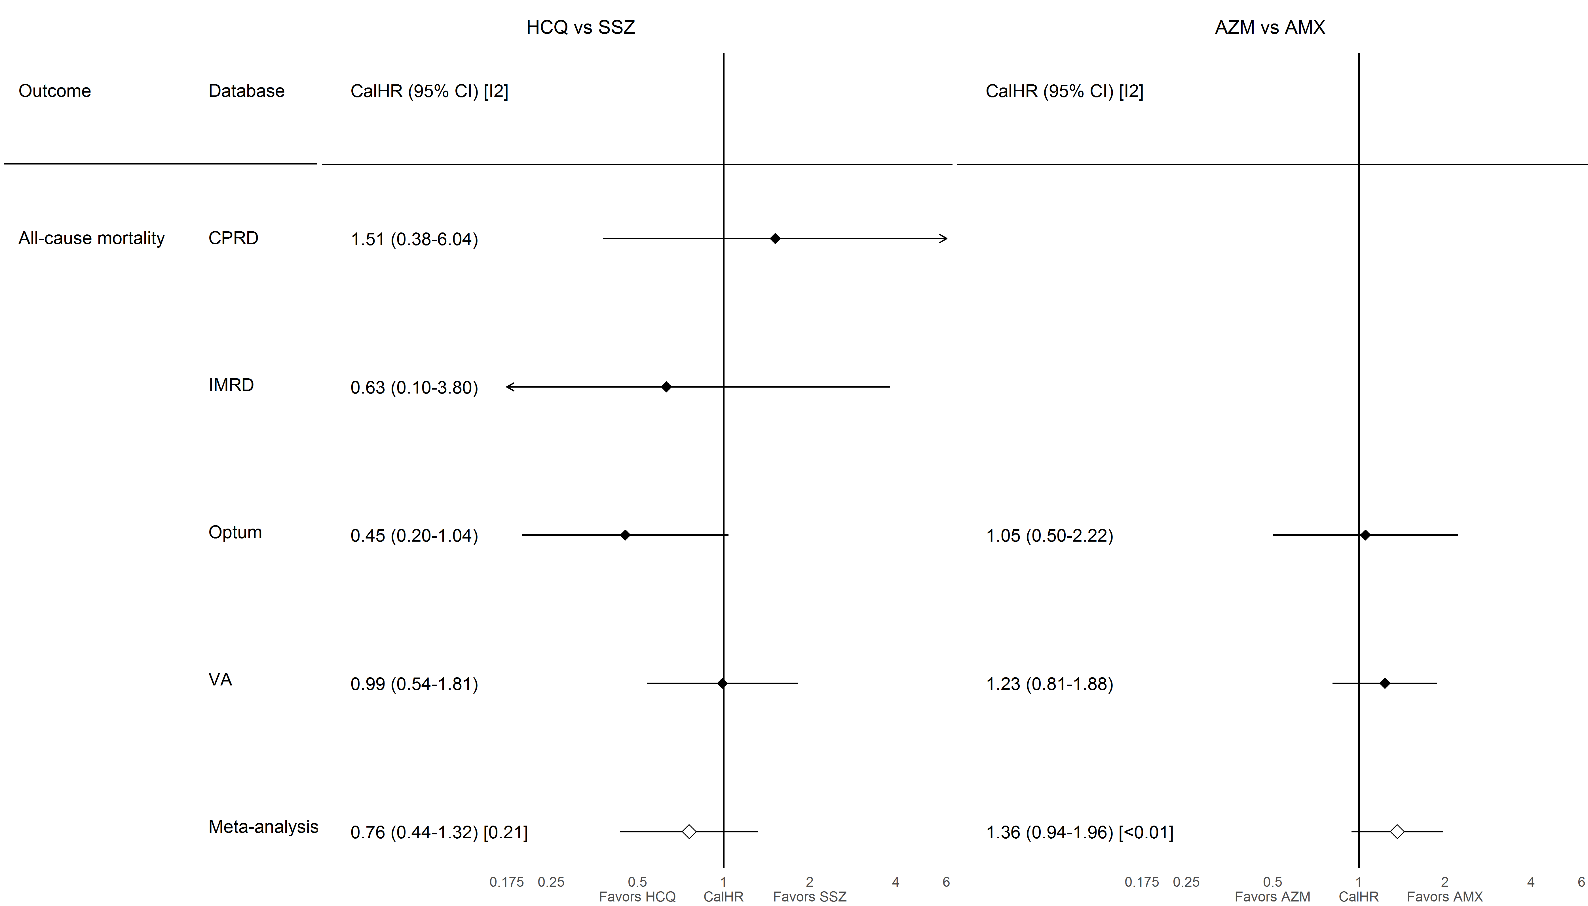

### **S8.1.2. CV-related mortality**

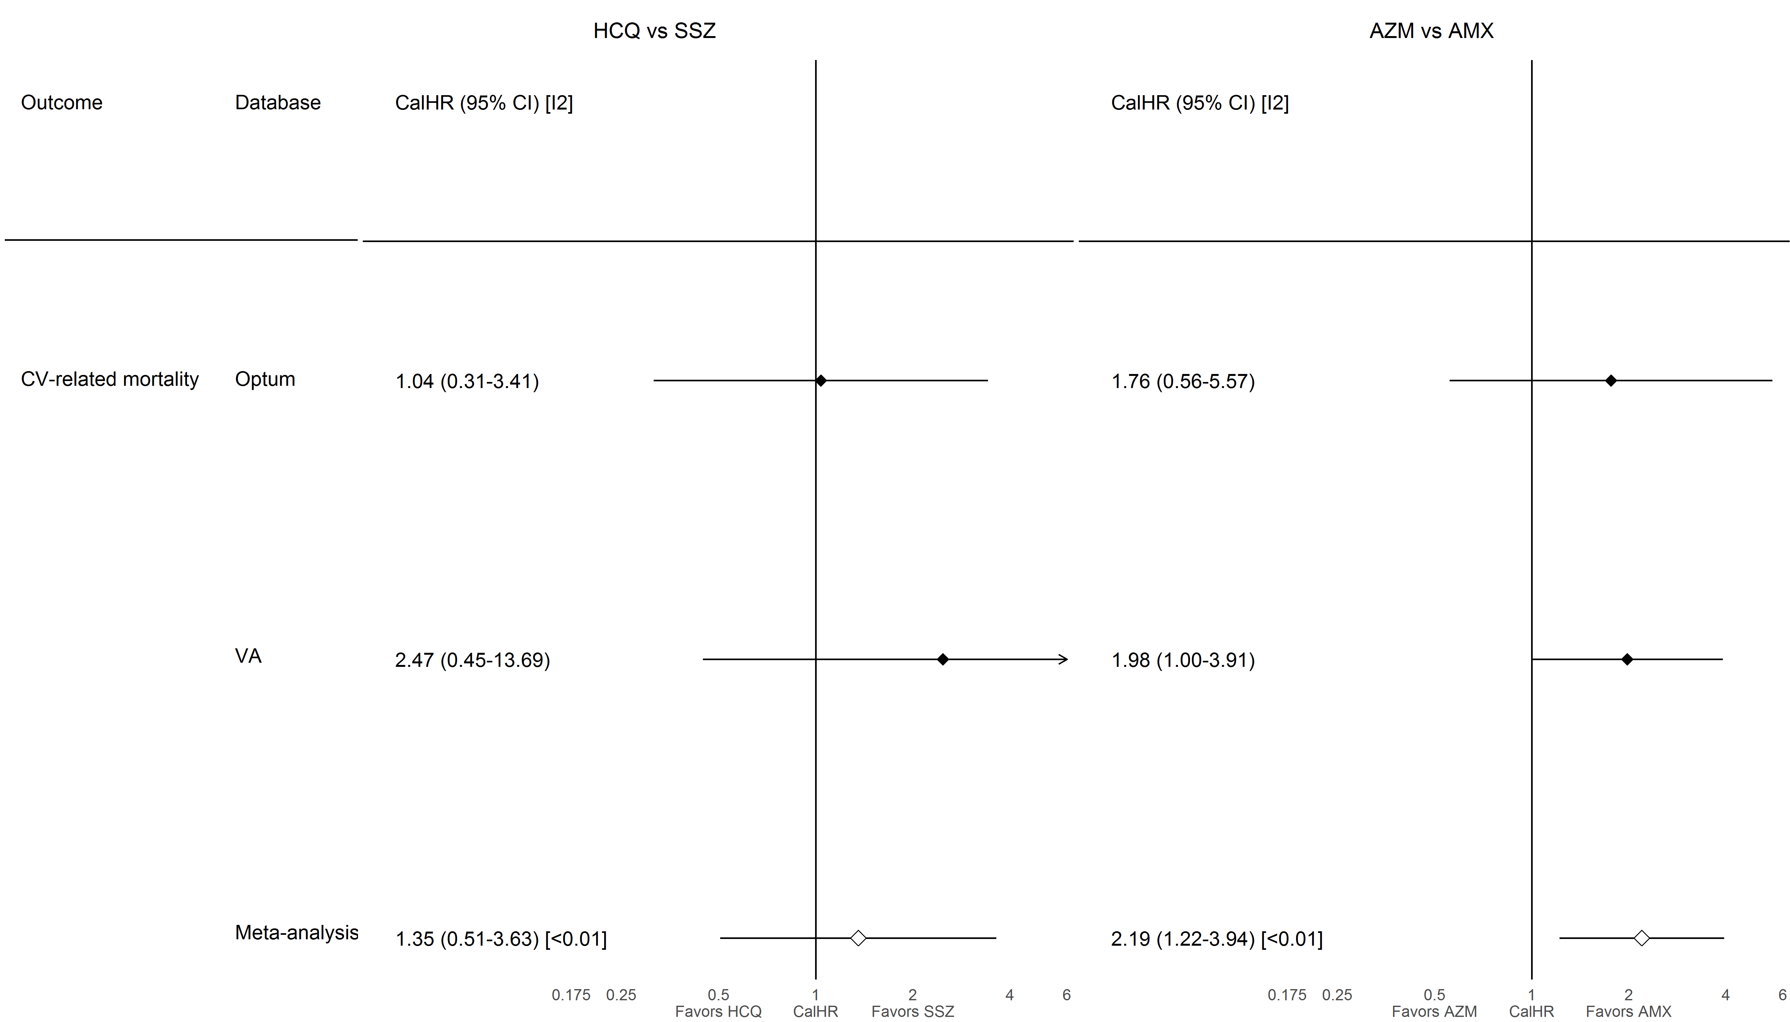

### **S8.1.3. Myocardial infarction**

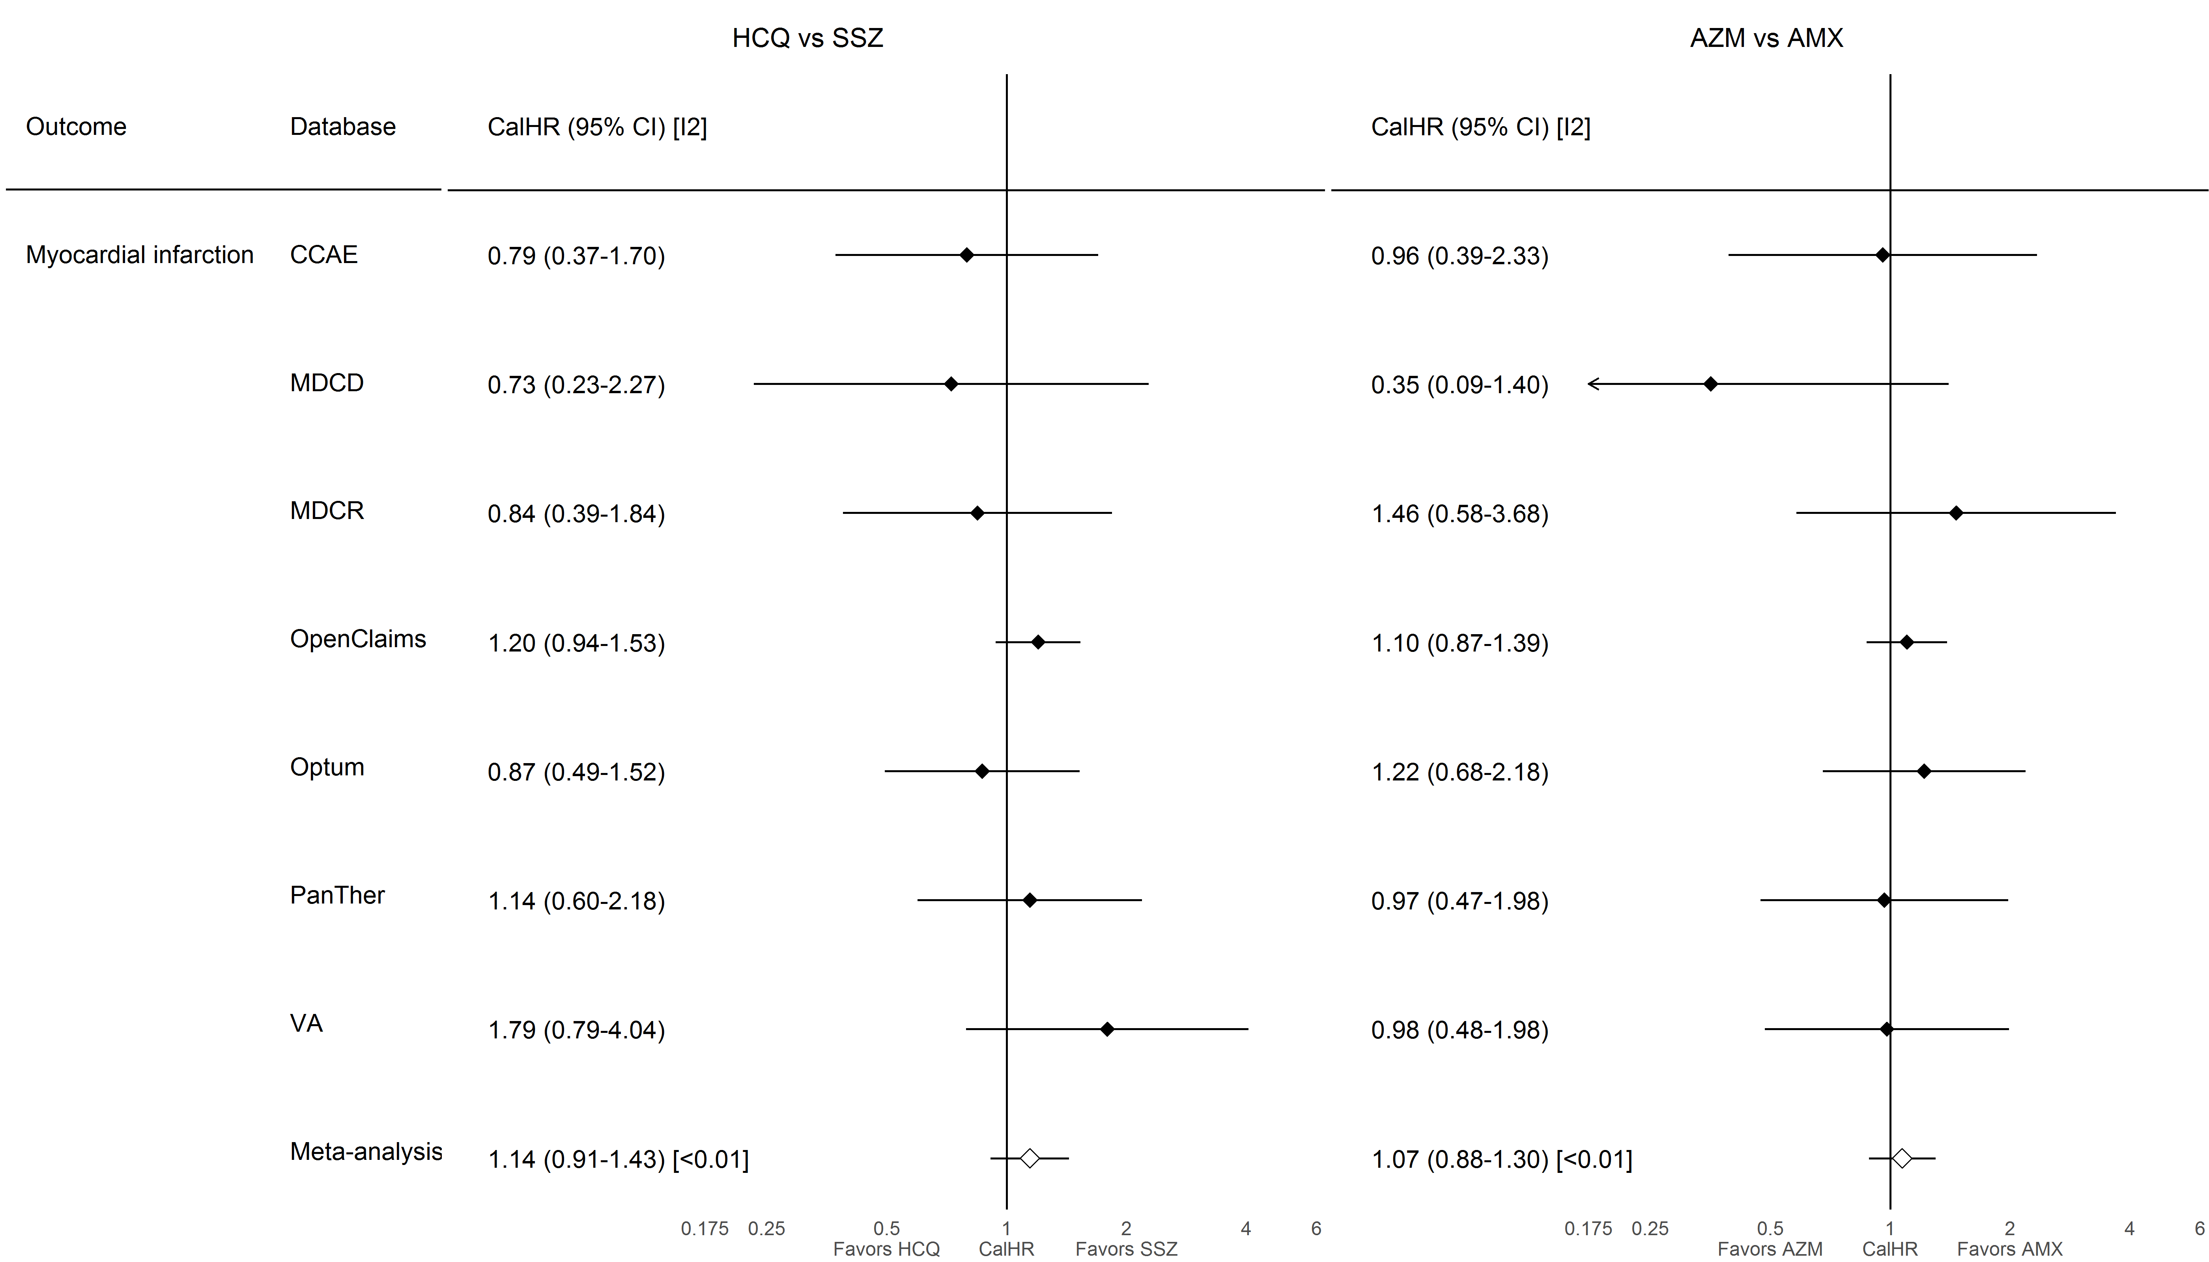

### **S8.1.4. Chest pain or angina**

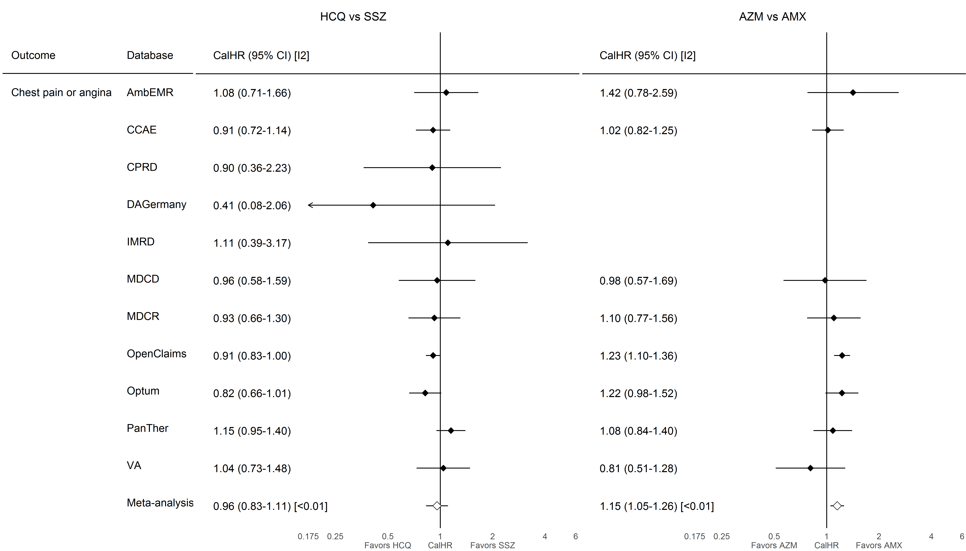

### **S8.1.5. Heart failure**

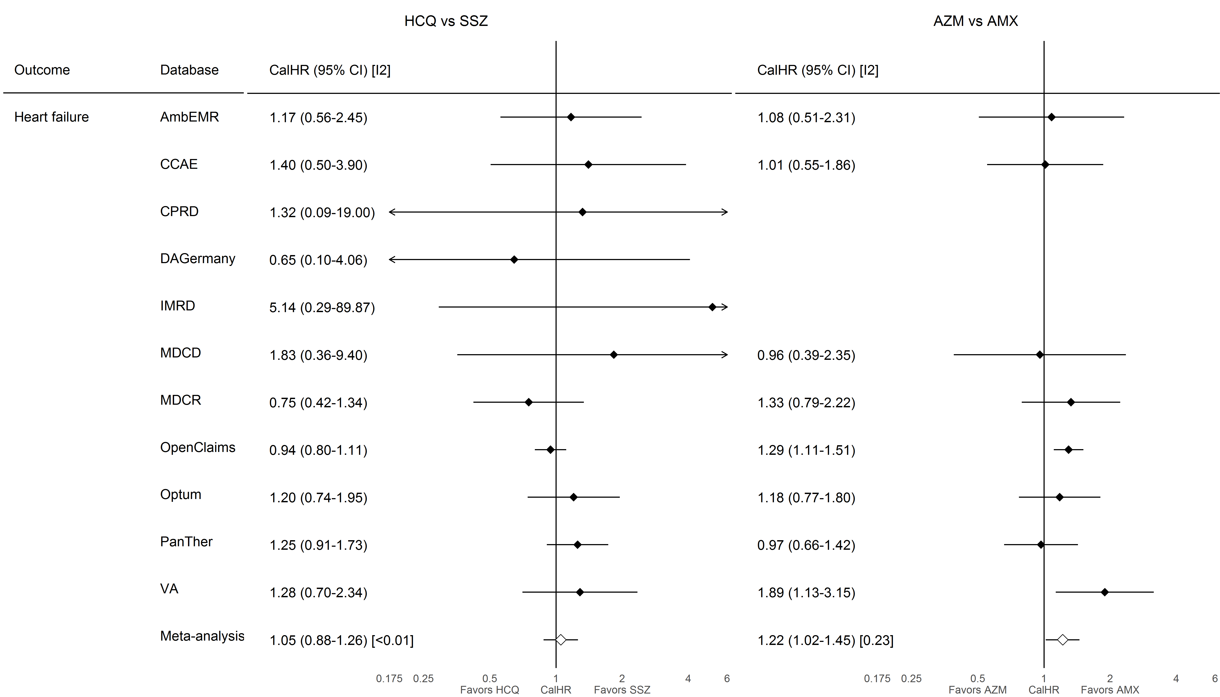

### **S8.1.6. Cardiovascular events**

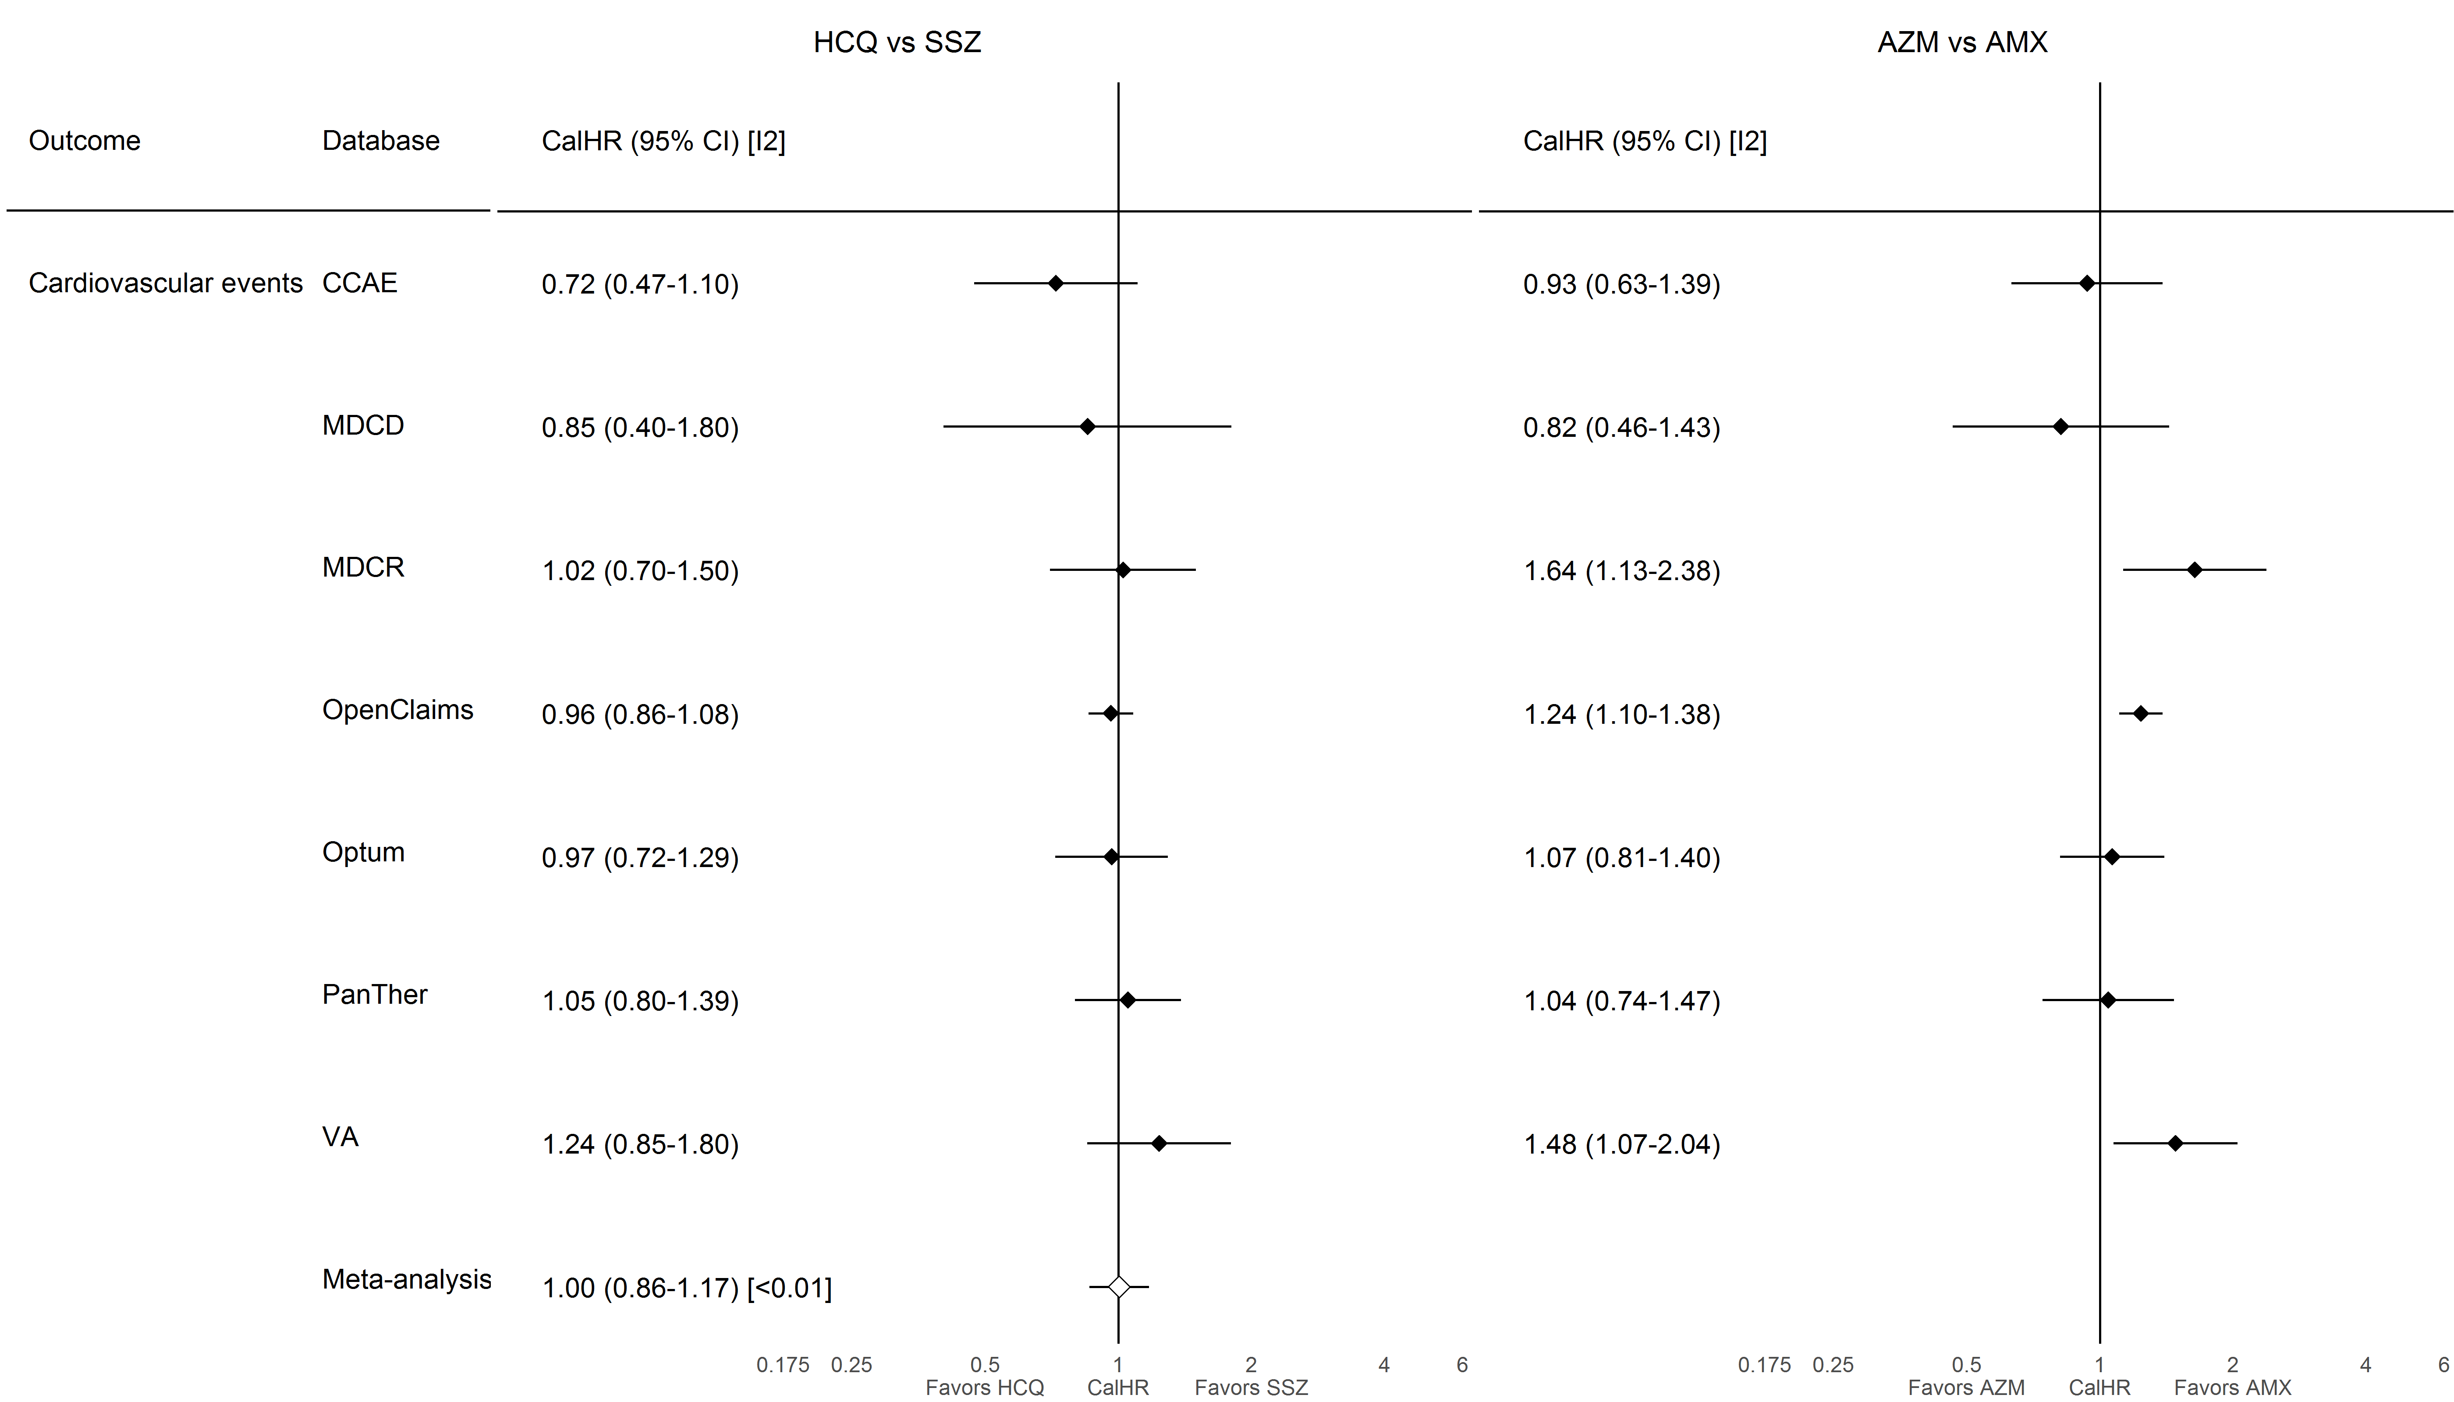

### **S8.1.7. Cardiac arrhythmia**

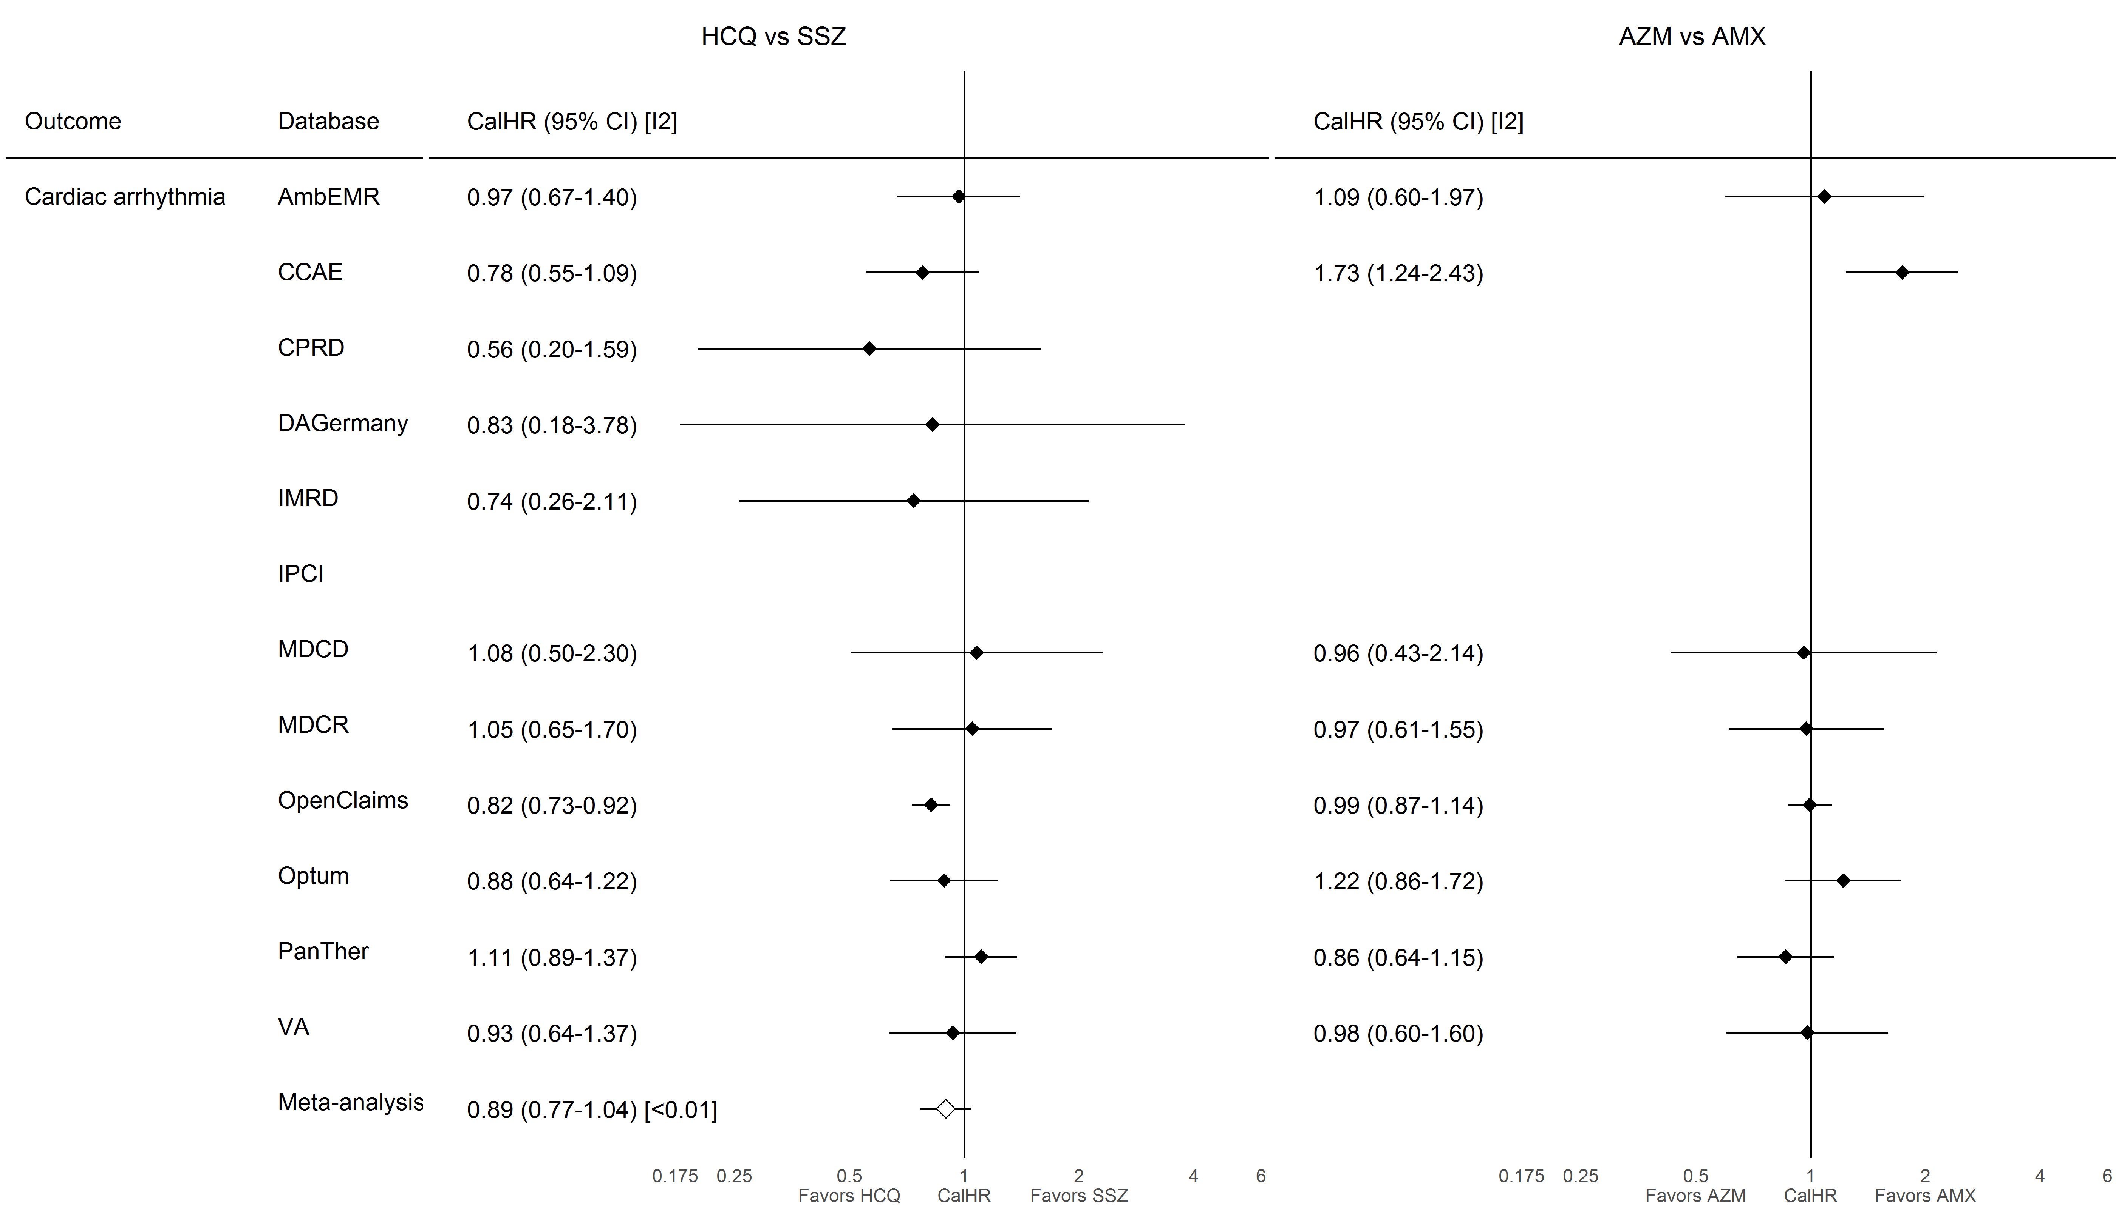

### **S8.1.8. Bradycardia**

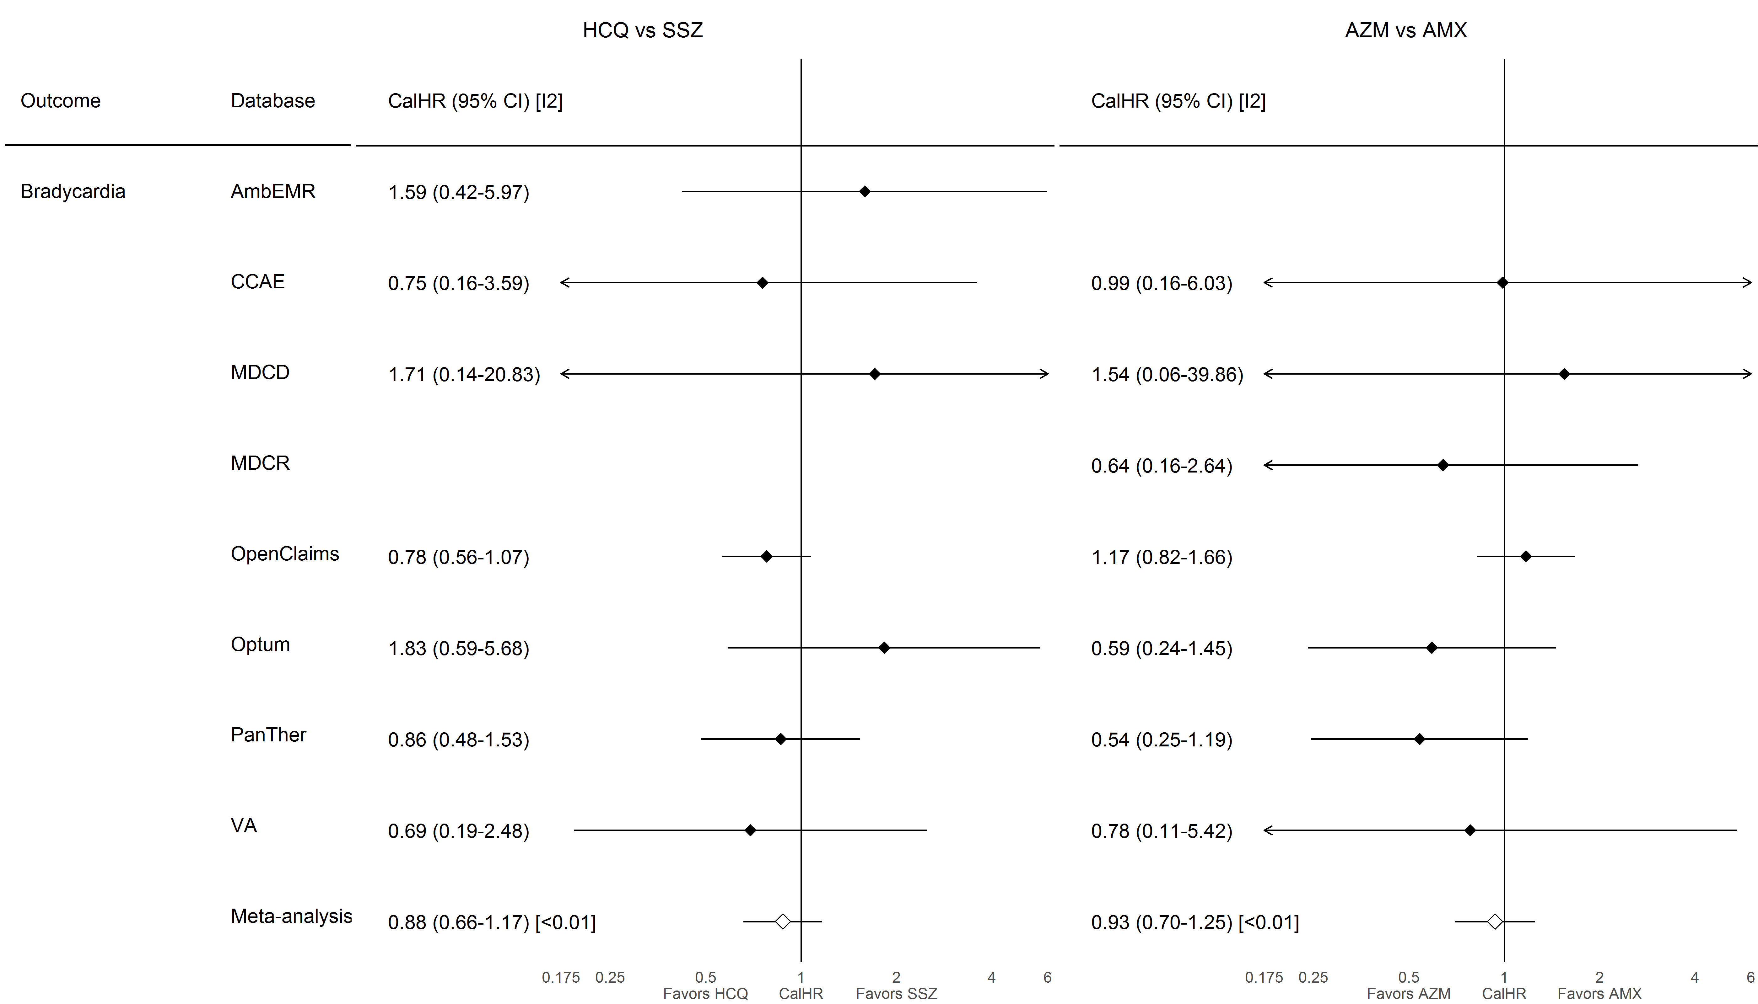

### **S8.1.9. Transient ischemic attack**

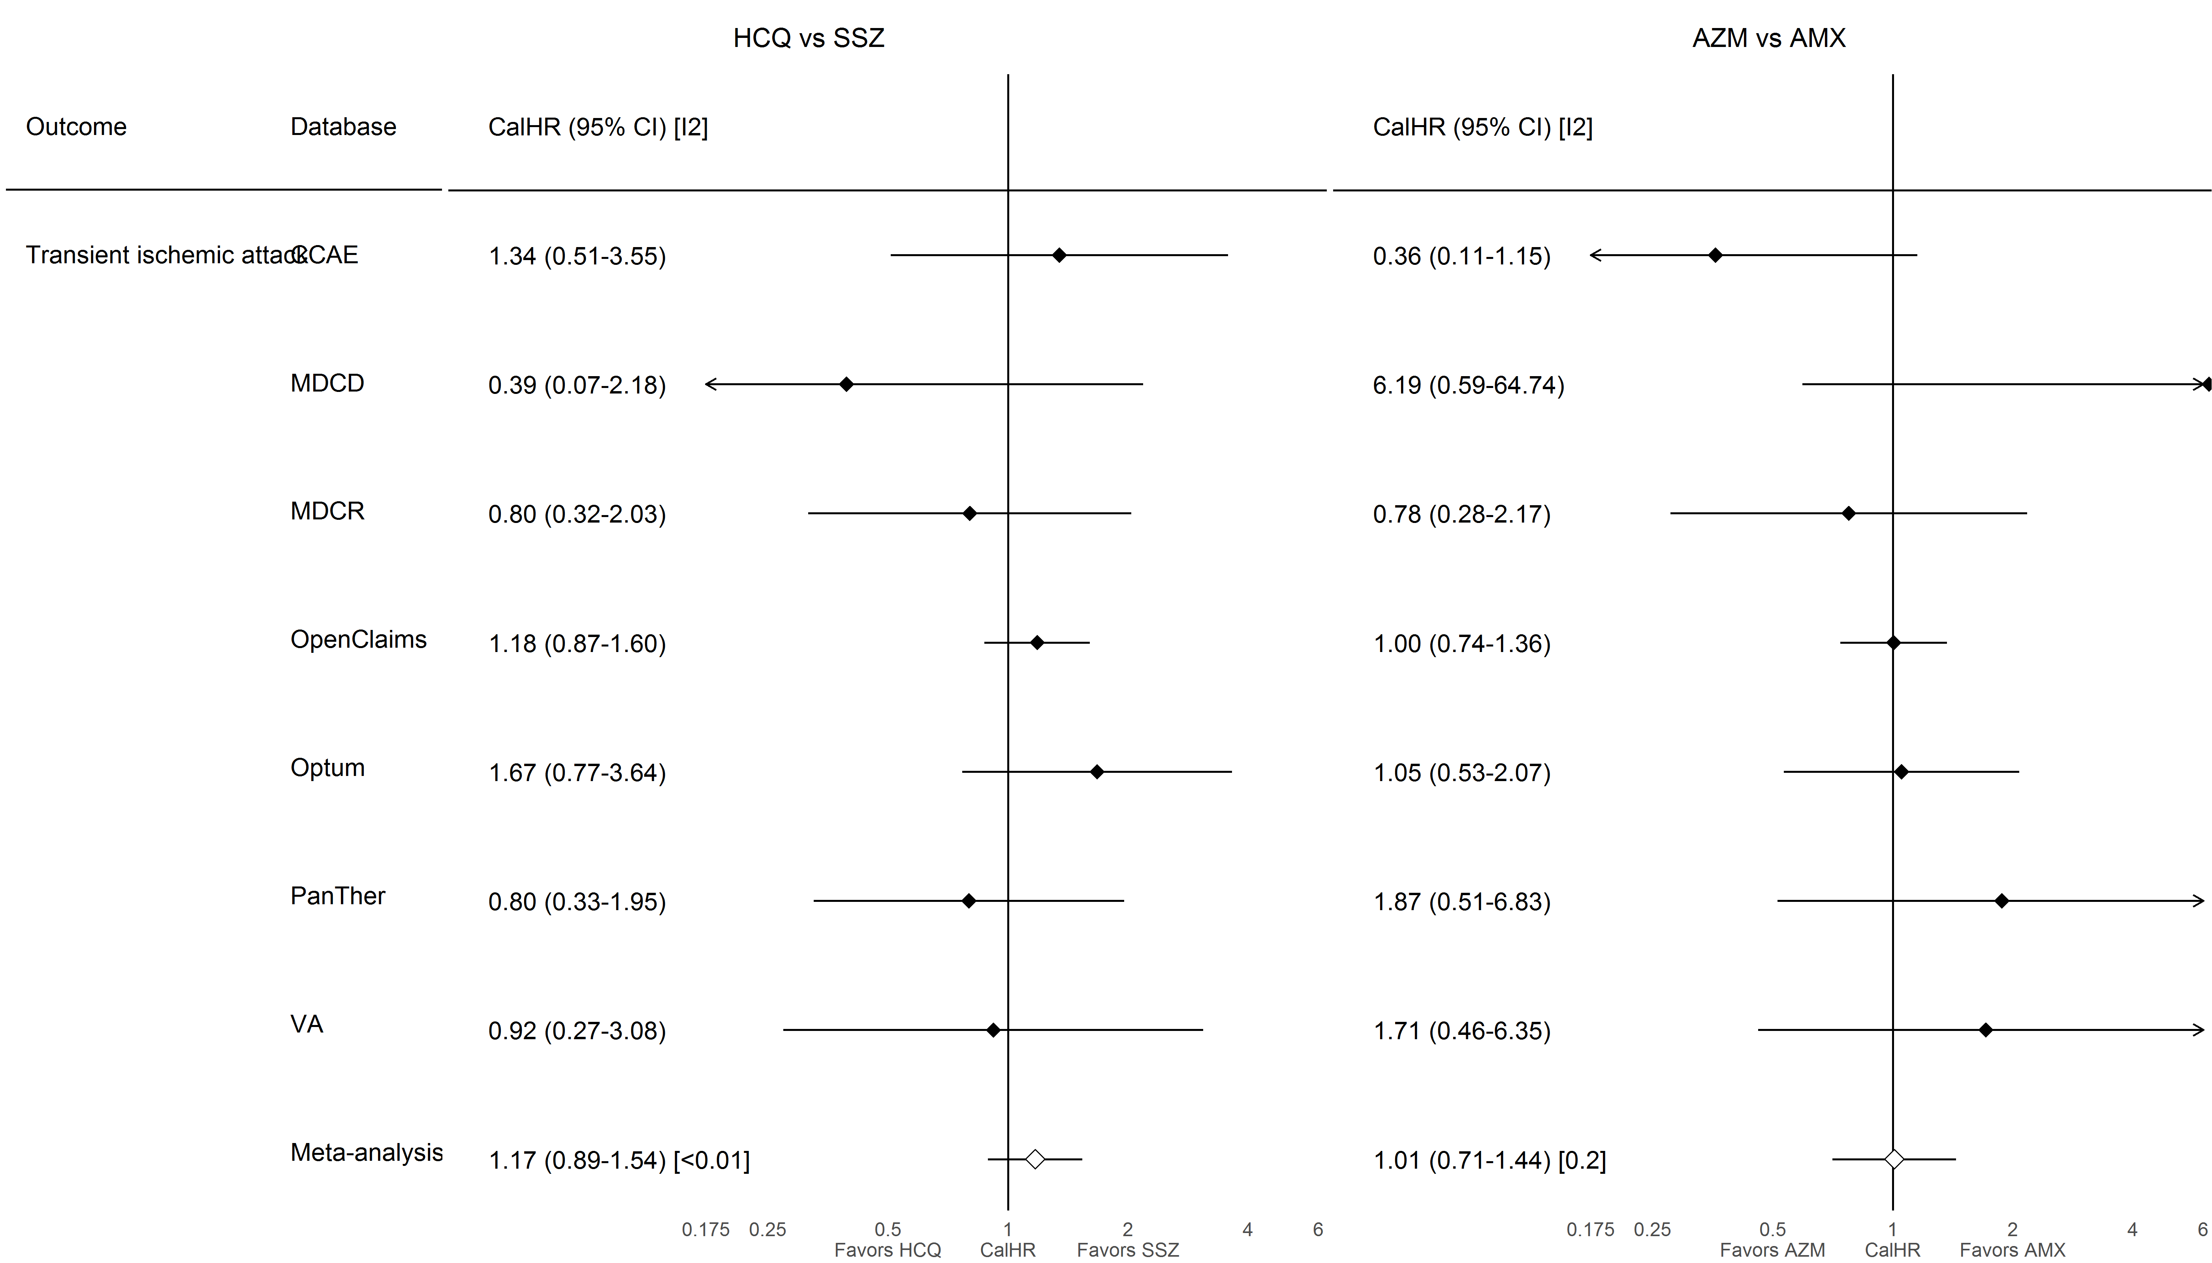

### **S8.1.10.Stroke**

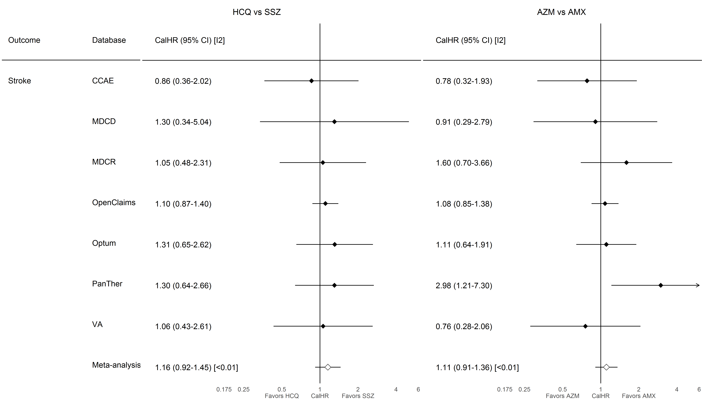

### **S8.1.11. Venous thromboembolism**

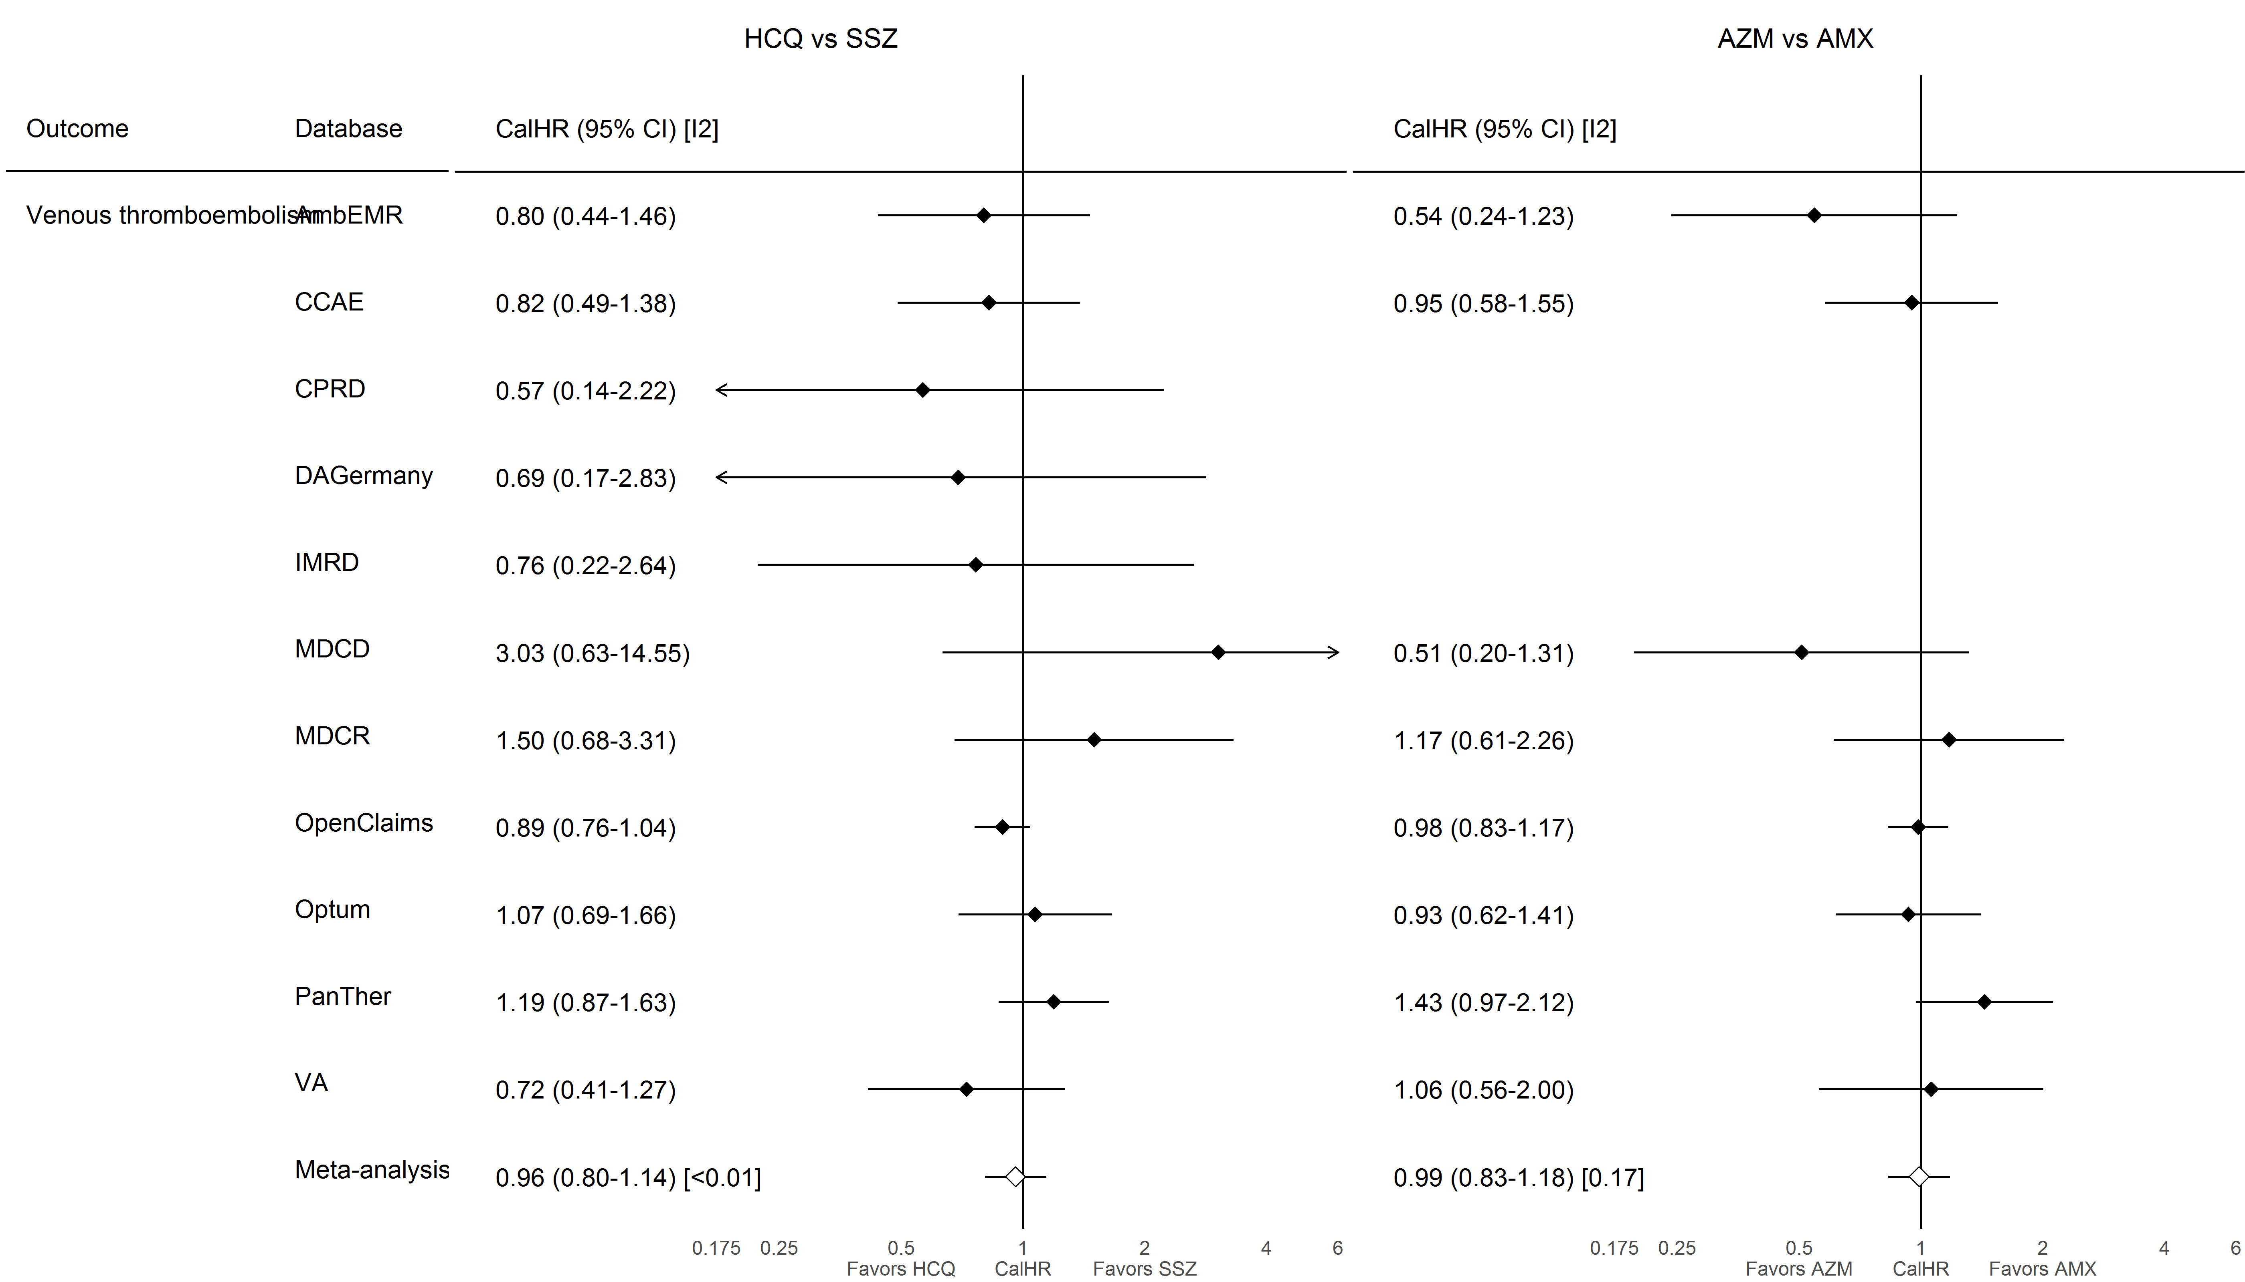

### **S8.1.12. Gastrointestinal bleeding**

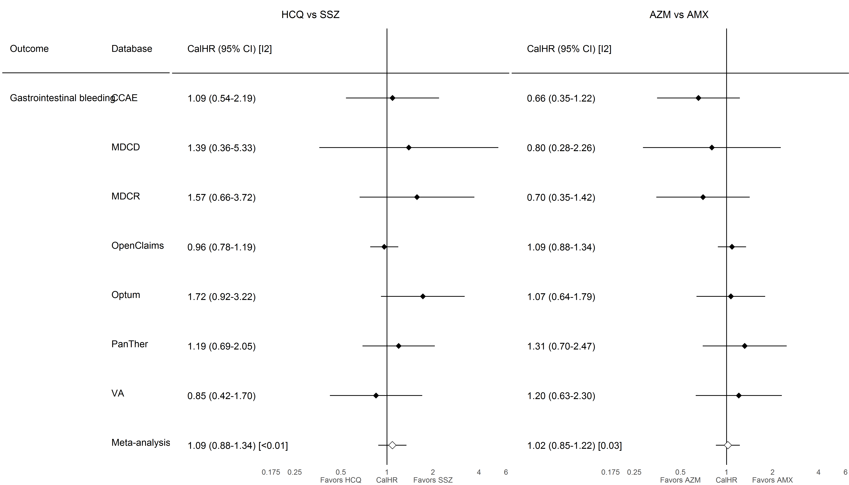

### **S8.1.13. Acute renal failure**

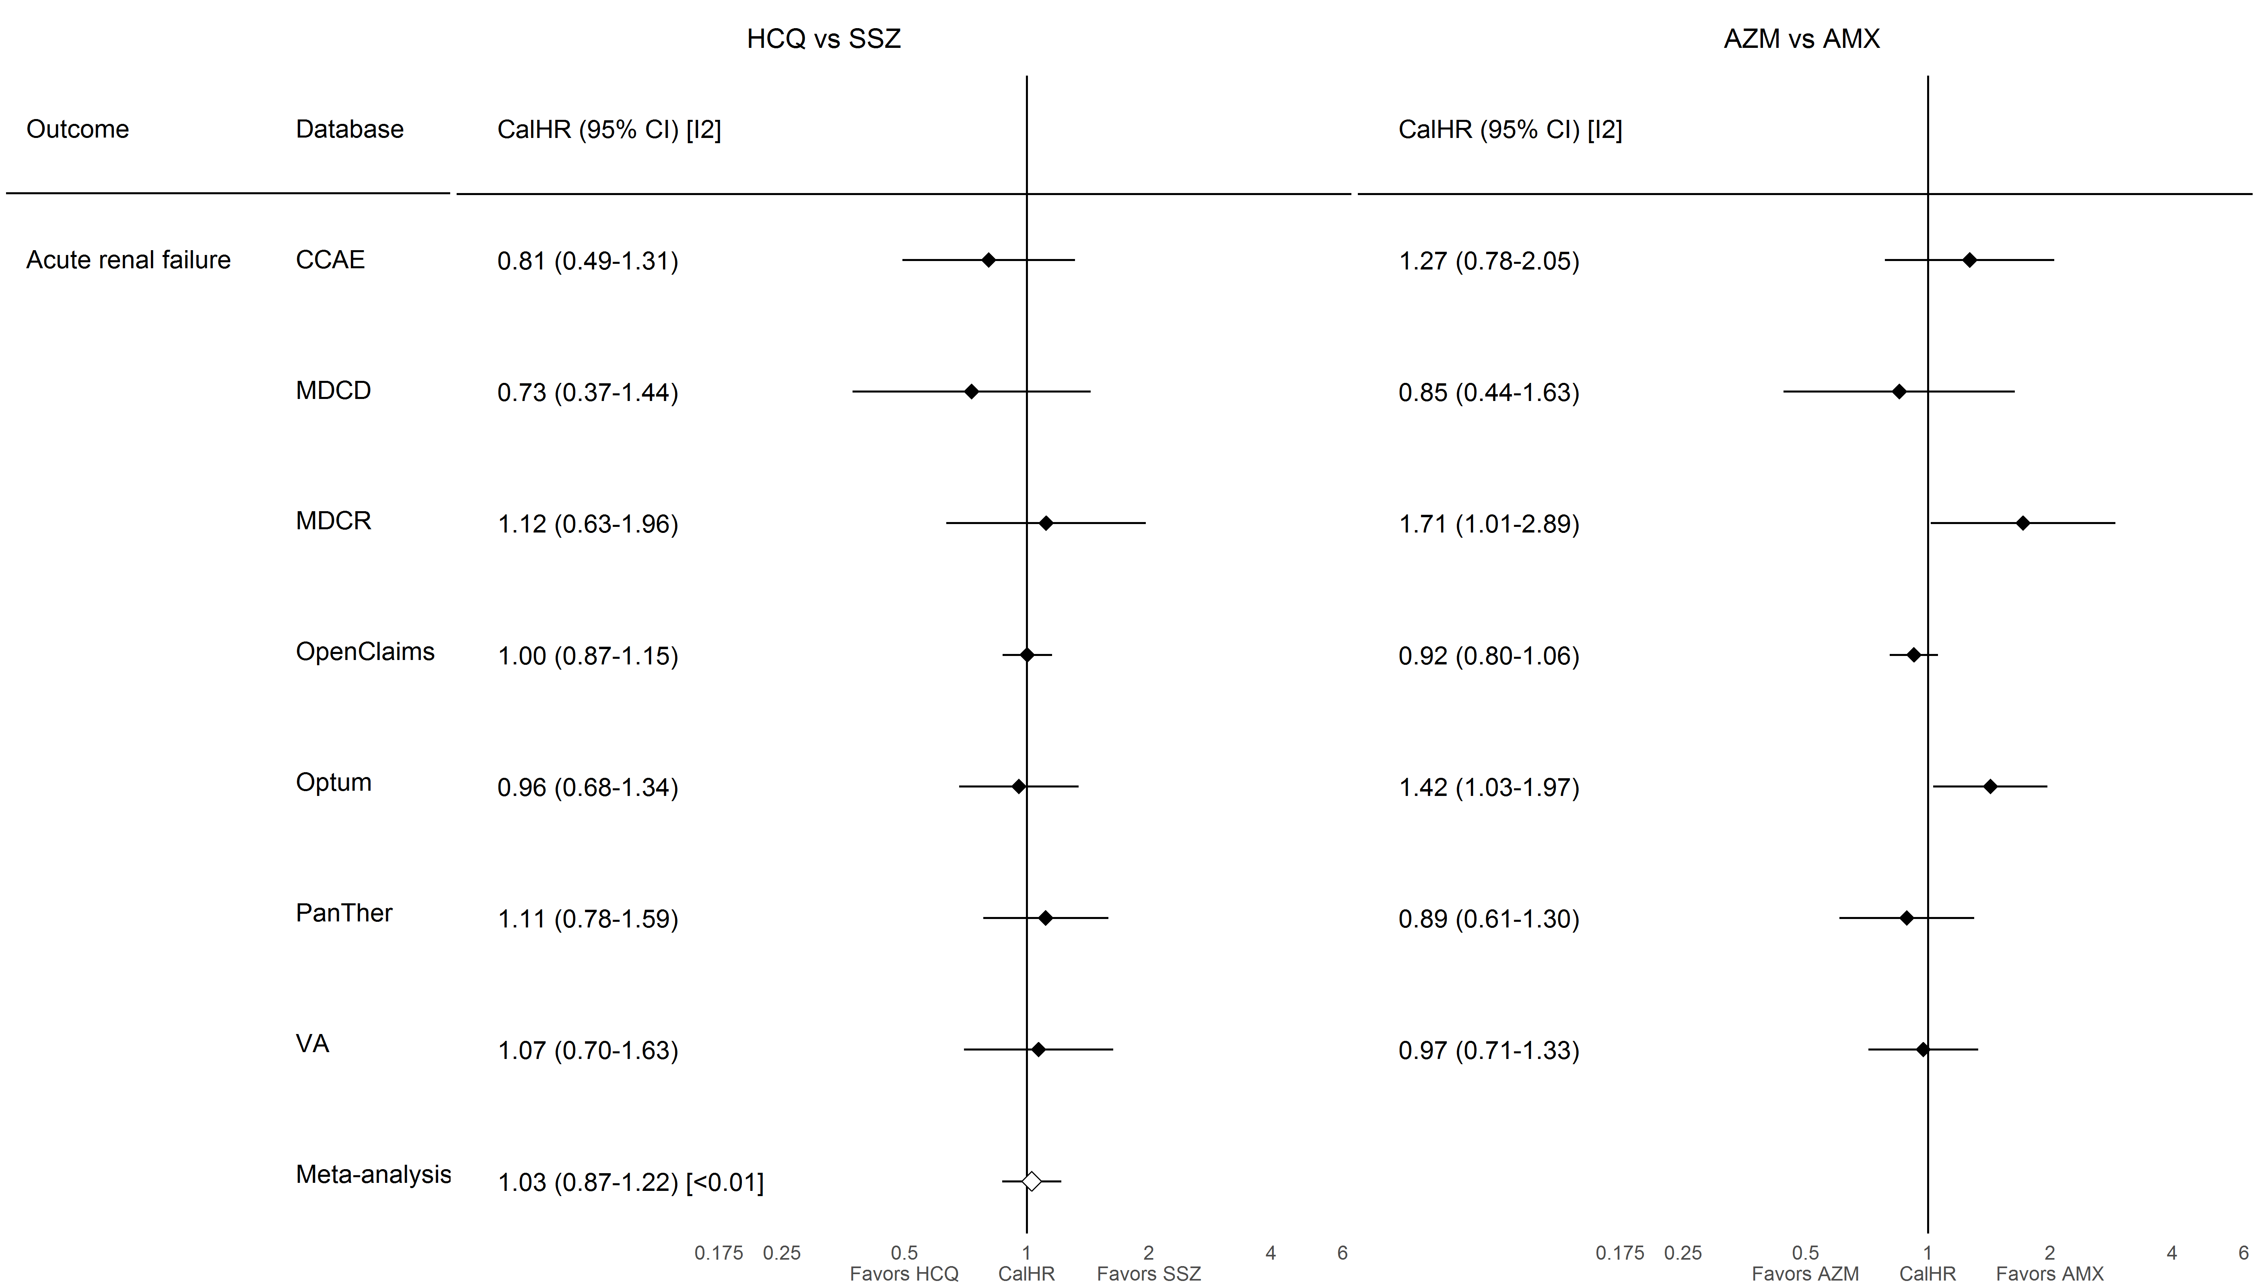

### **S8.1.14. End stage renal disease**

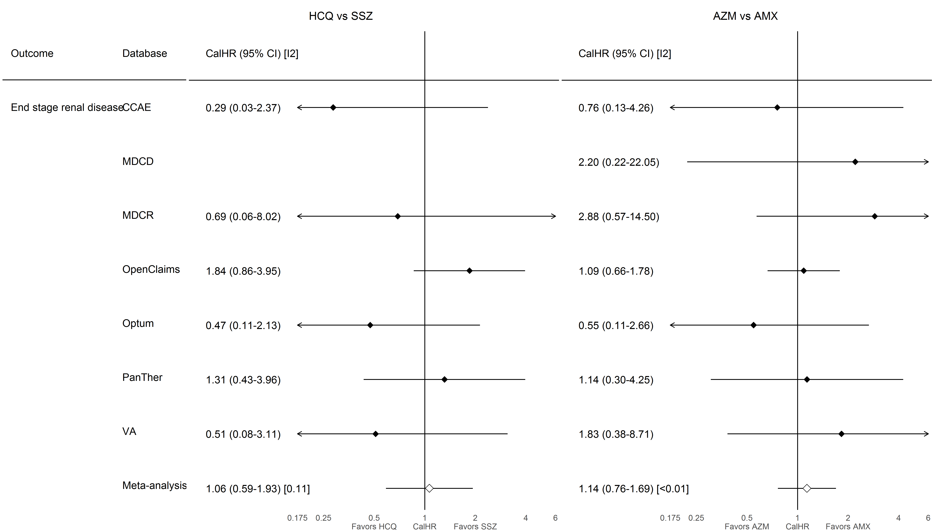

### **S8.1.15. Hepatic failure**

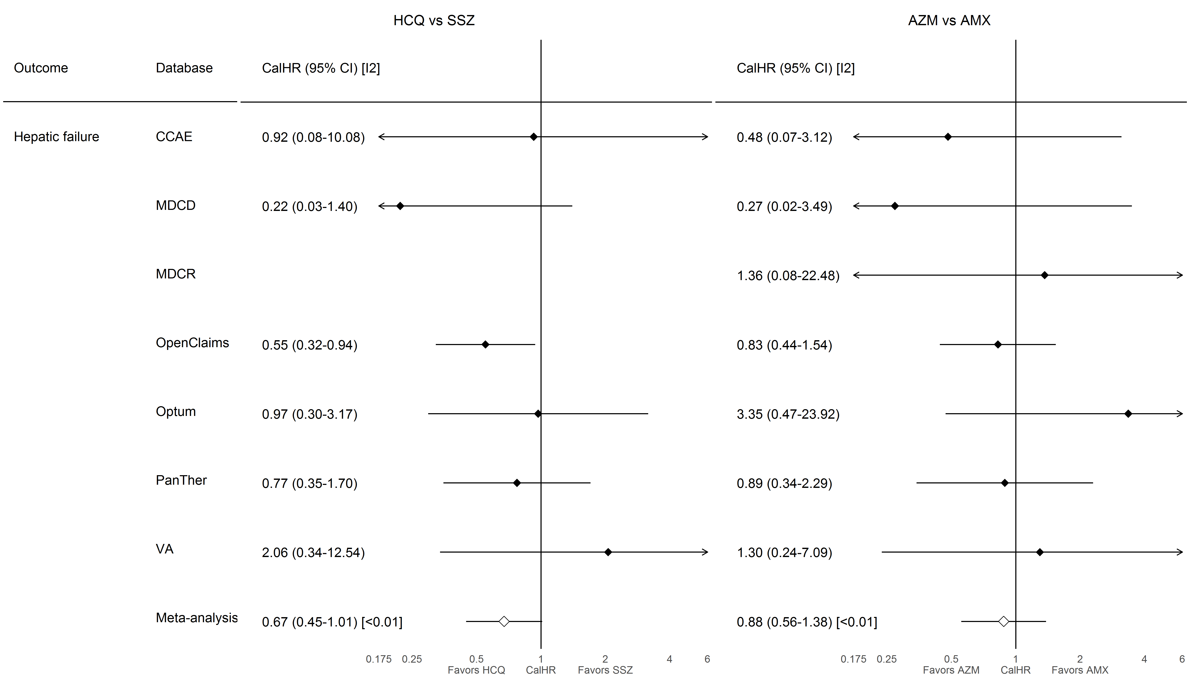

### **S8.1.16. Acute pancreatitis**

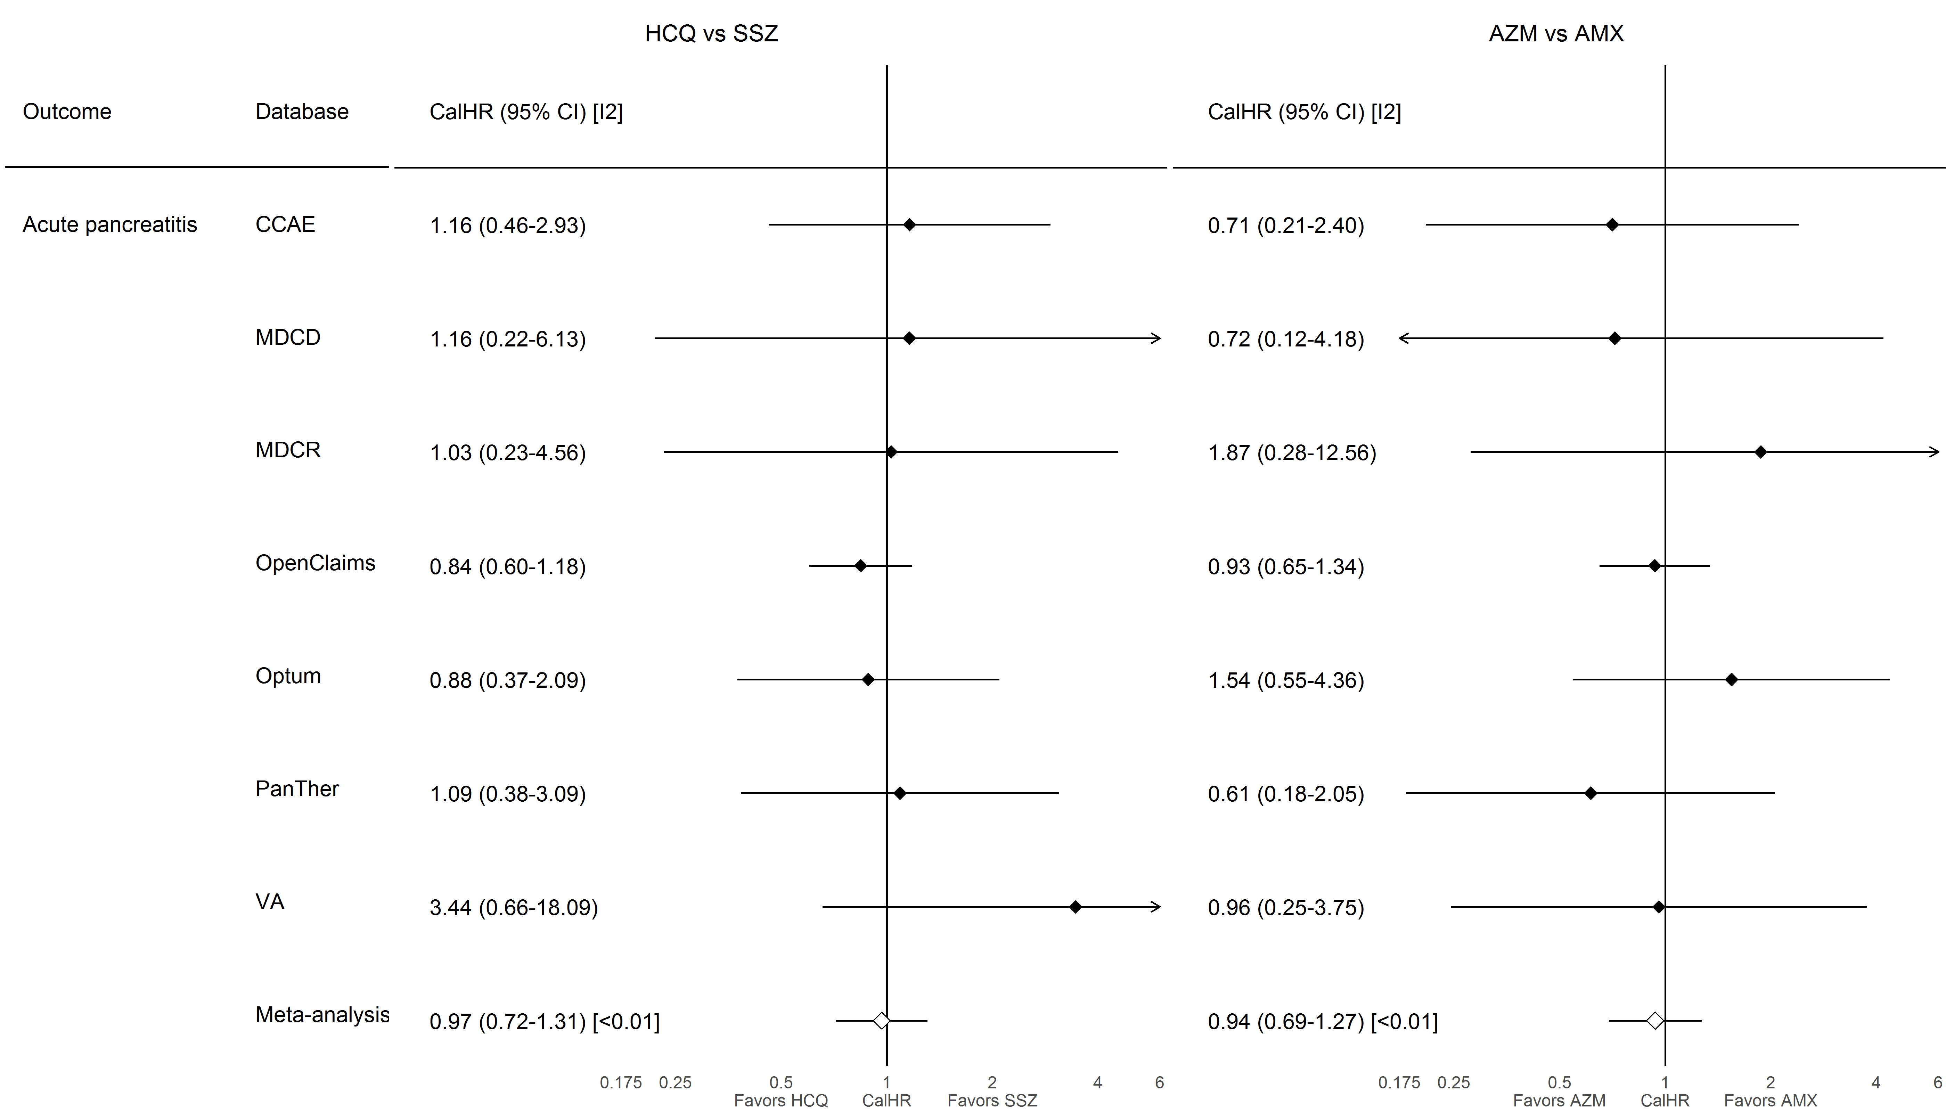

## **S8.2. On-treatment follow-up**

### **S8.2.1. All-cause mortality**

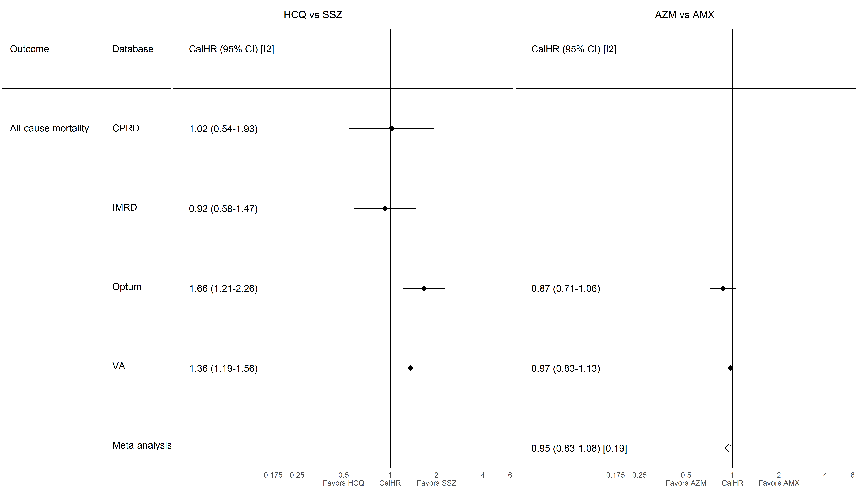

### **S8.2.2. CV-related mortality**

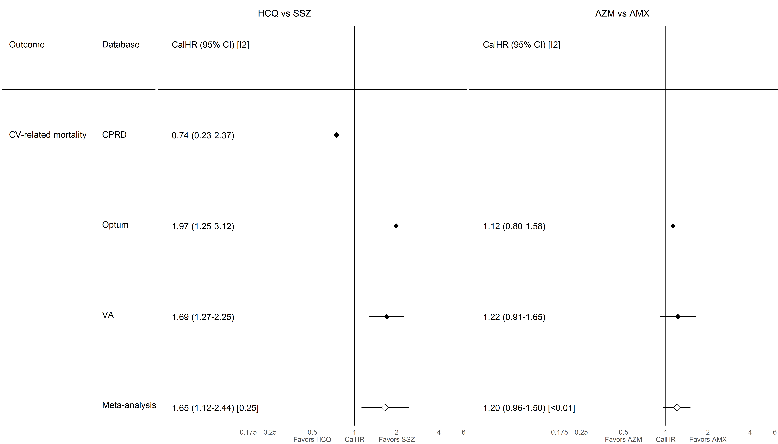

### **S8.2.3. Myocardial infarction**

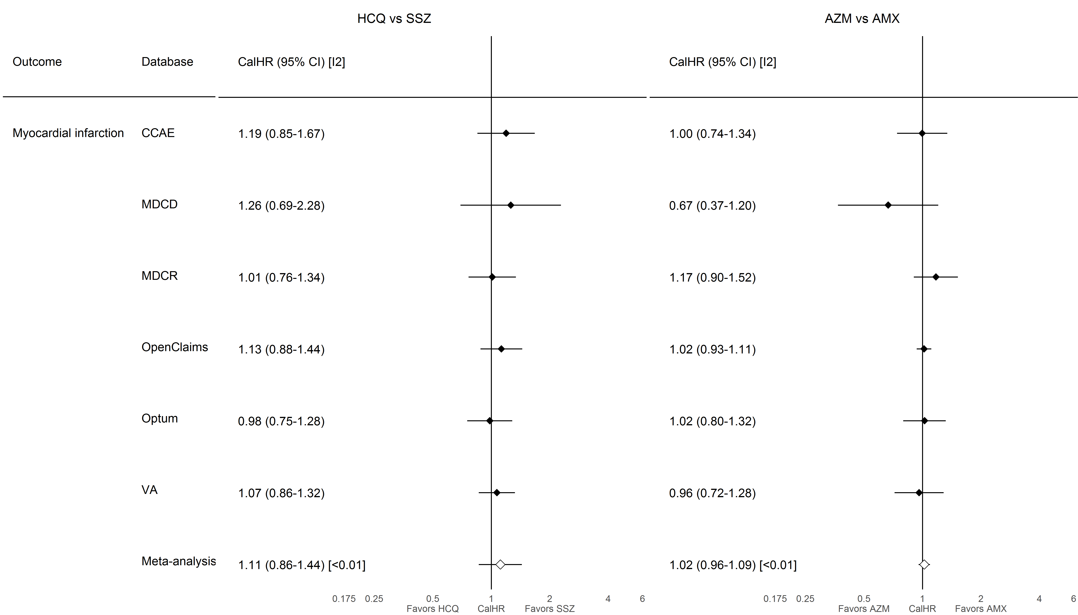

### **S8.2.4. Chest pain or angina**

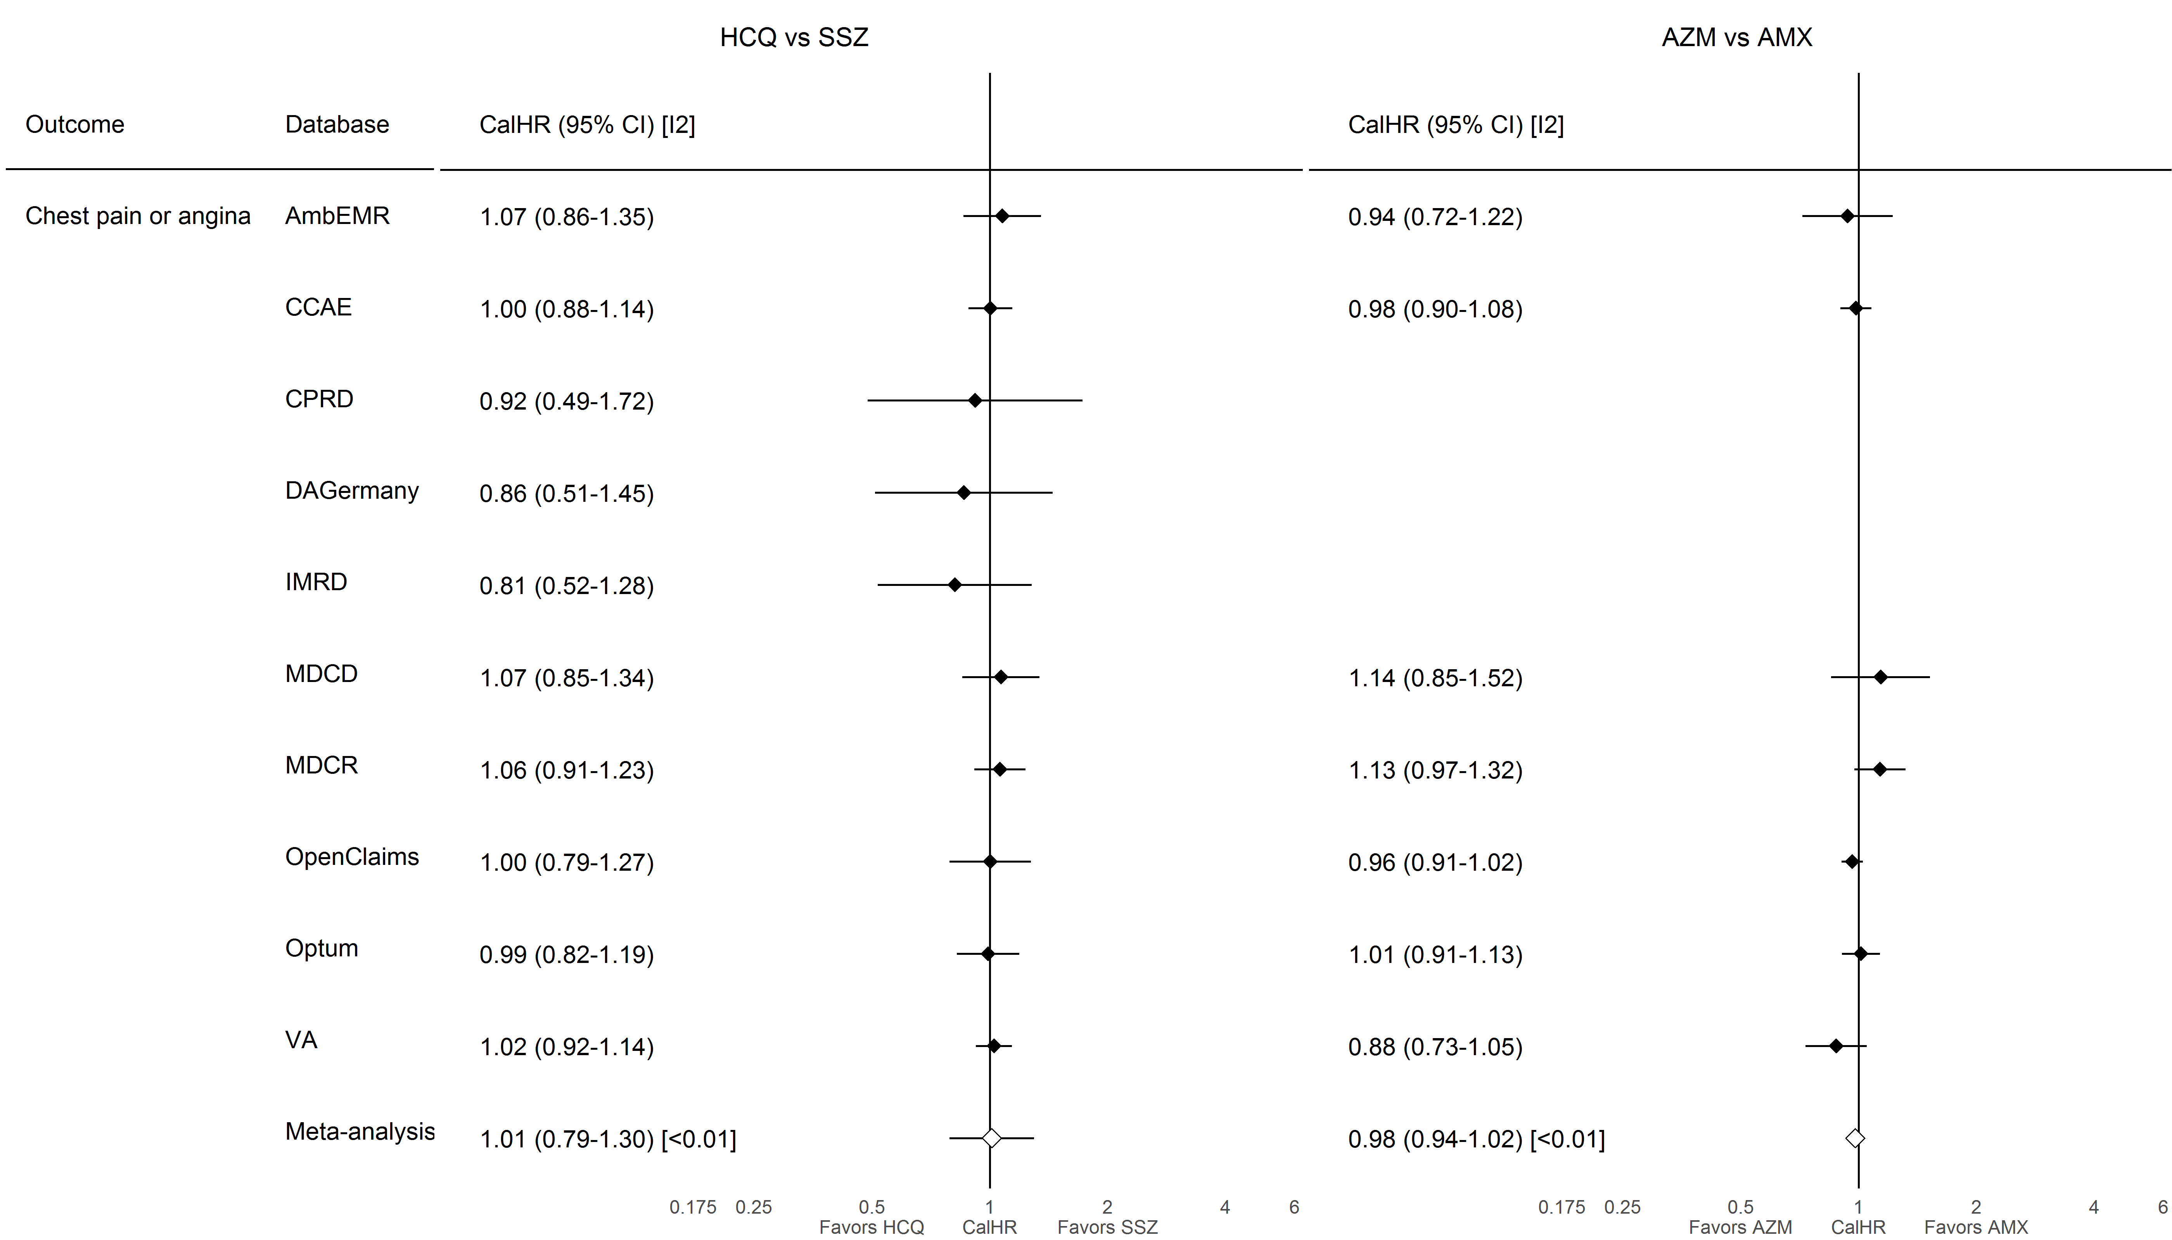

### **S8.2.5. Heart failure**

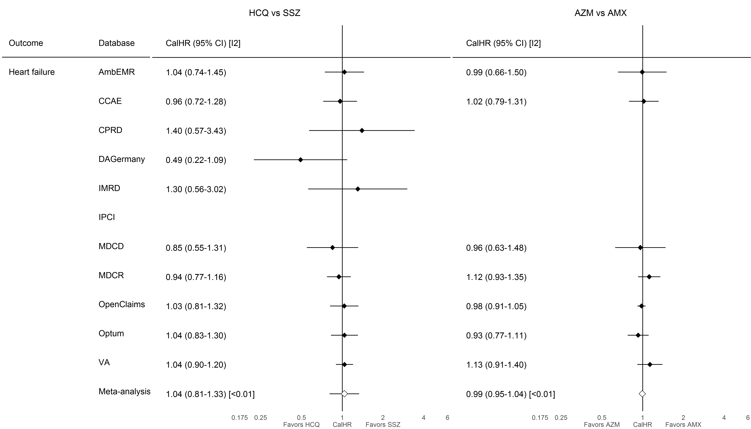

### **S8.2.6. Cardiovascular events**

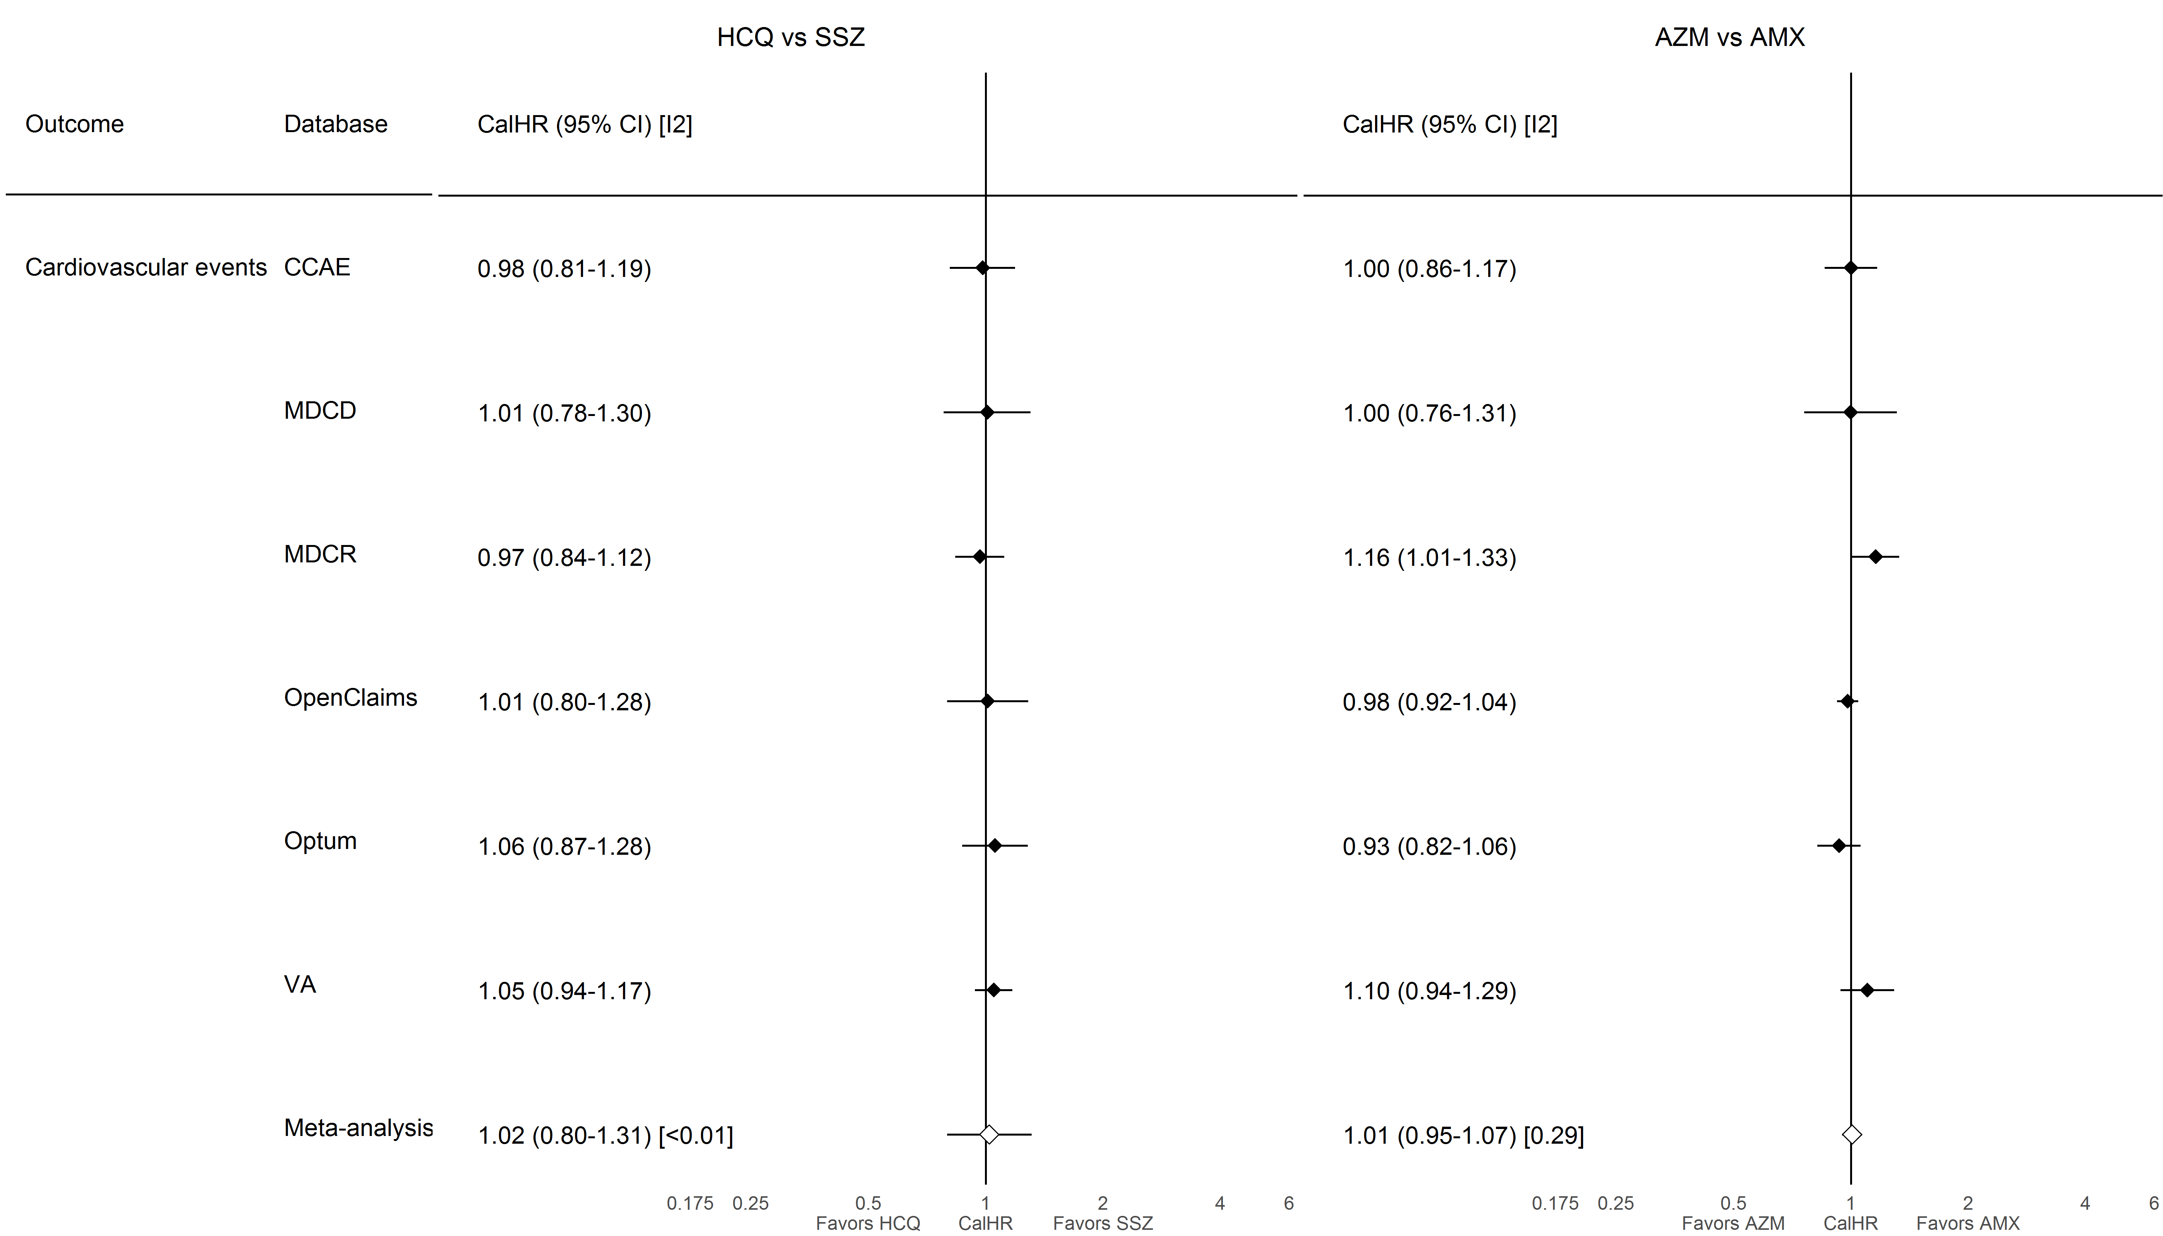

### **S8.2.7. Cardiac arrhythmia**

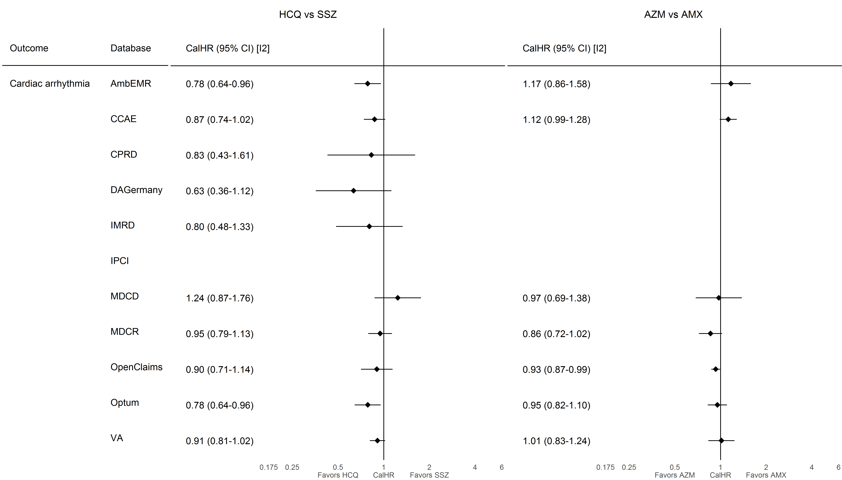

### **S8.2.8. Bradycardia**

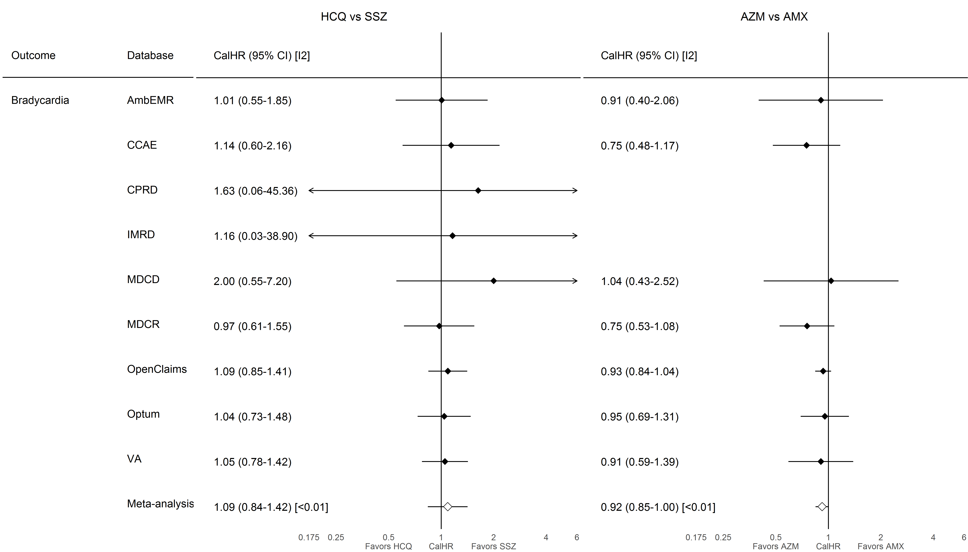

### **S8.2.9. Transient ischemic attack**

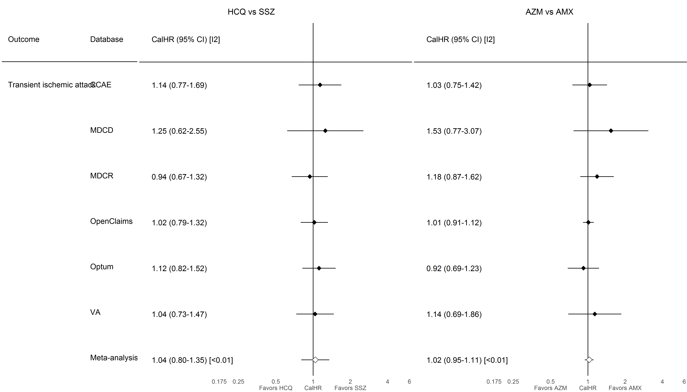

### **S8.2.10. Stroke**

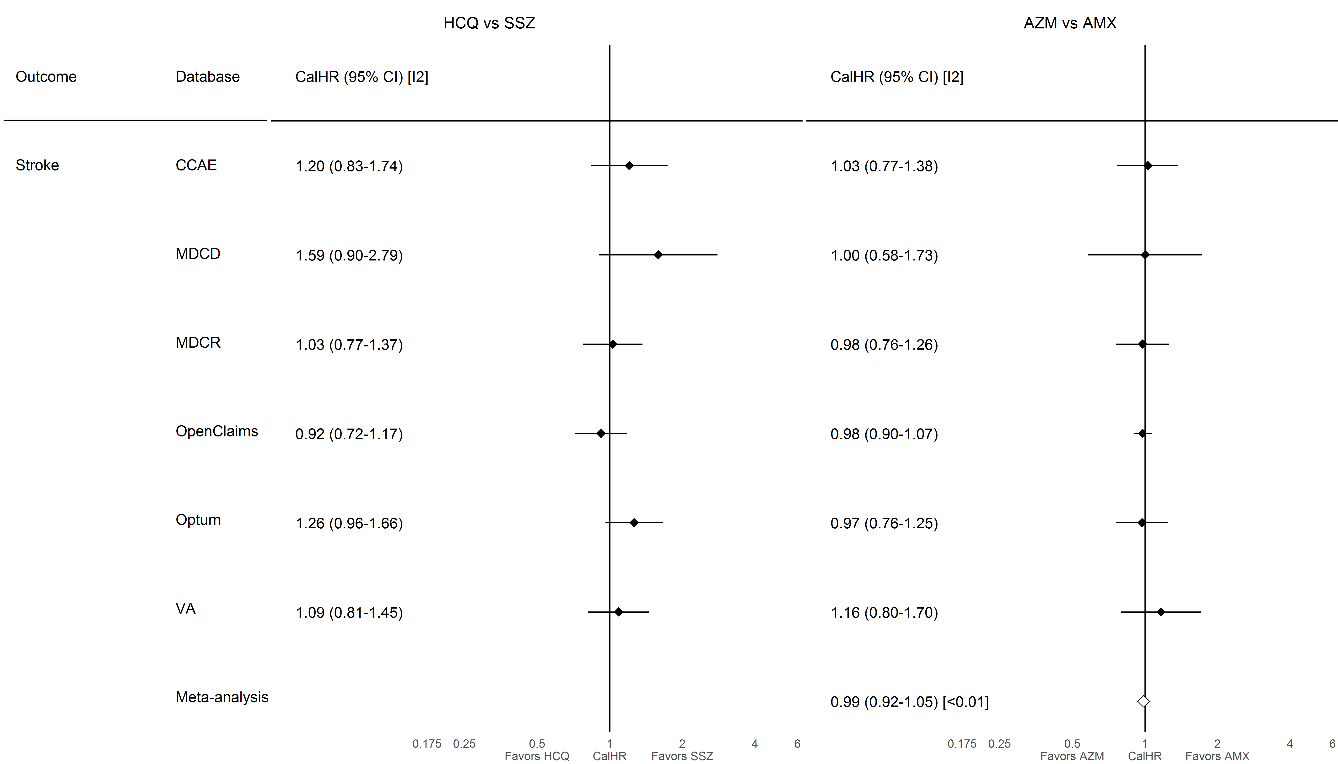

### **S8.2.11. Venous thromboembolism**

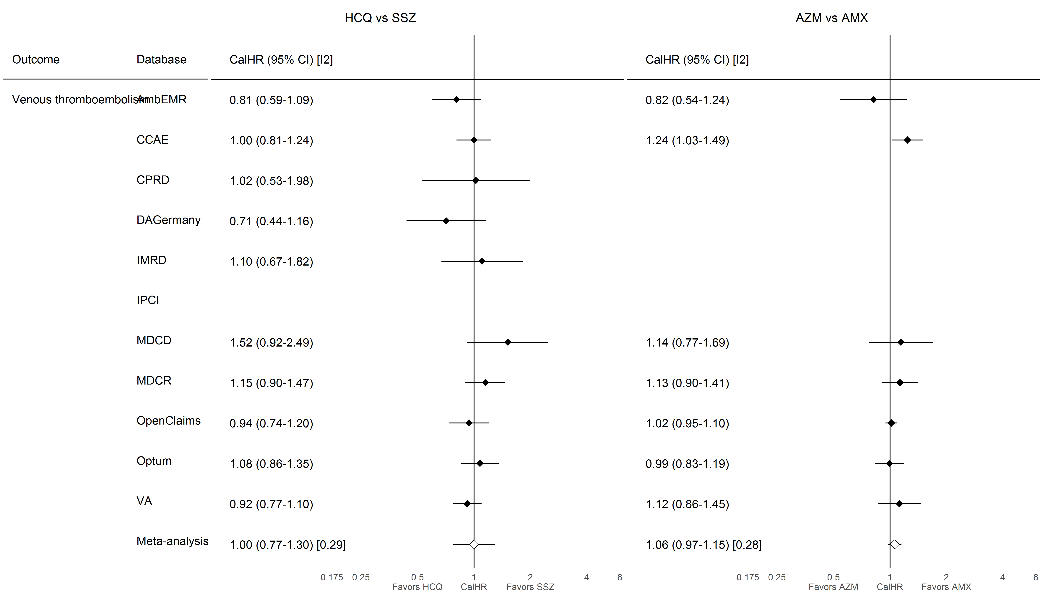

### **S8.2.12. Gastrointestinal bleeding**

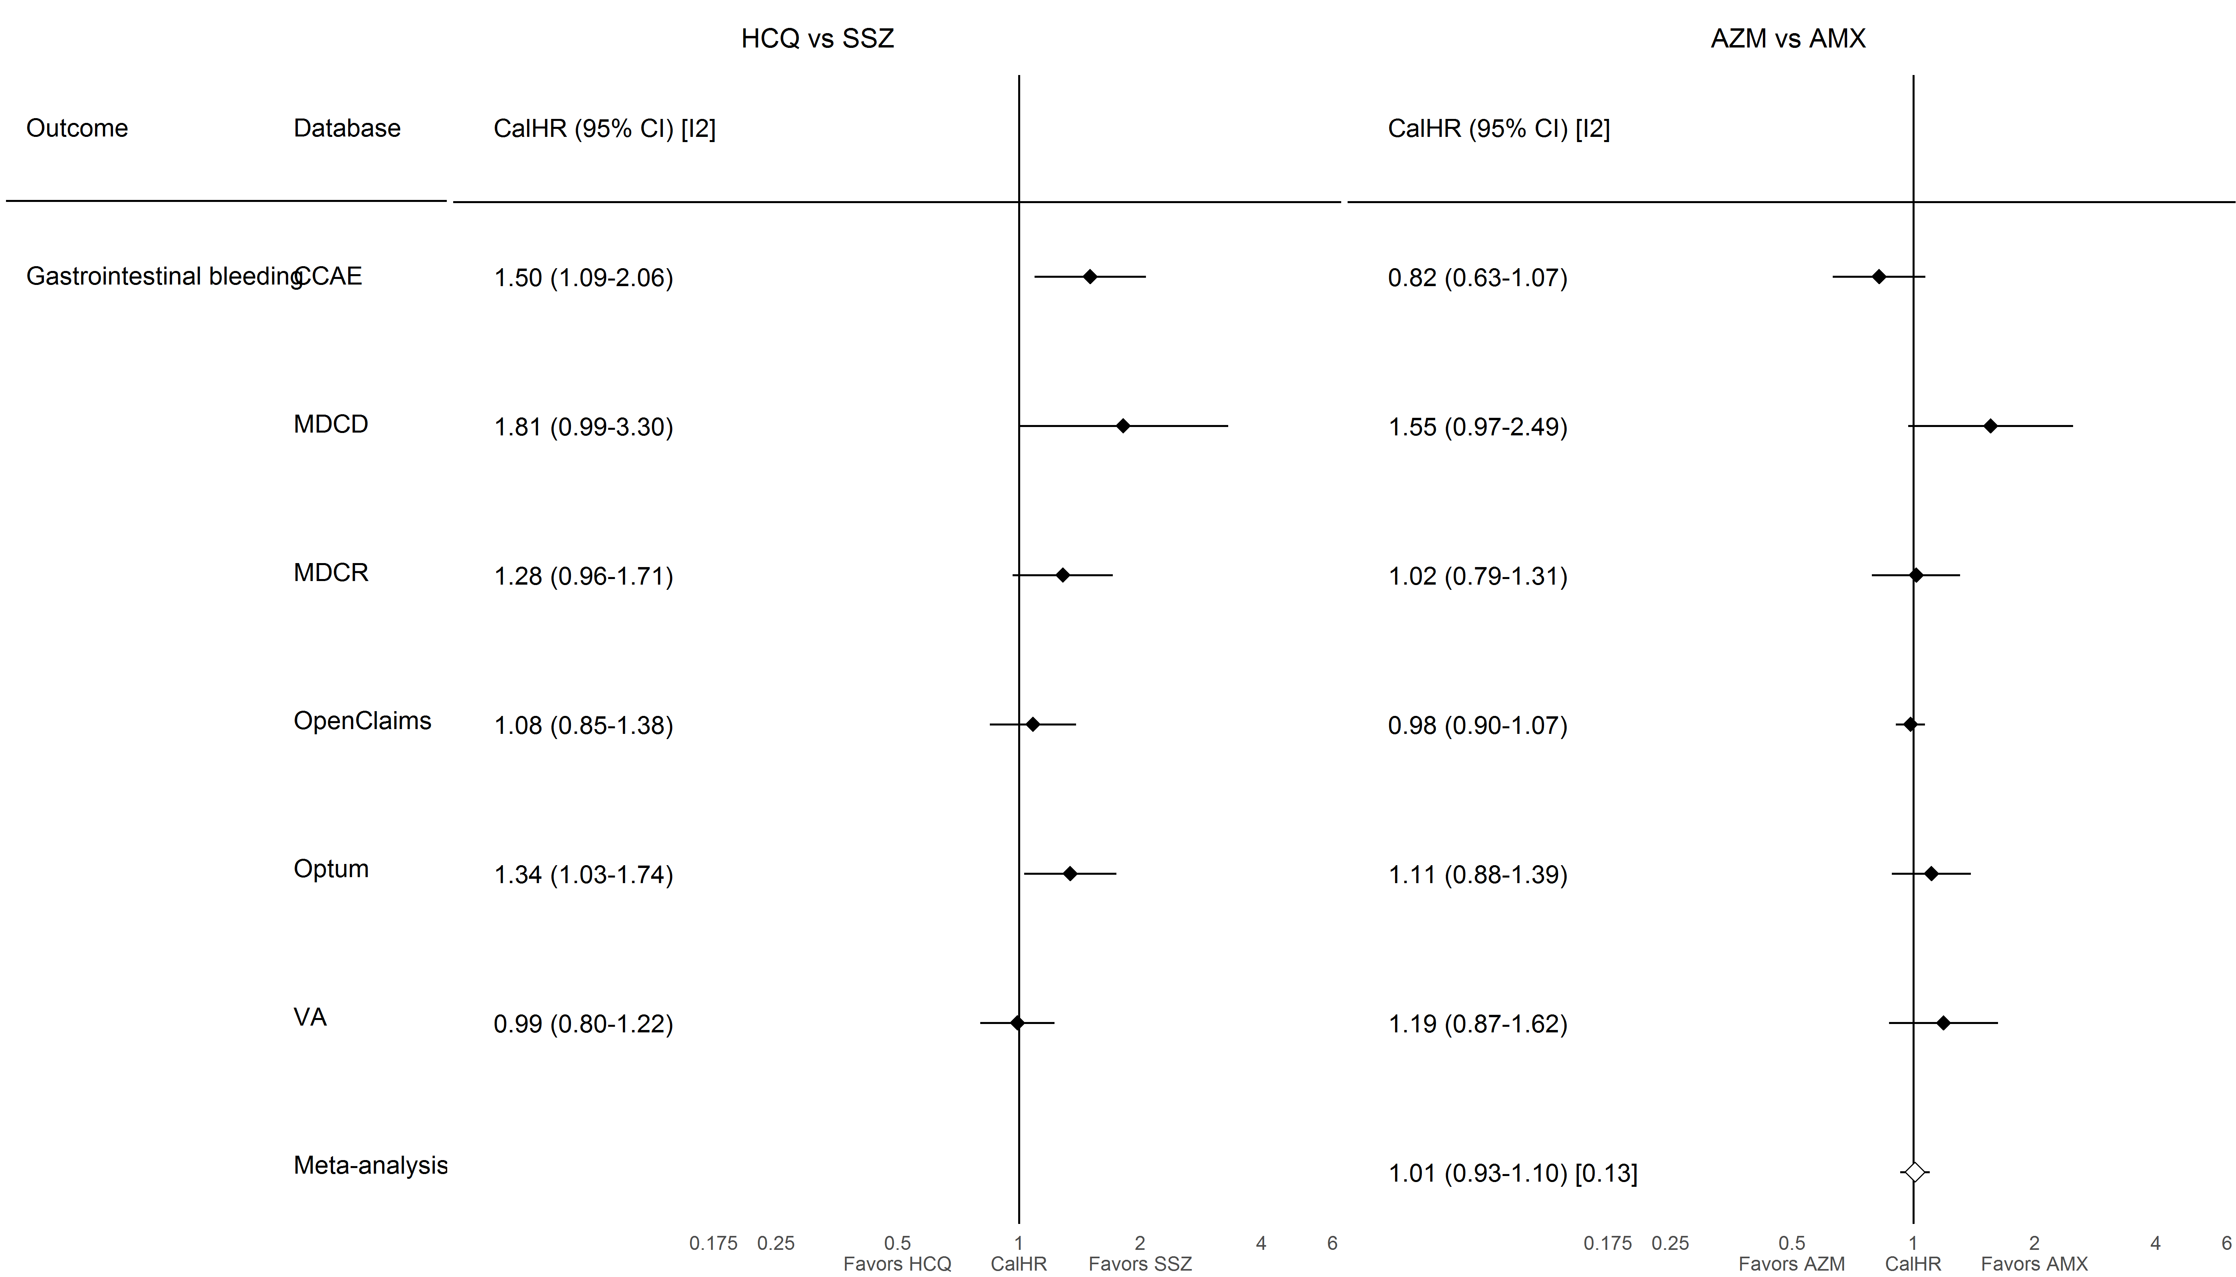

### **S8.2.13. Acute renal failure**

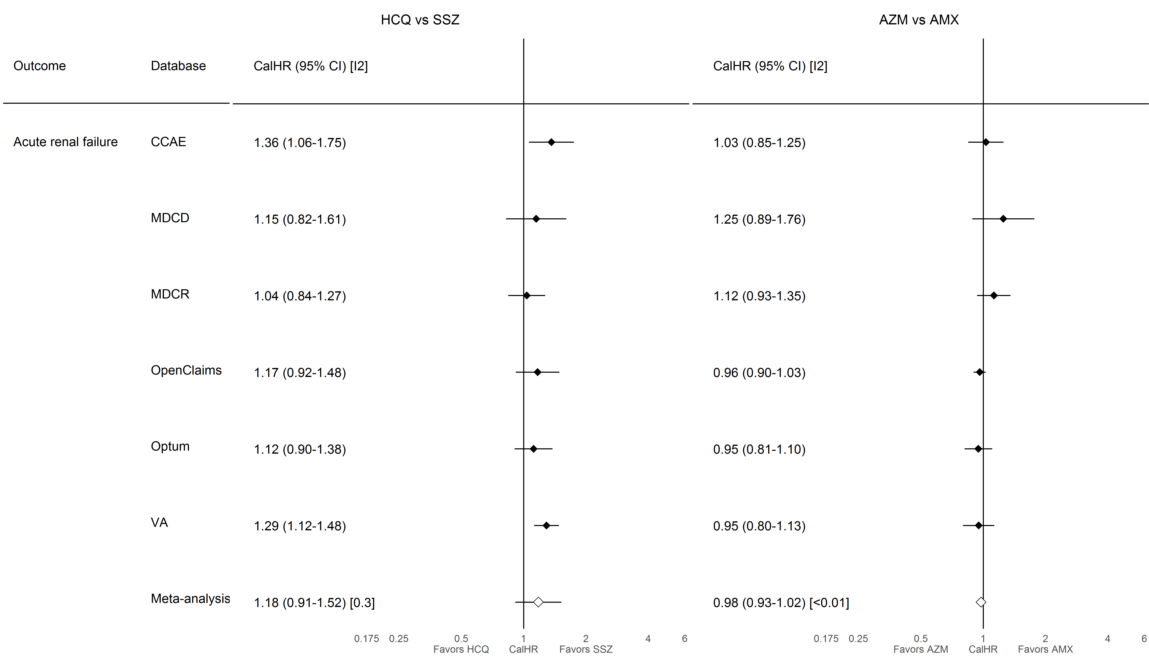

### **S8.2.14. End stage renal disease**

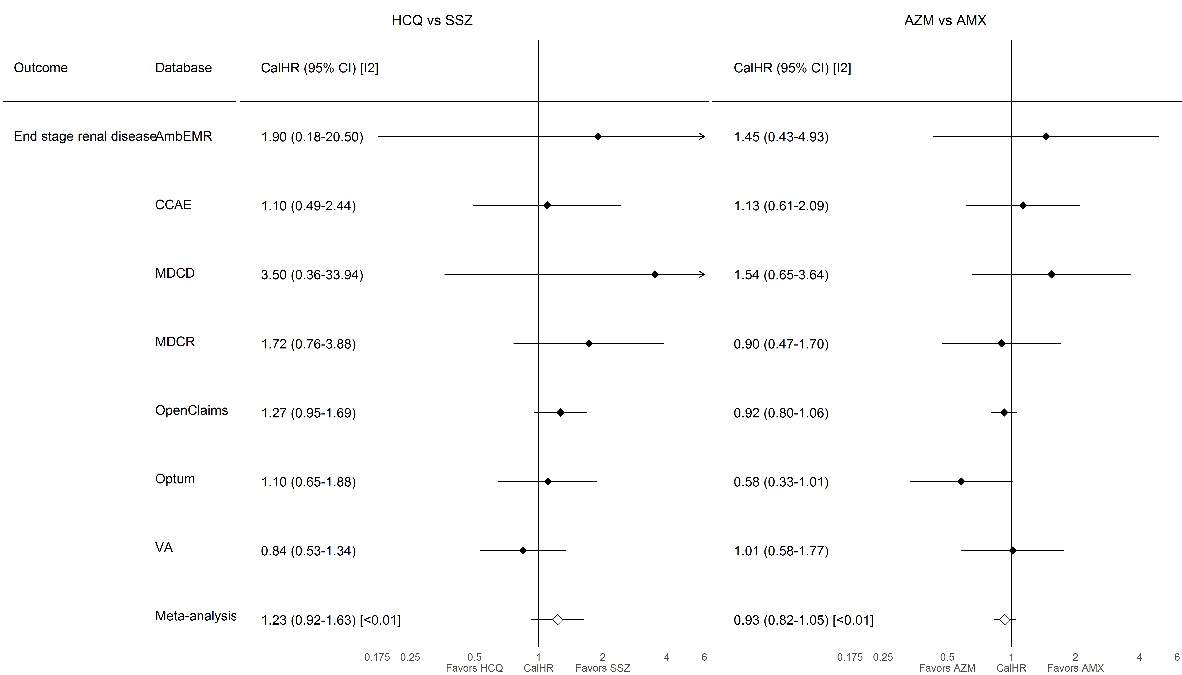

### **S8.2.15. Hepatic failure**

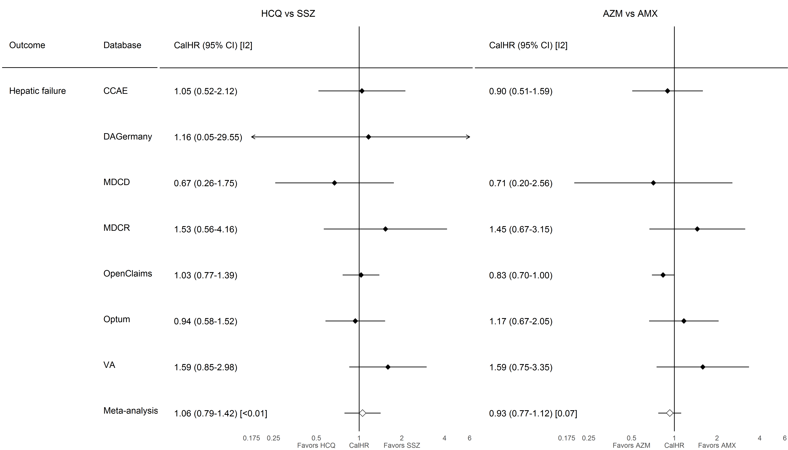

### **S8.2.16. Acute pancreatitis**

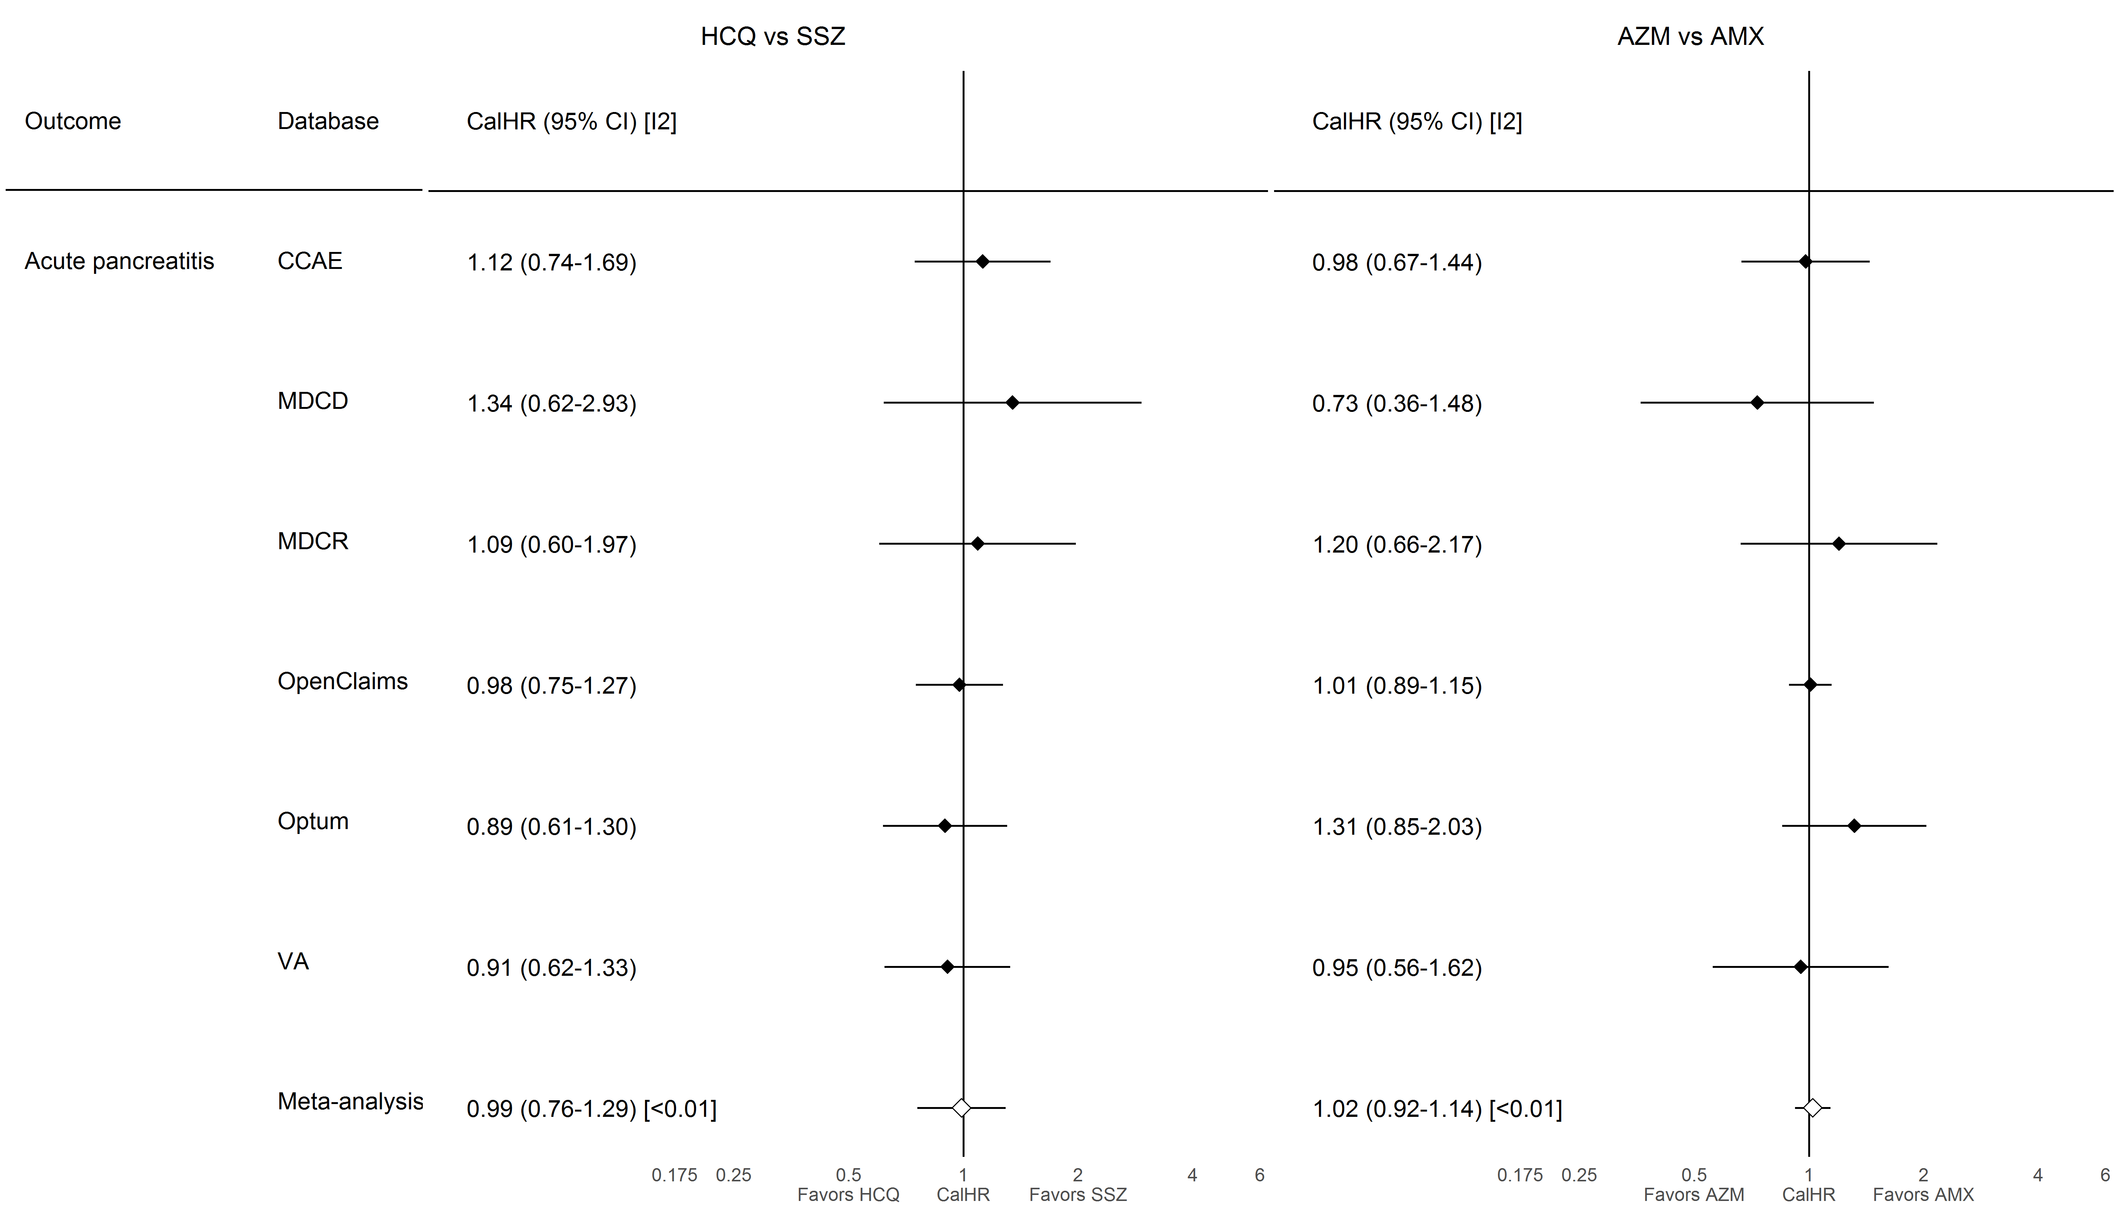

# **S9. Evidence evaluation diagnostics**

Preference score overlap, covariate balance, and empirical calibration plots are reported below. The preference score is a transformation of the propensity score that adjusts for differences in the sizes of the two exposure cohorts in a pairwise comparison. A higher overlap indicates patients in the two cohorts were more similar in terms of their predicted probability of receiving one exposure relative to the other. In the covariate balance plots, each dot represents the standardizes difference of means for a single covariate before and after propensity score stratification. The empirical calibration plots show effect estimates for the negative controls where the true hazard ratio is expected to equal 1. Estimates below the diagonal dashed lines are statistically significantly different (alpha = 0.05) from the true effect size. A well-calibrated estimator should produce the true effect sizes within the 95 percent confidence interval 95 percent of the time. Negative control estimates are not reported if fewer than 5 events are observed. *On-treatment* time-at-risk was unavailable in the PanTher databases so no negative control effects were estimated. In DAGermany and JMDC, the hydroxychloroquine+azithromycin and hydroxychloroquine+amoxicillin cohorts were of insufficient sample size for the cross-validation procedure for hyperparameter selection in the regularized regression used for fitting propensity scores, so diagnostics were not reported.

## **S9.1. AmbEMR**

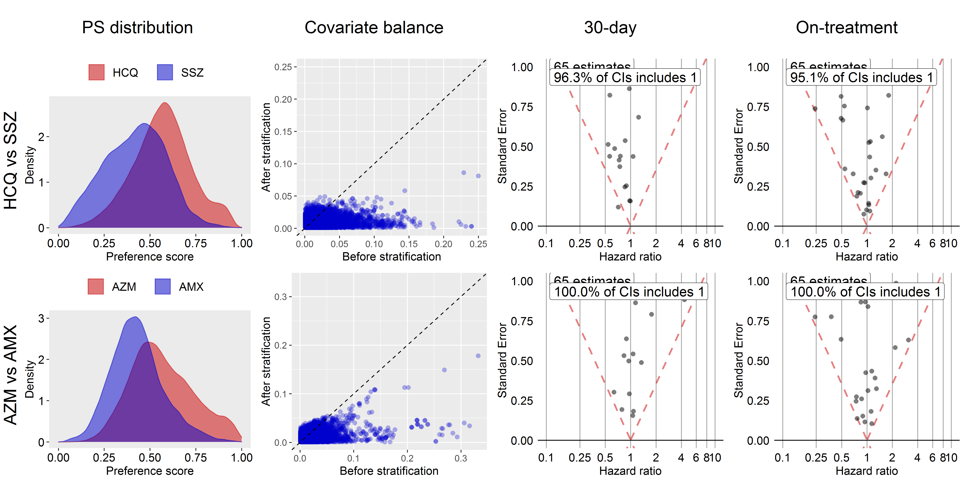

## **S9.2. CCAE**

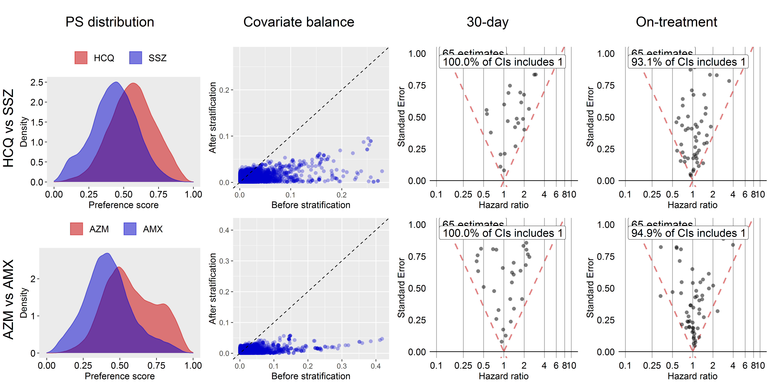

## **S9.3. CPRD**

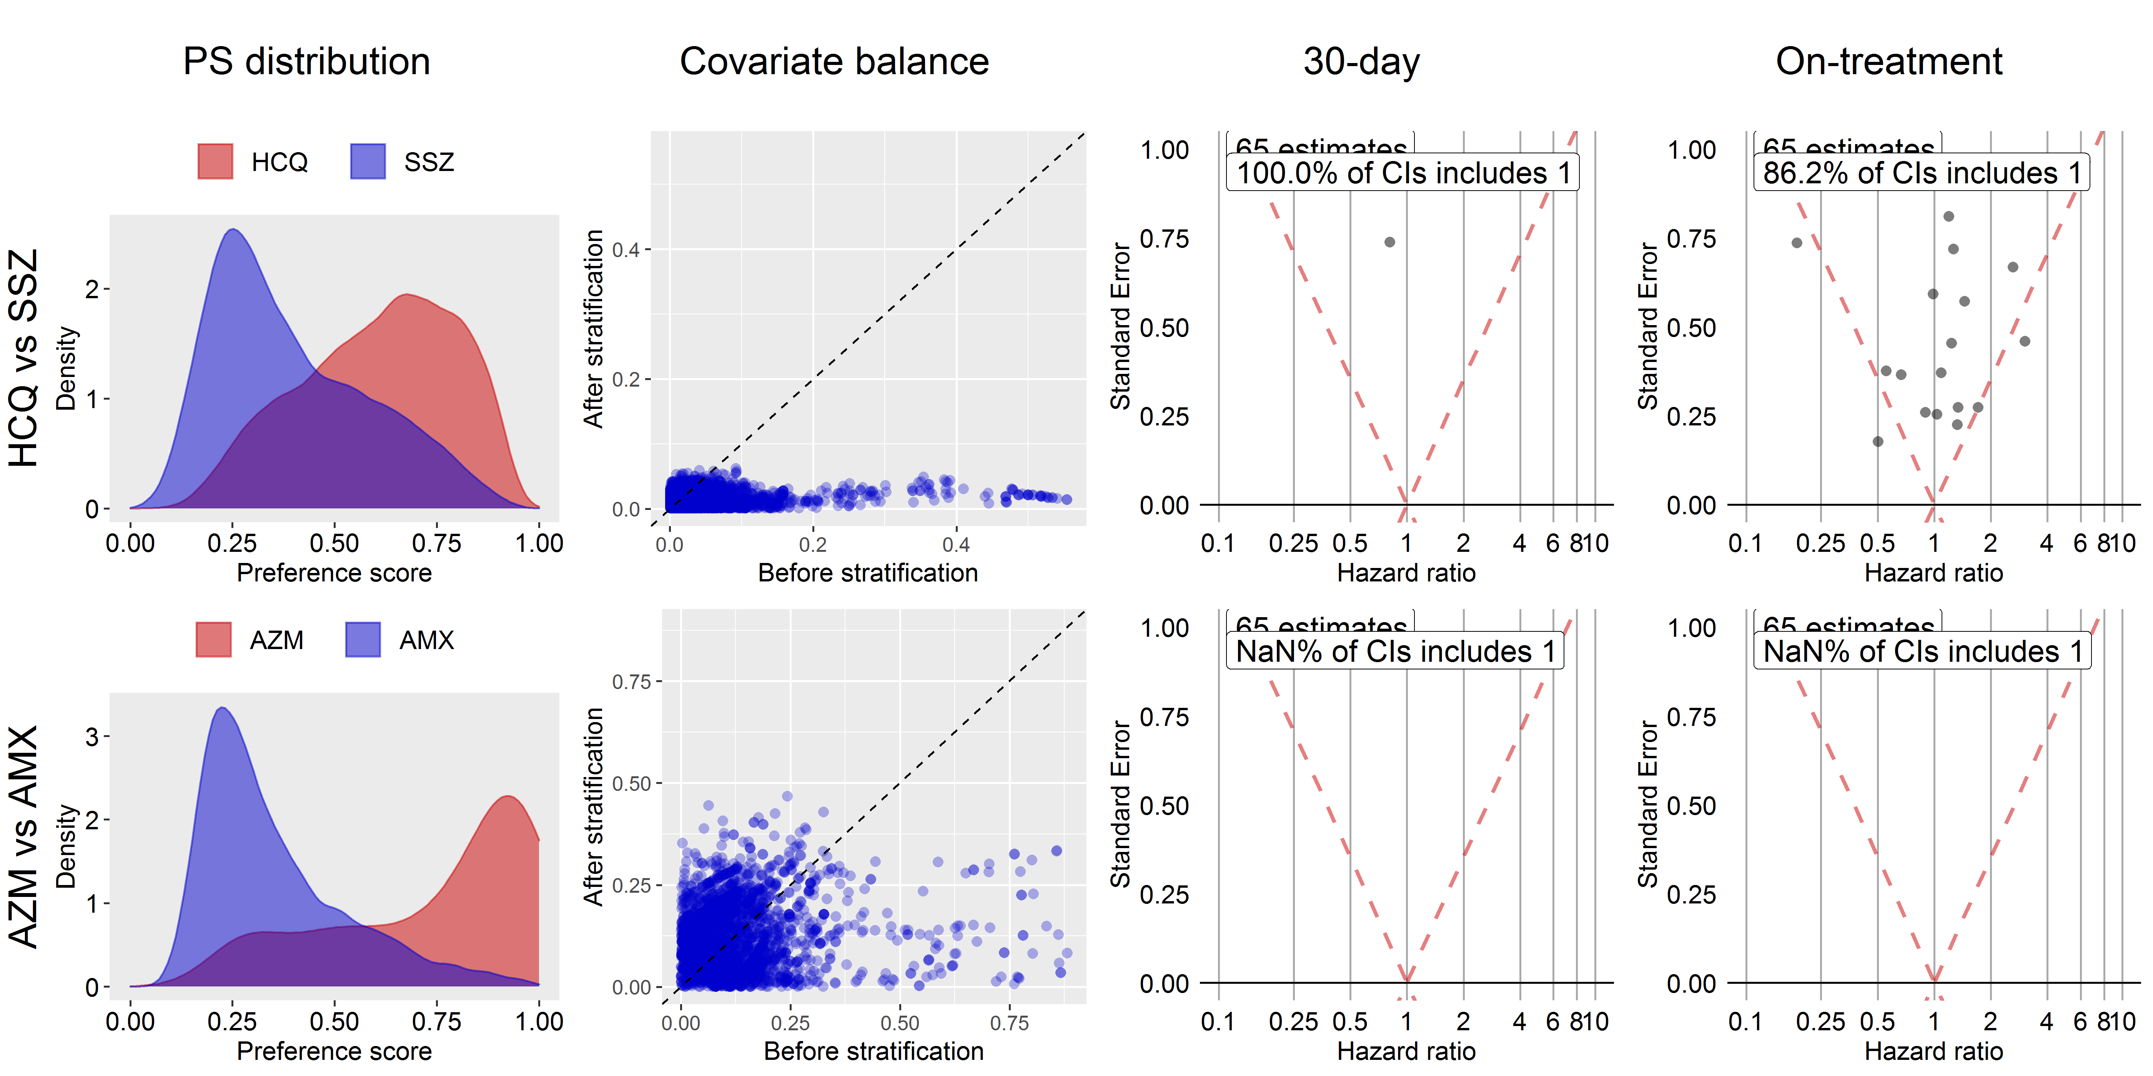

## **S9.4. DAGermany**

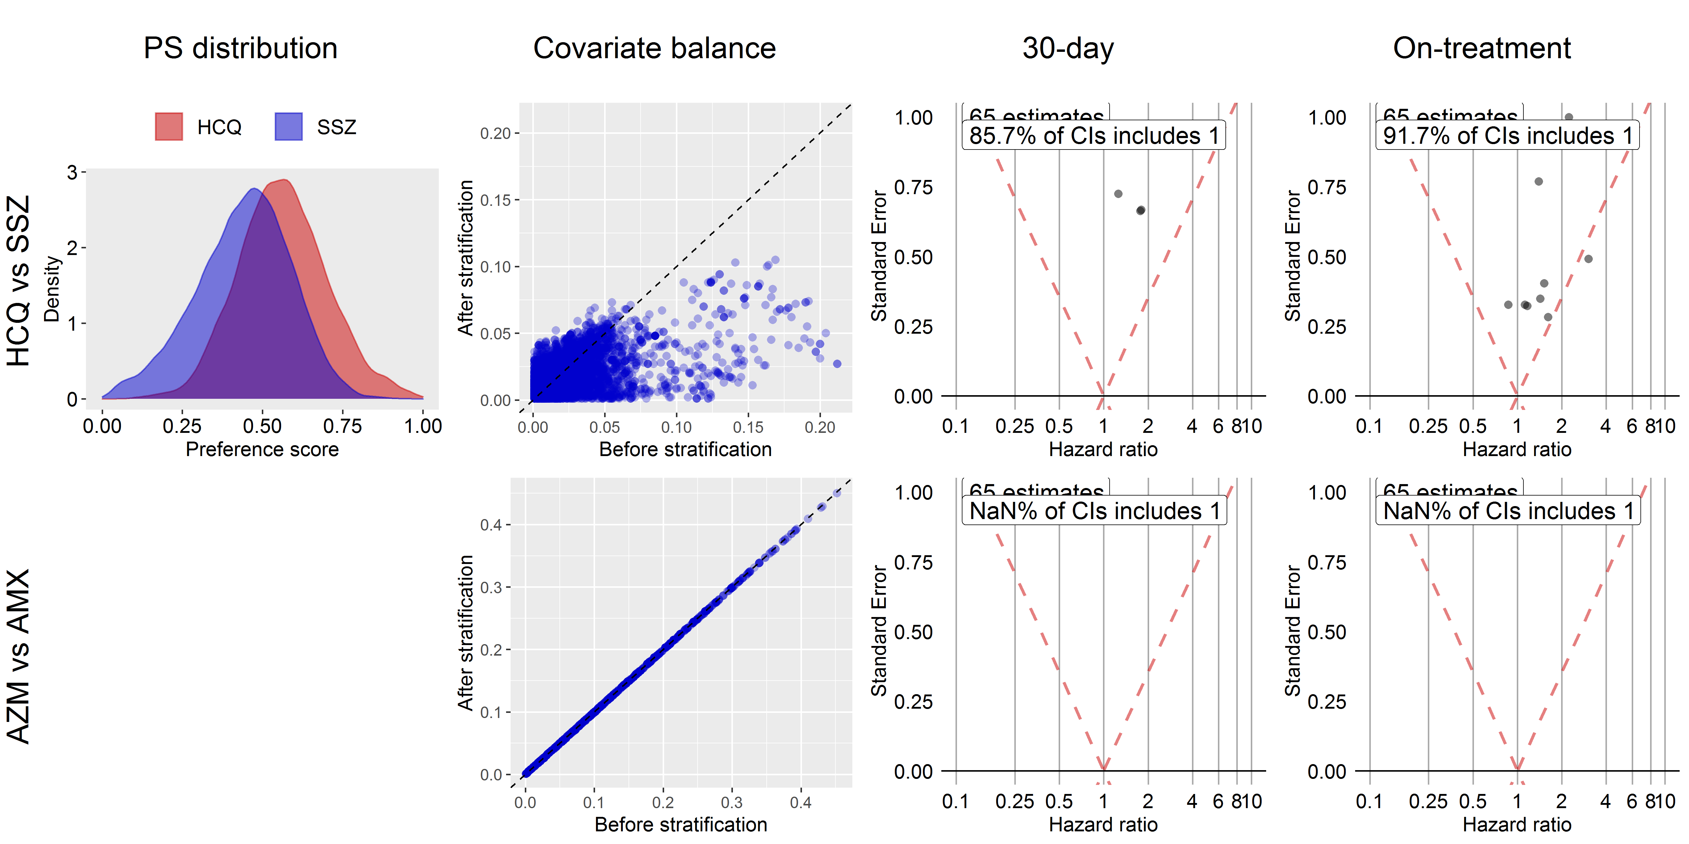

## **S9.5. IMRD**

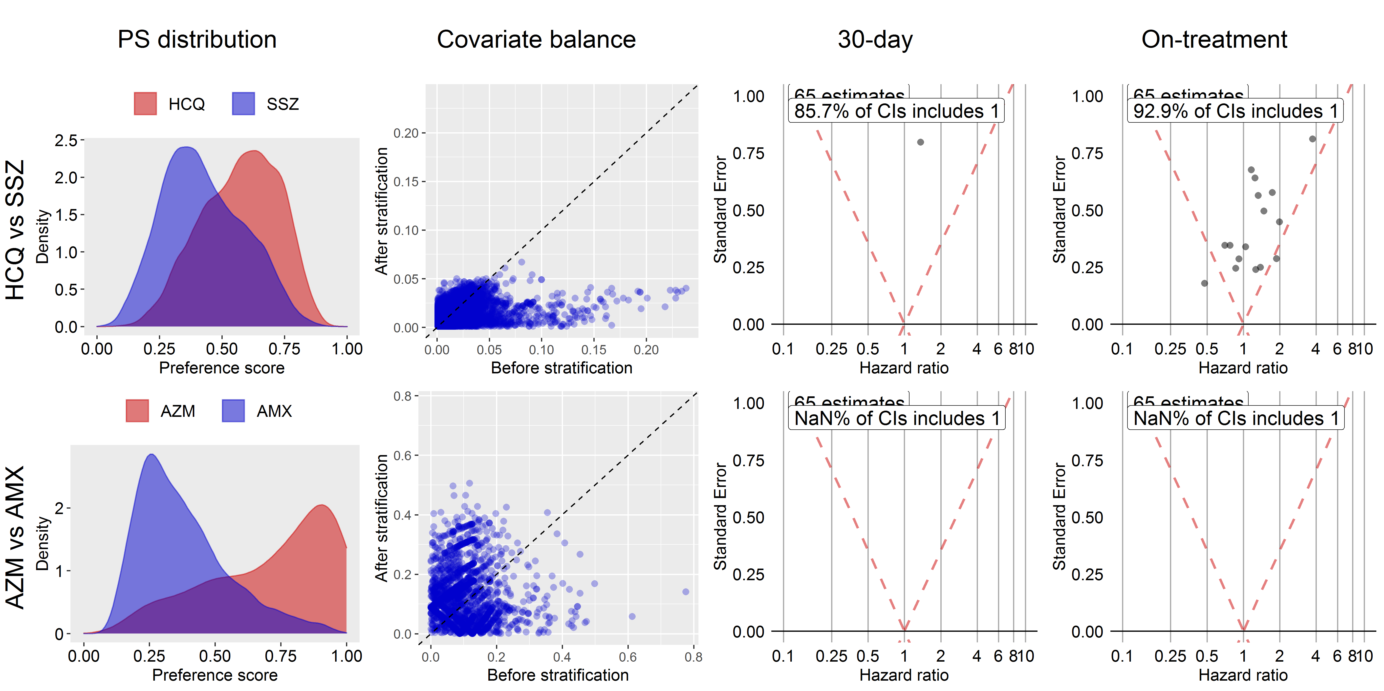

## **S9.6. IPCI**

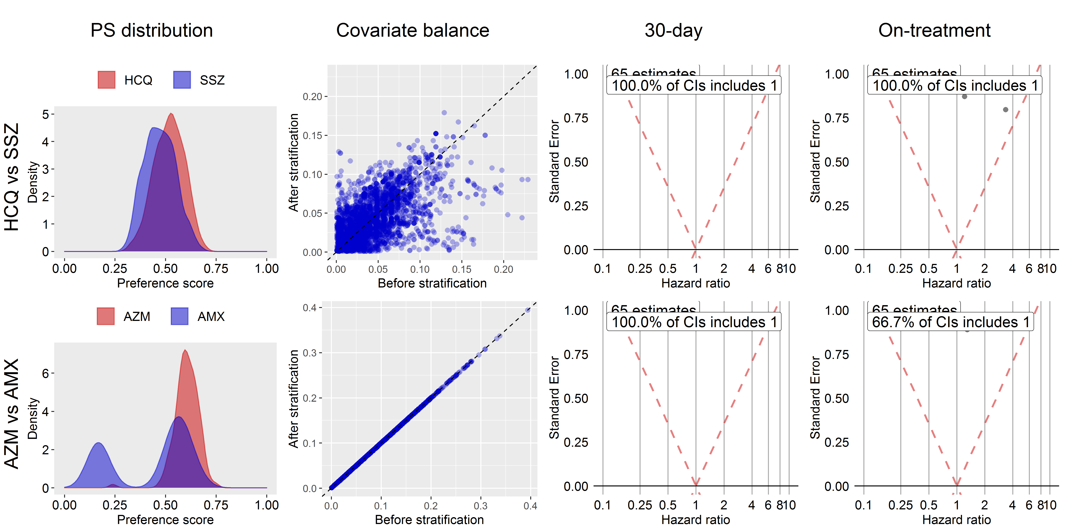

## **S9.7. JMDC**

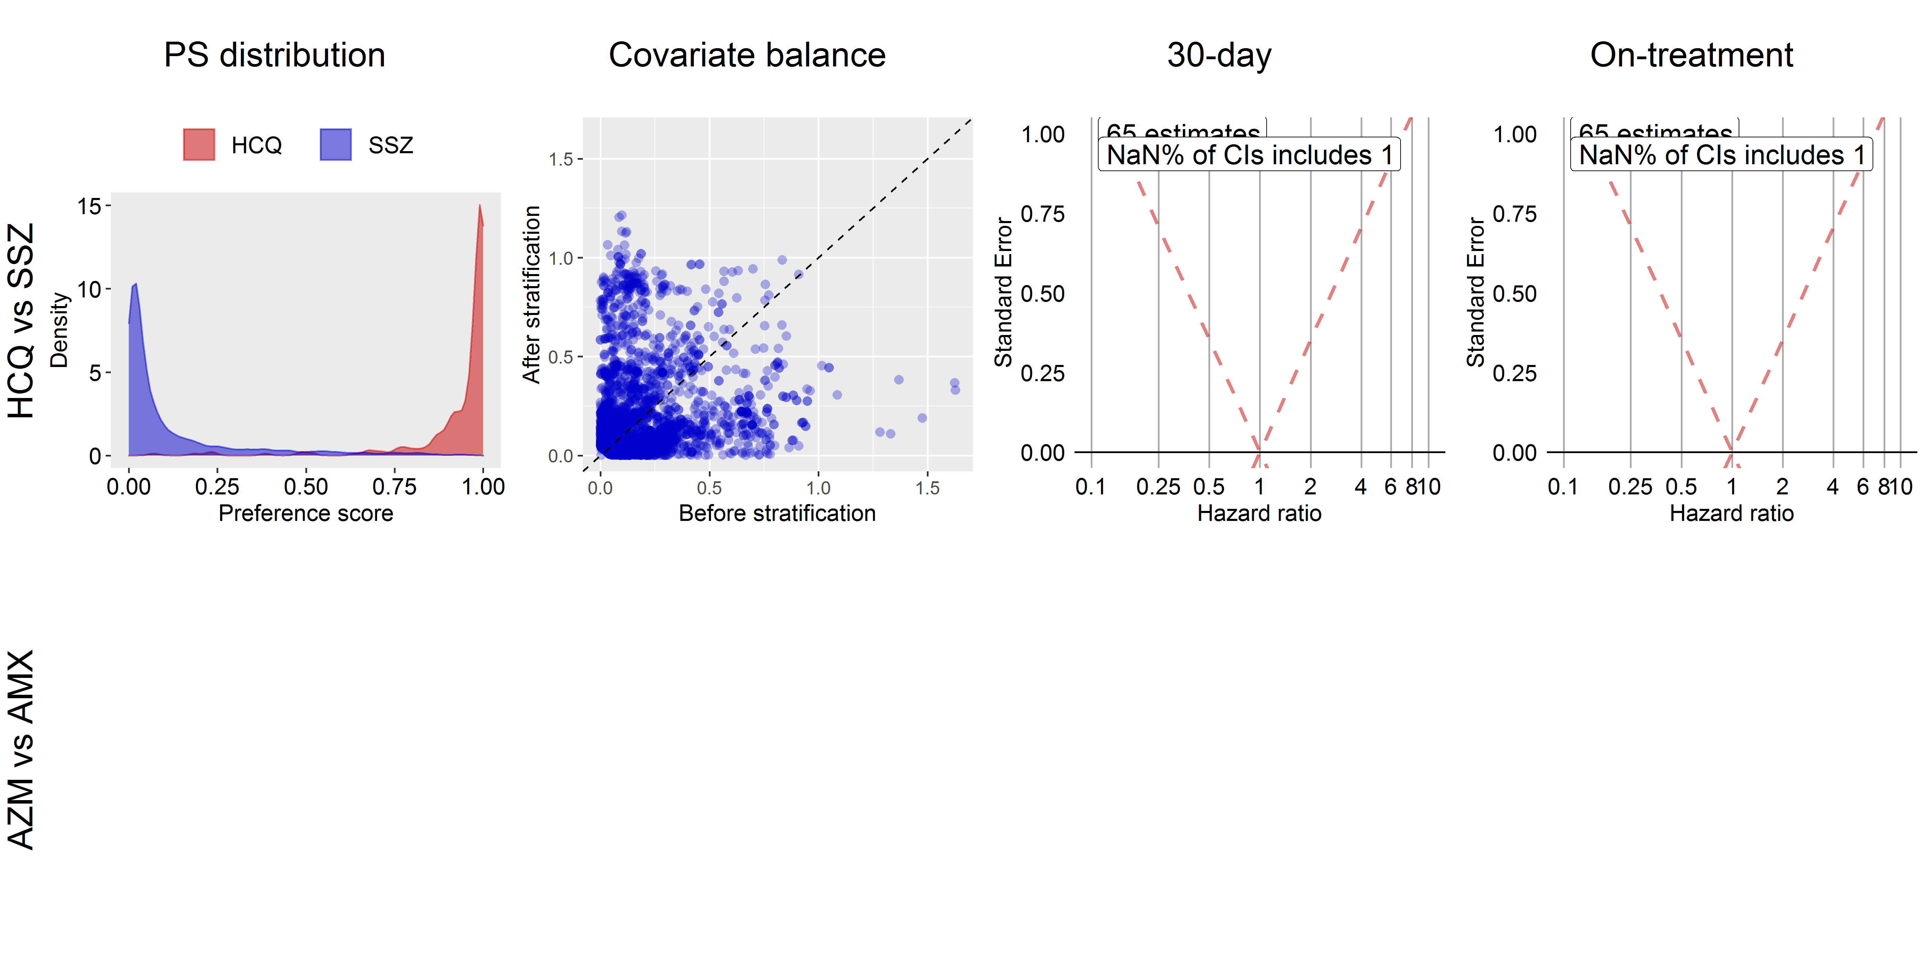

## **S9.8. MDCD**

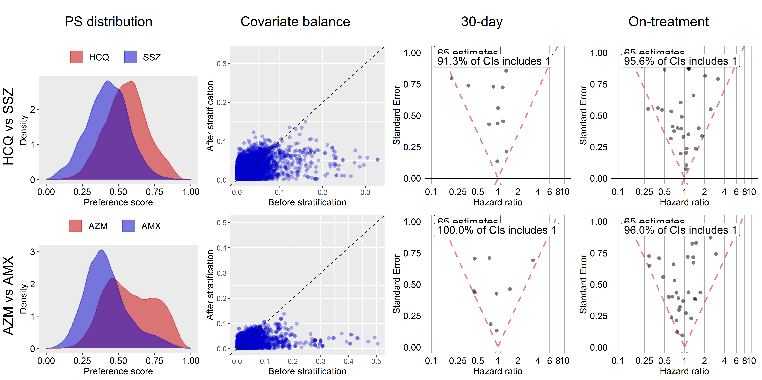

## **S9.9. MDCR**

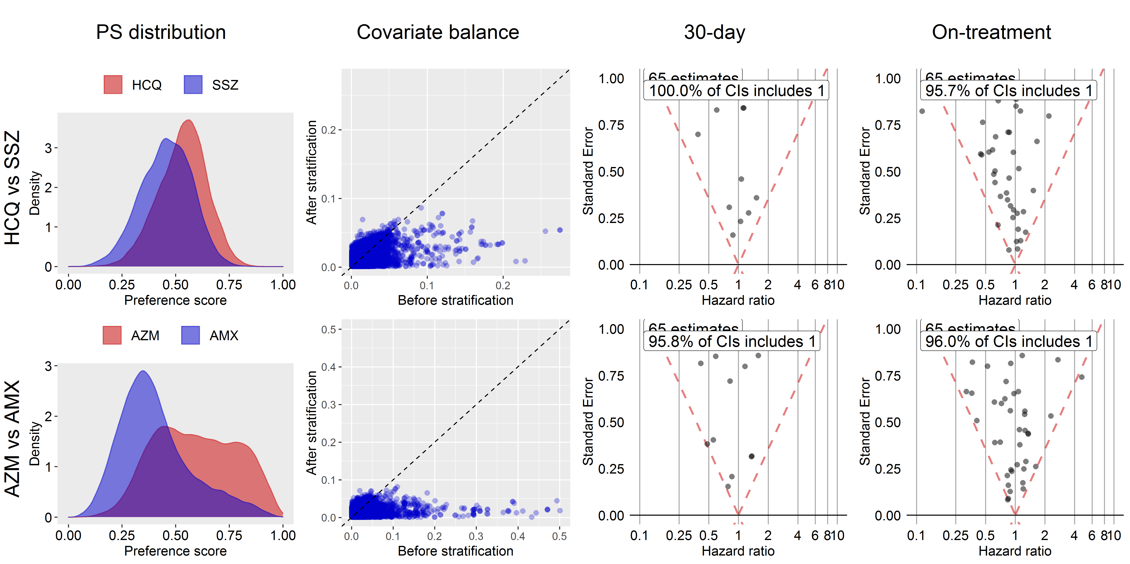

## **S9.10. OpenClaims**

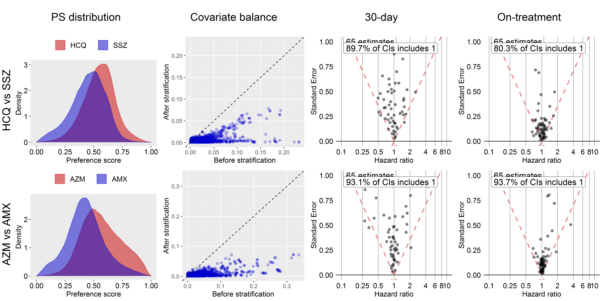

## **S9.11. Optum**

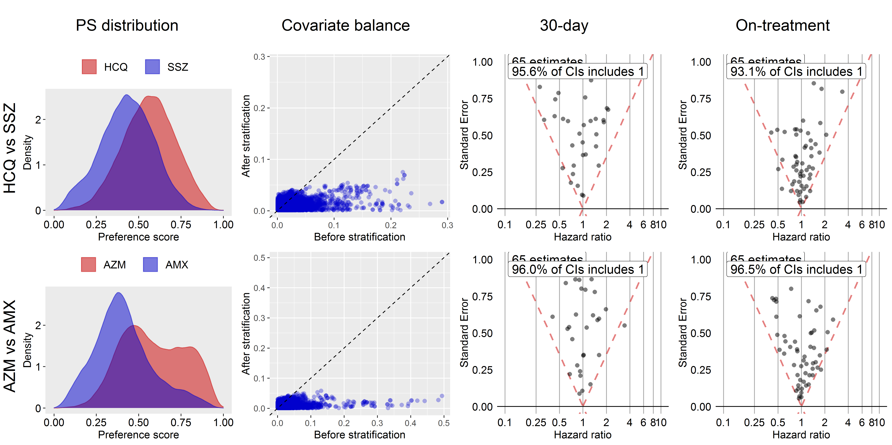

## **S9.12. PanTher**

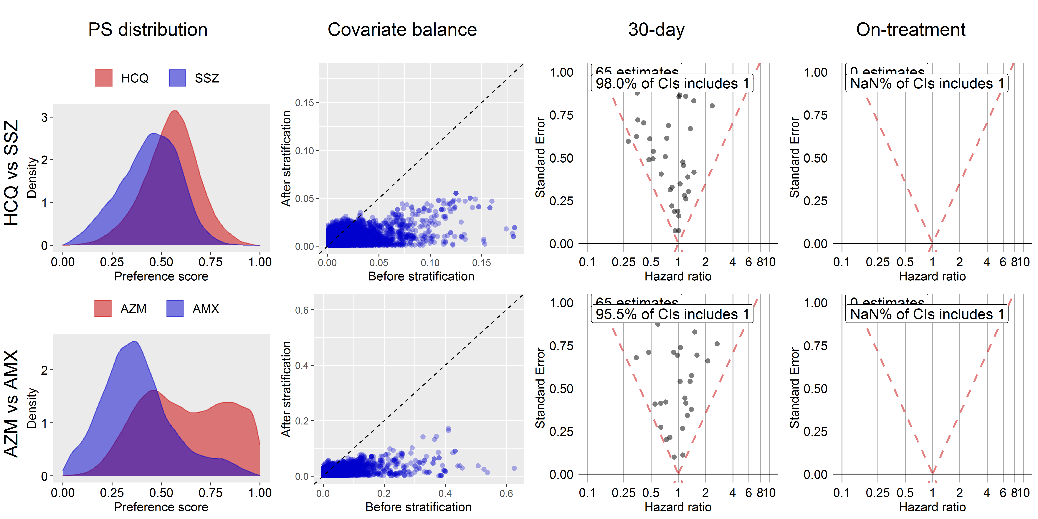

## **S9.13. SIDIAP**

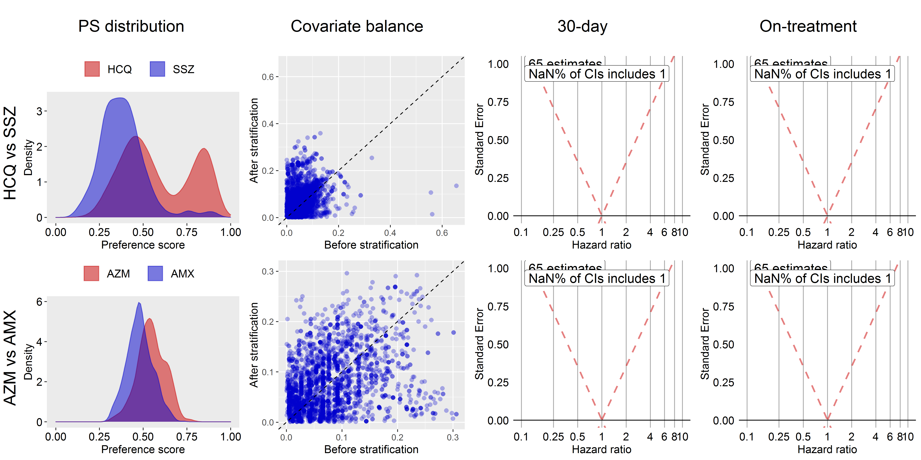

## **S9.14. VA**

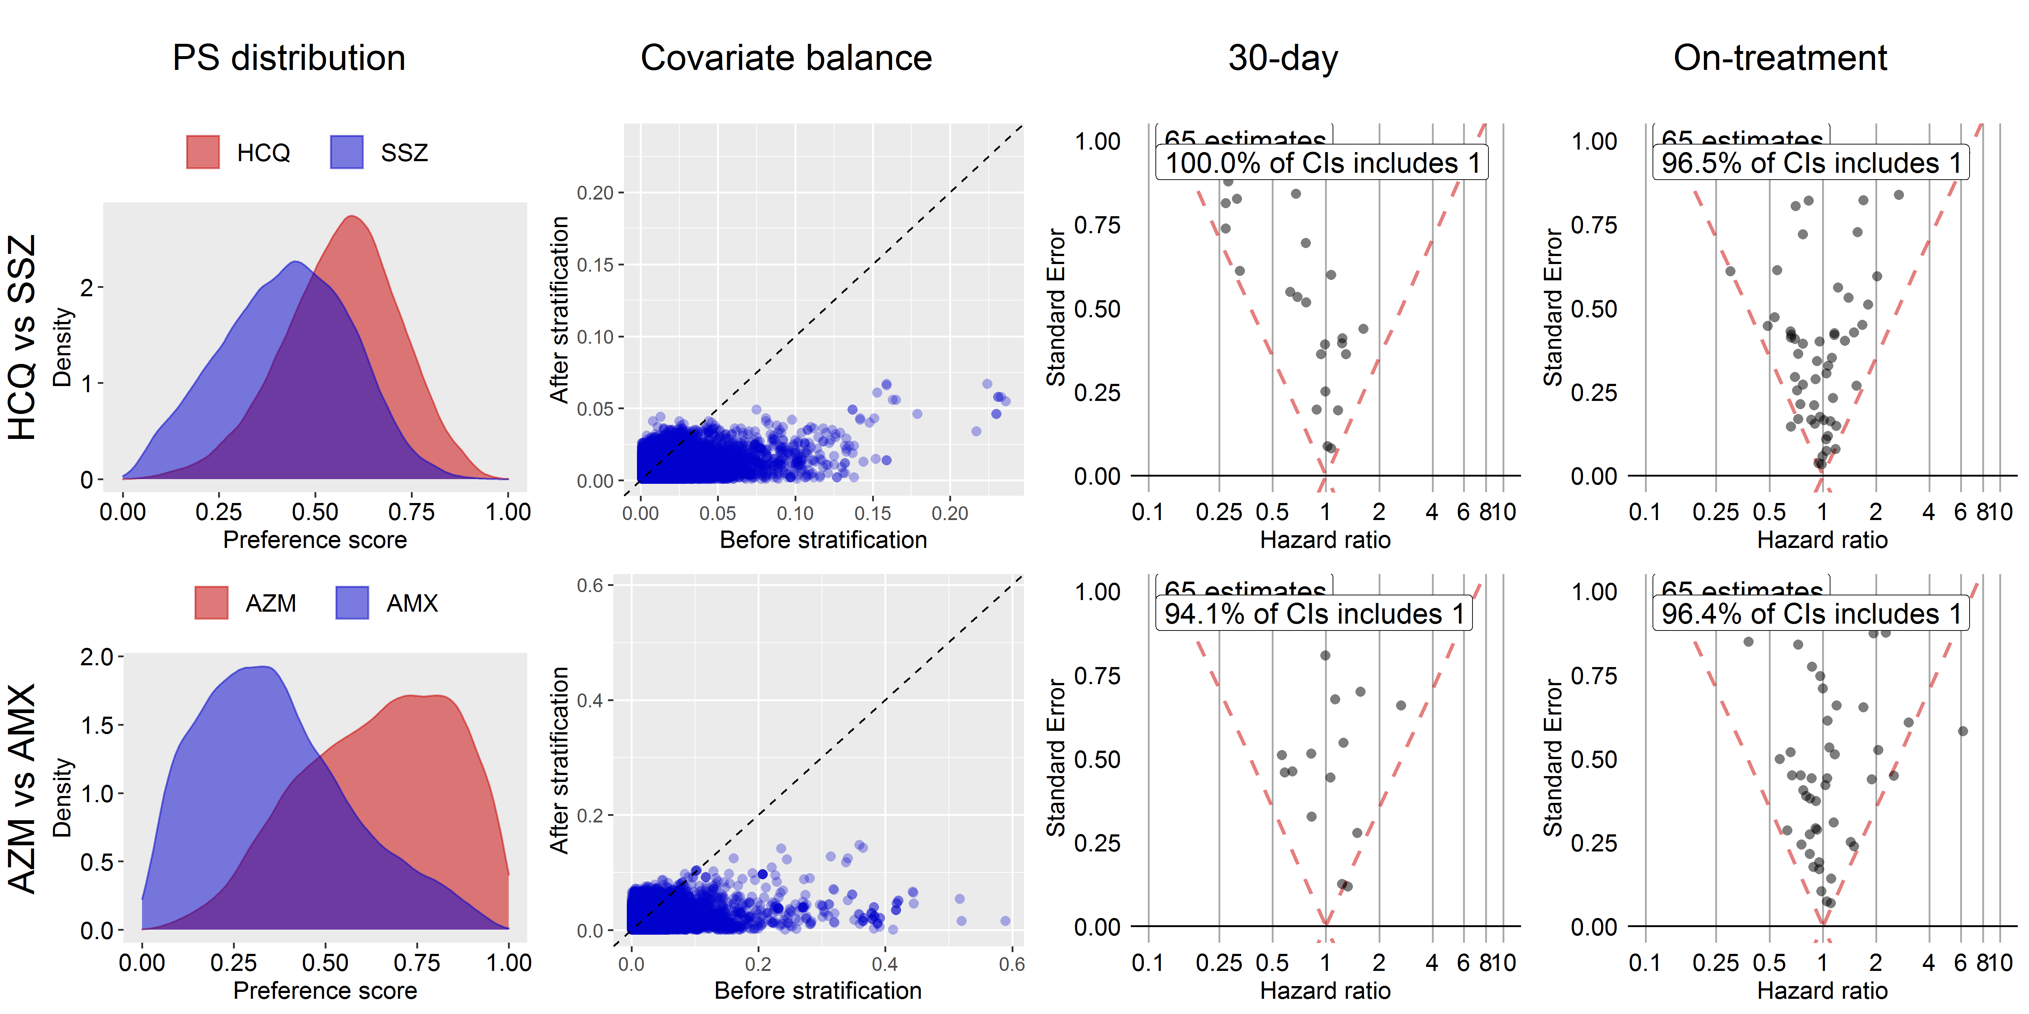

# **S10. Self-controlled case series results for hydroxychloroquine**

## **S10.1. CCAE**

|  |  |  |  |  |  |  |  |  |  |
| --- | --- | --- | --- | --- | --- | --- | --- | --- | --- |
| **Outcome** | **Analysis** | **Cases** | **IRR** | **95% CI LB** | **95% CI UB** | **Calibrated P** | **Calibrated IRR** | **Calibrated 95% CI LB** | **Calibrated 95% CI UB** |
| Myocardial infarction | Adjusting for event-dependent observation | 14,483 | 0.91 | 0.83 | 0.99 | 0.53 | 0.91 | 0.69 | 1.21 |
| Primary analysis | 14,483 | 0.91 | 0.84 | 1 | 0.57 | 0.92 | 0.7 | 1.22 |
| Acute pancreatitis events | Adjusting for event-dependent observation | 13,221 | NA | NA | NA | NA | NA | NA | NA |
|  | Primary analysis | 13,221 | 0.89 | 0.81 | 0.99 | 0.48 | 0.9 | 0.68 | 1.2 |
| Acute renal failure | Adjusting for event-dependent observation | 17,178 | 0.88 | 0.82 | 0.94 | 0.38 | 0.88 | 0.67 | 1.16 |
|  | Primary analysis | 17,178 | 0.9 | 0.84 | 0.96 | 0.47 | 0.9 | 0.69 | 1.19 |
| Gastrointestinal bleeding | Adjusting for event-dependent observation | 15,638 | NA | NA | NA | NA | NA | NA | NA |
|  | Primary analysis | 15,638 | 1 | 0.92 | 1.07 | 0.94 | 1.01 | 0.76 | 1.32 |
| Cardiac arrhythmia | Adjusting for event-dependent observation | 14,328 | 0.94 | 0.86 | 1.03 | 0.71 | 0.95 | 0.72 | 1.25 |
|  | Primary analysis | 14,328 | 0.94 | 0.86 | 1.03 | 0.74 | 0.95 | 0.72 | 1.26 |
| Bradycardia | Adjusting for event-dependent observation | 12,248 | NA | NA | NA | NA | NA | NA | NA |
|  | Primary analysis | 12,248 | 0.71 | 0.63 | 0.81 | 0.03 | 0.72 | 0.54 | 0.96 |
| Chest pain or angina | Adjusting for event-dependent observation | 13,399 | 0.9 | 0.81 | 1 | 0.53 | 0.91 | 0.69 | 1.21 |
|  | Primary analysis | 13,399 | 0.9 | 0.81 | 1 | 0.52 | 0.91 | 0.69 | 1.21 |
| End stage renal disease | Adjusting for event-dependent observation | 11,303 | 1.01 | 0.65 | 1.16 | 0.93 | 1.02 | 0.69 | 1.51 |
|  | Primary analysis | 11,303 | 1.02 | 0.88 | 1.18 | 0.85 | 1.03 | 0.76 | 1.39 |
| Heart failure | Adjusting for event-dependent observation | 15,626 | 0.98 | 0.9 | 1.05 | 0.91 | 0.99 | 0.75 | 1.29 |
|  | Primary analysis | 15,626 | 0.98 | 0.91 | 1.06 | 0.93 | 0.99 | 0.75 | 1.3 |
| Hepatic failure | Adjusting for event-dependent observation | 11,254 | 0.67 | 0.57 | 0.78 | 0.01 | 0.68 | 0.5 | 0.92 |
|  | Primary analysis | 11,254 | 0.64 | 0.54 | 0.75 | 0.01 | 0.64 | 0.47 | 0.88 |
| Stroke | Adjusting for event-dependent observation | 15,535 | NA | NA | NA | NA | NA | NA | NA |
|  | Primary analysis | 15,535 | 0.79 | 0.73 | 0.86 | 0.12 | 0.8 | 0.61 | 1.06 |
| Cardiovascular events | Adjusting for event-dependent observation | 15,200 | NA | NA | NA | NA | NA | NA | NA |
|  | Primary analysis | 15,200 | 0.86 | 0.79 | 0.93 | 0.3 | 0.86 | 0.66 | 1.14 |
| Transient ischemic attack | Adjusting for event-dependent observation | 14,563 | 0.9 | 0.85 | 0.98 | 0.51 | 0.91 | 0.69 | 1.2 |
|  | Primary analysis | 14,563 | 0.91 | 0.83 | 0.99 | 0.55 | 0.92 | 0.7 | 1.21 |
| Venous thromboembolism | Adjusting for event-dependent observation | 16,595 | 0.78 | 0.5 | 0.84 | 0.22 | 0.79 | 0.54 | 1.15 |
|  | Primary analysis | 16,595 | 0.8 | 0.75 | 0.86 | 0.14 | 0.81 | 0.62 | 1.07 |
| **IRR**= Incidence Rate Ratio **95%CI LB**= 95% Confidence Interval Lower Boundary **95%CI UB**= 95% Confidence Interval Upper Boundary | | | | | | | | | |

## **S10.2. CPRD**

|  |  |  |  |  |  |  |  |  |  |  |
| --- | --- | --- | --- | --- | --- | --- | --- | --- | --- | --- |
| **Outcome** | **Analysis** | **Cases** | **IRR** | **95% CI LB** | **95% CI UB** | **Calibrated P** | **Calibrated IRR** | | **Calibrated 95% CI LB** | **Calibrated 95% CI UB** |
| Myocardial infarction | Adjusting for event-dependent observation | 0 | NA | NA | NA | NA | NA | NA | | NA |
|  | Primary analysis | 0 | NA | NA | NA | NA | NA | NA | | NA |
| Acute pancreatitis events | Adjusting for event-dependent observation | 0 | NA | NA | NA | NA | NA | NA | | NA |
|  | Primary analysis | 0 | NA | NA | NA | NA | NA | NA | | NA |
| Acute renal failure | Adjusting for event-dependent observation | 0 | NA | NA | NA | NA | NA | NA | | NA |
|  | Primary analysis | 0 | NA | NA | NA | NA | NA | NA | | NA |
| Gastrointestinal bleeding | Adjusting for event-dependent observation | 0 | NA | NA | NA | NA | NA | NA | | NA |
|  | Primary analysis | 0 | NA | NA | NA | NA | NA | NA | | NA |
| Cardiac arrhythmia | Adjusting for event-dependent observation | 12,614 | 0.86 | 0.77 | 0.97 | 0.81 | 0.95 | 0.61 | | 1.47 |
|  | Primary analysis | 12,614 | 0.87 | 0.77 | 0.98 | 0.83 | 0.95 | 0.61 | | 1.48 |
| Bradycardia | Adjusting for event-dependent observation | 7,094 | 0.6 | 0.18 | 1.68 | 0.49 | 0.65 | 0.2 | | 2.16 |
|  | Primary analysis | 7,094 | 0.62 | 0.19 | 1.69 | 0.51 | 0.68 | 0.21 | | 2.18 |
| Chest pain or angina | Adjusting for event-dependent observation | 13,376 | 0.89 | 0.8 | 1 | 0.9 | 0.98 | 0.63 | | 1.52 |
|  | Primary analysis | 13,376 | 0.89 | 0.8 | 1 | 0.9 | 0.98 | 0.63 | | 1.52 |
| End stage renal disease | Adjusting for event-dependent observation | 1,496 | 0.84 | 0.14 | 4.51 | 0.92 | 0.91 | 0.15 | | 5.49 |
|  | Primary analysis | 1,496 | 0.83 | 0.14 | 4.41 | 0.91 | 0.91 | 0.15 | | 5.31 |
| Heart failure | Adjusting for event-dependent observation | 10,215 | 1.1 | 0.76 | 1.56 | 0.53 | 1.2 | 0.69 | | 2.09 |
|  | Primary analysis | 10,215 | 1.1 | 0.77 | 1.58 | 0.52 | 1.21 | 0.69 | | 2.11 |
| Hepatic failure | Adjusting for event-dependent observation | 2,710 | 1 | NA | NA | NA | NA | NA | | NA |
|  | Primary analysis | 2,710 | 0.09 | 0 | 0.77 | 0.08 | 0.09 | 0.01 | | 1.35 |
| Stroke | Adjusting for event-dependent observation | 0 | NA | NA | NA | NA | NA | NA | | NA |
|  | Primary analysis | 0 | NA | NA | NA | NA | NA | NA | | NA |
| Cardiovascular events | Adjusting for event-dependent observation | 0 | NA | NA | NA | NA | NA | NA | | NA |
|  | Primary analysis | 0 | NA | NA | NA | NA | NA | NA | | NA |
| Transient ischemic attack | Adjusting for event-dependent observation | 0 | NA | NA | NA | NA | NA | NA | | NA |
|  | Primary analysis | 0 | NA | NA | NA | NA | NA | NA | | NA |
| Venous thromboembolism | Adjusting for event-dependent observation | 12,454 | 0.64 | 0.56 | 0.72 | 0.12 | 0.7 | 0.45 | | 1.09 |
|  | Primary analysis | 12,454 | 0.63 | 0.55 | 0.71 | 0.11 | 0.69 | 0.44 | | 1.07 |
| **IRR**= Incidence Rate Ratio **95%CI LB**= 95% Confidence Interval Lower Boundary **95%CI UB**= 95% Confidence Interval Upper Boundary | | | | | | | | | | |

## **S10.3. JMDC**

|  |  |  |  |  |  |  |  |  |  |
| --- | --- | --- | --- | --- | --- | --- | --- | --- | --- |
| **Outcome** | **Analysis** | **Cases** | **IRR** | **95% CI LB** | **95% CI UB** | **Calibrated P** | **Calibrated IRR** | **Calibrated 95% CI LB** | **Calibrated 95% CI UB** |
| Myocardial infarction | Adjusting for event-dependent observation | 5,788 | 0 | NA | 0 | NA | NA | NA | NA |
|  | Primary analysis | 5,789 | 0 | NA | 1.19 | NA | NA | NA | NA |
| Acute pancreatitis events | Adjusting for event-dependent observation | 5,307 | 1.42 | 0.06 | 25.06 | 0.62 | 2.18 | 0.11 | 43.82 |
|  | Primary analysis | 5,307 | 1.38 | 0.06 | 13.42 | 0.6 | 2.11 | 0.14 | 31.5 |
| Acute renal failure | Adjusting for event-dependent observation | 3,598 | 0.86 | 0.18 | 3.12 | 0.73 | 1.33 | 0.31 | 5.71 |
|  | Primary analysis | 3,598 | 0.91 | 0.19 | 3.37 | 0.69 | 1.39 | 0.32 | 6.12 |
| Gastrointestinal bleeding | Adjusting for event-dependent observation | 10,009 | 0.16 | 0.01 | 0.82 | 0.25 | 0.25 | 0.03 | 2.44 |
|  | Primary analysis | 10,009 | 0.16 | 0.01 | 0.79 | 0.24 | 0.24 | 0.03 | 2.38 |
| Cardiac arrhythmia | Adjusting for event-dependent observation | 10,034 | 0.4 | 0.11 | 1.2 | 0.5 | 0.62 | 0.18 | 2.15 |
|  | Primary analysis | 10,034 | 0.38 | 0.1 | 1.11 | 0.43 | 0.58 | 0.17 | 1.98 |
| Bradycardia | Adjusting for event-dependent observation | 5,813 | 2.4 | 0.11 | 20.87 | 0.35 | 3.67 | 0.26 | 50.91 |
|  | Primary analysis | 5,813 | 2.41 | 0.11 | 21.25 | 0.35 | 3.69 | 0.26 | 51.54 |
| Chest pain or angina | Adjusting for event-dependent observation | 10,082 | 0.6 | 0.32 | 1.09 | 0.74 | 0.92 | 0.45 | 1.85 |
|  | Primary analysis | 10,082 | 0.6 | 0.31 | 1.08 | 0.74 | 0.91 | 0.45 | 1.84 |
| End stage renal disease | Adjusting for event-dependent observation | 2,439 | NA | NA | NA | NA | NA | NA | NA |
|  | Primary analysis | 2,445 | NA | NA | NA | NA | NA | NA | NA |
| Heart failure | Adjusting for event-dependent observation | 10,071 | 0.67 | 0.34 | 1.23 | 0.77 | 1.02 | 0.5 | 2.1 |
|  | Primary analysis | 10,071 | 0.66 | 0.34 | 1.22 | 0.76 | 1.02 | 0.49 | 2.08 |
| Hepatic failure | Adjusting for event-dependent observation | 3,014 | 1 | 0.04 | 15.31 | 0.79 | 1.54 | 0.08 | 30.15 |
|  | Primary analysis | 3,014 | 0.97 | 0.04 | 18.75 | 0.81 | 1.48 | 0.07 | 33.23 |
| Stroke | Adjusting for event-dependent observation | 10,001 | 0.74 | 0.23 | 2.1 | 0.8 | 1.13 | 0.36 | 3.55 |
|  | Primary analysis | 10,001 | 0.74 | 0.23 | 2.12 | 0.8 | 1.14 | 0.36 | 3.59 |
| Cardiovascular events | Adjusting for event-dependent observation | 10,035 | 0.33 | 0.13 | 0.72 | 0.21 | 0.51 | 0.21 | 1.25 |
|  | Primary analysis | 10,035 | 0.33 | 0.13 | 0.72 | 0.2 | 0.5 | 0.2 | 1.25 |
| Transient ischemic attack | Adjusting for event-dependent observation | 2,208 | 0 | NA | 0 | NA | NA | NA | NA |
|  | Primary analysis | 2,208 | 0 | NA | 38.67 | NA | NA | NA | NA |
| Venous thromboembolism | Adjusting for event-dependent observation | 10,029 | 0.98 | 0.41 | 2.14 | 0.45 | 1.51 | 0.62 | 3.67 |
|  | Primary analysis | 10,029 | 0.98 | 0.41 | 2.14 | 0.45 | 1.51 | 0.62 | 3.67 |
| **IRR**= Incidence Rate Ratio **95%CI LB**= 95% Confidence Interval Lower Boundary **95%CI UB**= 95% Confidence Interval Upper Boundary | | | | | | | | | |
|  |  |  |  |  |  |  |  |  |  |

## **S10.4. MDCD**

|  |  |  |  |  |  |  |  |  |  |
| --- | --- | --- | --- | --- | --- | --- | --- | --- | --- |
| **Outcome** | **Analysis** | **Cases** | **IRR** | **95% CI LB** | **95% CI UB** | **Calibrated P** | **Calibrated IRR** | **Calibrated 95% CI LB** | **Calibrated 95% CI UB** |
| Myocardial infarction | Adjusting for event-dependent observation | 11,276 | NA | NA | NA | NA | NA | NA | NA |
|  | Primary analysis | 11,276 | 0.97 | 0.83 | 1.13 | 0.39 | 0.89 | 0.7 | 1.15 |
| Acute pancreatitis events | Adjusting for event-dependent observation | 10,851 | 1.22 | 1.02 | 1.46 | 0.39 | 1.13 | 0.86 | 1.47 |
|  | Primary analysis | 10,851 | 1.22 | 1.02 | 1.45 | 0.4 | 1.12 | 0.86 | 1.46 |
| Acute renal failure | Adjusting for event-dependent observation | 12,714 | NA | NA | NA | NA | NA | NA | NA |
|  | Primary analysis | 12,714 | 1.09 | 0.98 | 1.21 | 0.92 | 1 | 0.8 | 1.25 |
| Gastrointestinal bleeding | Adjusting for event-dependent observation | 12,000 | 1.03 | 0.91 | 1.16 | 0.66 | 0.95 | 0.75 | 1.2 |
|  | Primary analysis | 12,000 | 1.03 | 0.91 | 1.17 | 0.69 | 0.95 | 0.76 | 1.2 |
| Cardiac arrhythmia | Adjusting for event-dependent observation | 12,340 | 1.01 | 0.89 | 1.13 | 0.53 | 0.93 | 0.74 | 1.17 |
|  | Primary analysis | 12,340 | 1.01 | 0.89 | 1.13 | 0.54 | 0.93 | 0.74 | 1.17 |
| Bradycardia | Adjusting for event-dependent observation | 10,541 | NA | NA | NA | NA | NA | NA | NA |
|  | Primary analysis | 10,541 | 0.8 | 0.64 | 1 | 0.05 | 0.74 | 0.55 | 0.99 |
| Chest pain or angina | Adjusting for event-dependent observation | 11,642 | 1.17 | 0.98 | 1.34 | 0.59 | 1.07 | 0.84 | 1.38 |
|  | Primary analysis | 11,642 | 1.16 | 1.01 | 1.34 | 0.58 | 1.07 | 0.84 | 1.36 |
| End stage renal disease | Adjusting for event-dependent observation | 10,562 | NA | NA | NA | NA | NA | NA | NA |
|  | Primary analysis | 10,562 | 1.34 | 1.1 | 1.64 | 0.15 | 1.24 | 0.93 | 1.64 |
| Heart failure | Adjusting for event-dependent observation | 12,030 | 1.03 | 0.91 | 1.17 | 0.68 | 0.95 | 0.75 | 1.2 |
|  | Primary analysis | 12,030 | 1.03 | 0.91 | 1.17 | 0.68 | 0.95 | 0.75 | 1.2 |
| Hepatic failure | Adjusting for event-dependent observation | 10,278 | 0.91 | 0.7 | 1.17 | 0.29 | 0.83 | 0.6 | 1.16 |
|  | Primary analysis | 10,278 | 0.83 | 0.64 | 1.09 | 0.13 | 0.77 | 0.55 | 1.07 |
| Stroke | Adjusting for event-dependent observation | 11,662 | 0.98 | 0.86 | 1.12 | 0.4 | 0.9 | 0.71 | 1.14 |
|  | Primary analysis | 11,662 | 0.92 | 0.81 | 1.06 | 0.2 | 0.85 | 0.67 | 1.08 |
| Cardiovascular events | Adjusting for event-dependent observation | 12,067 | 0.99 | 0.88 | 1.12 | 0.46 | 0.91 | 0.73 | 1.15 |
|  | Primary analysis | 12,067 | 0.93 | 0.82 | 1.05 | 0.21 | 0.86 | 0.68 | 1.08 |
| Transient ischemic attack | Adjusting for event-dependent observation | 10,938 | 1.02 | 0.86 | 1.22 | 0.66 | 0.94 | 0.72 | 1.23 |
|  | Primary analysis | 10,938 | 1 | 0.84 | 1.19 | 0.57 | 0.92 | 0.71 | 1.2 |
| Venous thromboembolism | Adjusting for event-dependent observation | 12,646 | 0.96 | 0.86 | 1.07 | 0.29 | 0.88 | 0.71 | 1.1 |
|  | Primary analysis | 12,646 | 0.95 | 0.85 | 1.05 | 0.25 | 0.87 | 0.7 | 1.09 |
| **IRR**= Incidence Rate Ratio **95%CI LB**= 95% Confidence Interval Lower Boundary **95%CI UB**= 95% Confidence Interval Upper Boundary | | | | | | | | | |

## **S10.5. MDCR**

|  |  |  |  |  |  |  |  |  |  |
| --- | --- | --- | --- | --- | --- | --- | --- | --- | --- |
| **Outcome** | **Analysis** | **Cases** | **IRR** | **CI95LB** | **CI95UB** | **Calibrated P** | **Calibrated IRR** | **Calibrated CI95LB** | **Calibrated CI95UB** |
| Myocardial infarction | Adjusting for event-dependent observation | 14,554 | 1.04 | 0.96 | 1.13 | 0.47 | 1.09 | 0.86 | 1.39 |
|  | Primary analysis | 14,554 | 0.94 | 0.86 | 1.03 | 0.91 | 0.99 | 0.78 | 1.26 |
| Acute pancreatitis events | Adjusting for event-dependent observation | 10,998 | 0.98 | 0.82 | 1.16 | 0.86 | 1.03 | 0.77 | 1.36 |
|  | Primary analysis | 10,998 | 0.94 | 0.79 | 1.12 | 0.93 | 0.99 | 0.74 | 1.32 |
| Acute renal failure | Adjusting for event-dependent observation | 15,657 | 1.03 | 0.95 | 1.11 | 0.53 | 1.08 | 0.85 | 1.37 |
|  | Primary analysis | 15,657 | 0.92 | 0.85 | 1 | 0.8 | 0.97 | 0.76 | 1.23 |
| Gastrointestinal bleeding | Adjusting for event-dependent observation | 15,255 | 0.97 | 0.9 | 1.05 | 0.85 | 1.02 | 0.81 | 1.3 |
|  | Primary analysis | 15,255 | 0.92 | 0.84 | 0.99 | 0.75 | 0.96 | 0.76 | 1.22 |
| Cardiac arrhythmia | Adjusting for event-dependent observation | 13,552 | 0.81 | 0.73 | 0.9 | 0.22 | 0.85 | 0.67 | 1.09 |
|  | Primary analysis | 13,552 | 0.82 | 0.74 | 0.9 | 0.24 | 0.86 | 0.67 | 1.1 |
| Bradycardia | Adjusting for event-dependent observation | 12,752 | 0.83 | 0.74 | 0.93 | 0.29 | 0.87 | 0.68 | 1.12 |
|  | Primary analysis | 12,752 | 0.83 | 0.74 | 0.93 | 0.28 | 0.87 | 0.68 | 1.12 |
| Chest pain or angina | Adjusting for event-dependent observation | 14,060 | 0.91 | 0.82 | 0.99 | 0.69 | 0.95 | 0.75 | 1.21 |
|  | Primary analysis | 14,060 | 0.9 | 0.82 | 0.99 | 0.65 | 0.94 | 0.74 | 1.2 |
| End stage renal disease | Adjusting for event-dependent observation | 10,839 | 0.84 | 0.69 | 1.01 | 0.41 | 0.88 | 0.66 | 1.18 |
|  | Primary analysis | 10,839 | 0.84 | 0.7 | 1.02 | 0.42 | 0.88 | 0.66 | 1.19 |
| Heart failure | Adjusting for event-dependent observation | 14,531 | 1.06 | 0.98 | 1.16 | 0.37 | 1.12 | 0.88 | 1.42 |
|  | Primary analysis | 14,531 | 1.04 | 0.96 | 1.13 | 0.48 | 1.09 | 0.86 | 1.39 |
| Hepatic failure | Adjusting for event-dependent observation | 10,325 | 0.78 | 0.6 | 1.03 | 0.28 | 0.82 | 0.58 | 1.17 |
|  | Primary analysis | 10,325 | 0.77 | 0.59 | 1.01 | 0.25 | 0.81 | 0.57 | 1.15 |
| Stroke | Adjusting for event-dependent observation | 14,536 | 0.96 | 0.88 | 1.05 | 0.91 | 1.01 | 0.8 | 1.29 |
|  | Primary analysis | 14,536 | 0.89 | 0.81 | 0.97 | 0.57 | 0.93 | 0.73 | 1.18 |
| Cardiovascular events | Adjusting for event-dependent observation | 14,573 | 1.05 | 0.97 | 1.14 | 0.43 | 1.1 | 0.87 | 1.4 |
|  | Primary analysis | 14,573 | 0.97 | 0.89 | 1.05 | 0.89 | 1.02 | 0.8 | 1.29 |
| Transient ischemic attack | Adjusting for event-dependent observation | 13,727 | 0.95 | 0.87 | 1.05 | 0.93 | 1 | 0.79 | 1.28 |
|  | Primary analysis | 13,727 | 0.93 | 0.84 | 1.02 | 0.82 | 0.97 | 0.76 | 1.24 |
| Venous thromboembolism | Adjusting for event-dependent observation | 16,067 | 0.72 | 0.67 | 0.78 | 0.02 | 0.76 | 0.6 | 0.96 |
|  | Primary analysis | 16,067 | 0.68 | 0.63 | 0.73 | 0.01 | 0.71 | 0.56 | 0.91 |
| **IRR**= Incidence Rate Ratio **95%CI LB**= 95% Confidence Interval Lower Boundary **95%CI UB**= 95% Confidence Interval Upper Boundary | | | | | | | | | |

## **S10.6. Optum**

|  |  |  |  |  |  |  |  |  |  |  |  |  |  |  |  |
| --- | --- | --- | --- | --- | --- | --- | --- | --- | --- | --- | --- | --- | --- | --- | --- |
| **Outcome** | **Analysis** | **Cases** | **IRR** | **CI95LB** | | **CI95UB** | | **Calibrated P** | | **Calibrated IRR** | | **Calibrated CI95LB** | | **Calibrated CI95UB** | |
| Myocardial infarction | Adjusting for event-dependent observation | 14,351 | 1.11 | 1.02 | 1.21 | | 0.51 | | 1.11 | | 0.81 | | 1.54 | |
|  | Primary analysis | 14,351 | 1.01 | 0.92 | 1.1 | | 0.92 | | 1.02 | | 0.74 | | 1.4 | |
| Acute pancreatitis events | Adjusting for event-dependent observation | 12,730 | 1.04 | 0.93 | 1.16 | | 0.78 | | 1.05 | | 0.75 | | 1.46 | |
|  | Primary analysis | 12,730 | 1.04 | 0.93 | 1.16 | | 0.78 | | 1.05 | | 0.75 | | 1.46 | |
| Acute renal failure | Adjusting for event-dependent observation | 14,919 | 0.96 | 0.48 | 1.04 | | 0.88 | | 0.96 | | 0.58 | | 1.59 | |
|  | Primary analysis | 14,919 | 0.99 | 0.91 | 1.07 | | 0.94 | | 0.99 | | 0.72 | | 1.37 | |
| Gastrointestinal bleeding | Adjusting for event-dependent observation | 14,884 | 1.12 | 1.03 | 1.22 | | 0.46 | | 1.13 | | 0.82 | | 1.55 | |
|  | Primary analysis | 14,884 | 1.05 | 0.97 | 1.14 | | 0.74 | | 1.06 | | 0.77 | | 1.46 | |
| Cardiac arrhythmia | Adjusting for event-dependent observation | 13,388 | 1.02 | 0.92 | 1.13 | | 0.88 | | 1.03 | | 0.74 | | 1.42 | |
|  | Primary analysis | 13,388 | 1.03 | 0.93 | 1.13 | | 0.85 | | 1.03 | | 0.74 | | 1.43 | |
| Bradycardia | Adjusting for event-dependent observation | 13,682 | 0.9 | 0.77 | 1 | | 0.58 | | 0.91 | | 0.65 | | 1.27 | |
|  | Primary analysis | 13,682 | 0.92 | 0.83 | 1.01 | | 0.63 | | 0.92 | | 0.67 | | 1.28 | |
| Chest pain or angina | Adjusting for event-dependent observation | 13,093 | 1.06 | 0.96 | 1.18 | | 0.7 | | 1.07 | | 0.77 | | 1.48 | |
|  | Primary analysis | 13,093 | 1.06 | 0.95 | 1.17 | | 0.72 | | 1.06 | | 0.76 | | 1.47 | |
| End stage renal disease | Adjusting for event-dependent observation | 11,891 | NA | NA | NA | | NA | | NA | | NA | | NA | |
|  | Primary analysis | 11,891 | 1.26 | 1.11 | 1.42 | | 0.17 | | 1.26 | | 0.9 | | 1.76 | |
| Heart failure | Adjusting for event-dependent observation | 13,817 | 1.14 | 1.04 | 1.25 | | 0.41 | | 1.15 | | 0.83 | | 1.58 | |
|  | Primary analysis | 13,817 | 1.12 | 1.02 | 1.23 | | 0.47 | | 1.13 | | 0.82 | | 1.56 | |
| Hepatic failure | Adjusting for event-dependent observation | 11,571 | NA | NA | NA | | NA | | NA | | NA | | NA | |
|  | Primary analysis | 11,571 | 0.72 | 0.62 | 0.83 | | 0.07 | | 0.73 | | 0.52 | | 1.02 | |
| Stroke | Adjusting for event-dependent observation | 14,342 | 0.97 | 0.89 | 1.05 | | 0.86 | | 0.97 | | 0.7 | | 1.34 | |
|  | Primary analysis | 14,342 | 0.89 | 0.82 | 0.97 | | 0.51 | | 0.9 | | 0.65 | | 1.24 | |
| Cardiovascular events | Adjusting for event-dependent observation | 14,189 | 0.9 | 0.18 | 0.98 | | 0.82 | | 0.9 | | 0.37 | | 2.21 | |
|  | Primary analysis | 14,189 | 0.94 | 0.86 | 1.03 | | 0.75 | | 0.95 | | 0.69 | | 1.31 | |
| Transient ischemic attack | Adjusting for event-dependent observation | 14,895 | 0.94 | 0.86 | 1.02 | | 0.73 | | 0.94 | | 0.68 | | 1.3 | |
|  | Primary analysis | 14,895 | 0.93 | 0.85 | 1.01 | | 0.68 | | 0.93 | | 0.68 | | 1.29 | |
| Venous thromboembolism | Adjusting for event-dependent observation | 15,377 | 0.85 | 0.79 | 0.92 | | 0.36 | | 0.86 | | 0.62 | | 1.18 | |
|  | Primary analysis | 15,377 | 0.84 | 0.77 | 0.91 | | 0.3 | | 0.84 | | 0.61 | | 1.16 | |
| **IRR**= Incidence Rate Ratio **95%CI LB**= 95% Confidence Interval Lower Boundary **95%CI UB**= 95% Confidence Interval Upper Boundary | | | | | | | | | | | | | | |

# **S11. Literature review sources**

## **S11.1. PubMed search strategy**

((((((((("Antirheumatic Agents"[Mesh]) OR (((disease modifying antirheumatic drug*[Title/Abstract] OR disease modifying anti-rheumatic drug*[Title/Abstract] OR disease modifying antirheumatic agent*[Title/Abstract] OR disease modifying anti-rheumatic agent*[Title/Abstract]) OR (DMARD*[Title/Abstract])))) OR (((((((((("hydroxychloroquine"[MeSH Terms]) OR Hydroxychloroquine[Title/Abstract]) OR chloroquinol[Title/Abstract]) OR ercoquin[Title/Abstract]) OR hydrochloroquine[Title/Abstract]) OR hydrocloroquine[Title/Abstract]) OR oxychloroquine[Title/Abstract]) OR plaquenil[Title/Abstract]) OR quensyl[Title/Abstract]) OR "sn 8137"[Title/Abstract])) OR (((((((("tocilizumab"[MeSH Terms]) OR tocilizumab[Title/Abstract]) OR actemra*[Title/Abstract]) OR atlizumab[Title/Abstract]) OR lusinex[Title/Abstract]) OR "r 1569"[Title/Abstract]) OR r1569[Title/Abstract]) OR roactemra[Title/Abstract])) OR "baricitinib"[Supplementary Concept]) OR ((((((((baricitinib[Title/Abstract]) OR "incb 028050"[Title/Abstract]) OR "incb 28050"[Title/Abstract]) OR "incb028050"[Title/Abstract]) OR "incb28050"[Title/Abstract]) OR "ly 3009104"[Title/Abstract]) OR "ly3009104"[Title/Abstract]) OR olumiant[Title/Abstract])) OR (((((((((((((((((((((((("methotrexate"[MeSH Terms]) OR methotrexate[Title/Abstract]) OR "a methopterine"[Title/Abstract]) OR abitrexate[Title/Abstract]) OR amethopterin*[Title/Abstract]) OR ametopterine[Title/Abstract]) OR antifolan[Title/Abstract]) OR biotrexate[Title/Abstract]) OR canceren[Title/Abstract]) OR "cl 14377"[Title/Abstract]) OR cl14377[Title/Abstract]) OR emtexate[Title/Abstract]) OR emthexat*[Title/Abstract]) OR enthexate[Title/Abstract]) OR emtrexate[Title/Abstract]) OR farmitrexat*[Title/Abstract]) OR farmotrex[Title/Abstract]) OR folex*[Title/Abstract]) OR ifamet[Title/Abstract]) OR imeth[Title/Abstract]) OR "intradose MTX"[Title/Abstract]) OR jylamvo[Title/Abstract]) OR lantarel[Title/Abstract]) OR ledertrexate[Title/Abstract])) OR (((((((((((((((((((((((((((((maxtrex[Title/Abstract]) OR metex[Title/Abstract]) OR methoblastin[Title/Abstract]) OR methohexate[Title/Abstract]) OR methotrate[Title/Abstract]) OR methotrexat*[Title/Abstract]) OR methoxtrexate[Title/Abstract]) OR methrotrexate[Title/Abstract]) OR methylaminopterin*[Title/Abstract]) OR meticil[Title/Abstract]) OR metoject[Title/Abstract]) OR metothrexate[Title/Abstract]) OR metotrex*[Title/Abstract]) OR metrex[Title/Abstract]) OR mexate*[Title/Abstract]) OR "mpi 5004"[Title/Abstract]) OR mpi5004[Title/Abstract]) OR MTX[Title/Abstract]) OR neotrexate[Title/Abstract]) OR nordimet[Title/Abstract]) OR novatrex[Title/Abstract]) OR "nsc 740"[Title/Abstract]) OR nsc740 AND "[Title/Abstract]) OR otrexup[Title/Abstract]) OR rasuvo[Title/Abstract]) OR reumatrex[Title/Abstract]) OR rheumatrex[Title/Abstract]) OR texate*[Title/Abstract]) OR texorate[Title/Abstract]) OR trexall[Title/Abstract]) OR xaken[Title/Abstract]) OR xatmep[Title/Abstract]) OR zexate[Title/Abstract])) OR (((((((((((((((((((((((((((((((sulfasalazine[MeSH Terms]) OR salazosulfapyridine[Title/Abstract]) OR " AND azlufidine en-tabs AND "[Title/Abstract]) OR azopyrin*[Title/Abstract]) OR azosulfidine[Title/Abstract]) OR azulfid*[Title/Abstract]) OR azulfin[Title/Abstract]) OR benzosulfa[Title/Abstract]) OR " AND colo pleon AND "[Title/Abstract]) OR " AND colo-pleon AND "[Title/Abstract]) OR colopleon[Title/Abstract]) OR disalazin[Title/Abstract]) OR gastropyrin[Title/Abstract]) OR " AND pleon ra AND "[Title/Abstract]) OR " AND pyralin en AND "[Title/Abstract]) OR rorasul[Title/Abstract]) OR rosulfant[Title/Abstract]) OR " AND s.a.s.-500 AND "[Title/Abstract]) OR salaz*[Title/Abstract]) OR " AND salicyl azo sulfapyridine AND "[Title/Abstract]) OR salicylazosulfapyridin*[Title/Abstract]) OR salisulf[Title/Abstract]) OR salopyr[Title/Abstract]) OR saridine[Title/Abstract]) OR " AND sas 500 Title/Abstract) OR sulcolon[Title/Abstract]) OR sulfasalazine[Title/Abstract]) OR sulfasalizine[Title/Abstract]) OR sulfosalazine[Title/Abstract]) OR sulphasalazine[Title/Abstract]) OR zopyrin[Title/Abstract]))) AND ((((((((((((((((((((((((((((("coronavirus infections"[MeSH Terms]) OR coronavirus*[Title/Abstract]) OR coronovirus*[Title/Abstract]) OR "2019-nCoV"[Title/Abstract]) OR "COVID-19"[Title/Abstract]) OR "CORVID-19"[Title/Abstract]) OR "WN-CoV"[Title/Abstract]) OR "HCoV-19"[Title/Abstract]) OR CoV[Title/Abstract]) OR ncov[Title/Abstract]) OR "SARS-CoV-2"[Title/Abstract]) OR SARSCov19[Title/Abstract]) OR ncov*wuhan[Title/Abstract]) OR "severe acute respiratory syndrome"[MeSH Terms]) OR "severe acute respiratory syndrome"[Title/Abstract]) OR "sudden acute respiratory syndrome"[Title/Abstract]) OR SARS[Title/Abstract]) OR MERS[Title/Abstract]) OR "Middle East Respiratory Syndrome"[Title/Abstract]) OR sars coronavirus[MeSH Terms]) OR viral infection[Title/Abstract]) OR viral disease[Title/Abstract]) OR virus infection[Title/Abstract]) OR virus disease[Title/Abstract]) OR viral pneumonia[MeSH Terms]) OR viral pneumonia[Title/Abstract]) OR influenza[MeSH Terms]) OR influenza[Title/Abstract]) OR flu[Title])

## **S11.2. Embase search strategy (1974 to present)**

|  |  |
| --- | --- |
| 1 | disease modifying antirheumatic drug/ (16237) |
| 2 | disease modifying antirheumatic drug*.ti,ab. (6045) |
| 3 | disease modifying anti-rheumatic drug*.ti,ab. (3750) |
| 4 | disease modifying antirheumatic agent*.ti,ab. (38) |
| 5 | disease modifying anti-rheumatic agent*.ti,ab. (37) |
| 6 | DMARD*.ti,ab. (14249) |
| 7 | hydroxychloroquine/ (23310) |
| 8 | Hydroxychloroquine.ti,ab. (7610) |
| 9 | chloroquinol.ti,ab. (2) |
| 10 | ercoquin.ti,ab. (0) |
| 11 | hydrochloroquine.ti,ab. (56) |
| 12 | hydrocloroquine.ti,ab. (0) |
| 13 | oxychloroquine.ti,ab. (6) |
| 14 | plaquenil.ti,ab. (305) |
| 15 | quensyl.ti,ab. (4) |
| 16 | "sn 8137".ti,ab. (1) |
| 17 | tocilizumab/ (10914) |
| 18 | tocilizumab.ti,ab. (6966) |
| 19 | actemra*.ti,ab. (71) |
| 20 | atlizumab.ti,ab. (21) |
| 21 | lusinex.ti,ab. (0) |
| 22 | "r 1569".ti,ab. (0) |
| 23 | r1569.ti,ab. (0) |
| 24 | roactemra.ti,ab. (43) |
| 25 | baricitinib/ (944) |
| 26 | Baricitinib.ti,ab. (600) |
| 27 | "incb 028050".ti,ab. (2) |
| 28 | "incb 28050".ti,ab. (1) |
| 29 | "incb028050".ti,ab. (18) |
| 30 | "incb28050".ti,ab. (0) |
| 31 | "ly 3009104".ti,ab. (2) |
| 32 | "ly3009104".ti,ab. (19) |
| 33 | olumiant.ti,ab. (8) |
| 34 | methotrexate/ (173846) |
| 35 | methotrexate.ti,ab. (65636) |
| 36 | "a methopterine".ti,ab. (0) |
| 37 | abitrexate.ti,ab. (0) |
| 38 | amethopterin*.ti,ab. (232) |
| 39 | ametopterine.ti,ab. (1) |
| 40 | antifolan.ti,ab. (0) |
| 41 | biotrexate.ti,ab. (3) |
| 42 | canceren.ti,ab. (1) |
| 43 | "cl 14377".ti,ab. (0) |
| 44 | cl14377.ti,ab. (0) |
| 45 | emtexate.ti,ab. (0) |
| 46 | emthexat*.ti,ab. (2) |
| 47 | emtrexate.ti,ab. (1) |
| 48 | enthexate.ti,ab. (0) |
| 49 | farmitrexat*.ti,ab. (0) |
| 50 | farmotrex.ti,ab. (0) |
| 51 | folex*.ti,ab. (3) |
| 52 | ifamet.ti,ab. (0) |
| 53 | imeth.ti,ab. (2) |
| 54 | "intradose MTX".ti,ab. (0) |
| 55 | jylamvo.ti,ab. (0) |
| 56 | lantarel.ti,ab. (3) |
| 57 | ledertrexate.ti,ab. (4) |
| 58 | maxtrex.ti,ab. (0) |
| 59 | metex.ti,ab. (12) |
| 60 | methoblastin.ti,ab. (0) |
| 61 | methohexate.ti,ab. (0) |
| 62 | methotrate.ti,ab. (4) |
| 63 | methotrexat*.ti,ab. (65844) |
| 64 | methoxtrexate.ti,ab. (3) |
| 65 | methrotrexate.ti,ab. (62) |
| 66 | methylaminopterin*.ti,ab. (6) |
| 67 | meticil.ti,ab. (0) |
| 68 | metoject.ti,ab. (13) |
| 69 | metothrexate.ti,ab. (108) |
| 70 | metotrex*.ti,ab. (257) |
| 71 | metrex.ti,ab. (18) |
| 72 | mexate*.ti,ab. (1) |
| 73 | "mpi 5004".ti,ab. (0) |
| 74 | mpi5004.ti,ab. (0) |
| 75 | MTX.ti,ab. (23376) |
| 76 | neotrexate.ti,ab. (0) |
| 77 | nordimet.ti,ab. (1) |
| 78 | novatrex.ti,ab. (0) |
| 79 | "nsc 740".ti,ab. (34) |
| 80 | "nsc740".ti,ab. (0) |
| 81 | otrexup.ti,ab. (2) |
| 82 | rasuvo.ti,ab. (1) |
| 83 | reumatrex.ti,ab. (0) |
| 84 | rheumatrex.ti,ab. (6) |
| 85 | texate*.ti,ab. (2) |
| 86 | texorate.ti,ab. (0) |
| 87 | trexall.ti,ab. (3) |
| 88 | xaken.ti,ab. (0) |
| 89 | xatmep.ti,ab. (0) |
| 90 | zexate.ti,ab. (0) |
| 91 | salazosulfapyridine/ (24991) |
| 92 | salazosulfapyridine.ti,ab. (403) |
| 93 | "azlufidine en-tabs".ti,ab. (0) |
| 94 | azopyrin*.ti,ab. (0) |
| 95 | azosulfidine.ti,ab. (1) |
| 96 | azulfid*.ti,ab. (81) |
| 97 | azulfin.ti,ab. (0) |
| 98 | benzosulfa.ti,ab. (0) |
| 99 | "colo pleon".ti,ab. (2) |
| 100 | "colo-pleon".ti,ab. (2) |
| 101 | colopleon.ti,ab. (0) |
| 102 | disalazin.ti,ab. (0) |
| 103 | gastropyrin.ti,ab. (0) |
| 104 | "pleon ra".ti,ab. (0) |
| 105 | "pyralin en".ti,ab. (0) |
| 106 | rorasul.ti,ab. (0) |
| 107 | rosulfant.ti,ab. (0) |
| 108 | "s.a.s.-500".ti,ab. (2) |
| 109 | salaz*.ti,ab. (1188) |
| 110 | "salicyl azo sulfapyridine".ti,ab. (2) |
| 111 | salicylazosulfapyridin*.ti,ab. (181) |
| 112 | salisulf.ti,ab. (0) |
| 113 | salopyr.ti,ab. (0) |
| 114 | saridine.ti,ab. (0) |
| 115 | "sas 500".ti,ab. (2) |
| 116 | sulcolon.ti,ab. (0) |
| 117 | sulfasalazine.ti,ab. (5325) |
| 118 | sulfasalizine.ti,ab. (4) |
| 119 | sulfosalazine.ti,ab. (5) |
| 120 | sulphasalazine.ti,ab. (1742) |
| 121 | zopyrin.ti,ab. (0) |
| 122 | 1 or 2 or 3 or 4 or 5 or 6 or 7 or 8 or 9 or 10 or 11 or 12 or 13 or 14 or 15 or 16 or 17 or 18 or 19 or 20 or 21 or 22 or 23 or 24 or 25 or 26 or 27 or 28 or 29 or 30 or 31 or 32 or 33 or 34 or 35 or 36 or 37 or 38 or 39 or 40 or 41 or 42 or 43 or 44 or 45 or 46 or 47 or 48 or 49 or 50 or 51 or 52 or 53 or 54 or 55 or 56 or 57 or 58 or 59 or 60 or 61 or 62 or 63 or 64 or 65 or 66 or 67 or 68 or 69 or 70 or 71 or 72 or 73 or 74 or 75 or 76 or 77 or 78 or 79 or 80 or 81 or 82 or 83 or 84 or 85 or 86 or 87 or 88 or 89 or 90 or 91 or 92 or 93 or 94 or 95 or 96 or 97 or 98 or 99 or 100 or 101 or 102 or 103 or 104 or 105 or 106 or 107 or 108 or 109 or 110 or 111 or 112 or 113 or 114 or 115 or 116 or 117 or 118 or 119 or 120 or 121 (226851) |
| 123 | Coronavirus infection/ (1778) |
| 124 | coronavirus*.ti,ab. (11962) |
| 125 | coronovirus*.ti,ab. (19) |
| 126 | "2019-nCoV".ti,ab. (233) |
| 127 | "COVID-19".ti,ab. (255) |
| 128 | "CORVID-19".ti,ab. (0) |
| 129 | "WN-CoV".ti,ab. (0) |
| 130 | "HCoV-19".ti,ab. (0) |
| 131 | CoV.ti,ab. (6191) |
| 132 | ncov.ti,ab. (246) |
| 133 | "SARS-CoV-2".ti,ab. (102) |
| 134 | SARSCov19.ti,ab. (0) |
| 135 | ncov*wuhan.ti,ab. (0) |
| 136 | ((outbreak* or "respiratory illness" or "respiratory disease" or respiratory symptom* or seafood market or food market or wildlife) and (Wuhan or China or Chinese)).ti,ab. (5699) |
| 137 | severe acute respiratory syndrome/ (8192) |
| 138 | "severe acute respiratory syndrome".ti,ab. (4884) |
| 139 | "sudden acute respiratory syndrome".ti,ab. (9) |
| 140 | SARS.ti,ab. (9457) |
| 141 | MERS.ti,ab. (4478) |
| 142 | "Middle East Respiratory Syndrome".ti,ab. (1889) |
| 143 | SARS coronavirus/ (4579) |
| 144 | virus infection/ (158726) |
| 145 | ((virus* or viral) adj (infection* or disease*)).ti,ab. (154324) |
| 146 | virus pneumonia/ (6683) |
| 147 | ((viral or virus) adj3 pneumonia).ti,ab. (2989) |
| 148 | exp influenza/ (83690) |
| 149 | influenza.ti,ab. (103586) |
| 150 | flu.ti,ab. (19565) |
| 151 | 123 or 124 or 125 or 126 or 127 or 128 or 129 or 131 or 132 or 133 or 134 or 135 or 136 or 137 or 138 or 139 or 140 or 141 or 142 or 143 or 144 or 145 or 146 or 147 or 148 or 149 or 150 (408377) |
| 152 | 122 and 151 (4890) |
| 153 | limit 152 to (chinese or english or italian or spanish) (4681) |

## **S11.3. ClinicalTrials.gov search strategy**

for: "disease modifying antirheumatic drug" OR "disease modifying anti-rheumatic drug" OR DMARD OR Hydroxychloroquine OR tocilizumab OR baricitinib OR methotrexate OR Sulfasalazine | Corona Virus Infection OR coronavirus OR coronovirus OR Covid-19 OR "2019-nCoV" OR "SARS-CoV-2" OR "SARSCov19" OR SARS OR "severe acute respiratory syndrome" OR MERS OR "Middle East Respiratory Syndrome" OR viral pneumonia OR influenza

## **S11.4. ICTRP strategy**

CORONAVIRUS INFECTIONS, CORONAVIRUS SARS-ASSOCIATED, CORONAVIRUS SARS-ASSOCIATED (DIAGNOSIS), MERS, RESPIRATORY SYNDROME, ACUTE, SEVERE, RESPIRATORY SYNDROME, SEVERE ACUTE, SARS, SARS ASSOC CORONAVIRUS, SARS-ASSOCIATED CORONAVIRUS, severe acute respiratory syndrome - middle east respiratory syndrome - CORONAVIRUS INFECT, CORONAVIRUS INFECTION, CORONAVIRUS INFECTION (DIAGNOSIS), CORONAVIRUS INFECTION (DISORDER), CORONAVIRUS INFECTION, UNSPECIFIED, CORONAVIRUS INFECTIONS, CORONAVIRUS INFECTIONS [DISEASE/FINDING], INFECT CORONAVIRUS, INFECTION, CORONAVIRUS, INFECTION; VIRAL, CORONAVIRUS, INFECTIONS, CORONAVIRUS, corona virus infection - PNEUMONIA VIRAL, PNEUMONIA VIRAL NOS, PNEUMONIA, VIRAL, PNEUMONIA, VIRAL [DISEASE/FINDING], PNEUMONIA; VIRAL, PNEUMONIA; VIRUS, PNEUMONIA;VIRAL, PNEUMONIAS, VIRAL, VIRAL PNEUMONITIS, VIRAL; PNEUMONIA, VIRUS; PNEUMONIA, viral pneumonia - coronovirus - CORONA VIRUS INFECTION, CORONAVIRIDAE, FAMILY CORONAVIRIDAE, FAMILY CORONAVIRIDAE (ORGANISM), coronavirus - sars-cov-2 - sarscov19 - AIDS, FLU, FLU SYNDROME, FLU VACCINE, FLU VACCINES, FLU, HUMAN, GRIPPE, HUMAN FLU, SYNDROME FLU, VACCINES, FLU, influenza - 2019-ncov - covid-19 - CORONAVIRUS INFECTIONS, FLJ20450, MERS, MITOCHONDRIAL SERRS, MTSERRS, RESPIRATORY SYNDROME, ACUTE, SEVERE, RESPIRATORY SYNDROME, SEVERE ACUTE, SERINE TRNA LIGASE 1, CYTOPLASMIC, SERINE TRNA LIGASE 2, MITOCHONDRIAL, SERRS, SERRSMT, SERS, SERYL-TRNA SYNTHETASE, SERYL-TRNA SYNTHETASE 2, SERYL-TRNA SYNTHETASE 2, MITOCHONDRIAL, SERYL-TRNA SYNTHETASE, MITOCHONDRIAL, SEVERE ACUTE RESPIRATORY SYNDROME, SEVERE ACUTE RESPIRATORY SYNDROME (DISORDER), SEVERE ACUTE RESPIRATORY SYNDROME [DISEASE/FINDING], SEVERE ACUTE RESPIRATORY SYNDROME NOS, SEVERE ACUTE RESPIRATORY SYNDROME VIRUS, SEVERE ACUTE RESPIRATORY SYNDROME-RELATED CORONAVIRUS, SEVERE ACUTE RESPIRATORY SYNDROME-RELATED CORONAVIRUS (ORGANISM), SYS, sars - CORONA VIRUS INFECTION, CORONAVIRUS INFECT, CORONAVIRUS INFECTION, CORONAVIRUS INFECTION (DIAGNOSIS), CORONAVIRUS INFECTION (DISORDER), CORONAVIRUS INFECTION, UNSPECIFIED, CORONAVIRUS INFECTIONS, CORONAVIRUS INFECTIONS [DISEASE/FINDING], CORONAVIRUS SARS-ASSOCIATED, CORONAVIRUS SARS-ASSOCIATED (DIAGNOSIS), INFECT CORONAVIRUS, INFECTION, CORONAVIRUS, INFECTION; VIRAL, CORONAVIRUS, INFECTIONS, CORONAVIRUS, RESPIRATORY SYNDROME, ACUTE, SEVERE, RESPIRATORY SYNDROME, SEVERE ACUTE, SARS, SARS (SEVERE ACUTE RESPIRATORY SYNDROME), SARS ASSOC CORONAVIRUS, SARS-ASSOCIATED CORONAVIRUS, SEA, SEA (ENVIRONMENT), SEAS, SEVERE ACUTE RESPIRATORY SYNDROME, SEVERE ACUTE RESPIRATORY SYNDROME (DISORDER), SEVERE ACUTE RESPIRATORY SYNDROME (SARS), SEVERE ACUTE RESPIRATORY SYNDROME (SARS) (DIAGNOSIS), SEVERE ACUTE RESPIRATORY SYNDROME [DISEASE/FINDING], SEVERE ACUTE RESPIRATORY SYNDROME NOS, mers - disease modifying anti-rheumatic drug - disease modifying antirheumatic drug - CHLOROQUINE, HCQ, HYDROXYCHLOROCHIN, OXYCHLOROCHIN, OXYCHLOROQUINE, hydroxychloroquine - SALAZOSULFAPYRIDINE, SALAZOSULPHAPYRIDINE, SALICYLAZOSULFAPYRIDINE, SALICYLAZOSULPHAPYRIDINE, SULFANILAMIDE, SULPHASALAZINE, sulfasalazine - AMETHOPTERIN, MTX, methotrexate - ATLIZUMAB, MONOCLONAL ANTIBODY, MRA, MRA, tocilizumab - baricitinib - [MS100] ANTIRHEUMATICS, AGENTS, ANTI-RHEUMATIC, AGENTS, ANTIRHEUMATIC, ANTI RHEUMATIC AGENTS, ANTI RHEUMATIC DRUGS, ANTI-RHEUMATIC AGENT, ANTI-RHEUMATIC AGENT (PRODUCT), ANTI-RHEUMATIC AGENT, NOS, ANTI-RHEUMATIC AGENTS, ANTI-RHEUMATIC DRUGS, ANTIRHEUMATIC AGENT, ANTIRHEUMATIC AGENT [TC], ANTIRHEUMATIC AGENTS, ANTIRHEUMATIC DISEASE MODIFYING SECOND LINE DRUGS, ANTIRHEUMATIC DISEASE-MODIFYING SECOND-LINE DRUGS, ANTIRHEUMATIC DRUGS, ANTIRHEUMATIC DRUGS DIS MODIFYING, ANTIRHEUMATIC DRUGS, DISEASE MODIFYING, ANTIRHEUMATIC DRUGS, DISEASE-MODIFYING, ANTIRHEUMATICS, DIS MODIFYING ANTIRHEUMATIC DRUGS, DISEASE MODIFYING ANTIRHEUMATIC DRUGS, DISEASE MODIFYING, ANTIRHEUMATIC SECOND LINE DRUGS, DISEASE-MODIFYING ANTIRHEUMATIC DRUG, DISEASE-MODIFYING ANTIRHEUMATIC DRUGS, DISEASE-MODIFYING, ANTIRHEUMATIC SECOND-LINE DRUGS, DRUGS, ANTI-RHEUMATIC, DRUGS, ANTIRHEUMATIC, DRUGS, DISEASE-MODIFYING ANTIRHEUMATIC, dmard

# **S12. References**

1. Suchard MA, Schuemie MJ, Krumholz HM, You SC, Chen R, Pratt N, Reich CG, Duke J, Madigan D, Hripcsak G, Ryan PB. Comprehensive comparative effectiveness and safety of first-line antihypertensive drug classes: a systematic, multinational, large-scale analysis. Lancet 2019; 19: <https://doi.org/10.1016/S0140-6736(19)32317-7>
2. Voss EA, Boyce RD, Ryan PB, van der Lei J, Rijnbeek PR, Schuemie MJ. Accuracy of an automated knowledge base for identifying drug adverse reactions. J Biomed Inform. 2017 Feb; 66:72-81. doi: 10.1016/j.jbi.2016.12.005.